Project

Proposal

Shuo Feng

University of Auckland

23 Symonds Street

Auckland, New Zealand, 1010

Sfen779@aucklanduni.ac.nz

027-236-0720

28/07/2023

Subject: Formal Proposal for Data Mining and Big Data Analytics Solution to Address SDG 8 - Decent Work and Economic Growth

This proposal is for a Data Mining and Big Data Analytics Solution aimed at supporting Sustainable Development Goal 8 (SDG 8) - Decent Work and Economic Growth. As the world grapples with the economic impact of recent challenges, like new waves of COVID-19, rising inflation, supply-chain disruptions, and the Ukraine crisis, we believe that harnessing the power of data-driven insights will be instrumental in driving inclusive and sustainable growth on a global scale.

Objectives:

The primary objective of this proposal is to leverage data mining and big data analytics to support governments, businesses, and international organizations in formulating effective strategies for global economic recovery. By analyzing comprehensive datasets and identifying key economic indicators, we aim to provide actionable insights to guide decision-making and policy formulation.

Data mining objectives:

Find the underlying relations among different variables related to global economy, like the amount of export and import, unemployment rate and ideologies of all countries and regions over the world. And find out by how we can improve the performance of several indices of global economic dynamism and sustainable growth.

Solution Components:

The Data Mining and Big Data Analytics Solution will consist of the following components:

1. Data Collection:

Gather relevant data from various sources, including HR systems, production databases, supply chain records, market databases, and economic indicators.

The data would be collected from <https://www.kaggle.com/datasets/sandorabad/banking-crisis-and-exports-dataset>

2. Data Integration and Preprocessing:

Integrate diverse datasets into a centralized repository and preprocess the data to ensure accuracy and consistency.

The usability of that dataset above is the highest level in Kaggle.com:

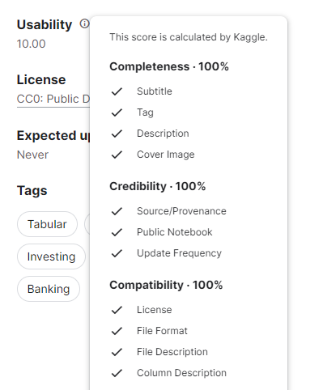

Describe:

Size: 17.64MB

File showing that during a crisis the export growth of a sector with a relatively high reliance on external finance, such as electric machinery, is reduced on average by 4 percentage points compared to a sector like footwear whose dependence is relatively low. We also find that exports of industries that tend to have more tangible assets grow relatively faster during a banking crisis confirming the hypothesis about the importance of collateral in a context when access to finance becomes scarcer. Finally, using a proxy for trade credit dependence (Fisman and Love,2003) we show that exports of industries relatively more reliant on inter-firm finance are not affected by a banking crisis more than others. A potential explanation for this finding is that if importers do not face a crisis themselves, they might be willing to accept less favorable payment conditions and extend trade credit to their suppliers in order to allow them to overcome their temporary credit constraints.

Data Explore (taking Japan as an example):

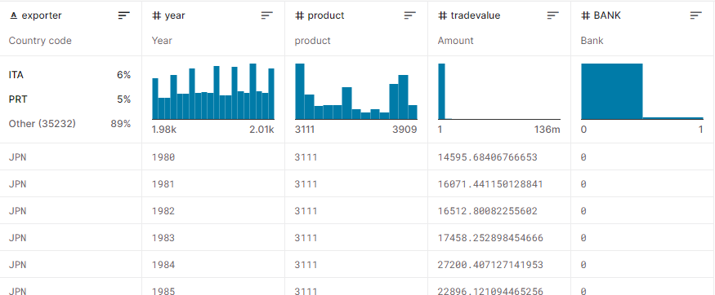

Project Timeline and Implementation:

We propose to execute the Data Mining and Big Data Analytics Solution over a period of this semester, with distinct milestones and deliverables at each stage. The implementation team will consist of skilled data scientists, domain experts, IT support, and business analysts, who will work collaboratively to ensure the success of the project.

Budget:

An estimated budget for the project, including necessary resources, software, and infrastructure, is included in the detailed project plan. We are committed to providing cost-effective solutions that align with your organization's goals and budgetary considerations.

Data Privacy and Security:

Ensuring data privacy and security is of utmost importance to us. We will adhere to strict data protection protocols and comply with all relevant regulations to safeguard sensitive information.

Conclusion:

By implementing the proposed Data Mining and Big Data Analytics Solution, you can enhance your productivity, promote decent work, and foster economic growth, aligning with SDG 8. We believe that this data-driven approach will provide valuable insights and recommendations to drive sustainable and inclusive economic development for your organization.

Thank you for considering our proposal. We look forward to the opportunity to contribute to your organization's growth and success. If you have any questions or require further information, please do not hesitate to contact us.

Sincerely,

Shuo

UoA