Scott Fenton

Homework 1

CS320

**Q1**: Let us define the successor of the set A to be the set A union {A}. Find the successors of the following sets:

a) A = {x}

Successor: A = {x,{x}}

b) B = {x,y}

Successor: B = {x,y,{x,y}}

c) C = { Ø}

Successor: C = { Ø,{ Ø}}

d) D = { Ø,{ Ø}

Successor: { Ø,{ Ø},{ Ø,{ Ø}}}

**Q2**: Find out for each of the following propositions whether it is a tautology, a contradiction, or neither(a contingency). Prove your answer.

a) [(p 🡪 q) ∧ (q 🡪 r)] 🡪 (p 🡪r)



This is a Tautology, we can see from the truth table that if we assign the truth value from the left side to be x, and the truth value from the right side to be y. Then if y is true then the expression is true, and if y is false and x is false then the expression is true. This logic turns out true for every expression of x 🡪 y.

b) (p **v** q **v** r) 🡪 [(q 🡪 r) **v** (p 🡪 q)]



This is a Tautology. If we set the left side truth value to x, and the right side truth value to y. Then we can see that if y is true then the expression is true.

**Q3**: Let us take a look at the sets A = {x,y,z}, B = {1,2}, C = {y,z}. List the elements of the following sets D, E, F, G, H, and I :

a) D = (B x A) – (B x C)

({1,2} x {x,y,z}) = {(1,x), (1,y), (1,z), (2,x), (2,y), (2,z)}

({1,2} x {y,z}) = {(1,y) (1,z), (2,y), (2,z)}

D = {(1,x), (1,y), (1,z), (2,x), (2,y), (2,z)} - {(1,y), (1,z), (2,y), (2,z)}

D = {(1,x),(2,x)}

b) E = 2A – 2C

2A = { Ø, x, y, z, {x,y}, {x,z}, {y,z}, {x,y,z}}

2C = { Ø, x, y, {x,y}}

E = { Ø, x, y, z, {x,y}, {x,z}, {y,z}, {x,y,z}} - { Ø, x, y, {x,y}}

E = {z, {x,z}, {y,z} {x,y,z}}

c) F = 2B

2B = { Ø, 1, 2, {1,2}}

F = {{},{{}},{{1}},{{2}},{{1,2}},{

d) G = (A x B x C) () (C x B x A)

e) H = {(a, b, c) | a, b, c∈Β ∧ b ≠ c ∧ a = b}

a = 1 b=1 c=2

H = {1,2}

f) I = {(a, b, c) | a∈A ∧ b∈B ∧ c∈C ∧ a = c}

a = z,y b = 1,2 c = z,y

I = {1,2,y,z}

**Q4**: Are the following statements true for all sets A,B, and C? Prove your answers.

a) |A ∪ B ∪ C| = |A - B - C|

b) |A ∪ B ∪ C| = |A| + |B| + |C| - |A ∩ B| - |A ∩ C| - |B ∩ C|

**Q5**: Find out whether the following functions from **R** to **R** are injective, surjective, and/or

Bijective (no proof necessary).

a) f(z) = -z

bijective

b) f(z) = 300z5 + 4

bijective

c) f(z) = z⋅sin z

Surjective

d) f(z) = z2/(z2+ 1)

not injective, surjective, or bijective

**Q6**: Give as good a big-O estimate as possible for the following complexity functions:

a) f(n) = (n⋅log n) (n2 + 2n)

O(n) = n2

b) f(n) = (2n! + 4n3) + (2n⋅n3)

o(n) = n!

c) f(n) = n4 + 5 log n + n3 (n2 + 2n)

O(n) = n2

**Q7**: Algorithms

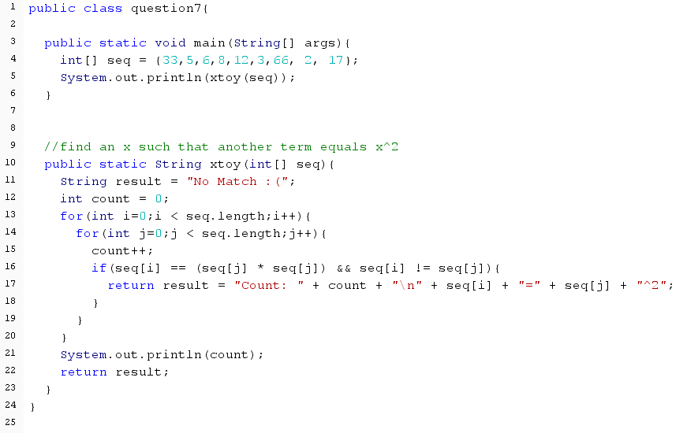a)

b) The input that causes worst-case time complexity is if the sequence does not contain two distinct terms such that x=y2. This causes worst case because if the equation is not met, then the algorithm must check each term against each other term. With two loops this means that the algorithm is O(n2). With a sequence containing 9 terms, the worst case scenario would result in 81 comparison checks then terminate.

c) f(n) = n2

This equation means that if the sequence contains 9 terms, the worst case scenario would require 81 checks before the algorithm terminates.

d) With Big-O notation, the algorithm would be defined as O(n2).

**Q8**: Draw the Venn Diagrams for the following sets:

a) A ∪ B ∪ C

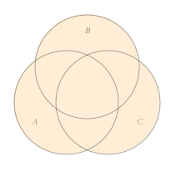

b) A ∪ (B - C)

c) (A ∩ B) ∪ (A ∩ C)

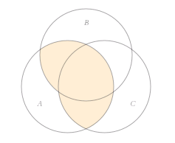



d)

