Scott Fenton

CS443

Homework 4 Questions

Q1. When using Geofencing scheme, what radius value can protect loc1? What radius value can

protect loc2? Why?

When using Geofencing scheme, I used a much larger radius of 50 to protect loc1, “JFK/UMASS station”, because there are other locations nearby that could reveal that the user passed by JFK otherwise. For loc2, “Boston Medical Center”, I used very small value of 5

**Geofencing with radius 50 Geofencing with radius 0**

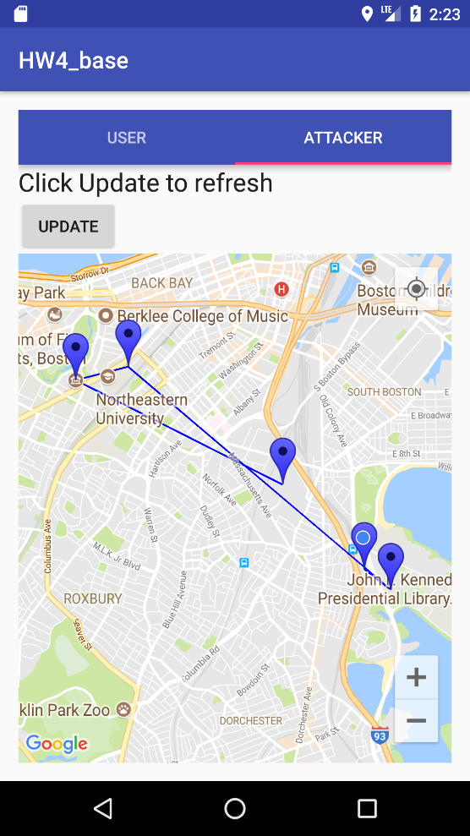 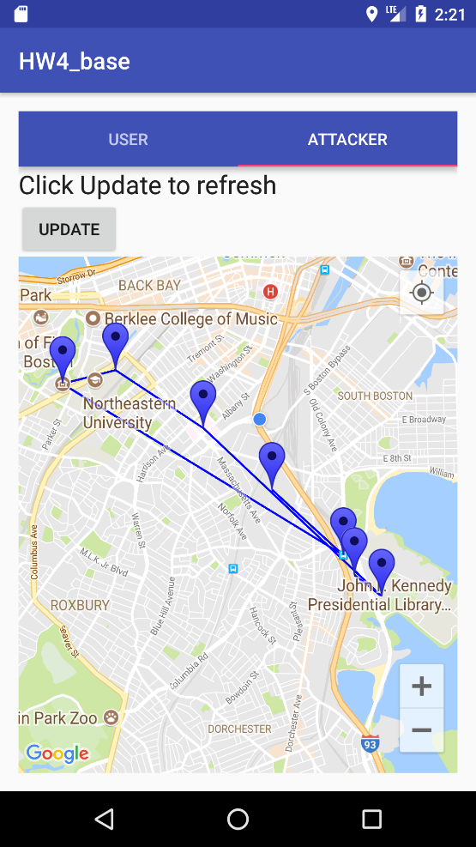

Q2. When choosing Region scheme, what radius value can protect loc1? What radius value can protect loc2? Why?

When using Region scheme, a radius of 100 can protect loc1, “JFK/UMASS station” because the “JKF/UMASS station” is close to other regions. A radius of 200 can protect loc2, “Boston Medical Center” because it is not as close to other destinations.

**Below is region with radius 100.** **Below is region with radius 200**.

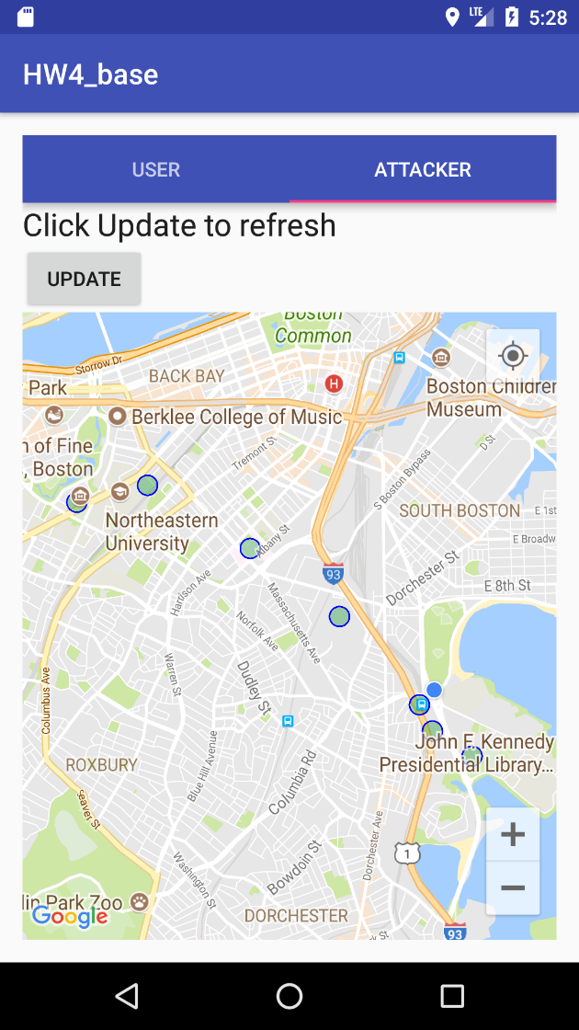 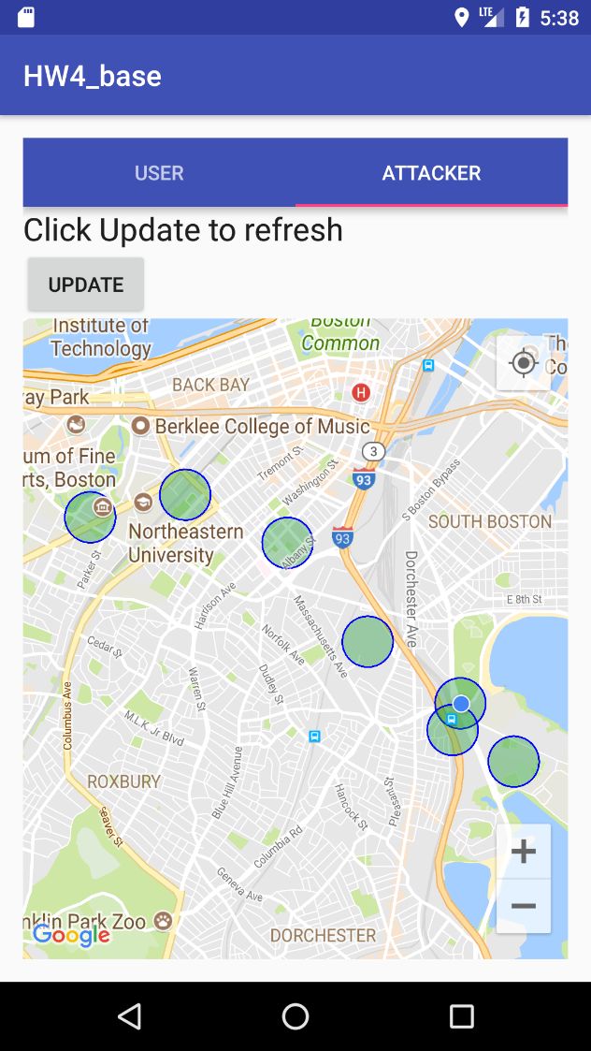

Q3. Compare loc1 and loc2, which location is easier to protect (i.e., harder for the attacker to identify), and why?

I think that loc2, Boston Medical Center, is easier to protect, because you can protect it with geofencing scheme, with any radius. It is easier to implement, and you do not lose many data points, as you would with region scheme.

Q4. Compare Geofencing and Region options, which scheme do you think is more effective for

protecting the location privacy and why?

Comparing Geofencing and Region options, I think that they both have strengths and weaknesses for protecting privacy depending on the circumstances. However, I believe that region scheme is better for protecting privacy, because it makes it more random.