## shop数据库包含两张表：

### product表

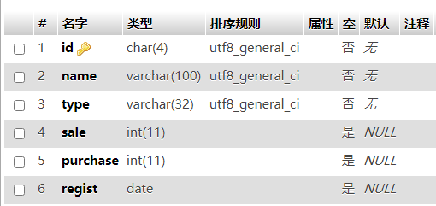

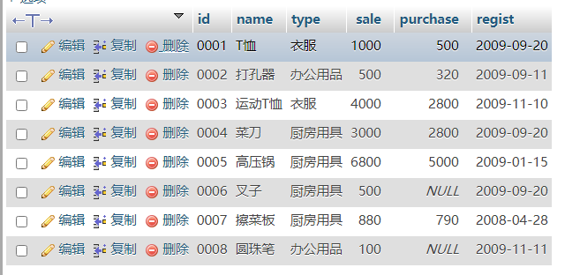

### shopproduct表

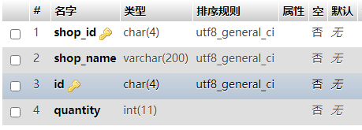

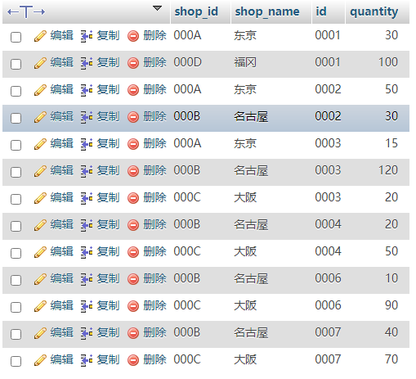

### 请完成下列查询

1. 查询Product表中销售单价最低的商品信息

Select * from product order by sale limit 1;

1. 对Product表按照商品种类统计每类商品的数量，如下图：

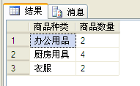

Select type,count(*) as ‘商品数量’ from product group by type;

1. 对Product表按照商品种类统计每类商品的售价总和，进价总和，如下图：

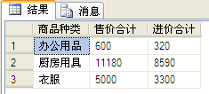

Select type,sum(sale) as ‘售价合计’,sum(purchase) as ‘进价合计’ from product group by type;

1. 以销售价格降序显示Product表所有商品信息。

Select * from product order by sale desc;

1. 以销售价格（降序）为第一关键字，商品编号（升序）为第二关键字排序显示Product表所有商品信息。

Select * from product order by sale desc,id asc;

1. 统计shopproduct表各商店商品数量的总和。

Select shop_name, sum(quantity) as ‘商品数量总和’ from shopproduct group by shop_name;

1. 查询大阪店的商品名称，销售单价和进货单价（至少用两种方法）。

Select name,sale,purchase from product where id in (select id from shopproduct where shop_name=’大阪’);

Select name,sale,purchase from product where exists (select * from shopproduct where shop_name=’大阪’ and product.id=shopproduct.id);

1. 查询商品编号，商品名称和数量。

Select p.id,p.name,sp.quantity from product as p join shopproduct as sp on p.id=sp.id;

1. 查询销售单价在[1000,5000]（闭区间）的商品名称，销售单价，商店名称和数量。

Select p.name,p.sale,sp.shop_name,sp.quantity from product as p join shopproduct as sp on p.id=sp.id where p.sale between 1000 and 5000;

1. 统计名古屋店的商品平均销售单价和平均进货单价。

Select avg(sale) as ‘平均销售单价’,avg(purchase) as ‘平均进货单价’ from product where id in (select id from shopproduct where shop_name=’名古屋’);

1. 按商店名称统计各商店的总销售单价和总进货单价。

Select sp.shop_name,sum(p.sale) as ‘总销售单价’,sum(p.purchase) as ‘总进货单价’ from product as p join shopproduct as sp on p.id=sp.id group by sp.shop_name ;

1. 计算各商店的利润。

Select sp.shop_name,sum(p.sale) as ‘总销售单价’,sum(p.purchase) as ‘总进货单价’ , (sum(p.sale)-sum(p.purchase)) as ‘利润’ from product as p join shopproduct as sp on p.id=sp.id group by sp.shop_name ;

1. 查询所有2009年商品名称，商店名称，进货单价和日期。

Select p.name,sp.shop_name,p.purchase,p.regist from product as p join shopproduct as sp on p.id=sp.id where year(p.regist)=2009;

1. 查询数量大于100的商品名称，进货单价和销售单价（至少用两种方法）。

Select p.name,p.sale,p.purchase from product as p join shopproduct as sp on p.id=sp.id where sp.quantity>100;

Select name,sale,purchase from product where id in(select id from shopproduct where quantity>100);