## 使用zg数据库，包含两张表

employee表

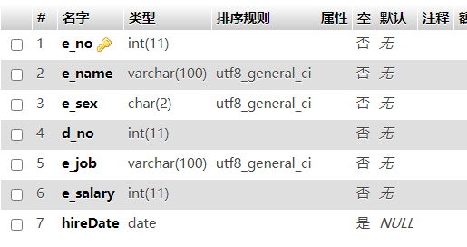

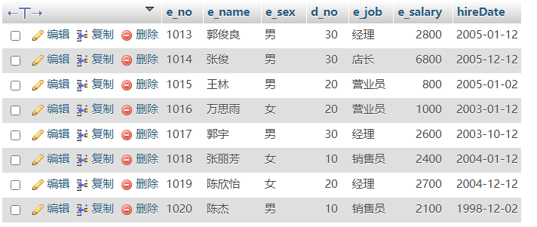

dept表

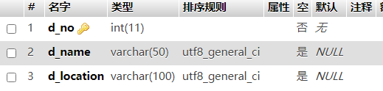

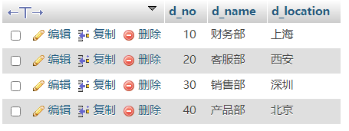

INSERT INTO employee VALUES

('1013','郭俊良','男',30,'经理',2800,'2005-1-12'),

('1014','张俊','男',30,'店长',6800,'2005-12-12'),

('1015','王林','男',20,'营业员',800,'2005-1-2'),

('1016','万思雨','女',20,'营业员',1000,'2003-1-12'),

('1017','郭宇','男',30,'经理',2600,'2003-10-12'),

('1018','张丽芳','女',10,'销售员',2400,'2004-1-12'),

('1019','陈欣怡','女',20,'经理',2700,'2004-12-12'),

('1020','陈杰','男',10,'销售员',2100,'1998-12-2');

CREATE table employee(e_no int(11) not null PRIMARY KEY,

e_name varchar(100) not null,

e_sex char(2) not null,

d_no int(11) not null,

e_job varchar(100) not null,

e_salary int(11) not null,

hireDate date);

请使用SQL指令完成下列操作：红色为多表查询

1. 复制employee全部内容到新表emcopy（带主键信息）

Create table emcopy like employee;

1. 对emcopy表操作，将店长的工资降低500元

Update emcopy set e_salary=e_salary-500 where e_job=’店长’;

1. 对emcopy表操作，将20号部门的营业员工资提升30%

Update emcopy set e_salary=e_salary*1.3 where d_no=20 and e_job=’营业员’;

1. 对emcopy表操作，将陈欣怡的入职日期改为2005-12-1

Update emcopy set hiredate = ‘2005-12-1’ where e_name=’陈欣怡’;

1. 删除emcopy表的入职日期在2005-1-1之前的所有信息

Delete from emcopy where year(hiredate) <2005 ;

1. 统计employee表每个职位（e_job）的人数，并保存为视图e1

Create view e1(职位,人数)

As

Select e_job,count(*) from employee group by e_job;

1. 查询客服部的员工姓名，性别，职位，工资和工作地点，将结果保存为视图e2

Create view e2(部门信息,员工姓名，性别，职位，工资，工作地点)

As

Select de.d_name,em.e_name,em.e_sex,em.e_job,em.e_salary,de.d_location from employee as em join dept as de on em.d_no=de.d_no ;

Select * from e2 where 部门信息=’客服部’;

1. 查询在北京工作的员工姓名和工号（使用两种方法）

Select e_name,e_no from employee where d_no in(select d_no from dept where d_location=’北京’);

Select em.e_name,em.e_no from employee as em join dept as de on em.d_no=de.d_no where de.d_location=’北京’;

1. 查询2005年入职的员工工号，姓名，部门名称和工作地点

Select em.e_no,em.e_name,de.d_name,de.d_location from employee as em join dept as de on em.d_no=de.d_no where year(em.hiredate)=2005;