Figures for Review — FLOPs Export Paper
This document contains draft maps and graphs for the FLOPs export paper. All figures use the cost-recovery adjusted baseline from the calibration. Figures are numbered sequentially; final numbering will depend on placement.

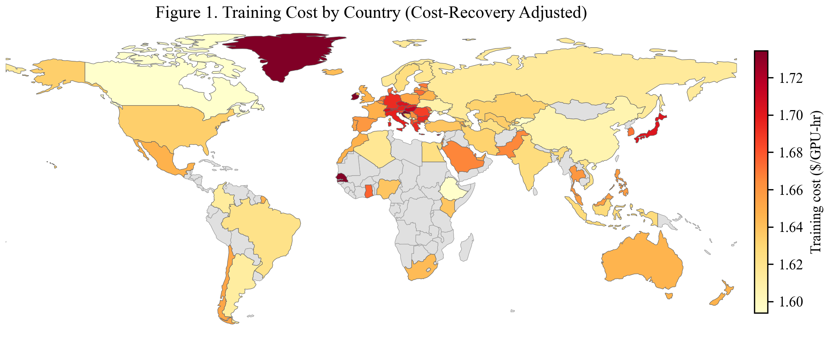
Figure 1. Training Cost by Country (Cost-Recovery Adjusted)
This map shows the all-in cost of one GPU-hour of training compute for each of the 85 countries in the calibration, after adjusting subsidized electricity prices to cost-recovery levels (Section 6). The cost includes hardware amortization, networking, electricity, and construction. Kyrgyzstan ($1.578/hr), Canada ($1.592/hr), and Ethiopia ($1.595/hr) are the three cheapest producers. The total cost range is narrow—$1.578 to $1.766 per GPU-hour—because hardware amortization is identical across countries and accounts for roughly 94% of total cost. The remaining cross-country variation comes from electricity prices (driven by the generation mix and climate-dependent cooling loads) and construction costs. Countries shown in gray are not in the calibration sample. Malta and Singapore are in the sample but too small to appear at this map resolution.

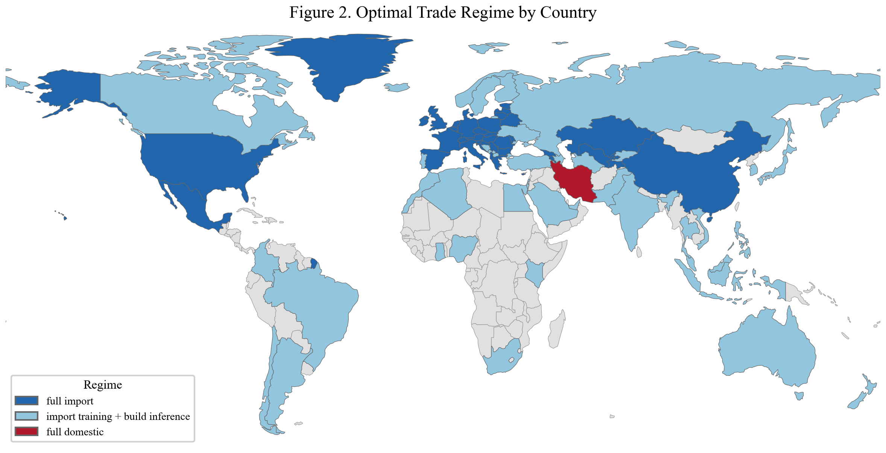
Figure 2. Optimal Trade Regime by Country
Each country is assigned to one of four trade regimes based on cost minimization (Section 3.4). Dark blue = full import: cheapest to import both training and inference from abroad (39 countries). Light blue = import training + build inference: cheaper to source training from low-cost exporters but build inference domestically to avoid the latency penalty (42 countries). Red = full domestic: cheapest to produce both services at home (Iran only, before cost-recovery adjustment). The fourth regime (build training + import inference) does not arise in the calibration. The dominance of the "import training + build inference" regime reflects the model’s central asymmetry: training is latency-insensitive and gravitates to the cheapest global producers, while inference is latency-sensitive and favors proximity to users.

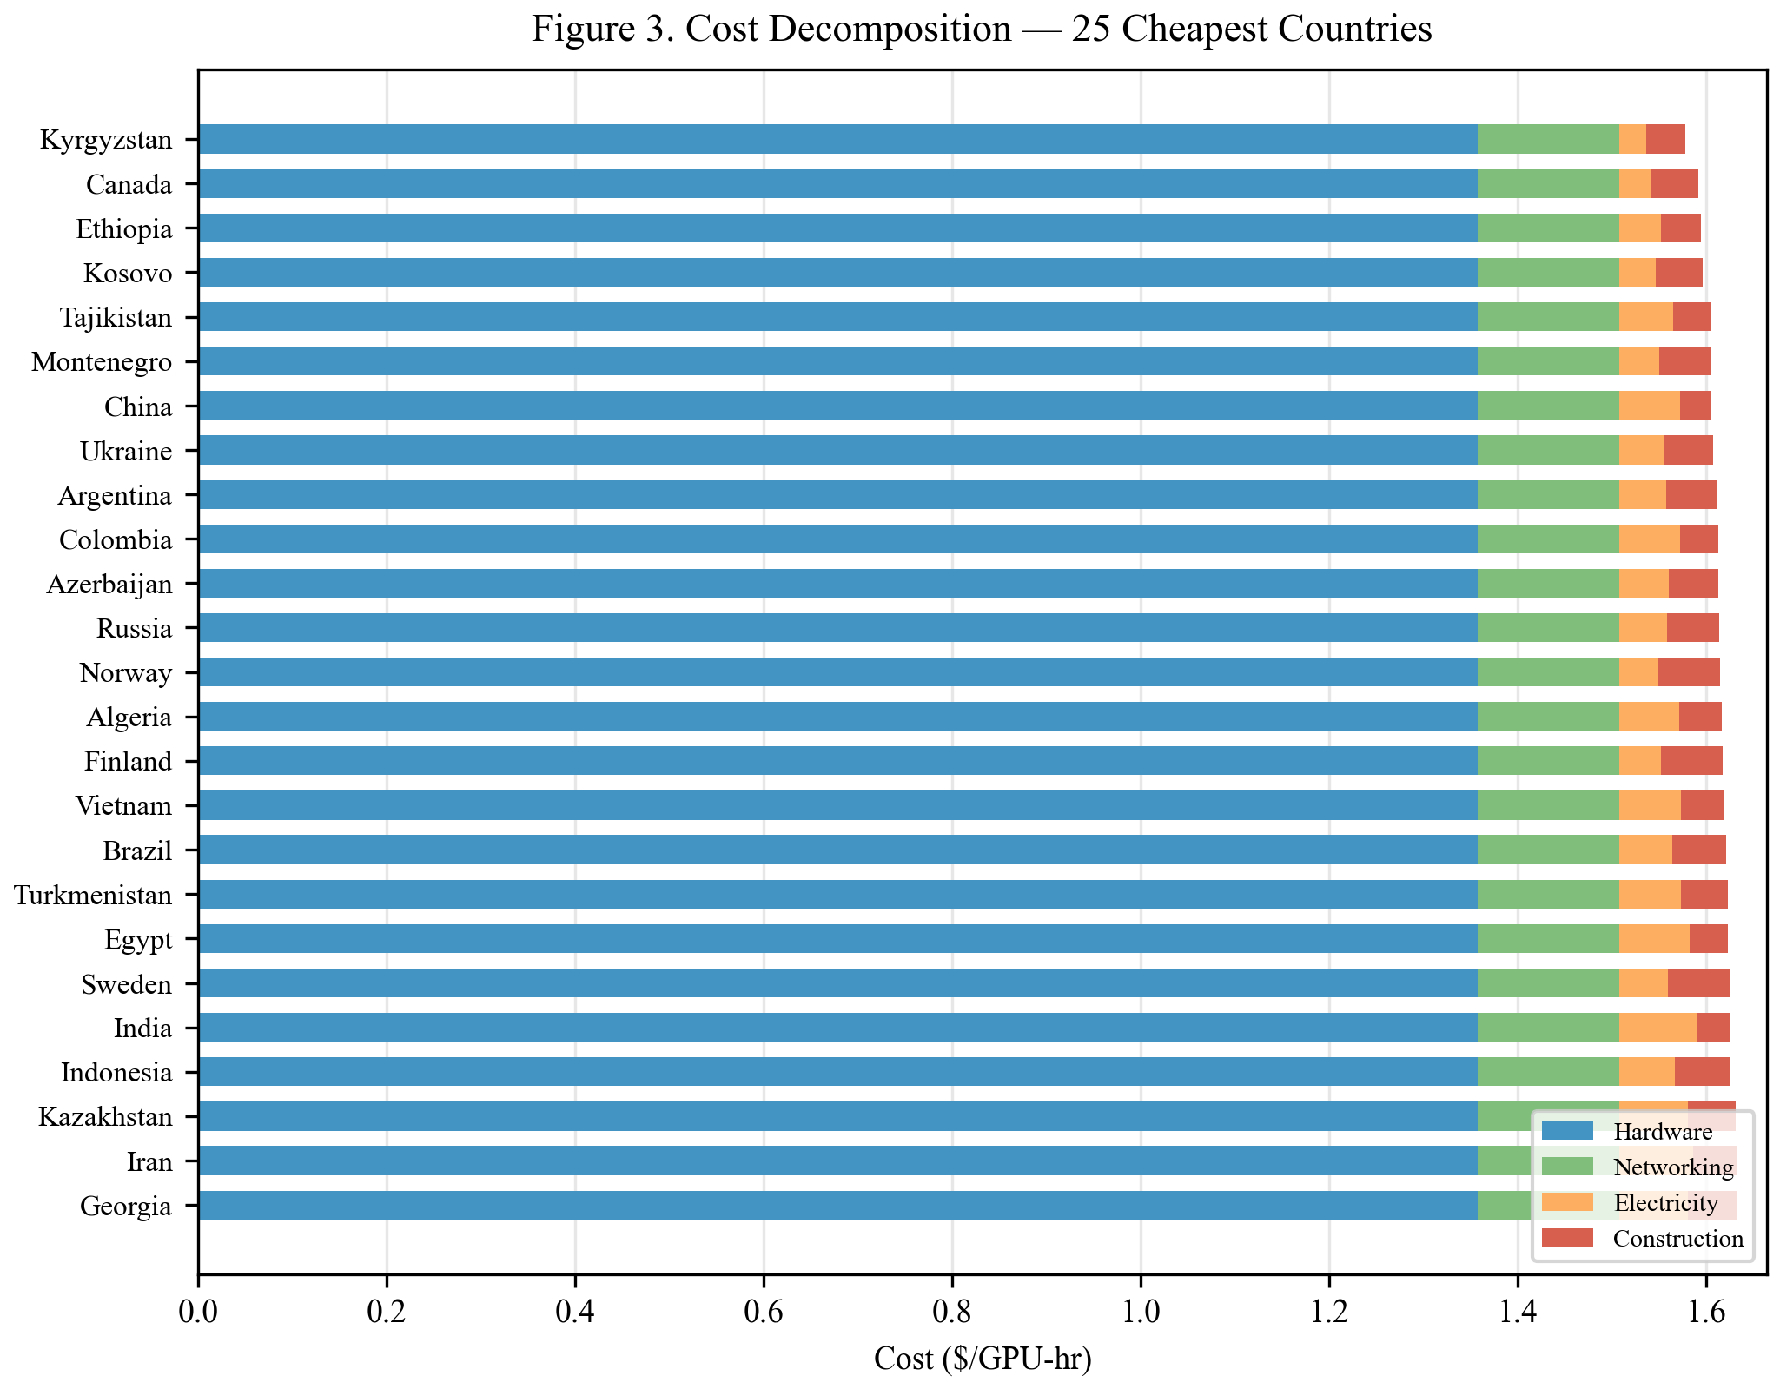
Figure 3. Cost Decomposition — 25 Cheapest Countries
Each bar decomposes the total training cost into four components: hardware amortization (GPU price / lifetime / utilization), networking (amortized interconnect and switching), electricity (PUE × GPU power draw × local electricity price), and construction (datacenter shell cost amortized over facility lifetime). Hardware is identical for all countries at $1.358/hr and dominates total cost, which is why the bars are nearly the same length. The visible differences at the right end of each bar come from electricity and construction. Countries with cheap hydropower (Kyrgyzstan, Canada, Ethiopia) or low construction costs (Kosovo, Tajikistan) gain a small but decisive edge. The near-uniformity of total cost explains the high Spearman rank correlation (ρ ≥ 0.992) across sensitivity scenarios in Table A3: perturbations to the small non-hardware share cannot overturn the ordering.

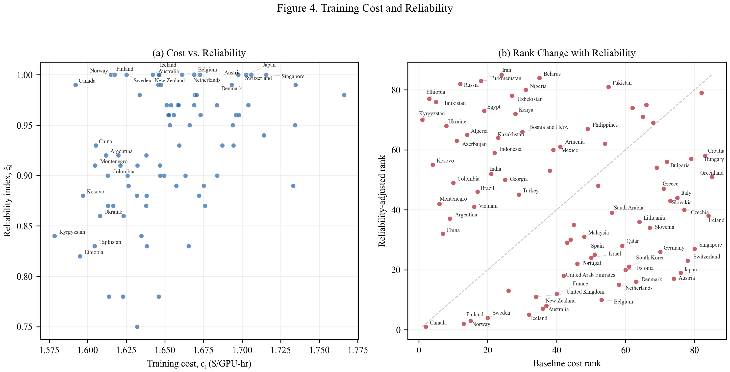
Figure 4. Training Cost and Reliability
Panel (a) plots each country’s training cost against its reliability index ξ, which combines governance quality, grid reliability, and sanctions exposure (equation 2a in the paper). Low-cost countries in the bottom-left (Kyrgyzstan, Ethiopia, Tajikistan) have low reliability scores, illustrating the cost–reliability tradeoff that buyers face. High-reliability countries (Canada, Norway, Finland) cluster near ξ = 1.0 but at moderately higher cost. Panel (b) compares each country’s baseline cost rank (x-axis) with its reliability-adjusted rank (y-axis), where adjusted cost = c / ξ. Countries on the 45-degree line are unaffected by the adjustment. Countries above the line (e.g., Iran, Turkmenistan, Ethiopia) fall in the rankings because low reliability inflates their adjusted cost. Countries below the line (e.g., Canada, Norway, Sweden) rise because high reliability leaves their cost nearly unchanged. The Spearman rank correlation between the two orderings is −0.13, indicating that reliability fundamentally reshuffles the ranking: the cheapest producers on paper are not the most attractive once governance and grid quality are priced in.

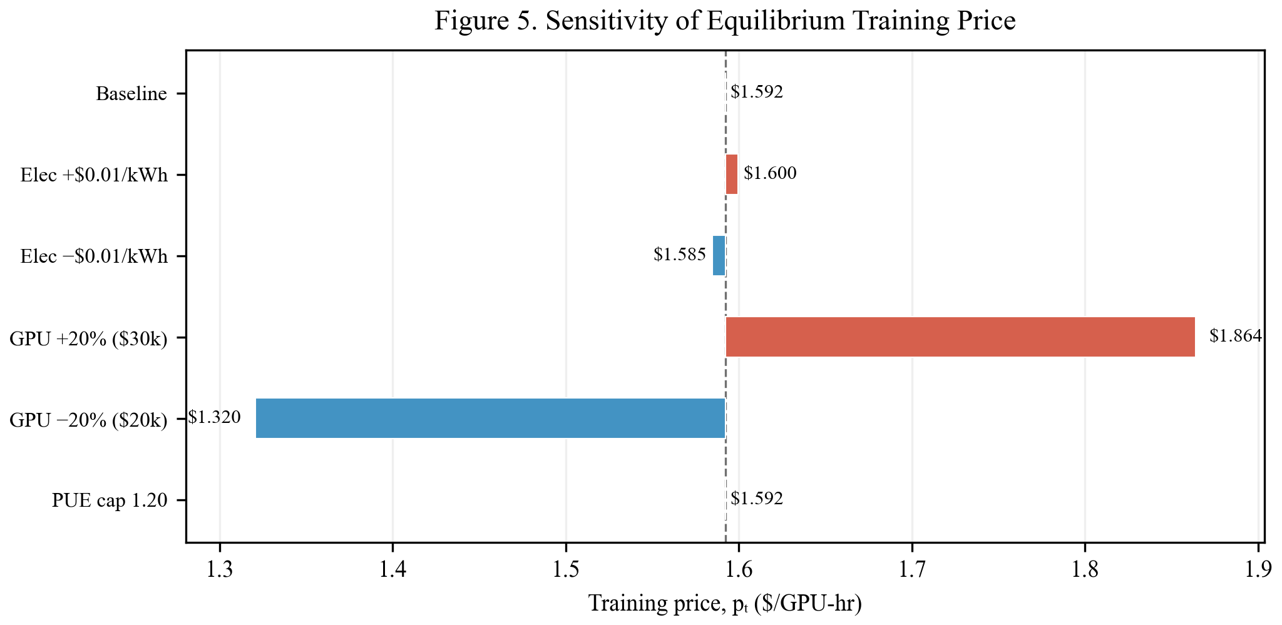
Figure 5. Sensitivity of Equilibrium Training Price
Each bar shows how the equilibrium training price pₜ deviates from the baseline ($1.592/hr) under a single parameter perturbation. GPU price changes have by far the largest effect: a 20% increase (to $30,000) raises pₜ to $1.864/hr, while a 20% decrease (to $20,000) lowers it to $1.320/hr. Electricity perturbations of ±$0.01/kWh shift pₜ by less than $0.01/hr in either direction. Capping PUE at 1.20 (eliminating climate-driven cooling variation) has no visible effect on the equilibrium price because the marginal exporter’s PUE is already near 1.20. These results confirm that hardware cost is the dominant driver of equilibrium outcomes, and that the model’s qualitative predictions are robust to substantial variation in electricity and cooling parameters.

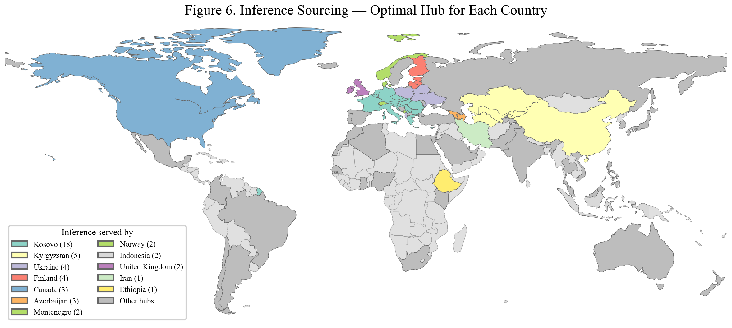
Figure 6. Inference Sourcing — Optimal Hub for Each Country
Each country is colored by the foreign or domestic provider that minimizes its latency-adjusted inference cost P_I = (1 + τ · RTT) · c (Section 3.2). The map reveals strong regional clustering: Kosovo serves most of Europe and North Africa (15 countries), Kyrgyzstan serves Central Asia (5 countries), Canada serves North America, and Finland serves the Nordics. This pattern arises because inference is latency-sensitive — round-trip time enters the delivered cost multiplicatively — so buyers prefer nearby low-cost providers even if a more distant country has slightly lower production cost. The contrast with training is stark: training is sourced from only 1–2 global exporters (Figure 2), while inference fragments into roughly a dozen regional hubs. This geographic structure is the model’s central prediction and is consistent with observed patterns of datacenter investment (Lehdonvirta, Wu, and Hawkins 2024).

