Group 6

**Quick Sands**

September 24, 2020

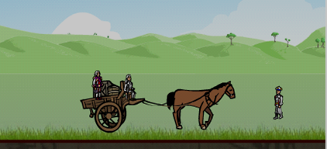

“A game is an opportunity to focus our energy, with relentless optimism, at something we’re good at (or getting better at) and enjoy. In other words, gameplay is the direct emotional opposite of depression.”

― Jane McGonigal, Reality is Broken: Why Games Make Us Better and How They Can Change the World

**(https://www.goodreads.com/quotes/tag/video-games)**

**Table of Contents**

1. Introductions ...….................................................................................................. 3
2. Industry Analysis …............................................................................................... 4
3. Mission Statement …............................................................................................ 5
4. Feasibility/Technical Explanation …..................................................................... 5
5. Schedule .............................................................................................................. 6
6. Stakeholder Analysis …......................................................................................... 6
7. System Request …..................................................................................................7
8. Constraints/Business Rules .................................................................................. 8
9. Functional Requirements ......................................................................................8
10. Non-functional Requirement ................................................................................9
11. SWOT Analysis ......................................................................................................10
12. SWOT Justification ............................................................................................... 11
13. Business Use Case Diagram ................................................................................. 13
14. Activity Diagrams ….............................................................................................. 14
15. Use Case Descriptions ......................................................................................... 14
16. System Use Case Diagrams …............................................................................... 22
17. Conceptual Model of Use Case …......................................................................... 29
18. Use Case Specifications + Interface Mock-ups ….................................................. 33
19. Data Dictionary ….................................................................................................. 38
20. Database Choice and Justification …......................................................................40
21. Database Table …...................…........................................................................... 41
22. Project Quality Management Plan …..................................................................... 42
23. Project Communication Management Plan …....................................................... 42
24. Cost Estimate ....................................................................................................... 43
25. Risk Management Plan …...................................................................................... 45
26. Cost Benefit Analysis …......................................................................................... 46
27. PRJ666 Schedule …............................................................................................... 47
28. Work Division ….................................................................................................... 48
29. PID Revision …....................................................................................................... 50
30. Research Sources ….............................................................................................. 50

**Introductions**

Group 6:

* Robert Parker-Lak
* Andriy Ostapovych
* Faramarz Hosseini

Version: 1.00, updated December 09, 2020

**Contract**

We in Group 6 agree to the following conditions:

* We will meet every weekly deliverable as outlined in the Addendum for this course.
* The violence in this game will not be excessive and will not cross the line to areas of hate or discrimination of any kind. No bullying or reference to this topic will be present in the game.

We all understand the terms and conditions of this approval by Seneca.

**Industry Analysis**

Over the past two decades the video games industry has grown significantly. The revenue from video games before Covid-19 rivaled that of all the movies, tv shows and other media combined.

When Covid-19 reached Canada, it forced the country into lockdown, and this naturally caused a massive hit to many sectors of the economy. The video game industry was not an exception here, as many workers were forced to stay home. Despite this, it proved more resilient than many other sectors, and continues to make profits. People forced into isolation have more time available and many choose video games to pass the time. As such there is evidently demand for games.

Based on our vision, and work on this game so far, we believe that this game would be rated E. Taking this into consideration, we would like to point you to games with a Rating of "E for Everyone" ages 10+:

* The world-famous Pokémon, whose battle system mirrors our project (https://www.esrb.org/ratings/36456/Pok%C3%A9mon+Shield/)
* Super Smash Bros, a game with the only goal being defeating the other fighters (https://www.esrb.org/ratings/35839/Super+Smash+Bros+Ultimate/)
* The Zelda Series, an adventure game of fighting monsters across the world to save a princess (https://www.esrb.org/ratings/9947/The+Legend+of+Zelda/)
* Decap Attack, a game with a mummy that throws its Decapitated Head at enemies to defeat them (https://www.esrb.org/ratings/30035/Decap+Attack/)

Quick Sands is an Indie game based around the building and management of an adventure party that travels, trades, and engages in combat on transports that expand the party size and cargo capacity. Boost party stats with a loot drop based crafting system, gathering scales and chitin to craft class specific armor and weapons. Traverse an unforgiving barren world, conquer the beasts and rival factions controlling it, and unite the scattered remnants of humanity.

This game would appeal to many people's interests, and sales would be boosted by showing up on the PC marketplace such as Steam.

**Mission Statement**

Our project’s objective is to build an MVP (Minimum Viable Product) of a PC Game Application that will prosper in the ever-growing demand for entertainment influenced by the current Covid-19 Pandemic Isolation.

When finished, the Application will serve as the Demo Product of an official video game company, for a Kickstarter which will aim at:

* Raising Funding
* Updating the artwork
* Adding a Campaign
* Adding a Multiplayer Arena
* Adding a Cosmetic-Micro Transaction Store

And many other interesting features.

This project aims to use the skills developed in the team members by Seneca to create a marketable piece of software, simulating realistic software time management and feature development.

**Feasibility**

Unity is a powerful game design software that is being used to precisely implement our game and compile it for Personal Computers. Most of the coding will be done in C#. The character design is handled by Photoshop for the art and Spine for bone rigging and animation, an incredible tool set to create 2D renders and animation for character models.

These tools are popular and widely used in the industry, providing a solid safety net of online tutorials for both feature development and error handling that might occur along the way.

Having a viable plan is one of the important steps in this project, keeping the project interesting with many solid core features, and interesting stretch goals. These goals would be alright to leave out but would enrichen the final product if there is additional time available.

We will enforce feature limitations to make sure our ideas do not exceed our abilities and time allocated. The result is not going to be an overly ambitious incomplete game, but an engaging RPG title that meets the expectations of the players and developers based on the set boundaries.

Combining powerful industry tools with comprehensive training material, and project guidelines placed on ourselves, we believe this project’s completion to be feasible.

**Schedule**

The schedule is included in a separate document

**Stakeholder Analysis**

|  |  |  |  |
| --- | --- | --- | --- |
| **Stakeholder** | **Stakeholder Interest in the Project** | **Assessment of Impact** | **Potential Strategies for Gaining Support/Reducing Obstacles** |
| Developers | Creating the Project | Maximum | Time Managed Plan,  Communication Plan,  Project Layout |
| Consumers | Using the Result | Maximum | Contacting the Customer Service |
| CRA | Making sure the revenue is taxed | Minimal | Inspecting the money cycle |
| Seneca | Sponsoring the developers | Moderate | Signing a contract with the developers |
| Instructor | Responsible for developers’ final product | Maximum | Inspecting the whole process, Signing a contract with the developers |
| Distributor | Provides a marketplace which allows for online transactions, charging a portion of each. | Moderate | Abide by the terms of agreement, and the rating of the ESRB. |
| ESRB | Rating the game for a certain age. | Moderate | Abide by the rating of the ESRB. |

The Stakeholders are:

* Consumers
* ESRB
* CRA
* Seneca
* Creative Designer
* Distributor
* Design Director
* Technology Manager

This list may be subject to change.

**System Request**

**Quick Sands**

**Project Sponsor:** Professor Ben Torres

**Business Needs:** Unlike many other sectors of the economy in the current Covid-19 Crisis, the video game industry is booming. This is due in large part to the fact that video games are a medium that you can enjoy on your own/in socially distanced groups. This video game is designed to appeal to a sizable part of the market in that industry, providing enjoyment and profit in equal measure.

**Business Requirements:**

* User must be able to launch and play game
* User must be able to select a character
* User must be able to explore game world
* User must be able to engage in game systems: travel, combat, and trading

**Business Value:** This game will provide entertainment for consumers and profit for the creators and investors. The current pricing outlook for this game is that the game will likely be free, but with an in-game store to sell additional content to consumers. This is a common pricing method for mobile games and can make these game a great deal of money.

**Special Issues or Constraints:**

* This project needs to be finished in four months.
* The full project must be finished in eight months.

**Business Rules**

1. BR 01: Users must have a computer to use Application
2. BR 02: Users must be above or at least 10 years of age
3. BR 03: User must have access to Internet to download Application
4. BR 04: User must have enough storage available for Application on device

**Constraints**

1. Regulatory Constraint - limited by Seneca's Academic Standards and our Contract
2. Academic Constraint - limited by the time we have available to complete the project
3. Technological Constraint - limited by the software available and their features
4. Funding – limited by the money that the project has available for assets, and software
5. Talent - limited by the skills that we have as developers/programmer

**Functional Requirements**

1. Provide ability to: Select Character (Warrior, Archer, Mage)
2. Provide ability to: Travel to Foreign Locations (Towns, Nests)
3. Provide ability to: Engage in Encounters (Positive or Negative)
4. Provide ability to: Load and Control Battles (Win or Lose)
5. Provide ability to: Manage Quests (Accept or Abandon)
6. Provide ability to: Collect Rewards (Quest or Battle)
7. Provide ability to: Buy or Sell (Trade Goods, Armor, or Weapons)

**Non-Mandatory Goals**

* A reputation system
* A faction system
* Special Abilities for each hero
* Additional touch-screen implementation
* A crafting system

**Non-Functional Requirements**

* Security: This game will be an offline game, not requiring online database security.
* Reliability: Reliability will be ensured through stringent testing before the release of the final product. The game will be stress-tested on all its potential platforms to ensure a smooth gameplay experience.
* Performance: With the advances in game engine technologies and the never-ending increase of graphical standards, it is challenging to maintain the appearance of the game alongside optimizing its performance on a wide range of devices, each with different hardware strength.
* Maintainability: We will be gathering feedback from users before and after the release of the game to learn what new features are wanted. Continued support after release will add new features, balance patch - microtransactions, patches
* Scalability: We will use the object-oriented model hierarchies to scale our classes, weapons, armor, enemies and transports, which increases and maintains performance as the project grows.
* Usability: Understanding game mechanics can be confusing for users with less experience. It is required for the game to be self-explanatory and use easy to remember controls while keeping the gameplay challenging and fun.

**SWOT Analysis**

|  |  |
| --- | --- |
| **Strengths**  Accessibility  Indie Appeal  Free to Play  Expandable | **Weaknesses**  Hardware Limitations  Data Plan Limitations |
| **Opportunities**  Covid Pandemic  Multi-platform | **Threats**  Distributor Issues  Numerous Competitors  ESRB Rating limitations  Scope Creep |

**SWOT Justification**

**Strengths**

* Indie Appeal: Independent games have a very large fanbase. This is a consumer base that this game will tap.
* Free to Play: This game will be free to download and play, giving it a broader appeal.
* Expandable: A game lives on through updates and new features. Having a story makes it possible and more convenient to bring content updates to our game, resulting in more relevancy.

**Weaknesses**

* Hardware Limitations: The game requires space on the device to install, and many users are limited by their storage.
* Data Plan Limitations: Users are often discouraged from downloading sizable games when limited by their Data Plan, they might hold off until they are connected to Wi-Fi or skip the product entirely.

**Opportunities**

* Covid Pandemic: The Covid-19 Pandemic is causing intermittent lockdowns around the world. These lockdowns keep people inside, and as such, limit their options in day-to-day life. With less to do, more people are looking at new games on distributor sites. This gives our game a possible boost.
* Multi-platform: This game is multi-platform; it will be hosted on Google Play and on Steam, which will allow this game to be played on PC. This gives the game a wider market, and so more opportunities for sales.
* Marketing Campaign - Modern day Indie Devs are starting marketing early in the project development with the use of Development Update Videos (Dev Blogs) posted to YouTube. This generates a following, revenue, free alpha and beta testers, massive amounts of feedback, and even produces free game assets in the forms of artistic contributions from fans.

**Threats**

* Distributor Issues: The game will be available on two distributor stores: Steam and Google Play. If one of these distributors is having issues (e.g., a DDOS attack), then this game will be unable to download.
* Numerous Competitors: There are thousands of Indie games on the Steam store, so there is a lot of competition for this game. This could cause customers to choose another game over this one.
* ESRB Rating limitations: Anything above an E rating will limit the potential consumer base for this game.
* Scope Creep: Always a threat, the more we try to add to the development of this game the more work it will take to do it all.

**Business Use Case Diagram**

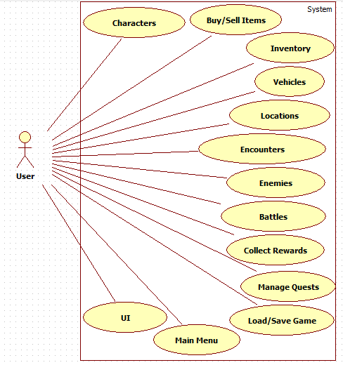

**Activity Diagrams**

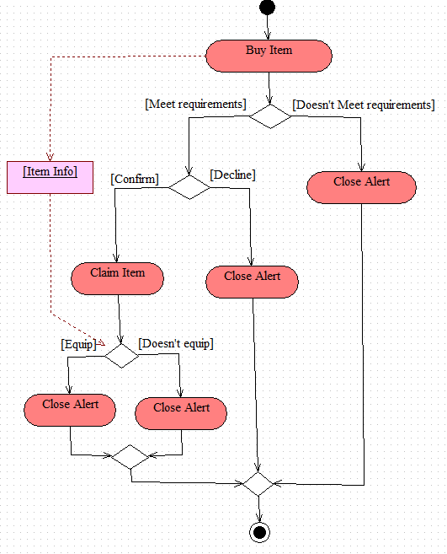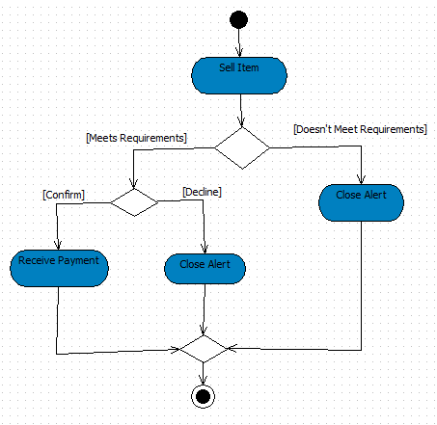

**Use Case Description**

**Launch Game**

|  |  |  |
| --- | --- | --- |
| Use Case Name: Launch Game | ID: 1 | Importance Level: High |
| Primary Actor: User Use Case Type: Detail, Essential | | |
| Stakeholders and Interests:  User - wants to play the game  Distributor – Hosts the game | | |
| Brief Description: This use case describes how a user starts the game | | |
| Trigger: User wants to play the game  Type: External | | |
| Relationships:  Association: User, Host Application, Game  Include:  Extend:  Generalization: | | |
| Normal Flow of Events:   1. User taps the game icon on mobile device 2. User presses ‘Play’ to start game 3. System boots up, after a period of loading user is presented with the main menu | | |
| SubFlows: | | |
| Alternate/Exceptional Flows: | | |

**Buy Items**

|  |  |  |
| --- | --- | --- |
| Use Case Name: Buy Item(s) | ID: 2 | Importance Level: Medium |
| Primary Actor: User Use Case Type: Detail | | |
| Stakeholders and Interests: User, wants to purchase in-game item(s) | | |
| Brief Description: User purchases in-game item(s) | | |
| Trigger: User decides to buy item(s)  Type: Internal | | |
| Relationships:  Association: User  Include:  Extend:  Generalization: | | |
| Normal Flow of Events:   1. User opens dialogue with an in-game vendor 2. System displays list of items available for purchase 3. User selects desired item and presses ‘Buy’ 4. System checks if user has enough money 5. If user has met requirements for purchase, system pops-up request for confirmation 6. User selects ‘yes’ 7. System removes money from user and places item(s) in inventory | | |
| SubFlows: | | |
| Alternate/Exceptional Flows:  5a. User does not meet requirements  6a. System displays message “Not enough money for purchase.”  7b. User closes trade dialogue | | |

**Sell Items**

|  |  |  |
| --- | --- | --- |
| Use Case Name: Sell Item(s) | ID: 3 | Importance Level: Medium |
| Primary Actor: User Use Case Type: Detail | | |
| Stakeholders and Interests: User, wants to sell item(s) | | |
| Brief Description: User wants to sell item(s) | | |
| Trigger: User decides to sell item(s)  Type: Internal | | |
| Relationships:  Association: User  Include:  Extend:  Generalization: | | |
| Normal Flow of Events:   1. User chooses to sell item(s) 2. System checks if the user meets the requirements 3. An alert comes up showing the amount of gold the item is worth 4. User confirms selling the item 5. The item is removed from the user’s inventory 6. The user is given the amount of gold the item was worth | | |
| SubFlows: | | |
| Alternate/Exceptional Flows:  2a. User does not meet the requirements  3a. System displays message “Not eligible to sell item”  4a. User closes the alert | | |

**Inventory**

|  |  |  |
| --- | --- | --- |
| Use Case Name: Inventory Management | ID: 4 | Importance Level: High |
| Primary Actor: User Use Case Type: Detail, Essential | | |
| Stakeholders and Interests:  User - wants to access, equip and manage items in their inventory | | |
| Brief Description: This use case describes how a user uses the database that contains all of the items they have acquired, including equipping or dropping an item. | | |
| Trigger: User wants to interact with an item  Type: Internal | | |
| Relationships:  Association: User, Host Application, Game  Include:  Extend:  Generalization: | | |
| Normal Flow of Events:   1. User taps the inventory icon on their UI 2. System displays inventory screen, with items delineated by icons 3. User selects a basic item icon 4. System displays information on item 5. User selects drop icon 6. System displays message “Drop Item?” 7. User selects “Yes” 8. System removes item from inventory 9. User drags item icon to equip slot 10. System puts item into character’s equip slot 11. User drags item from equip slot 12. System removes item from character’s equip slot 13. User selects “X” on top-right of Inventory screen 14. System closes inventory screen | | |
| SubFlows: | | |
| Alternate/Exceptional Flows:  7a. User selects “No” | | |

**Vehicles**

|  |  |  |
| --- | --- | --- |
| Use Case Name: Vehicles | ID: 5 | Importance Level: High |
| Primary Actor: User Use Case Type: Detail, Essential | | |
| Stakeholders and Interests:  User – wants to travel from location to location, have a larger inventory and fun items | | |
| Brief Description: This use case describes how a user interacts with in-game vehicles | | |
| Trigger: User wants to use a vehicle  Type: Internal | | |
| Relationships:  Association: User, Host Application, Game  Include:  Extend:  Generalization: | | |
| Normal Flow of Events:   1. User interacts with vehicle merchant 2. System displays list of vehicles available for purchase 3. User selects vehicle to purchase 4. System removes vehicle from merchant list and adds vehicle to user vehicle list 5. User clicks on “X” in top-right corner 6. System closes vehicle merchant screen 7. User clicks on Vehicle drop-down list and selects new vehicle 8. System sets vehicle to user current vehicle, removes all party members from user | | |
| SubFlows: | | |
| Alternate/Exceptional Flows:  3a. User clicks on “X” in top-right corner  4a. System closes vehicle merchant screen | | |

**Locations**

|  |  |  |
| --- | --- | --- |
| Use Case Name: Locations | ID: 6 | Importance Level: Medium |
| Primary Actor: User Use Case Type: Detail, Essential | | |
| Stakeholders and Interests: User, wants to access another part of the in-game map | | |
| Brief Description: This use case describes how a user changes their in-game location | | |
| Trigger: User is ready to leave area  Type: Internal | | |
| Relationships:  Association: User, Game  Include:  Extend:  Generalization: | | |
| Normal Flow of Events:   1. User presses ‘World Map’ button 2. System game map opens, highlights accessible areas with individual buttons 3. User selects a location button to travel to that area 4. System displays pop-up confirming desire to travel to new area 5. User selects ‘Yes’ 6. System displays loading screen as it loads Travel/Battle Scene 7. User is placed in starting area of Travel/Battle Scene | | |
| SubFlows: | | |
| Alternate/Exceptional Flows:  3a. User presses ‘Close Map’  4a. System closes map, displays player characters again  5b. User selects ‘No’  6b. System closes pop-up, displaying map again | | |

**Encounters**

|  |  |  |
| --- | --- | --- |
| Use Case Name: Encounters | ID: 7 | Importance Level: High |
| Primary Actor: User Use Case Type: Detail, Essential | | |
| Stakeholders and Interests:  User – wants to be able to engage in random encounters when travelling | | |
| Brief Description: This use case describes how a user interacts with encounters | | |
| Trigger: user is travelling and an encounter randomly spawns  Type: Internal | | |
| Relationships:  Association: User, Host Application, Game  Include:  Extend:  Generalization: | | |
| Normal Flow of Events:   1. User is travelling between locations 2. System generates a number of encounters when the user starts travelling based on length of trip with random types 3. System spawns an encounter of a battle type 4. System displays battle event 5. User engages in battle event and wins 6. System displays reward screen 7. User selects rewards and closes rewards screen 8. System puts user back into travelling scene 9. System spawns an encounter of trade type 10. System displays trade screen for user 11. User trades as desired and closes the screen when done 12. System puts user back into travelling scene 13. User reaches destination 14. System pulls user out of travelling scene, puts them in location | | |
| SubFlows: | | |
| Alternate/Exceptional Flows: | | |

**Battles**

|  |  |  |
| --- | --- | --- |
| Use Case Name: Battles | ID: 8 | Importance Level: High |
| Primary Actor: User Use Case Type: Detail, Essential | | |
| Stakeholders and Interests:  User – wants to be able to fight enemies | | |
| Brief Description: This use case describes how a user fights a battle | | |
| Trigger: user is travelling and engages in a battle encounter  Type: Internal | | |
| Relationships:  Association: User, Host Application, Game  Include:  Extend:  Generalization: | | |
| Normal Flow of Events:   1. User encounters a battle 2. System spawns' enemies and displays the Battles screen 3. User chooses action: attack, item, run away 4. System enacts user action 5. Enemies do action 6. System enacts enemies' action 7. Repeat steps 3-6 until User wins, loses or successfully flees 8. User Wins 9. System displays rewards screen 10. User chooses rewards and closes screen 11. System closes battle screen | | |
| SubFlows: | | |
| Alternate/Exceptional Flows:  8a. User loses  9a. System closes battle screen  10a. System moves player back to previous location  11a. System removes all rewards player had earned on that travel  12a. User resumes play  8b. User successfully runs away  9b. System closes battle screen and puts player back into travel scene they were in  8c User Unsuccessfully runs away  9c User loses turn | | |

**Rewards**

|  |  |  |
| --- | --- | --- |
| Use Case Name: Rewards | ID: 9 | Importance Level: High |
| Primary Actor: User Use Case Type: Detail, Essential | | |
| Stakeholders and Interests:  User – wants to be able to acquire items | | |
| Brief Description: This use case describes how a user gets rewarded after completing a quest or a battle | | |
| Trigger: user completes a quest or wins a battle  Type: Internal | | |
| Relationships:  Association: User, Host Application, Game  Include:  Extend:  Generalization: | | |
| Normal Flow of Events:   1. User wins a battle or completes a quest 2. System calculates rewards based on numerous factors 3. System displays rewards screen with items it calculated should be in there 4. User selects items they want from rewards screen 5. System moves selected items into player inventory 6. User closes reward screen by clicking “x” on top right of screen | | |
| SubFlows: | | |
| Alternate/Exceptional Flows: | | |

**Quests**

|  |  |  |
| --- | --- | --- |
| Use Case Name: Quest | ID: 10 | Importance Level: High |
| Primary Actor: User Use Case Type: Detail, Essential | | |
| Stakeholders and Interests:  User – wants to be able to complete quests for rewards and entertainment | | |
| Brief Description: This use case describes how a user begins and finishes a quest | | |
| Trigger: user interacts with a quest-giver  Type: Internal | | |
| Relationships:  Association: User, Host Application, Game  Include:  Extend:  Generalization: | | |
| Normal Flow of Events:   1. User interacts with a quest-giver 2. System displays list of available and active quests 3. User selects a quest from the list 4. System displays quest message, explaining details about the available quest 5. User selects “Accept” 6. System adds a quest to the user and moves quest from available list to active list 7. System displays available quest list 8. User selects “Active Quests” 9. System displays active quests list 10. User selects “x” on top right corner of quests screen 11. System closes quests screen 12. User completes quest objectives (defeat enemies, trade goods, etc) 13. System removes quest from user, displays reward screen 14. User selects reward 15. System adds rewards to user inventory and closes reward screen 16. System displays quest screen | | |
| SubFlows: | | |
| Alternate/Exceptional Flows:  5a User selects “Decline”  6a System displays available quest list | | |

**Save/Load Game**

|  |  |  |
| --- | --- | --- |
| Use Case Name: Save/Load | ID: 11 | Importance Level: High |
| Primary Actor: User Use Case Type: Detail, Essential | | |
| Stakeholders and Interests:  User – wants to be able to save their progress and continue it later | | |
| Brief Description: This use case describes how a user saves and loads a game | | |
| Trigger: user interacts with a quest-giver  Type: Internal | | |
| Relationships:  Association: User, Host Application, Game  Include:  Extend:  Generalization: | | |
| Normal Flow of Events:   * 1. User selects “start game” from the main menu   2. System loads the current save file   3. User changes something in their inventory   4. System saves over the current save file   5. User Starts a travel scene   6. System saves over the current save file   7. User ends a travel scene   8. System saves over the current save file   9. User changes their party composition   10. System saves over the current save file   11. User begins or completes a quest   12. System saves over the current save file | | |
| SubFlows: | | |
| Alternate/Exceptional Flows: | | |

**System Use Case Diagrams**

**Start Menu**

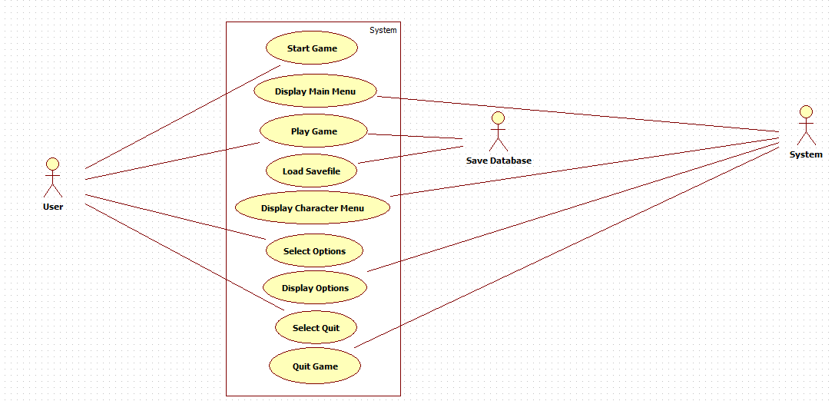

**Select Hero**

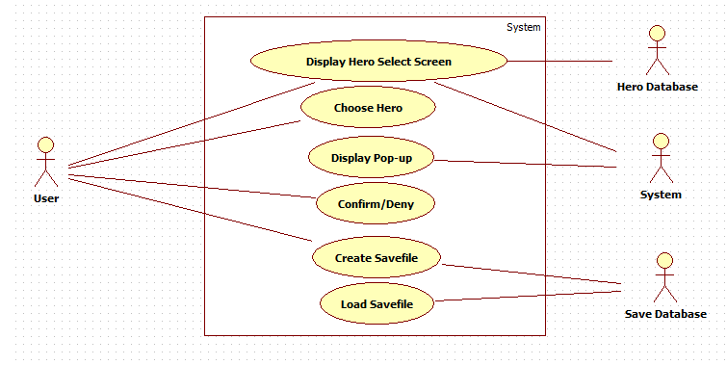

**Buy Item**

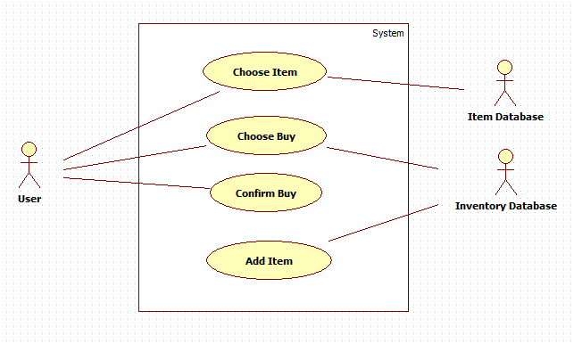

**Sell Item**

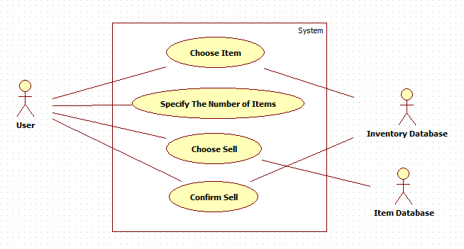

**Inventory**

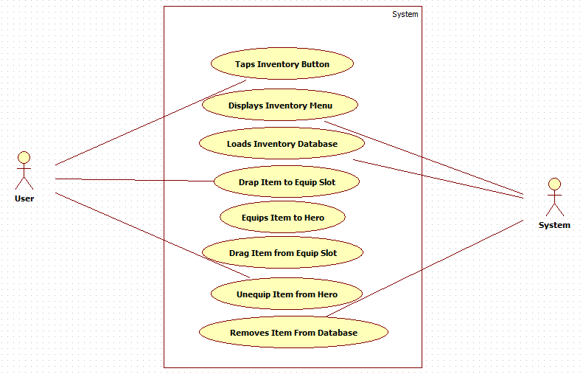

**Vehicles**

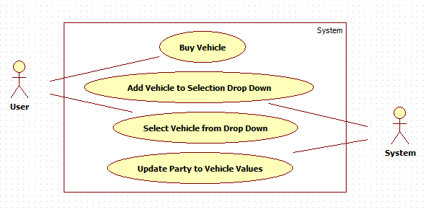

**Location**

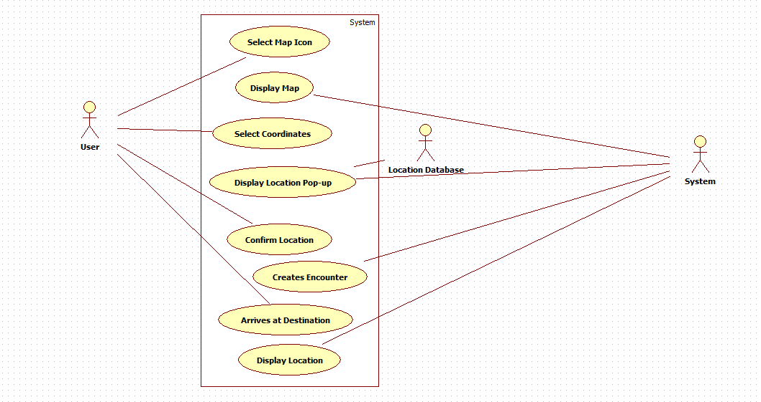

**Battle Encounter**

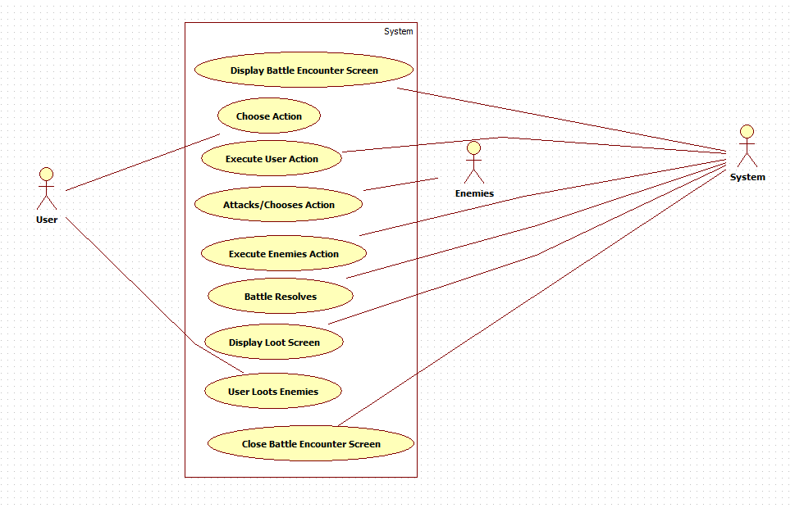

**Quest Encounter**

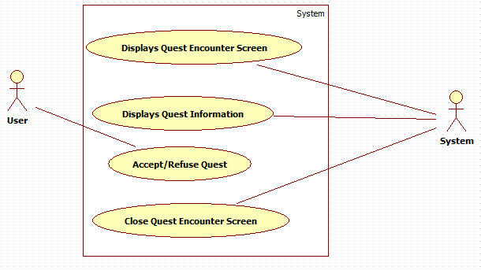

**Treasure Encounter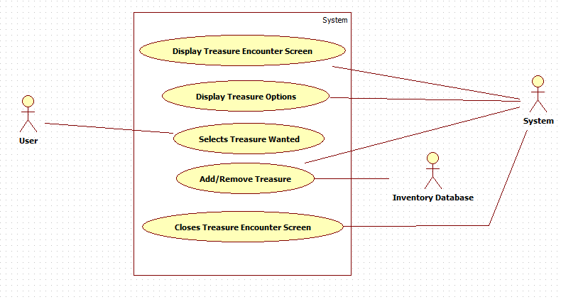Battles**

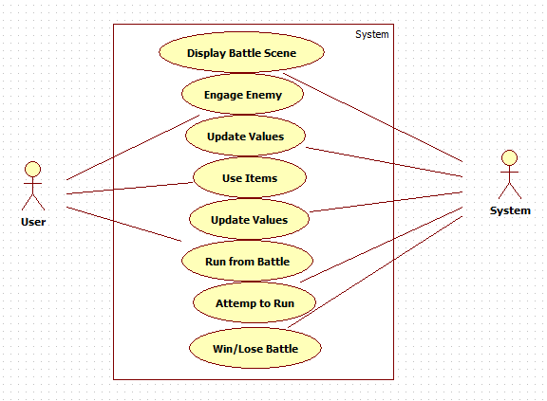

**Rewards**

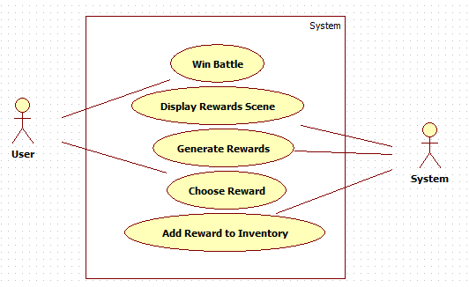

**Quests**

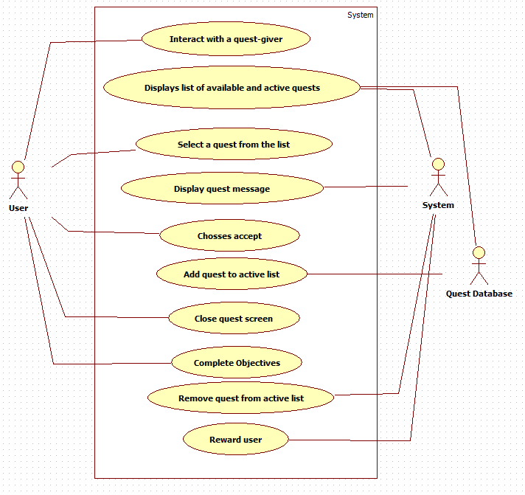

**Load/Save Game**

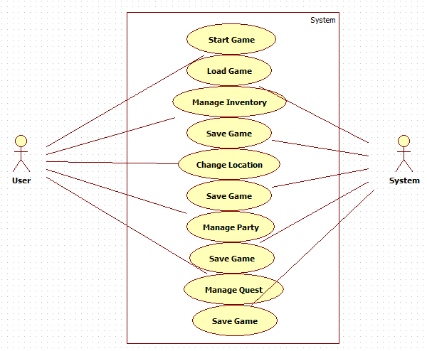

**Preliminary Conceptual Model of Use Case**

**CRD Cards**

**Launch Game Card**

|  |  |  |
| --- | --- | --- |
| **Class Name:** User | **ID:** 1 | **Type:** Concrete, Domain |
| **Description:** The user can choose to launch the game, select from the main menu to play a game or to quit | **Associated Use Cases:** 11 | |
| **Responsibilities** | **Collaborators** | |
| **Attributes**  Level (int)  Inventory (UserInventory)  Currency (double) | | |
| **Relationships**  Other Associations: | | |

**Select Character**

|  |  |  |
| --- | --- | --- |
| **Class Name:** Hero | **ID:** 2 | **Type:** Concrete, Domain |
| **Description:** Heros are the characters the user can play as or recruit later | **Associated Use Cases:** 1 | |
| **Responsibilities**  Fight enemies  Save the world | **Collaborators** | |
| **Attributes**  Name (text)  Capacity (double)  Damage (double)  Health (int)  CritDamage (double)  CritChance (double)  Icon (Icon)  Ability (Ability) | | |
| **Relationships** | | |

**Buy/Sell Cards**

|  |  |  |
| --- | --- | --- |
| **Class Name:** User | **ID:** 3 | **Type:** Concrete, Domain |
| **Description:** The user can choose to interact with the vendors to buy and sell items from their inventory | **Associated Use Cases:** 11 | |
| **Responsibilities**  Open Inventory  Buy from vendors  Sell to vendors | **Collaborators**  UserInventory  VendorInventory  UserInventory | |
| **Attributes**  Level (int)  Inventory (UserInventory)  Currency (double) | | |
| **Relationships**  Other Associations: UserInventory | | |

|  |  |  |
| --- | --- | --- |
| **Class Name:** UserInventory | **ID:** 4 | **Type:** Concrete, Domain |
| **Description:** This holds all the items the user has. | **Associated Use Cases:** 2 | |
| **Responsibilities**  Increases in size when new items bought  Decreases in size when items are sold  Items in inventory can be accessed by user | **Collaborators**  VendorInventory  VendorInventory  User | |
| **Attributes**  Capacity (double) | | |
| **Relationships**  Generalization (is a part-of) - Inventory  Other Associations: User | | |

|  |  |  |
| --- | --- | --- |
| **Class Name:** Item | **ID:** 5 | **Type:** Concrete, Domain |
| **Description:** An object that can go in the user's inventory | **Associated Use Cases:** 2 | |
| **Responsibilities**  Buy from vendors  Sell to vendors  Loot from battles | **Collaborators**  VendorInventory  VendorInventory  Battle | |
| **Attributes**  Name(text)  Type (ItemType)  Value (double)  Capacity (double)  Sellable (boolean)  Rarity (Rarity) | | |
| **Relationships**  Generalization (has classes that are a kind-of relationship): Equipable, Tradeable, Cartable  Composition: Rarity | | |

|  |  |  |
| --- | --- | --- |
| **Class Name:** Vendor | **ID:** 6 | **Type:** Concrete, Domain |
| **Description:** Merchants who buy and sell items from the user | **Associated Use Cases:** 2 | |
| **Responsibilities**  Buy Items from players  Sell Items to players | **Collaborators**  UserInventory  VendorInventory | |
| **Attributes**  Name (text)  Location (Location) | | |
| **Relationships**  Other association: Location | | |

**Class Diagram**

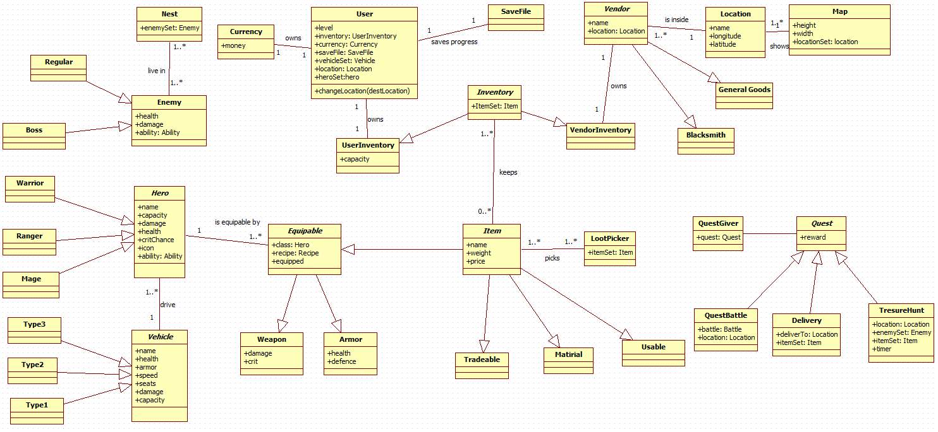

**Buy/Sell Object Diagram**

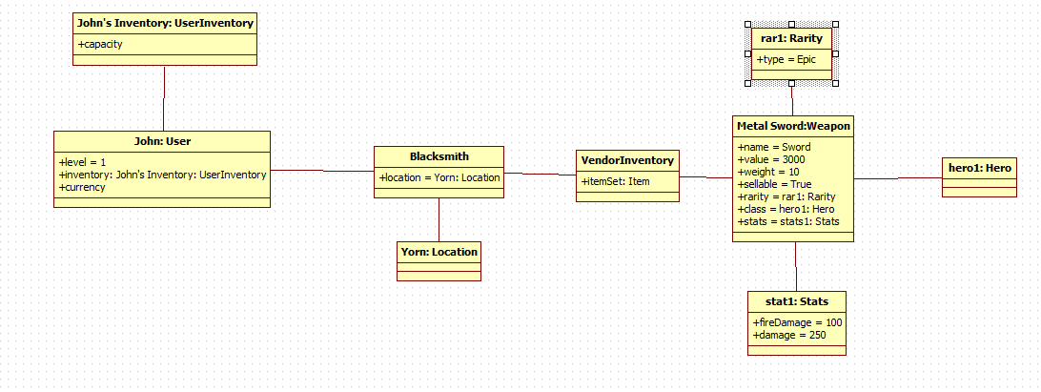

**Use Case Specifications + Interface Mock-ups**

**Use Case: Main Menu**

The user can start the game by pressing the Play button or Quit the game pressing the Quit button.

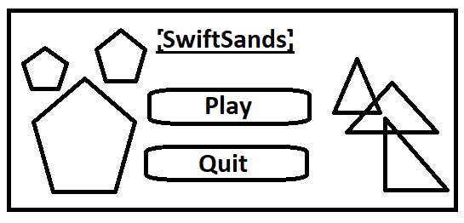

**Use Case: Character Selection**

User get to choose the first Hero that will be joining his/her party pressing on a hero's icon pops up a window that confirms selection which the user can accept or reject.

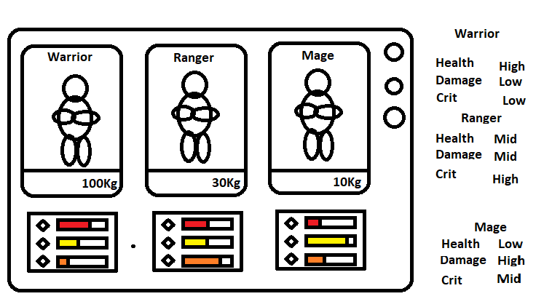

**Use Case: Buy Item**

The user taps on one of the several buildings in town, that he or she wants to visit. The user than gets moved inside the store of choice with a merchant saying something. There is a Shop Menu already displaying, with everything the vendor sells. (Default to Buy) There is a Green “Buy” Button and a Red “Sell” Button to let you switch between your inventory and the vendor’s inventory.

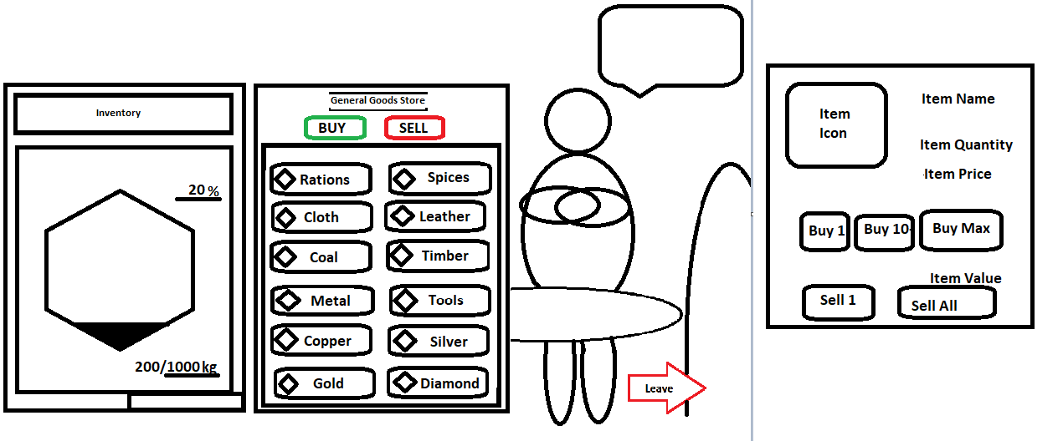

The user can select an item to bring up a small screen in the center of the screen that will display the details of the item. The items available have the following stats: Name, Type, Class, Rarity, and Price. This screen will show the icon of the item on the left side, display a detailed list of the item’s stats on the right, and the bottom will have a button that says, “Buy”. If the user wants to buy the item, they can press the button, if they want to check another item, they can close the small box by clicking on the “X” at the top-right corner or maybe swipe the pop up away.

When the user is done, there is a RED “Leave” Arrow Button beside the merchant that will let you leave the store.

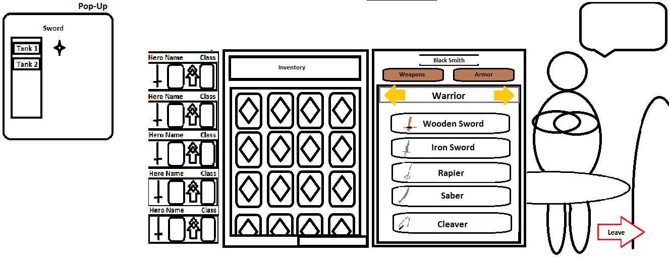

**Use Case: Sell Item**

1. The user taps on one of the several buildings in town, that he or she wants to visit. The user than gets moved inside the store of choice with a merchant saying something. There is a Shop Menu already displaying.

The user clicks on “Sell”, which makes the system close the Buy Item Screen and opens the Sell Item Screen. The Sell Item screen is an image of the player’s inventory. This screen looks like a rectangle that holds smaller black squares, each of which is a card that represents something stored in the user’s inventory. When the user clicks on an item a small pop-up appears next to the card showing its properties and how much money the user would get in return for selling the item. If the user wants to sell the item, they can click on the items “sell” button. The item will disappear from their inventory and their money will go up. If the user wants to close the cards details screen, they can press the “X” on the top-right corner of the card or click away or on a different card.

**Use Case: Inventory/Party**

In the Inventory the player can manage their cargo, choose their vehicle which sets the party size and control the amount of hero slots available which you must reselect each time you change a vehicle. The game doesn’t let you start unless you have ATLEAST 1 hero selected.

Here you can drop cargo, equip items, unequip items, and use items.

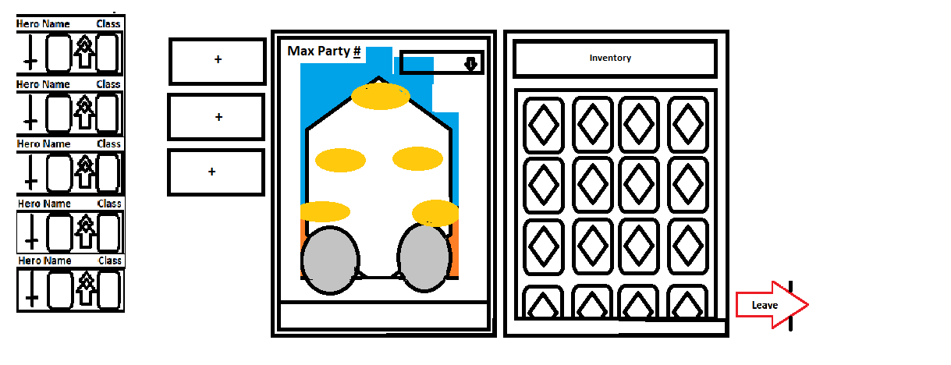

**Use Case: Locations**

When selecting a new location to travel to, you press on a location points in the map, which displays a window with that locations name and the price comparison of goods in the location compared to your own. This is a stretch goal that might end up the name and icon of the location. Pressing the “Travel” button confirms the desire to change locations.

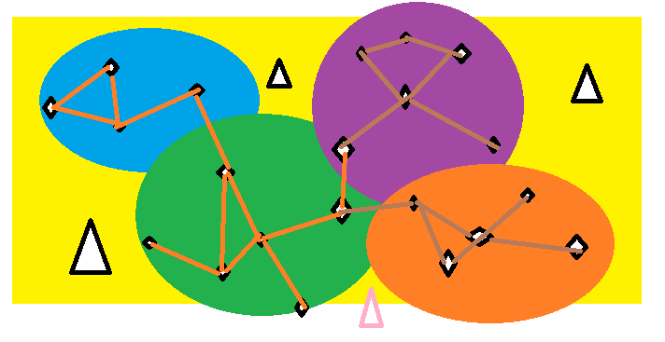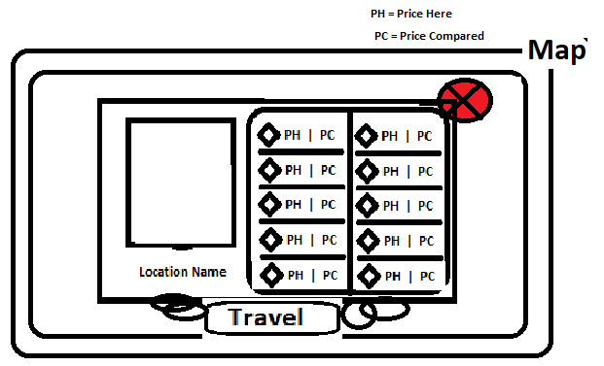

**Use Case: Battles**

When a user is put into a battle encounter or a quest battle, the system will display the battle screen. The battle screen will show the user’s party members and all the enemies they are fighting arrayed for battle. From this screen the user can choose to have their party-members attack the enemy, use an item or run away. After the user has made their choice of action, their turn ends. The system enacts their choice and the enemy's attack. After the enemies do their action it is the user’s turn again. The user may attempt to run away, if they succeed the battle ends and the battle screen closes, if they fail, they waste their turn and their enemy’s attack. The battle lasts so long as the heroes and enemy's health remain above zero. Once either the heroes or enemy's health reaches zero, or the heroes successfully run away. the battle is over, and the battle screen closes.

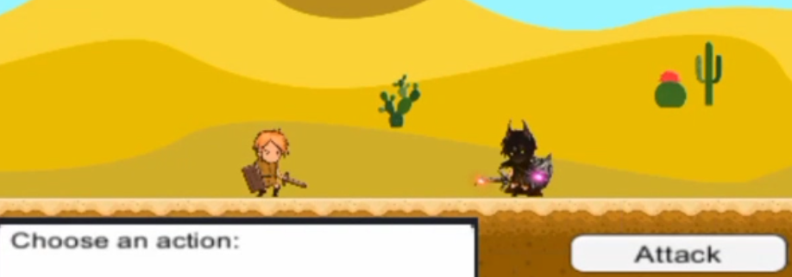

**Use Case: Rewards**

When the user wins a battle or completes a quest the system will present the user with the rewards screen. This screen will show the user the items that their victory has won them and allow them to take items from the screen and put them in their inventory.

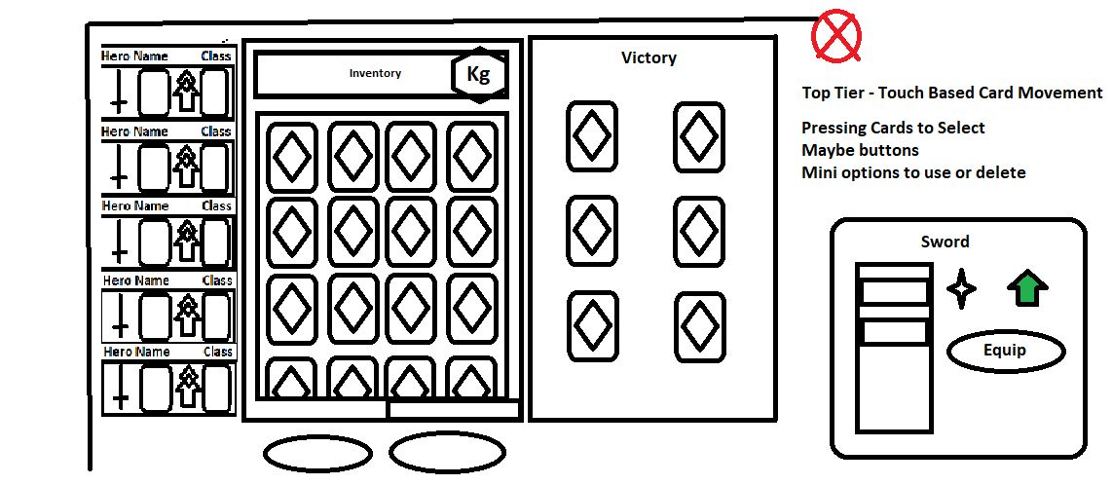

**Use Case: Quests**

User can have up to five quest at any time and every town carries up to three randomly generated quests from a pool of quantities, trade goods and destinations/locations. User can Drop a quest at any time by clicking on the Icon to the right, a confirmation window pops up. Accepting Quests is as easy as pressing the icon on the right of the Town Quests board quests, a confirmation window pops up.

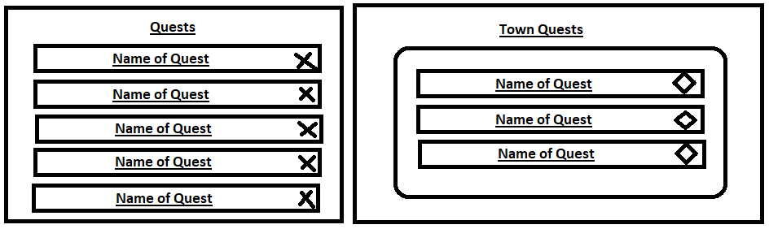

**Data Dictionary**

**Weapon**

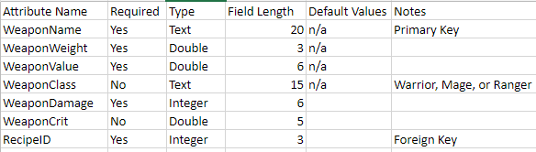

**Armour**

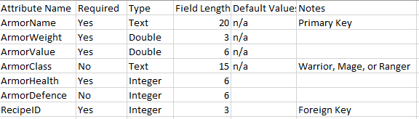

**Hero**

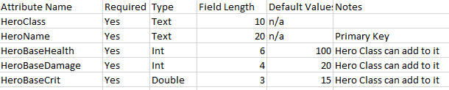

**Enemy**

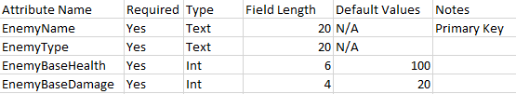

**Tradeable**

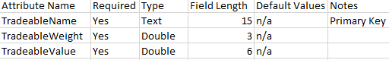

**Usable**

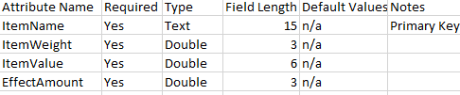

**Quest**

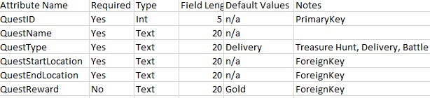

**Location**



**Party**



**Vehicle**

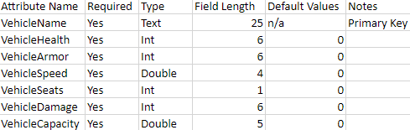

**DATABASE Choice and Justification**

For our game app we chose to use Lists of Databases as no new Data is added by the users, so there is no use for a large-scale online database.

Lists in Unity Games are used by many programmers and so there are a lot of tutorials available on building item class database structures like the ones that we will be using.

Additionally, Recipes for crafting new items can be stored in such a manner as well, which is a late game feature of ours.

The following are examples of a structure used by a game tutorial building an example database:

https://www.youtube.com/watch?v=S-XR37KM7_o&list=PLMp2peNEblP1IchkRi-26k1HwdNyz2mdp&index=37&ab_channel=GameDevHQ

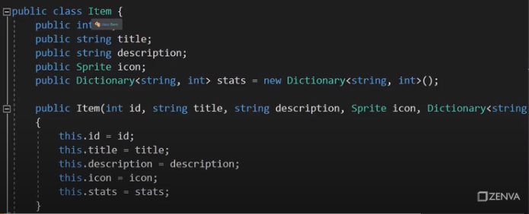

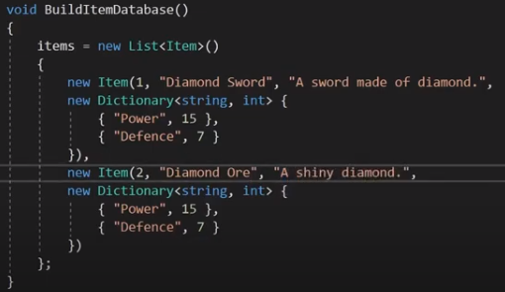

Based on this choice we have built this preliminary DB design.

**Database Tables**

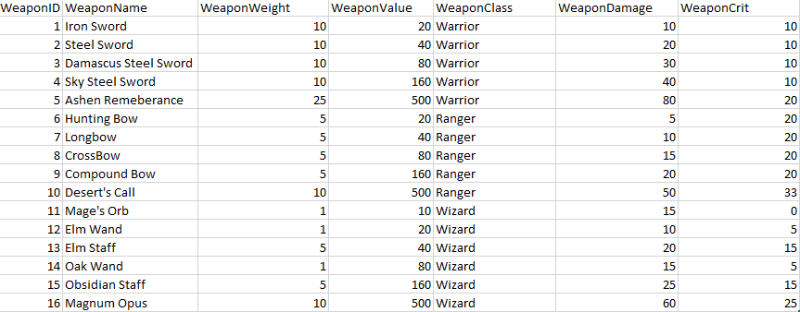

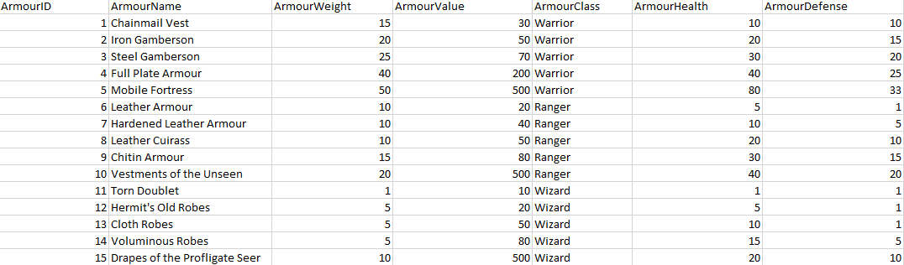

**Project Quality Management Plan**

**Planning Quality Management**

* Game should keep system load times short
* Game is single-player, system will handle one user at time
* Game should allow users to access all Functional Requirements (p. 8)
* Game may allow users to access non-mandatory goals (p. 9) if there is additional time
* Game must run on computer

**Performing Quality Assurance**

* Team will perform many tests on the game
* Glitches that are found in testing will be isolated and fixed
* All team members will be developers and Quality Assurance
* Team will update schedule as required

**Control Quality Assurance**

* Team will create an online forum for user feedback
* User feedback will be gathered to identify strengths and weaknesses of game
* Feedback will help team develop features users might be interested in
* Feedback will help identify glitches that team will work on fixing

**Project Communications Management Plan**

**Plan Communications Management**

* Provide Deliverables and Work Division on time to our Professor Stakeholder
* Seneca’s Administration will receive the final submission as a Stakeholder
* Keep the Team up to date on everything that goes on with the project as the Main Stakeholders

**Manage Communications**

* All Deliverables will be submitted by the Team either by email or by submission link as specified by the Professor Stakeholder
* Seneca’s Administration will receive the final submission by submission link at the end of the final term as a Stakeholder
* The team will communicate via: Discord, WhatsApp, Email, and Telegram.

**Monitoring and Controlling Communications**

* Keeping our weekly Deliverables done and handed in on time for the Professor Stakeholder
* Having a finished working final submission on time for the Seneca Administration Stakeholder
* The Teams Communication will keep updating on all needs of the project for Data Transfer, work and home communication, and several project tracking software such as MS Teams, Click Up, and MS Projects. Meetings required for project communication.

**Cost Estimates**

Our costs will be relatively low. This is because, as a student project for Seneca College, we are not being paid for the work. In addition to that, we are using our own hardware so the cost for computers does not factor in. Most of the Software we are using is free, but we will have to use Spine, which costs money. Our main expenses come from Spine and from paying graphics designers to create the visuals.

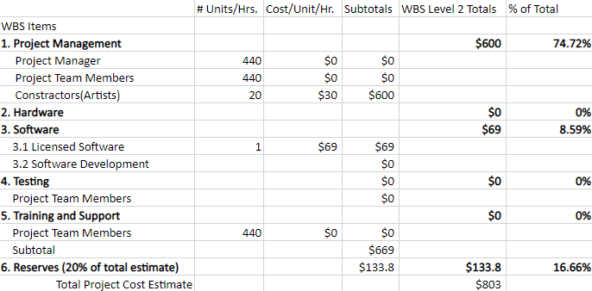

**Risk Management Plan**



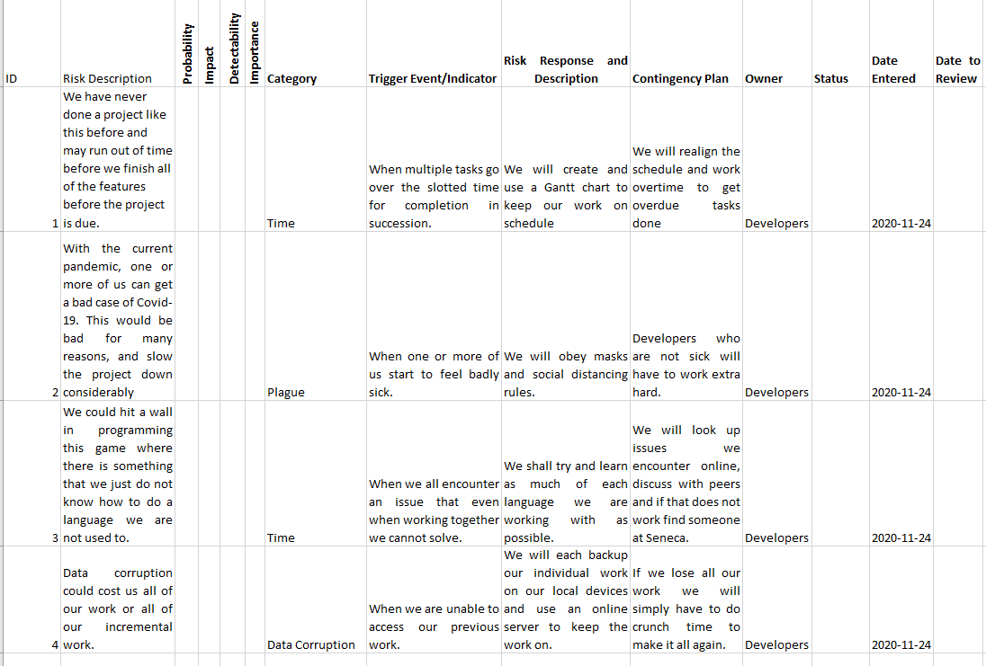

**Cost Benefit Analysis**

Development Cost from Cost Estimate

Operating Costs Include: Advertising, and Supplies with no further expenses post development

The Tangible Benefits equal to the sales of the app which in Game Application history Games rise in sales and if no further updates are introduced the sales level out and then drop significantly.

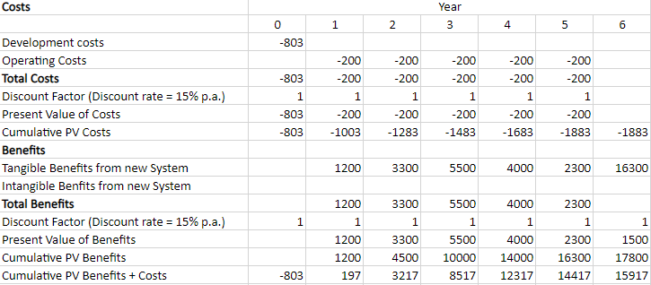

**PRJ666 Schedule**

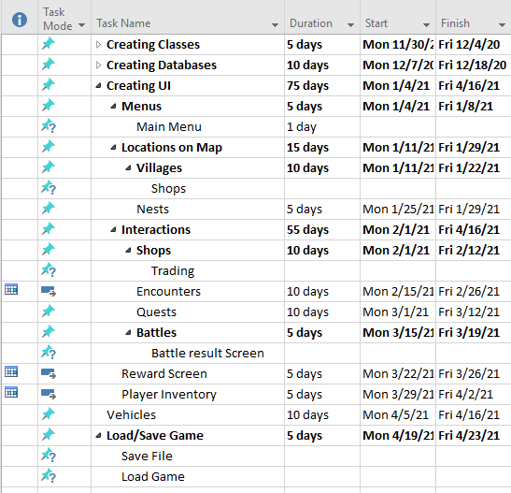

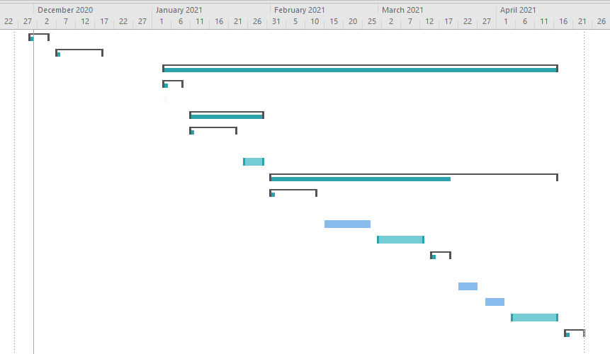

**Work Division**

* **Robert Parker-Lak**

Industry Analysis

The Stakeholders

Stakeholder Analysis

System Request

Functional & Non - Functional Requirements

SWOT

Use Case Descriptions

Preliminary Conceptual Model of the System Use Case

Use Case Specifications and corresponding interface mock-ups

Interface Mock-ups

Data Dictionary

ERD or JSON model

Project Quality Management Plan

Project Communications Management Plan

Risk Management Plan

Cost Benefit Analysis

* **Andriy Ostapovych**

Problem Statement

Constraints/Business Rules

Functional & Non - Functional Requirements

SWOT

Business Use Case Diagrams

DFDs

System Use Case Diagrams

Domain Class Diagram

Data Dictionary

ERD or JSON model

Project Quality Management Plan

Project Communications Management Plan

Project Cost Estimate

Cost Benefit Analysis

* **Faramarz Hosseini**

Feasibility Report

PRJ566 Schedule

Stakeholder Analysis

Functional & Non - Functional Requirements

SWOT

Activity Diagram

DFDs

System Use Case Diagrams

Preliminary Conceptual Model of the System Use Case

Domain Class Diagram

Data Dictionary

ERD or JSON model

Project Quality Management Plan

Project Communications Management Plan

Implementation Schedule for PRJ666

Work Breakdown Structure

**PID Revision**

* **Robert Parker-Lak**

Added 10 Use Case Descriptions

Revised the text from Introductions to SWOT Justification

* **Andriy Ostapovych**

Added 10 Use Case Diagrams

Revised the text from Introductions to SWOT Justification

Added 6 Interface Mock-ups

* **Faramarz Hosseini**

Added 1 Use Case Diagram

Added 1 Use Case Description

Added 3 Data Dictionaries

Added Screen Shots

Added PRJ666 Schedule

**Research Sources**

* + Mobile Vs. Desktop Internet Usage - <https://www.broadbandsearch.net/blog/mobile-desktop-internet-usage-statistics>
  + <https://www.reddit.com/r/gamedev/comments/28td8c/how_are_databases_used_in_games/>
  + StackOverflow – research on databases vs arrays
  + <https://www.projectengineer.net/tutorials/pmp-exam-tutorial/project-communications-management/> - Communication management template research
  + Game Database Design - <https://vertabelo.com/blog/mmo-games-and-database-design/>