# COMBINING APP ISSUES

### Date unknown, sometime early 2023

**Problem**: App would load in previous detections file fine, but when you click on the previous detections tab, it wouldn’t display. An error message would come up that said “Error: the condition has length >1”

**Solution:** Waiting on a response from Sam*******

### April/May 2023

**Problem:** The previous and new stationary files loaded into the app fine, but when you click on the combined tab you’d get an error message that said

“Error: Can't combine `..1$EFA` <double> and `..2$EFA` <character>”

The raw master file from March had an extra column in it, which just contained row numbers. Sam says this extra column appeared because he was working with the master csv from March (WGFP_Raw_20230307) before he left (in R), and when he saved his work he used **write.csv** and forgot to specify to NOT include a column containing row numbers (by default write.csv adds a column of row numbers, it’s something you have to manually opt out of. **The original problem that he was trying to troubleshoot when this new issue arose is explained on the next page.**

**Attempted solutions:** The first attempted solution was to simply cut out the extra column, using R. We did that, and used write.csv to export the new master file. When we used that master file in the combining app again, it loaded in fine, and displayed properly in the “combined” tab. However, when the March Raw + RB1 combined file was exported, the file size was **smaller** than the original March Raw file. We tried a number of times and got the same result, even with other stationary sites from that same download.

After talking to Sam, we realized the issue arose from the use of **write.csv** vs **write_csv** when editing the R file, (Becca and Sam both made this mistake and two different points in time). We went back to the WGFP_Raw_20230307_CF5 file, which had not been edited and thus did not have the extra column like the WGFP_Raw_20230307 file did, and combined that with the individual antenna files up to the May download, with no issues.

**Main takeaway: if you have to edit the master csv in R at all, you MUST use write_csv instead of write.csv at the end, so the file compresses in a way that is compatible with the app!** If you made this mistake, just go back to the previous unedited version and make the necessary edits again, but save it using **write_csv** this time.

### ORIGINAL PROBLEM

After loading the stationary file from March 2023 into the Encounters History app, Sam noticed there was a detection from Nov 9th 2060 from HP3.

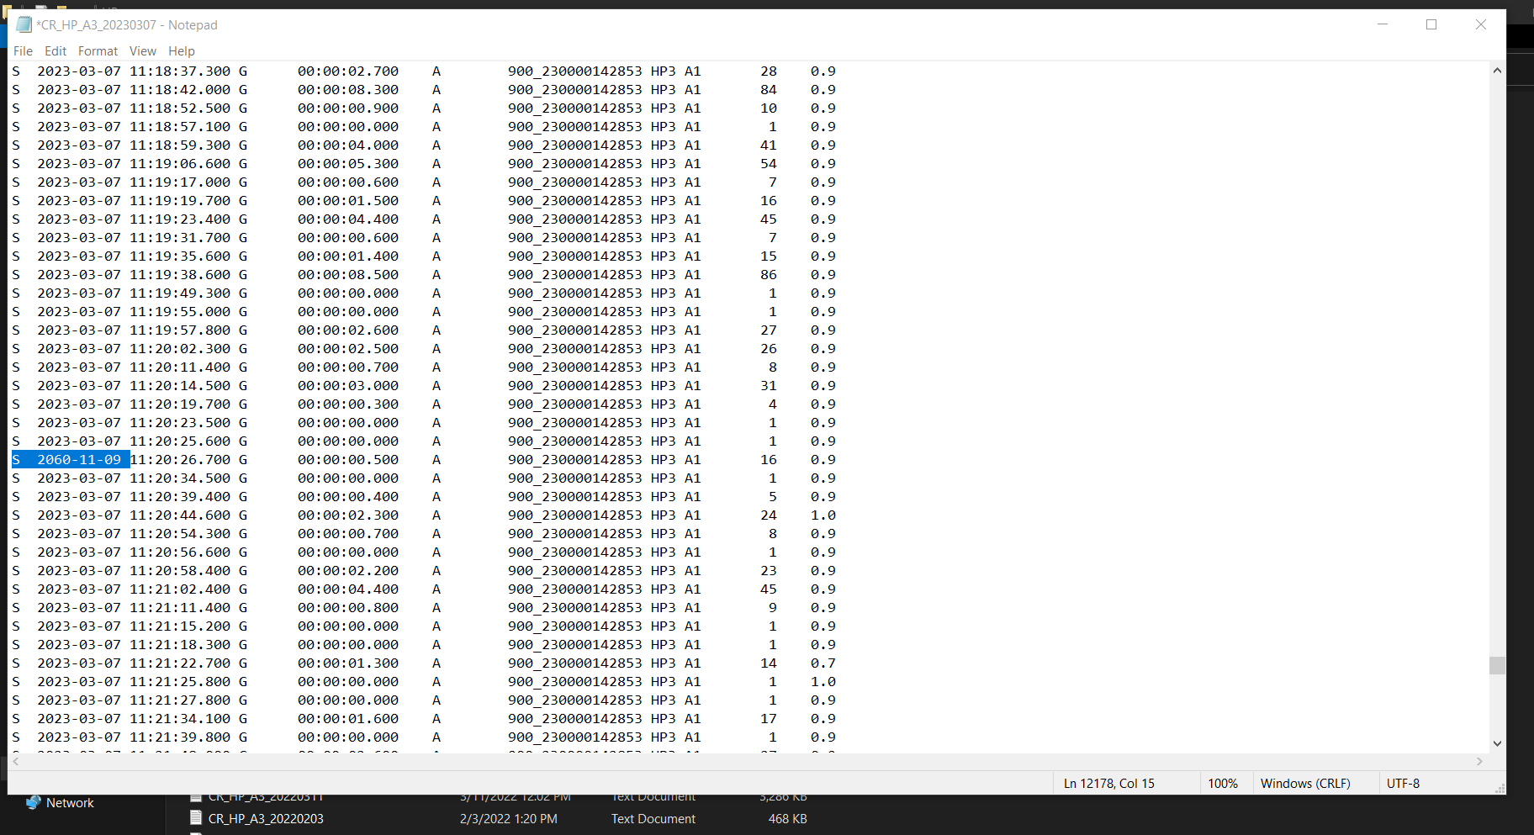

*Raw txt file from March 2023 HP3 download, showing a detection from the future*

This false detection was cut out of the combined raw .csv by Sam using a separate R script, but he saved it using **write.csv** which caused the problems we addressed in the section above. We reverted back to an earlier version so now the master file works, but there’s still that observation from Nov 2060. The observation from this date was tag number 900_230000142853, which has 113866 observations with the correct dates at HP3 and HP4 from May 2022-May 2023. We removed the 2060 observation using the following code:

setwd("U:\\Projects\\Colorado_River\\Windy_Gap_FishMovementStudy\\Data\\RFID\\Detections\\All_Stationary")

raw <- read_csv("U:\\Projects\\Colorado_River\\Windy_Gap_FishMovementStudy\\Data\\RFID\\Detections\\All_Stationary\\WGFP_Raw_20230504.csv")

str(raw)

raw <- raw[!(raw$DTY=="2060-11-09"),]

write_csv(raw, "WGFP_Raw_20230504_trimmed.csv")

And saved the new csv to the All_Stationary folder. The original file with the 2060 detection was renamed “WGFP_Raw_20230504_detection_2060-11-09” and moved to the Archive folder, and the "WGFP_Raw_20230504_trimmed" file was renamed to “WGFP_Raw_20230504”. This file was also copied into the “Data” folder in the encounter histories app.

We ran into another issue when we tried to open the encounters history app with this updated file, when you hit “run app” it tried to open, then after a few minutes gave the error

Error in filter(., Scan_Date >= as.Date("2020-08-06")) :

object 'All_detections1' not found

Talked to Sam, discovered this was because the way we read in the csv to trim it did not match the way it is read in in the encounters history app. We went back to the previous file that had the detection from 2060, loaded it in and trimmed it with the CORRECTED code below:

setwd("U:\\Projects\\Colorado_River\\Windy_Gap_FishMovementStudy\\Data\\RFID\\Detections\\All_Stationary")

raw <- read.csv("U:\\Projects\\Colorado_River\\Windy_Gap_FishMovementStudy\\Data\\RFID\\Detections\\All_Stationary\\WGFP_Raw_20230504.csv")

str(raw)

raw <- raw[!(raw$DTY=="2060-11-09"),]

write_csv(raw, "WGFP_Raw_20230504_trimmed.csv")

**ANOTHER TAKEAWAY FROM THIS:** if you have to edit any of the .csv inputs to the encounters app, **check to see if they use read.csv or read_csv in the encounters history app and make sure you use that.**

Quick guide:

Stationary, Mobile, and Biomark all use **read.csv**

AvianPredation and GhostTags use = **read_csv**