Questions
- Write out 2³² in a way that you can approximate the solution in your head.
  - 2¹⁰ *2¹⁰ *2¹⁰ *2²
- Match the name that each layer uses for a packet with that layer.
  - Application : message, Transport : segment, Network : datagram, Link : frame, System : --
- What are two reasons packets might get lost?
  - The queue at a router if full
  - The packet has corrupted bits and was discarded by a router
- Define what each variable in this formula stands for: d_{end-to-end} = N
  - d_{end-to-end}: The time it takes on packet to go from one router to another
  - N: number of routers
  - L: length (in bits) of the packet
  - R: transfer rate of the packets in bits per second
- There are two models of networking, one with 5 layers and one with 7 layers. How does the model with 5 layers handle the loss of two levels of abstraction?
  - The Internet protocol stack (5 layer model) handles the loss of two layers from the ISO OSI model (7 layer model) by placing the two lost layers into the highest layer and leaves the tasks assigned to those layers to the Application programmers.
- There are certain applications that require reliable data transfer and some applications that don’t. List one application that does and on application that does not require reliable data transfer and why that application does or does not need reliable data transfer.
  - Need: Banking applications, without the accurate transfer of information errors could develop in accounts that could mean financial trouble for the bank
  - Does not need: Media streaming applications, Few people will notice if part of their music doesn’t contain all the necessary bits to a song, and this lower standard means that more data can be streamed at a time.
- How many bits are in a 4th generation IP address?
  - 32

- Draw a diagram to show the difference between Frequency dependent multiplexing and Time dependent multiplexing.
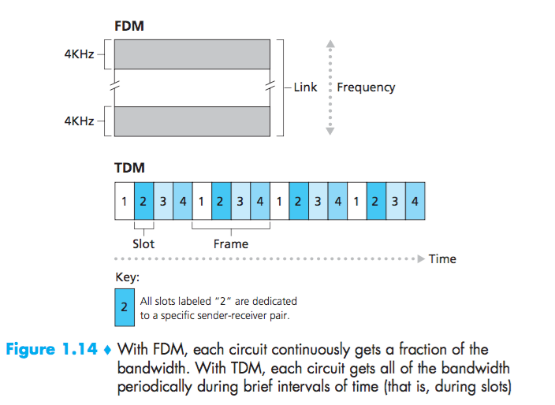

- What was the outsourced question asked of the audience at Jennifer’s talk?
  - What do we name the program?

