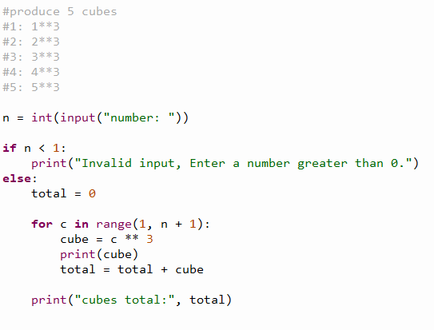
Trace table:
N | Expected cubes | Expected total
1 | 1 | 1
2 | 1,8 | 9
3 | 1,8,27 | 36
4 | 1,8,27,64 | 100
5 | 1,8,27,64,125 | 225

