EARLY DETECTION OF BLIGHT PLAGUE ON COFFEE PLANTATIONS BY AUTOMATION PROCESSES
Simón Flórez Silva  Universidad Eafit  Colombia  sflorezs1@eafit.edu.co | Adrián Alberto Gutiérrez Leal  Universidad Eafit  Colombia  aagutierrl@eafit.edu.co | Mauricio Toro  Universidad Eafit  Colombia  mtorobe@eafit.edu.co
NOTE: To have more information about the sections in this report, please read “Guía para la realización del Proyecto Final de Estructura de Datos 1.” For the final version of this report: 1. Detele all text in red. 2. Adjust spaces among words and paragraphs. 3. Change the color of all the texts to black. You should also keep in mind the meaning of the colors:
Black text = To complete for the 1st deliverable
Blue text = To complete for the 2nd deliverable
Violet text = To complete for the 3rd deliverable

ABSTRACT
In the following paper, we address the blight plague on coffee plantations, a problem that affects Colombian agriculture and therefore, its economy. In addition, lack of automation makes it harder to make an early diagnosis and, of course, makes it harder to control. As it was previously mentioned, the importance of this problem relapses on its consequences over the coffee exportation, from which thousands of Colombian families depend and, of course, the economy of the country as a whole. Some have already tried to treat this problem by implementing algorithms such as ID3 and C4.5 (which is a slightly better version of the latter) algorithms for decision trees.
To write the abstract, you should answer the following questions in a paragraph: What is the problem? Why is the problem important? Which are the related problems? What is the solution you proposed?, what results did you achieve? , What are the conclusions of this work? Abstract should have at most 200 words.

Keywords
Keywords that you consider meaningfull to index this report
in libraries and data bases.

ACM CLASSIFICATION Keywords
Only keywords in the ACM classification which can be
found at http://bit.ly/2oVE5 2i
You cannot create your own keywords here.

Example: Theory of computation → Design and analysis of algorithms → Graph algorithms analysis → Shortest paths

1. INTRODUCTION
In the current times, it becomes evident that automation can make some difficult processes a lot easier. That is the case for the early diagnosis and control of the blight plague on coffee plantations, a problem that has been harming productivity and incomes of Colombian coffee production during the last years. In this paper, the team will approach different algorithmic solutions and implement decision trees in order to detect this fungus as soon as possible.

2. PROBLEM
The main problem, from a software perspective, is to design an algorithm based on decision trees to predict if a caturra coffee batch is infected with the blight plague. It's worth noting that it has an immense impact on Colombian economy, as coffee consists in one of Colombia's main exports and therefore, many people depend on it to sustain themselves.

3. RELATED WORK

3.1 ID3
For this algorithm, the pseudocode implementation would be:
Create a root node for the tree
If all examples are positive, Return the single-node tree Root, with label = +.
If all examples are negative, Return the single-node tree Root, with label = -.
If number of predicting attributes is empty, then Return the single node tree Root,
with label = most common value of the target attribute in the examples.
Otherwise Begin
A ← The Attribute that best classifies examples.
Decision Tree attribute for Root = A.
For each possible value, vi, of A,
Add a new tree branch below Root, corresponding to the test A = vi.
Let Examples(vi) be the subset of examples that have the value vi for A
If Examples(vi) is empty
Then below this new branch add a leaf node with label = most common target value in the examples
Else below this new branch add the subtree ID3 (Examples(vi), Target_Attribute, Attributes – {A})
End
Return Root

3.2 CART
In this case, the algorithm in pseudocode is:
1. Start at the root node.
2. For each ordered variable X,
convert it to an unordered variable X’ by grouping its values in the node into a small number of intervals if X is unordered, then set X’ = X
3. Perform a chi-squared test of independence of each X’ variable versus Y on the data in the node and compute its significance probability.
4. Choose the variable X* associated with the X’ that has the smallest significance probability.
5. Find the split set {X*∈S*} that minimizes the sum of Gini indexes and use it to split the node into two child nodes.
6. If a stopping criterion is reached, exit,
Otherwise, apply steps 2-5 to each child node.
7. Prune the tree with the CART method

3.3 C4.5
The pseudocode for this algorithmic is:
1. Check for the above base cases.
2. For each attribute a, find the normalized information gain ratio from splitting on a.
3. Let a_best be the attribute with the highest normalized information gain.
4. Create a decision node that splits on a_best.
Recur on the sublists obtained by splitting on a_best, and add those nodes as children of node.

3.4 Random Forest
Finally, for the Random Forest algorithm, the pseudocode implementation would be:
Fina
To generate c classifiers:
for i=1 to c do
Randomly sample the training data D with replacement to produce D_{i}
Create a root node, N_{i} containing D_{i}
Call BuildTree( Ni )
end for
BuildTree(N):
if N contains instances of only one class then
return
else
Randomly select x% o of the possible splitting features in N
Select the feature F with the highest information gain to split on
Create f child nodes of N, N₁, … , N_{f} , where F has f possible values (F₁, … , F_{f})
for i=1 to f do
Set the contents of N_{i} to D_{i}, where D_{i} is all instances in N that match F_{i}
Call BuildTree( N_{i})
end for
end if

4. Title of the first data structure designed

Design a data structure to solve the problem and make a figure explaining it. Do not use figures from the Internet.
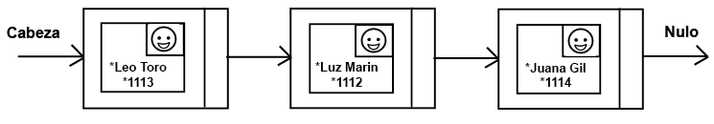
Figure 1: Linked List of persons. Una person is a class that contains a name, id number and photo.

4.1 Operations of the data structure
Design the oepration of the data structure to solve the problem efficiently. Include one figure to explain each operation.
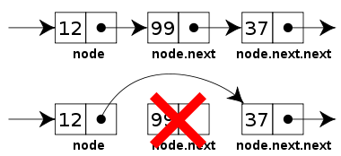

Figure 2: Delete operation of a Linked List.
4.2 Design criteria of the data structure
Explain objetive criteria that you considered to design the data structure. Examples of objective criteria are efficiency in time and space. Non-objective criteria will lower your grade. Examples of non-objetive criteria are: “I was sick”, “it was the first data structure that I found on the Internet”, “I did it on the last day before deadline”, etc. Remember: This is 40% of the project grade.
4.3 Complexity analysis
Derive the complexity of each operation of the data structure for the worst case and best case, As an example, this is a way to report the complexity analysis:
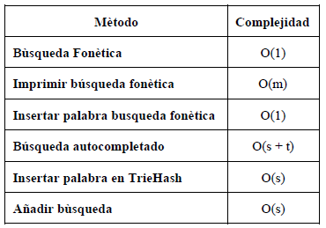

Table 1: Table to report complexity analysis

4.4 Execution time
Measure (I) execution time and (II) memory used by the operations of the data structure, for the data set found in the .ZIP file.

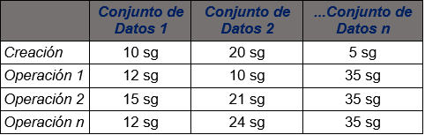
Measure the execution time and memory used 100 for each data set and for each operation of the data structure. Report the average values.

Table 2: Execution time of the operations of the data structure for each data set.

4.5 Memory used
Report the memory used for each data set
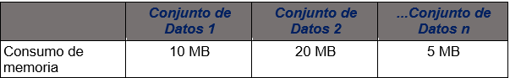

Table 3: Memory used for each operation of the data structure and for each data set data sets.

4.6 Result analysis
Explain the results obtained. As an example, compare different implementation of the data structure and report the comparison in a table or graph.

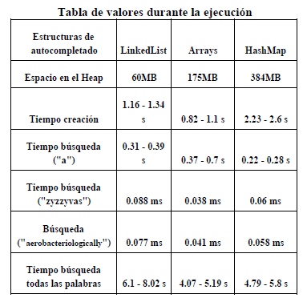

Table 4: Analysis of the results
5. Title of the last data structure designed

Design a data structure to solve the problem and make a figure explaining it. Do not use figures from the Internet.
Figure 1: Linked List of persons. Una person is a class that contains a name, id number and photo.

5.1 Operations of the data structure
Design the oepration of the data structure to solve the problem efficiently. Include one figure to explain each operation.

Figure 2: Delete operation of a Linked List.
5.2 Design criteria of the data structure
Explain objetive criteria that you considered to design the data structure. Examples of objective criteria are efficiency in time and space. Non-objective criteria will lower your grade. Examples of non-objetive criteria are: “I was sick”, “it was the first data structure that I found on the Internet”, “I did it on the last day before deadline”, etc. Remember: This is 40% of the project grade.
5.3 Complexity analysis
Derive the complexity of each operation of the data structure for the worst case and best case, As an example, this is a way to report the complexity analysis:

Table 5: Table to report complexity analysis

5.4 Execution time
Measure (I) execution time and (II) memory used by the operations of the data structure, for the data set found in the .ZIP file.

Measure the execution time and memory used 100 for each data set and for each operation of the data structure. Report the average values.

Table 6: Execution time of the operations of the data structure for each data set.

5.5 Memory used
Report the memory used for each data set

Table 7: Memory used for each operation of the data structure and for each data set data sets.

5.6 Result analysis
Explain the results obtained. As an example, compare different implementation of the data structure and report the comparison in a table or graph.

Table 8: Analysis of the results
6. CONCLUSIONS
To write the conclusions, proceed in the following way. 1. Write a paragraph with a summary, the most important issued of the report. 2. In another paragraph, explain the most important results that you obtained with the last data structure you designed. 3. Compare your first solution with the last solution. 4. At last, explain future work, a future continuation of this project. You can also mention in the conclusions, technical problems that you had during the development of the data structure and its implementation and you solved them.

6.1 Future work
Answer, what would you like to improve in the future? How would you like to improve your data structure and its implementation?

ACKNOWLEDGEMENTS
Identify the kind of acknowledgment you want to write: for a person or for an institution. Consider the following guidelines: 1. Name of teacher is not mentioned because he is an author. 2. You should not mention websites of authors of articles that you have not contacted. 3. You should mention students, teachers from other courses that helped you.
internet ni autores de artículo leídos con quienes no se han contactado. 3. Los nombres que sí van son quienes ayudaron, compañeros del curso o docentes de otros cursos.
As an example: This research was supported/partially supported by [Name of Foundation, Grant maker, Donor].
We thank for assistance with [particular technique, methodology] to [Name Surname, position, institution name] for comments that greatly improved the manuscript.

REFERENCES
Reference sourced using ACM reference format. Read ACM guidelines in http://bit.ly/2pZnE5g
As an example, consider this two references:
1.Adobe Acrobat Reader 7, Be sure that the references sections text is Ragged Right, Not Justified. http://www.adobe.com/products/acrobat/.
2. Fischer, G. and Nakakoji, K. Amplifying designers’ creativity with domainoriented design environments. in Dartnall, T. ed. Artificial Intelligence and Creativity: An Interdisciplinary Approach, Kluwer Academic Publishers, Dordrecht, 1994, 343-364.

