Although the discipline of statistics has many specializations and nearly limitless applications, there are only a few concepts required to get started. In this introduction, we'll cover some core statistical concepts such as:

* mathematical data types
* null and alternative hypothesis
* p-values and hypothesis testing
* t-test of the means
* correlation and linear regression tests
* comparing frequency distribution using chi-squared test

Due to the structured nature of statistical testing, if we can determine any two components of a statistical analysis (input variables, analytical question, or statistical test), we can infer the third. To simplify the process of inferring what component is needed, you can use a statistical test lookup table such as the following:

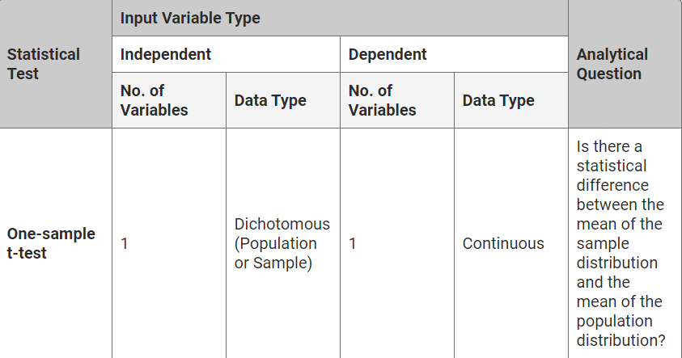

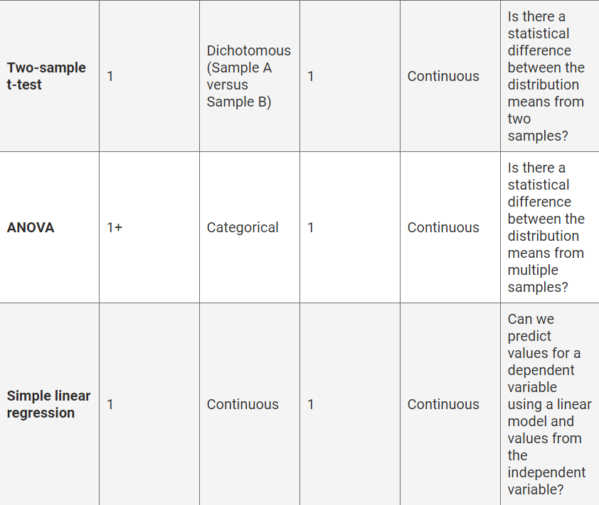

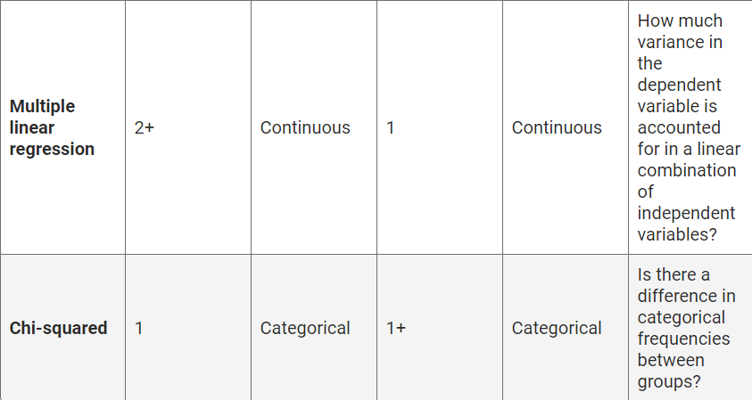

There are several helpful lookup tables that can reinforce statistical concepts. For your convenience, we've aggregated many of these lookup tables into a single cheat sheet you can download and use for the remainder of the module.

[Download Stats_Cheat_Sheet.pdf](https://2u-data-curriculum-team.s3.amazonaws.com/dataviz-online/module_15/Stats_Cheat_Sheet.pdf)

In addition, the remaining sections will provide supplementary notes on the in-depth statistical concepts. These will focus on common statistical interview questions, analytical "gotchas," and other pertinent contexts to bolster your understanding of each statistical concept. If this is your first time learning statistical concepts, or if you're still brushing off the mental cobwebs, we suggest you delay studying these optional notes until you're comfortable with this module's core statistical concepts. Take your time with each section, and refer to the statistics cheat sheet for help.

**IMPORTANT**

Once you're more familiar with statistical analysis, start searching for more elaborate statistical lookup tables with non-normal, generalized statistical tests. As you practice characterizing datasets, asking questions, determining a hypothesis, and testing using statistics, the process will become easier.