We must first install R before installing RStudio. This way, RStudio can easily find our R installation while being configured; otherwise, we would have to manually tell RStudio where to find our installed applications.

To install R on macOS or Windows, navigate to [R's Comprehensive R Archive Network (CRAN) server (Links to an external site.)](https://cran.r-project.org/mirrors.html) and select a mirror link near our region. In most cases, any U.S. mirror link will do (see the following images):

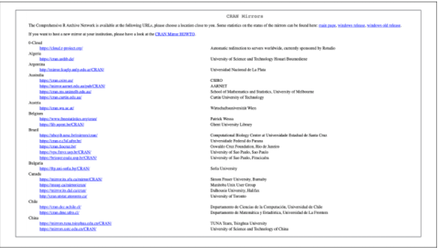

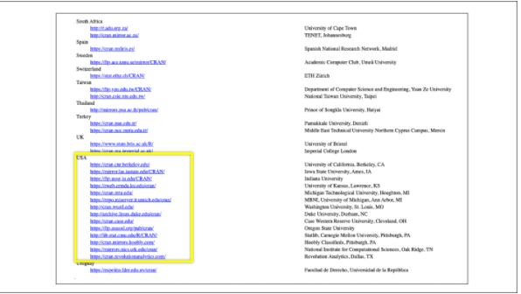

After you navigate to a CRAN mirror site, you'll reach a self-explanatory download page. Follow the appropriate download link for either your macOS or Windows environment:

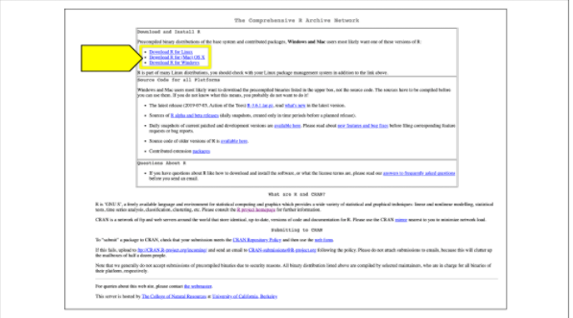

For those running a macOS environment, select the latest release .pkg file (the link is midpage):

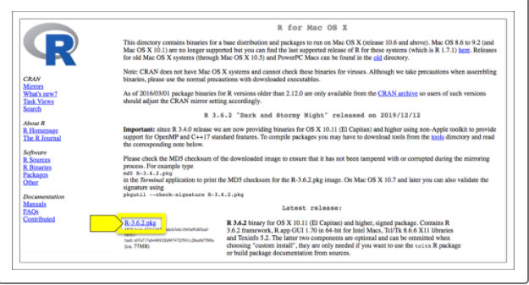

For those running a Windows environment, click on the base installer link. On the next page, click the "Download R for Windows" link to start downloading the installer:

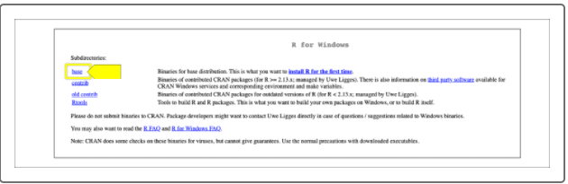

Once your installer files are successfully downloaded (.pkg for macOS or .exe for Windows), run them just as you would for any other installation program. Use all default install options and, if prompted, check all boxes to allow all R components to install.