In the data world, there are few analytical and graphical tools more popular and recognizable than R's [ggplot2](https://ggplot2.tidyverse.org/) library. Due to its adoption among research groups and government agencies, ggplot2 figures and visualizations can be found in almost every scientific paper written from 2005 to the present. ggplot2 is a favorite of many R and non-R users alike because it is easy to implement, read, and interpret, yet capable of performing a deep and complex analysis.

In this section, we'll learn about the ggplot library components and how to implement our basic plots, such as bar, line, and scatter plots. Once we have mastered the basics of plotting in ggplot2, we'll learn how to plot more advanced visualizations such as boxplots and heatmaps.

All figures in ggplot2 are created using the same three components:

1. **ggplot function**—tells ggplot2 what variables to use
2. **geom function**—tells ggplot2 what plots to generate
3. **formatting or theme functions**—tells ggplot2 how to customize the plot
4. Similar to how we generate figures using Python's Matplotlib library, we build our ggplot2 visualizations by layering multiple plots and adding customized colors, scales, and labels to represent our data effectively. Also, similar to Matplotlib, the ggplot2 documentation is very clear with examples for each option and function, which makes ggplot2 far more approachable than many programming languages.
5. Before we start to build our basic figures, we need to declare our input data and variables using the ggplot() function. Type the following code into the R console to look at the ggplot()documentation in the Help pane:

> ?ggplot()

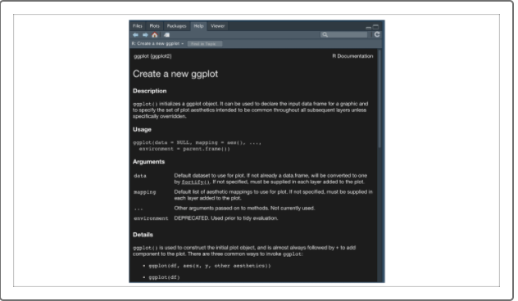

The ggplot() function only requires two arguments to declare the input data:

* **data**
* **mapping**
* **IMPORTANT**
* There are a number of optional aes() arguments to assign such as color, fill, shape, and size to customize the plots. We'll cover these optional assignments in this module.
* The return value of the ggplot() function is our ggplot object, which is used as the base to build our visualizations. Once we have established a base ggplot object, we can add any number of plotting and formatting functions using an addition (+) operator.