**Qualitative Test for Normality**

The **qualitative test for normality** is a visual assessment of the distribution of data, which looks for the characteristic bell curve shape across the distribution. In R, we would use ggplot2 to plot the distribution using the geom_density() function.

For example, if we want to test the distribution of vehicle weights from the built-in mtcars dataset, our R code would be as follows:

> ggplot(mtcars,aes(x=wt)) + geom_density() #visualize distribution using density plot

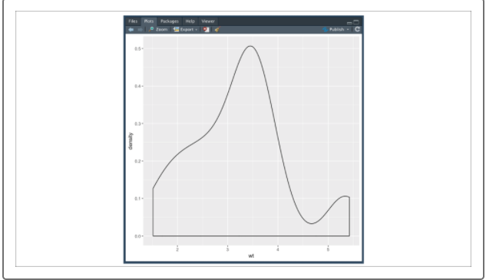

The geom_density() function plots a numerical vector by creating buckets of similar values and calculating the density (number of bucket data points/total number of data points) for each bucket.

The results of each bucket density calculation are plotted, connected, and smoothed out to create our distribution plot. Although our data distribution does not perfectly match the normal bell curve shape, the distribution does approximate a normal distribution and could be used for further analysis.

But what if our data distribution is noisy—meaning that the dataset contains uncharacteristically large or small values at high frequency—or we need to make more informed, quantitative decisions? In these cases, we would want to perform our quantitative test.