**Quantitative Test for Normality**

The **quantitative test for normality** uses a statistical test to quantify the probability of whether or not the test data came from a normally distributed dataset.

In most cases, data scientists will use the Shapiro-Wilk test for normality, though there are many other statistical tests available. In R, we can use the built-in stats library to perform our quantitative test with the shapiro.test() function.

Type the following code into the R console to look at the shapiro.test() documentation in the Help pane:

>?shapiro.test()

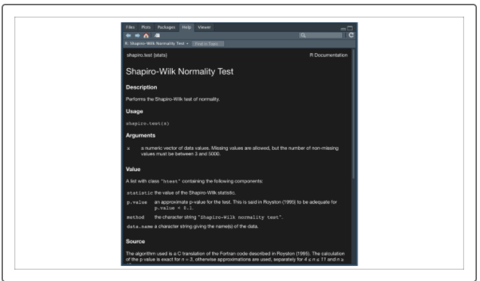

The shapiro.test() function only requires the numeric vector of values you wish to test. Therefore, if we want to perform a quantitative Shapiro-Wilk test on our previous example, our R code would look as follows:

> shapiro.test(mtcars$wt)

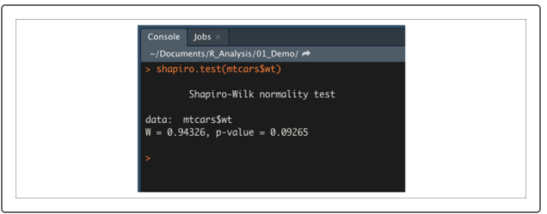

Later we'll discuss what a p-value is and how it is used in statistics. For our purposes, you just need to know that if the p-value is greater than 0.05, the data is considered normally distributed.

Remember that most basic statistical tests assume an **approximate** **normal distribution**. Therefore, if our p-value is around 0.05 or more, we would say that our input data meets this assumption. But what happens if our data distribution does not look like a bell curve, or the p-value of the Shapiro-Wilk tests is too small?