Data analysis and visualization typically begin with reading in an external data source into our programming environment.

There are built-in R functions to import the most common data formats, such as comma-separated values (CSV) and JavaScript Object Notation (JSON), as well as plenty of documentation and support online to import more advanced data structures.

To read in a CSV file, we use R's read.csv() function. read.csv() has a few required arguments to work properly. To identify the required arguments, type the following code into the R console to look at the read.csv() documentation in the Help pane, listed under the subhead "Usage" in the image below:

> ?read.csv()

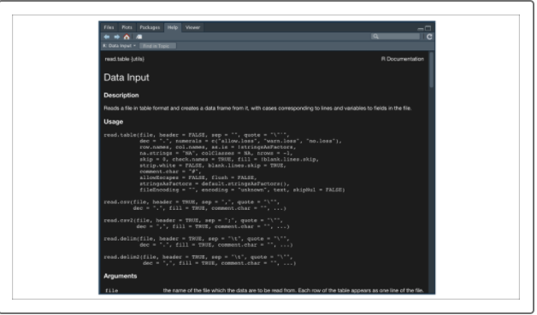

As we can see from the documentation, read.csv() is one of many read functions that all serve the same purpose: to read in tabular, character-delimited files and create a data frame object within our R environment.

Depending on what delimiter (or value-separating character) is used, we can use read.csv()for comma-delimited files, read.delim() for tab-delimited files, or read.table() if we need to manually tell the function what delimiter is used.

Although optional arguments are used to parse more complicated datasets, for our purposes, we'll only concentrate on the following arguments:

* **file**
* **header**
* **sep**
* **check.names**
* **stringsAsFactors**
* Now that we understand how to use the function, let's practice reading in a demo CSV file containing a hypothetical coworker's vehicle information.
* To practice reading in a CSV file, first download our sample CSV file:
* [Download demo.csv (Links to an external site.)](https://2u-data-curriculum-team.s3.amazonaws.com/dataviz-online/module_15/demo.csv)
* After demo.csv has downloaded, place the data file into your active working directory. Next, we'll use read.csv() in our source RScript pane to read in the demo file into our R environment. Type the following code:



**NOTE**

It isn't necessary to put a source file into our active working directory. If we ever want to read in a file from elsewhere on our computer, we would provide the full file path to our file argument.

By writing our read statement in our RScript, we can always quickly create and recreate the data frame by sending our assignment function in the RScript to our R console.

There are two ways to send RScript lines to our R console. We can either use the "Run" button in the top-right source pane or use the following shortcut:

* Command + Enter (Mac)
* CTRL + Enter (Windows)

If we send our read.csv() function to the R console, we should see our demo_table created in our R environment without any errors, as shown in the following image:

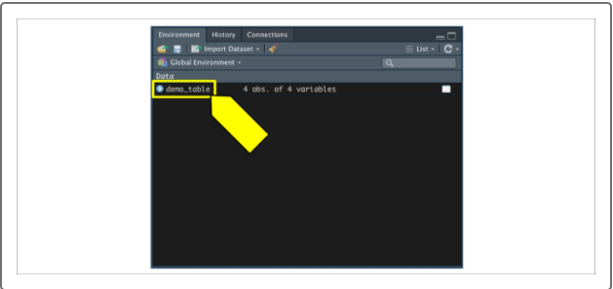

Additionally, if we click on the demo_table in our environment pane, it will show us our data frame in a view-only tab in the source pane. Refer to the following image:

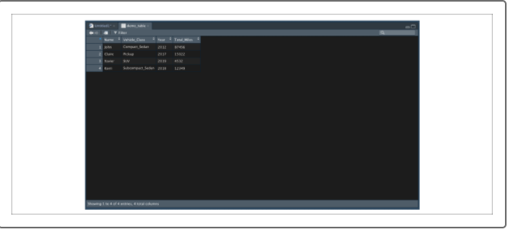

This view-only data frame tab can be very helpful when we are trying to transform columns and rows of data in our RScripts, or when trying to select data to use in a visualization or statistical model.

But what if we want to bring in a dataset from an application programming interface (API) query?

The JSON format is one of the most common data formats returned from a URL request. Although native JSON data can be easier to work with in Python, many data scientists still prefer to use R for their data analysis. To accommodate this need, R developers created the jsonlite library to read in JSON data structures and convert them to an R data frame. Because the jsonlite library was not built into R, we must import it into our R environment.

To import a library into R, we'll use the library(package)function. Just like in Python, it's good practice to import any required libraries at the top of our RScript.

Let's try loading in our installed jsonlite package using the library(jsonlite) function. Be sure to write the statement in your RScript and then send the statement to your R console (Command + Enter for Mac or CTRL + Enter for Windows).

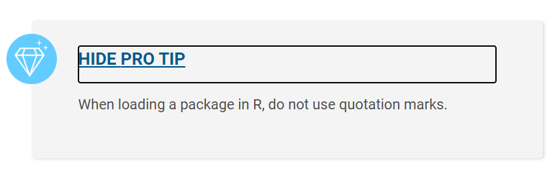

If we imported our library correctly, we should see the R console return characters without any errors:

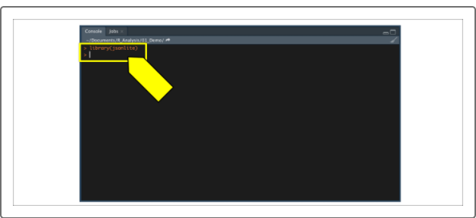

**NOTE**

Often you'll see conflicts or warnings when loading up packages in R, and usually these can be ignored. Only worry if your commands throw an error, which will print out in red text.

If at any time your R console throws errors when trying to import a library, you can always try to reinstall the package using the install.packages() function.

At this point, you may wish to save your R script by going to File, then Save. That way, you'll be able to open it later as you left it.

Now that we have successfully imported our jsonlite package, we can use the fromJSON() function to read in a JSON file into R.

First, type the following code into the R console to look at the fromJSON() documentation in the Help pane:

> ?fromJSON()

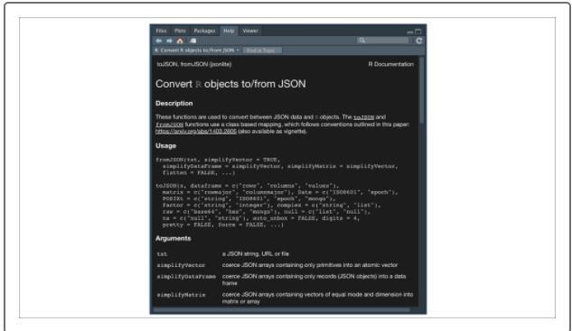

s we can see, we only need to provide the txt argument to properly read in a JSON file into R because the other parameters have default values indicated with equations (e.g. simplifyVector=True). txt is the file path of the JSON file on our machine. Alternatively, we can provide the fromJSON() function a JSON URL directly. Now let's practice reading in our first JSON file.

First, download the sample JSON file containing used car data using the link below.

[Download demo.json (Links to an external site.)](https://2u-data-curriculum-team.s3.amazonaws.com/dataviz-online/module_15/demo.json)

Place the downloaded data file in your active working directory. Next, use fromJSON() in our source RScript pane to read in the used car data into our R environment, as follows:

Place the downloaded data file in your active working directory. Next, use fromJSON() in our source RScript pane to read in the used car data into our R environment, as follows:

demo_table2 <- fromJSON(txt='demo.json')

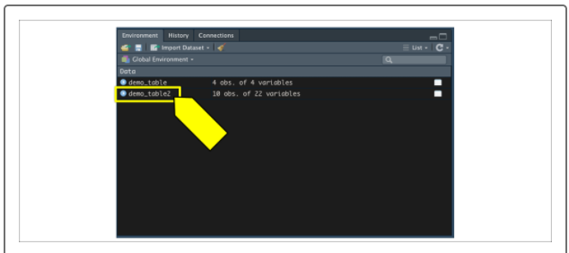

Once again, if we click the demo_table2 in our environment pane, it will show us our data frame in a view-only tab in the source pane:

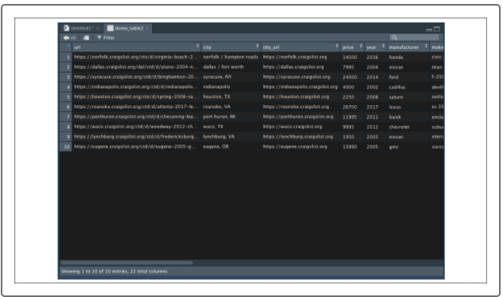

Now that we know how to create data structures and data frames in R, let's learn how to slice and sample our datasets.