Neural networks (also known as **artificial neural networks**, or **ANN**) are a set of algorithms that are modeled after the human brain. They are an advanced form of machine learning that recognizes patterns and features in input data and provides a clear quantitative output. In its simplest form, a neural network contains layers of **neurons**, which perform individual computations. These computations are connected and weighed against one another until the neurons reach the final layer, which returns a numerical result, or an encoded categorical result.

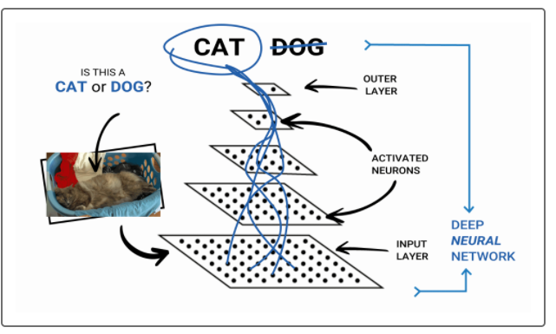

Neural networks are particularly useful in data science because they serve multiple purposes.

One way to use a neural network model is to create a classification algorithm that determines if an input belongs in one category versus another. Alternatively neural network models can behave like a regression model, where a dependant output variable can be predicted from independent input variables. Therefore, neural network models can be an alternative to many of the models we have learned throughout the course, such as random forest, logistic regression, or multiple linear regression.

There are a number of advantages to using a neural network instead of a traditional statistical or machine learning model. For instance, neural networks are effective at detecting complex, nonlinear relationships. Additionally, neural networks have greater tolerance for messy data and can learn to ignore noisy characteristics in data. The two biggest disadvantages to using a neural network model are that the layers of neurons are often too complex to dissect and understand (creating a black box problem), and neural networks are prone to overfitting (characterizing the training data so well that it does not generalize to test data effectively). However, both of the disadvantages can be mitigated and accounted for.

**REWIND**

Overfitting occurs when a model gives undue importance to patterns within a particular dataset that are not found in other, similar datasets.

Neural networks have many practical uses across multiple industries. In the finance industry, neural networks are used to detect fraud as well as trends in the stock market. Retailers like Amazon and Apple are using neural networks to classify their consumers to provide targeted marketing as well as behavior training for robotic control systems. Due to the ease of implementation, neural networks also can be used by small businesses and for personal use to make more cost-effective decisions on investing and purchasing business materials. Neural networks are scalable and effective—it is no wonder why they are so popular.