Before we can begin using Spark, we need a place to do so. **Cloud-based notebooks** provide a remote workspace with stronger resources than our local laptop might allow. Cloud notebooks permit us to share our work with others, such as coworkers, similar to GitHub.

We'll use [Google Colaboratory](https://colab.research.google.com/notebooks/welcome.ipynb) (Colab), which are Google-hosted notebooks. Some setup is required, so we'll start there before getting back to the basics of PySpark.

First, you'll need a Google account. If you don't already have an account, be sure to sign up for one.

Once you have created a Google account and signed in, navigate to the [Google Colaboratory](https://colab.research.google.com/) webpage. Once on the page you will see a menu like the one below.

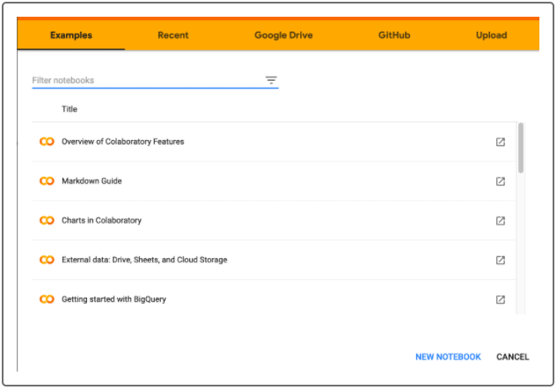

Click **NEW NOTEBOOK** which will then redirect to you a fresh new notebook to use. Google will store all the notebooks you create in a a folder called **Colab Notebooks** on your Google Drive



A new tab will launch with a new notebook. The functionality is very similar to using Jupyter Notebook, except now everything is hosted online.

Just like we do with our local environment, we need to install packages for libraries we want to use. PySpark does not come native to Google Colab and needs to be installed. We'll do so by running the following code in the first cell:

**NOTE**

Don't be scared by this installation code. All this does is install Spark for our notebook to use. It can be copied and pasted into any new notebooks you wish to run.

We are now up and running with cloud notebooks with PySpark.

