**With** everything shut down in AWS you should no longer accrue any costs. To be sure, you will check your billing dashboard to confirm nothing falls through.

From the AWS Management Console search for "Billing" and click on the result:

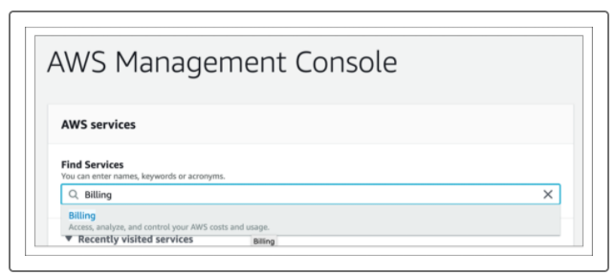

This will bring you to your Billing & Cost Management Dashboard. If you scroll down you will see your "Spend Summary." This is only a forecast and not what you will actually be charged, and this doesn't apply your AWS free usage credits. However, this should be no more than a few dollars:

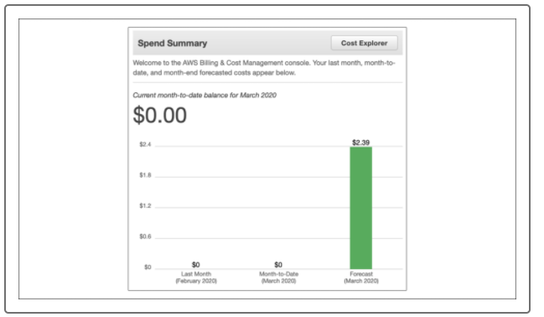

If you keep scrolling down you will find the "Top Free Tier Services by Usage" section. Double check to make sure all your services are within the Free Tier Usage. If they are close to full or higher than expected be sure to delete that service and limit future usage for the month:

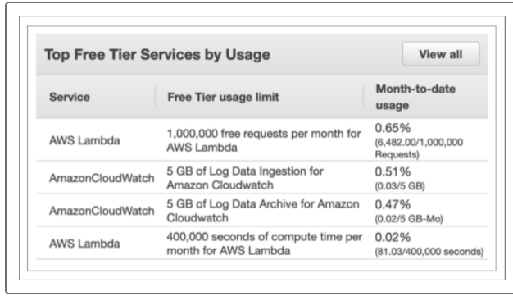

Scroll back up and select "Bills" on the navigation menu located on the left hand side of the page:

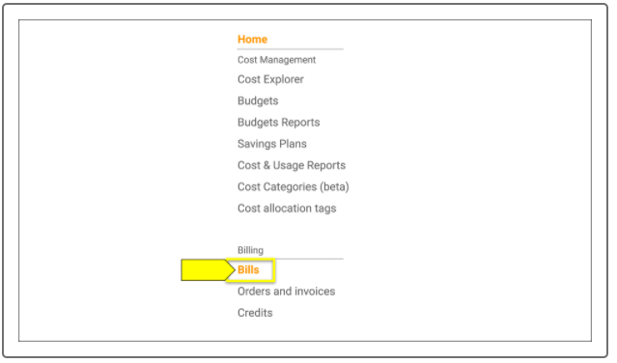

The dashboard that this brings you to will show you what you are actually being charged. You should see "$0.00**"** listed next to each service. You can explore individual services by selecting the arrow to the left of the service:

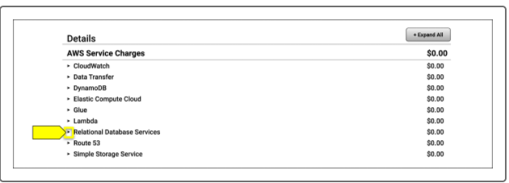

This page will also display where the AWS Free Tier credits will be applied. Clicking the arrow next to "Relational Database Services" will show the charge you accrued and the AWS credits applied to it:

Be sure to constantly check your billing to make sure surprise costs are not happening. For more information on handling Free Tier, please checkout this [AWS article](https://aws.amazon.com/premiumsupport/knowledge-center/stop-future-free-tier-charges/).