In the last section, you might have noticed that when calling a column with Spark, no real results were shown. As you might recall, Spark uses lazy evaluation. This means that Spark takes a list of instructions and formulates the best way to fulfill them, and then waits until you tell Spark to complete them. The process of listing and reading the instructions is called **transformation**, and your directive to complete them is called an **action**.

For example, say you have a new coffee maker. First, you read the instructions to learn what you need to do. You don't immediately make coffee, though. Instead, you wait for someone to ask if you can make coffee. Once you receive that request, you follow all the steps to make coffee. The transformation is you reading the instructions, and the action is the request to make coffee.

Let's start with an example.

**NOTE**

If you're using a new notebook for the next example, be sure to install Spark in the first cell, as we did in the previous example.

Start by creating a Spark session and loading in data, using the following code:

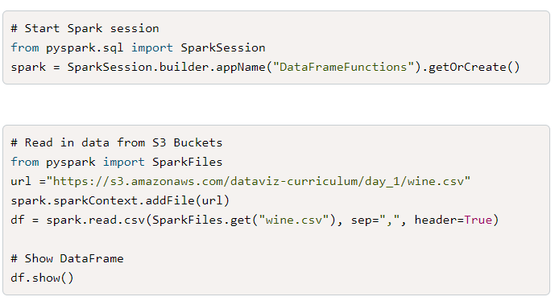

Now we'll use this data to identify the difference between transformations and actions.

**Transformations**

**Transformations** are the instructions for the computation. With the data loaded in, let's perform some transformations. What do you think will happen after we run the following code?

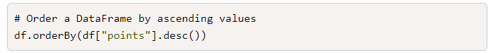

If you guessed that nothing would happen yet, you would be correct. Here we applied the transformation to order the DataFrame by points in descending order. All we're doing is telling Spark that we want this DataFrame to be organized in this particular way, and Spark says, "Okay, got it—just let me know when you want me to do this."

## Actions

**Actions** direct Spark to perform the computation instructions and return a result. What do you think will happen when you add .show(5) to the DataFrame?

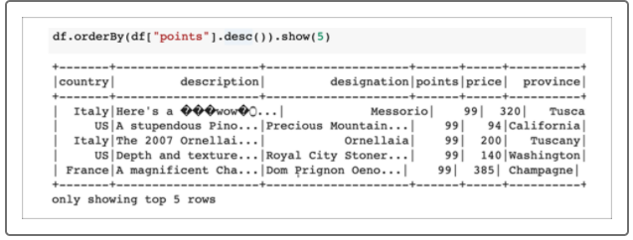

If you guessed that a DataFrame organized by points would display, you would be correct. The show(5) method is an action that tells Spark to show the first five results.

## Recap

Let's break down these concepts one more time:

* orderBy() and desc() are transformations telling Spark how to organize the data. Spark will read these transformations as instructions, but it won't act on them just yet.
* show() is an action that gives the go-ahead for Spark to run all of those transformations and to produce a result.

## More Functions

Let's take a look at a few more functions that we can use with Spark. As you continue to enter the code in your notebooks, keep in mind which methods you think are transformations and which ones are actions.

Spark can import additional functions, such as averages. Type and run the following code:

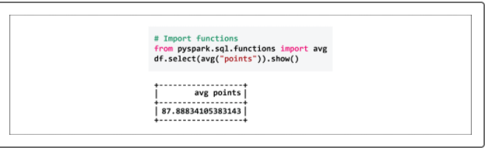

The avg() function is the transformation, and show() is the action.

Spark can filter on columns by supplying the name of the column and operator and what to compare it against. Refer to the following code and results:

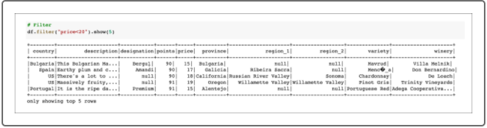

Filter is the transformation and show is the action.

We can also filter and select certain columns:

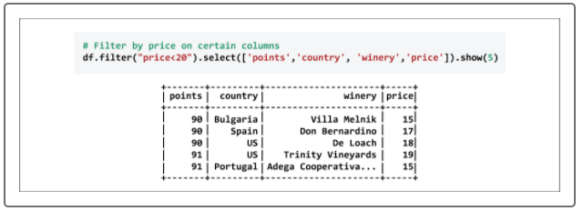

Both filter and select are separate transformations, and show is again the action.

Spark has multiple ways to perform transformations. For instance, how we were filtering our DataFrame was actually using SQL context with price<20.

However, we can also perform the same transformations using Python:

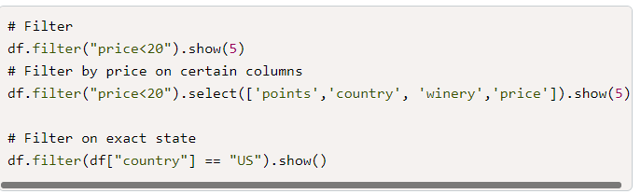

You might notice that there are more transformations than actions. Usually, we want to do several things with a dataset, but we'll only want to see those results in a few ways.

Now that you have an understanding of using Spark, it's time to dive into the next step of your challenge: learning how computers interpret textual data. For this step we'll explore natural language processing, which we'll use in conjunction with Spark.