Before we test our connection with our RDS instance and pgAdmin, let's learn about persistent data storage. **Persistent data storage** is where data is saved even when a machine's power is off (i.e., your computer's hard drive). SQL databases, such as the one we just connected to with AWS, is persistent storage.

The four basic functions of persistent data storage are **Create, Read, Update,** and **Delete (CRUD).** Let's test our connection to the RDS instance by performing some simple CRUD operations. This is review material, but it's important to understand which queries and operations belong to which part of CRUD.

Before we begin, from pgAdmin, create a new database within our RDS instances called "medical."

**Create**

The first function of CRUD is creating data. We'll make tables and insert data into them. Inserting is the main part of creating data to be stored within the database. Let's run the following query.

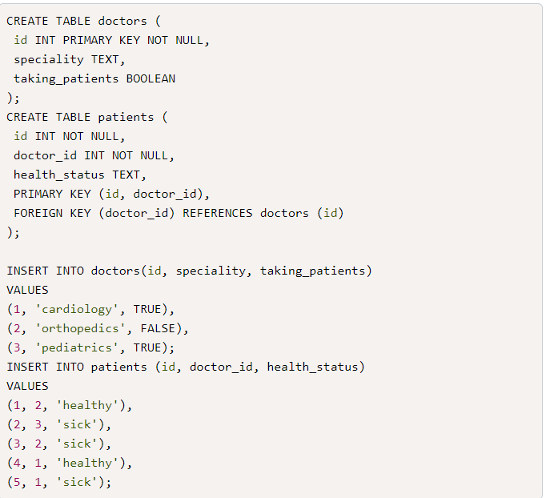

Great! We have just created some data. Although you have seen this before, it's important to understand where these queries fall in CRUD whenever you see it referenced.

## Read

The second function is reading our data. We'll run our SELECT statements for the data we want to retrieve from our tables. Let's run the following query to confirm our data has been successfully inserted.

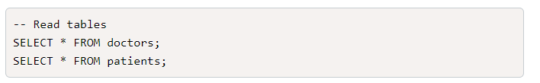

## Update

The third function is updating data that is currently stored. We'll run the following query to update our data.

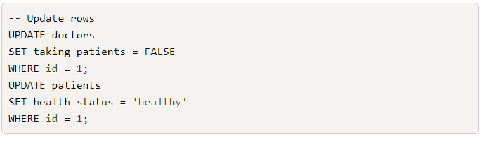

To confirm our update, run a SELECTstatement, which as you recall is the read function of CRUD.

## Delete

The final function is deleting data. We'll run the following query to delete data.

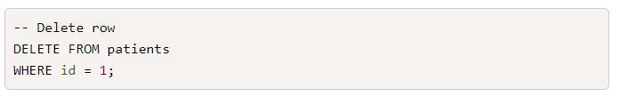

You're not likely to use the DELETEstatement because we're in the business of collecting data, not removing it. You should always be very careful when deleting data—often a system or rules are in place to secure your database and make data removal difficult to prevent mistakes, which can happen.

You now have an RDS instance running and tested by the CRUD functions within persistent data storage. It's time to learn how raw data is stored.