To merge your Simple_Leaflet_Map branch with the main branch, we will:

1. Compare the changes between the Simple_Leaflet_Map branch and the main branch so that we can merge them.
2. If we are able to merge the Simple_Leaflet_Map branch into the main branch, we need to create a pull request on GitHub.
3. After we review the pull request, we can merge the branch into the main branch.

Let's compare the changes between our Simple_Leaflet_Map branch and the main branch:

1. Navigate to your Mapping_Earthquake GitHub repository.
2. To start merging your branch into the main branch, compare the branches to confirm they can be merged.

**NOTE**

If changes have been made in the main branch after you added your files to a branch, you might not be able to merge.

1. You have two ways to compare your branch with the main branch:
   * Click the green "Compare & pull request" button, or
   * Click the gray "New pull request" button.

(If you click the "Compare & pull request" button, skip to Step 5.)

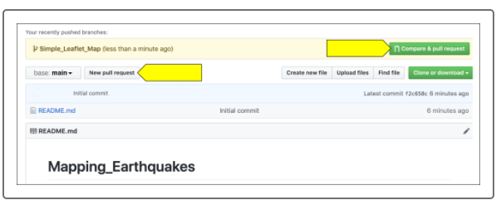

1. If you click the "New pull request" button, a new page will open with two buttons: "base: **main**" and "compare: **main**." Compare the Simple_Leaflet_Map branch with the base or main branch.

**NOTE**

Developers and team members often refer to pull requests as "PRs."

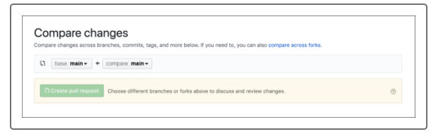

1. Click on the "compare: **main**" button and select the branch you want to compare (the Simple_Leaflet_Map branch).

