Branching makes it possible to create an isolated environment when creating a new feature, or to correct an issue in the main code no matter the scope.

Creating branches off the main branch is where Git shines. A branch allows you to make changes to the main code "off to the side," like a branch on a tree. Once the code on the branch has been reviewed and approved, only then can the branch be merged into the main branch. This ensures that the main branch always contains production-quality code.

Before we create a branch and add files to the new branch, make sure your copy of the main branch on your computer is up to date with the main branch on GitHub.

It's a best practice to either "pull" from the main branch to get the latest changes to the main branch, or pull "upstream" of the branch you are creating. This is important because your version of the main branch on your computer needs to be up to date with the main branch on GitHub.

Follow these steps to create a branch:

1. Navigate to the repository folder on your computer.
2. In Terminal on macOS or Git Bash on Windows, type git pull or git pull origin main and press Enter.
3. Type git checkout -b Simple_Leaflet_Map and press Enter.
   * git checkout lets us navigate between branches.
   * -b indicates we are creating a new branch.
   * The name of the new branch follows -b.

After pressing Enter, your terminal or Git Bash should return the following:



Now we are in the Simple_Leaflet_Map branch. Confirm this by typing git branch and pressing Enter. The output in Terminal or Git Bash should look as follows, with an asterisk next to the branch name:

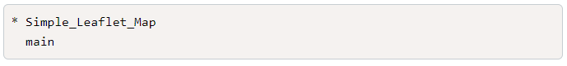

At this point, the folder structure on your computer hasn't changed. The files you had in your main branch are now in your Simple_Leaflet_Map branch. Visually, the repository should look like the following:

