This step is essential when working with your Disaster Reporting Network team. It will allow Basil and Sadhana to review and run your code to verify there are no errors. If there are errors in your code, or if the code can be modified to be easier to read, then they will ask you to make changes. If your code looks good and there are no changes to be made, then you can merge your branch with the main branch.

Let's walk through the process of creating a pull request. First, select the Simple_Leaflet_Map branch.

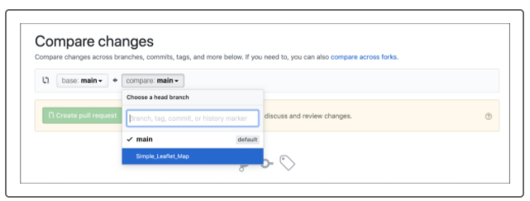

Or, you can select the green "Compare & pull request" button.

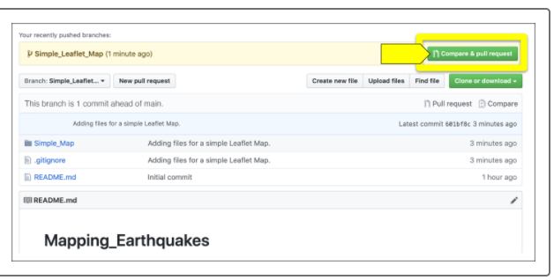

A new page called "Open a pull request" will launch.

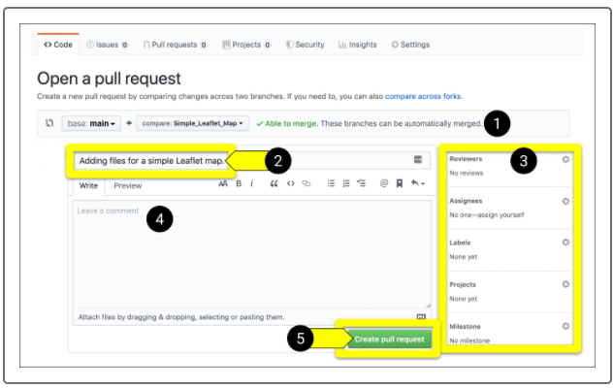

The page shows the five key elements of a pull request:

1. Near the top of the page is a green checkmark and text stating "Able to merge." If you're unable to merge, GitHub will display an explanatory message.
2. Next is the commit message you made.
3. "Reviewers" and "Assignees" are members, such as yourself, with access to the repository. You can assign the pull request to yourself. Labels, Projects, and Milestones are completed by team members and owners of the repository. Click on a gear wheel to modify any of these items.
4. In the "Leave a comment" field, describe what you're adding to the main branch in the pull request.
5. After entering a comment, click the green "Create pull request" button.

Scroll below "Open a pull request" to see the files you're adding to the pull request.

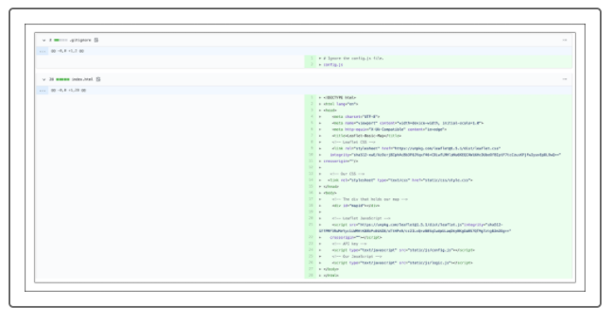

Write a message and create a pull request. In the "Leave a comment" field, type the following message:

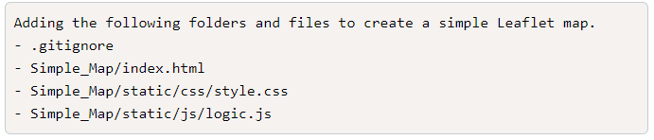

After you click the green "Create pull request" button, the page should look similar to the following:

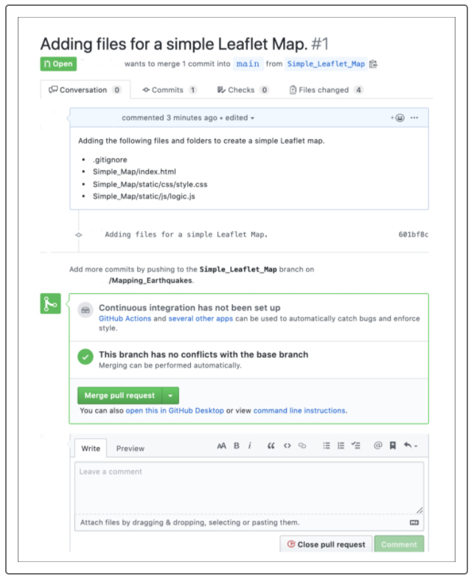

Reviewers can add a comment in the "Leave a comment" field. For example, Sadhana or Basil could type approval and further instructions: "Looks good to me. You can merge." Once a reviewer approves your pull request in a comment, you can click the green Merge pull request button.

If your code looks good, click the "Merge pull request" button.