After clicking the "Merge pull request" button, the page will refresh with two options: "Confirm merge" or "Cancel."

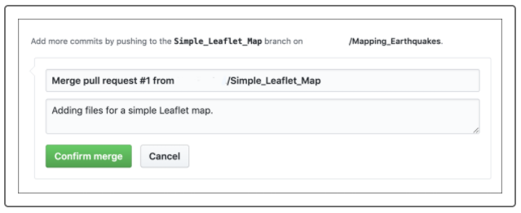

Click the green "Confirm merge" button. The page refreshes to confirm, in three places, that the pull request has been merged into the main branch.

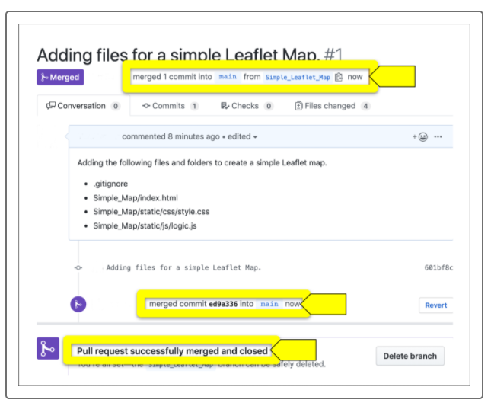

This page gives the option of deleting the branch. However, don't delete it so that future interns can use it to create a simple Leaflet map.

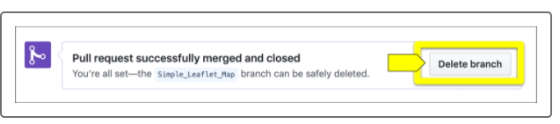

Navigate to the main branch on GitHub to confirm all the folders and files have been merged from the Simple_Leaflet_Map branch.

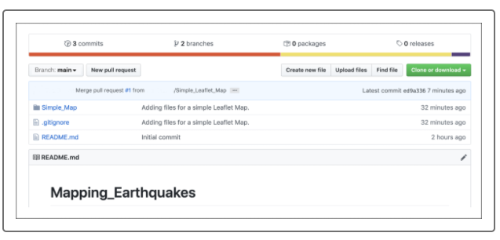

We are almost done!

Next, pull the latest changes on the main branch on our computer because the main branch on our computer is not up to date. Follow these steps.

1. Open the terminal or Git Bash and type git checkout main and press Enter.
2. Type git status and press Enter. The output might tell you that you are up to date, which can be misleading, or it might say you are "1" commit behind the Simple_Leaflet_Map branch.
3. Type git pull and press Enter. The output should look like the following:

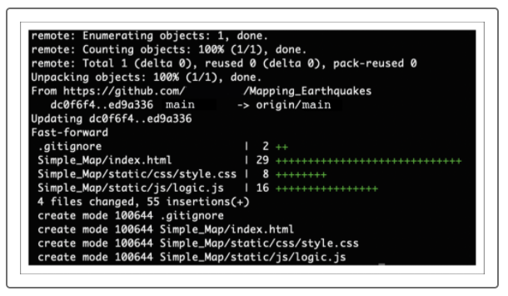

To confirm that the files are in the main branch on your computer, if you have a Mac type open . to view the directory in Finder, or if you have a PC type start . to view the directory in File Explorer.