## The Leaflet JavaScript Library

On the [Leaflet](https://leafletjs.com/index.html) homepage, scroll midpage and click the [Leaflet Quick Start Guide](https://leafletjs.com/examples/quick-start/) link:

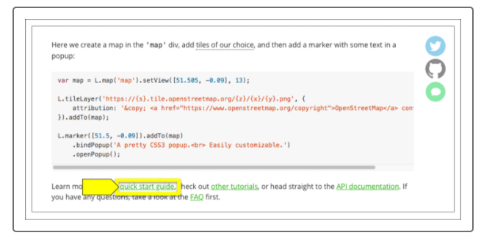

The Leaflet Quick Start Guide provides steps for setting up a Leaflet map. To begin, scroll midpage to the "Preparing your page" section:

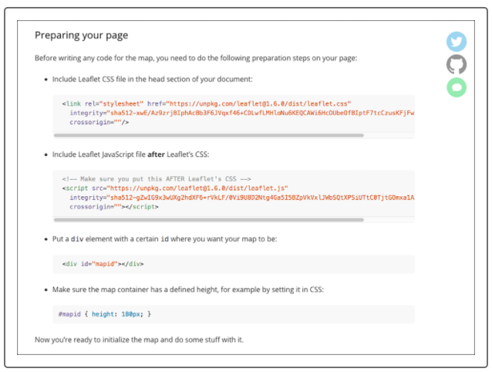

The "Preparing your page" section includes links and HTML code that we'll add to our index.html page. First, we'll create a folder structure for our earthquake map webpage.