In VS Code, create a new file in the Simple_Map folder and name it .gitignore. Your repository folder should look like the following:

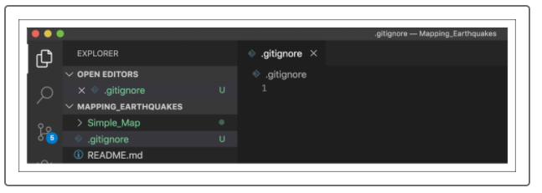

Next, add the following lines to the .gitignore file and save the file:

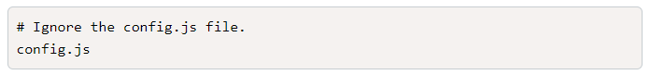

In the command line, type git status - u and press Enter. The output should have the .gitignore file and all the files as before, except the config.js file. All the files in red will be tracked when we use git add, with the exception of the config.js file.

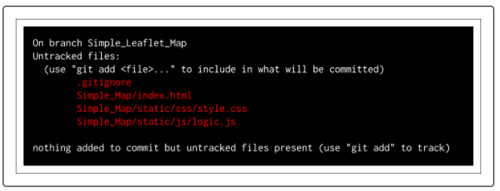

After typing git push and pressing Enter, the output message will look like the following:

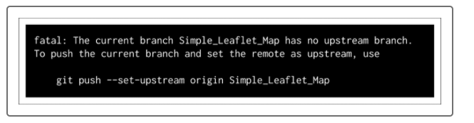

To push the folders and files to the Simple_Leaflet_Map branch for the first time, type git push --set-upstream origin Simple_Leaflet_Map in the command line and press Enter.