# Manual

## Project Instructions

Unity 2021.1.23f1c1 is used in this project. You can download it from the [Unity website](https://unity.com/download).

Configuration: import the unitypackage provided (Assets→Import Package→CustomPackage), and install the *Input System* package via Package Manager (Window→Package Manager). In build settings (File→Build Settings), add scenes *Lobby* and *IDC2022*. Set *active input handling* (Edit→Project Settings→Player→Other Settings→Configuration→Active Input Handling) to *Both*.

Folders that contestants are mainly concerned with are *Scenes* and *Resources*.

*Scenes* is the main folder that contains the scenes, prefabs, scripts and other things used in the contest. *Resources* is the folder that Photon Unity Networking (PUN) uses for instantiating objects. Things created in the last IDC contest are scattered in the *IDC* folder and *Assets* folder. Only part of them are removed, and you may use the rest of them for reference. The rest of the folders contain packages, scripts and other things needed to support the program.

The *Script* folder contains 2 subfolders. The *System* folder includes scripts that support gameplay. Scripts outside the *System* folder are provided for the participants to use, but you should not change the code inside the scripts. If you need to make changes, create a new script. It is recommended to put the new scripts you have created into the *PlayerScript* folder to keep the project tidy.

The *Prefabs* folder contains the prefabs. To create a prefab simply drag the gameobject from the Hierarchy window to the Project window. Like the *Script* folder, there is a *PlayerPrefabs* folder for you to store your prefabs.

When naming your prefabs and scripts, it is recommended that the name starts with *your team number + A* or *your team number + B*, so as to avoid having the same name as the creation of other teams.

Double click *test01* in the *Scenes* folder to enter the field, where you can build and test your robot. Select *GameManager* in the Hierarchy window, drag your robot from the Hierarchy window to *LocalRobot* in the Inspector window to finish configuration. When directly running this scene you can not adjust your starting position run-time, and you will not be timed. In an actual match you will start from the *Lobby* scene. In this case you need to put your robot prefab into the *Resources* folder in advance.

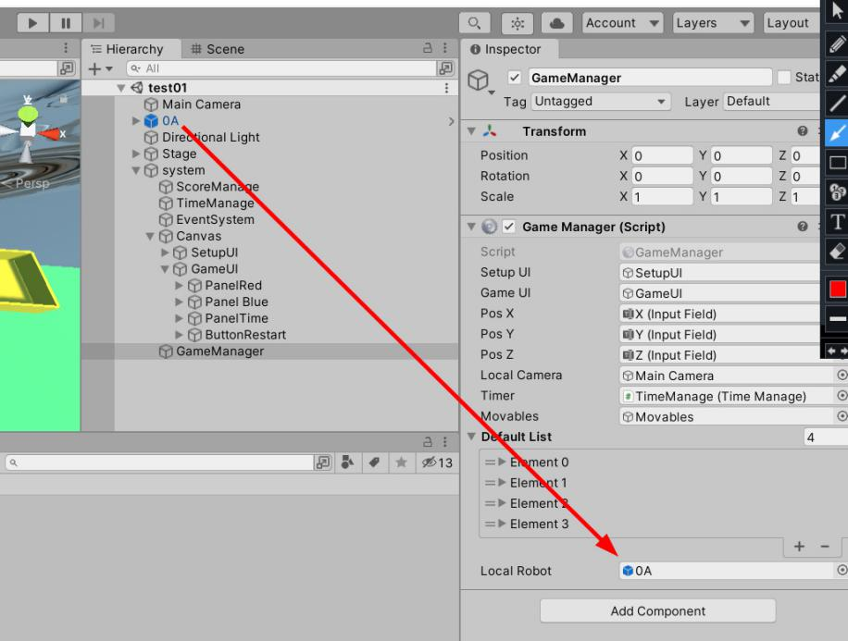

The *IDC2022* scene is a backup duplication of *test01* for multiplayer cases. **Do not make any changes to it**, or you may not be able to connect with others.

## Build Instructions

Click *Build And Run* to make a build of the program.

Double click New Unity Project（4）.exe to open the program and enter the lobby scene. Single player mode can be run offline. In Multiplayer mode, wait until only the input field for robot name and the confirm button remain, meaning that the program has successfully connected to the server.

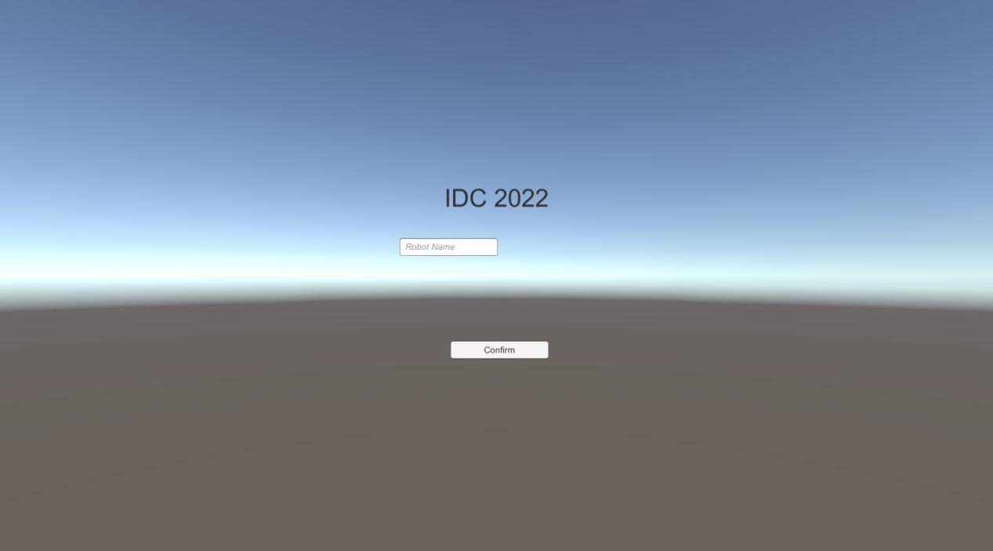

Initially the program includes robots such as *0A* and *0B*. Before creating a build, all robots used in the match should be included in the *Resources* folder. In the input field enter the name of your robot prefab. Then click the confirm button and go to room settings.

Type in the name of your room and choose the number of players in this room. Choose your starting area in the field. E.g., R1 means starting area 1 on the red side, which is located on the upper left corner of the field with the task of ball transportation. R2 means starting area 2 on the red side, with the task of planting trees. Due to the limitations of PUN, interacting with objects of other participants may cause serious lagging (especially the balls, which bump into each other frequently since they are densely packed), so make sure that you choose the correct starting area. Click *Join Room* to confirm your settings.

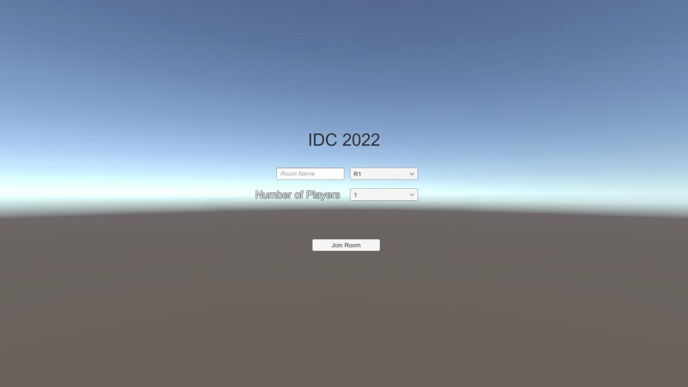

On joining the room your robot will appear on the chosen starting area. By entering new coordinates in input fields *X*, *Y* or *Z*, you can adjust your starting position. Click *Ready* when you are finished. The match will start after all participants are ready. If you can not see the button and the input fields, enlarge the window size.

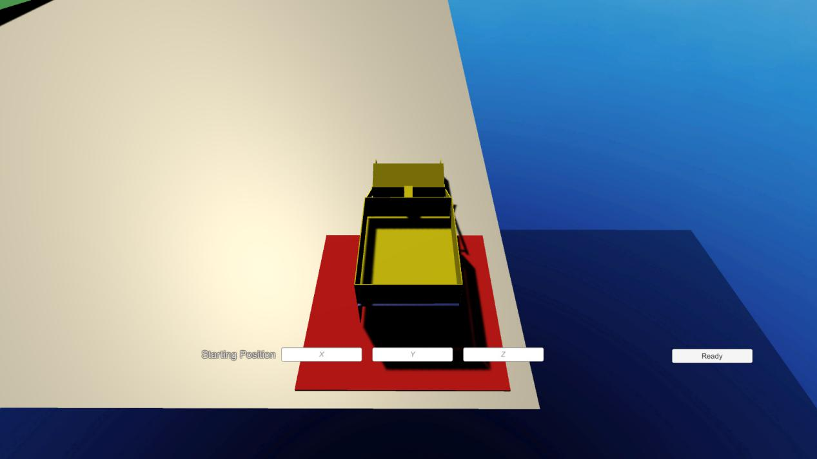

When the match starts, the timer and the score of both teams will appear. Click Restart to return your robot to its starting position.

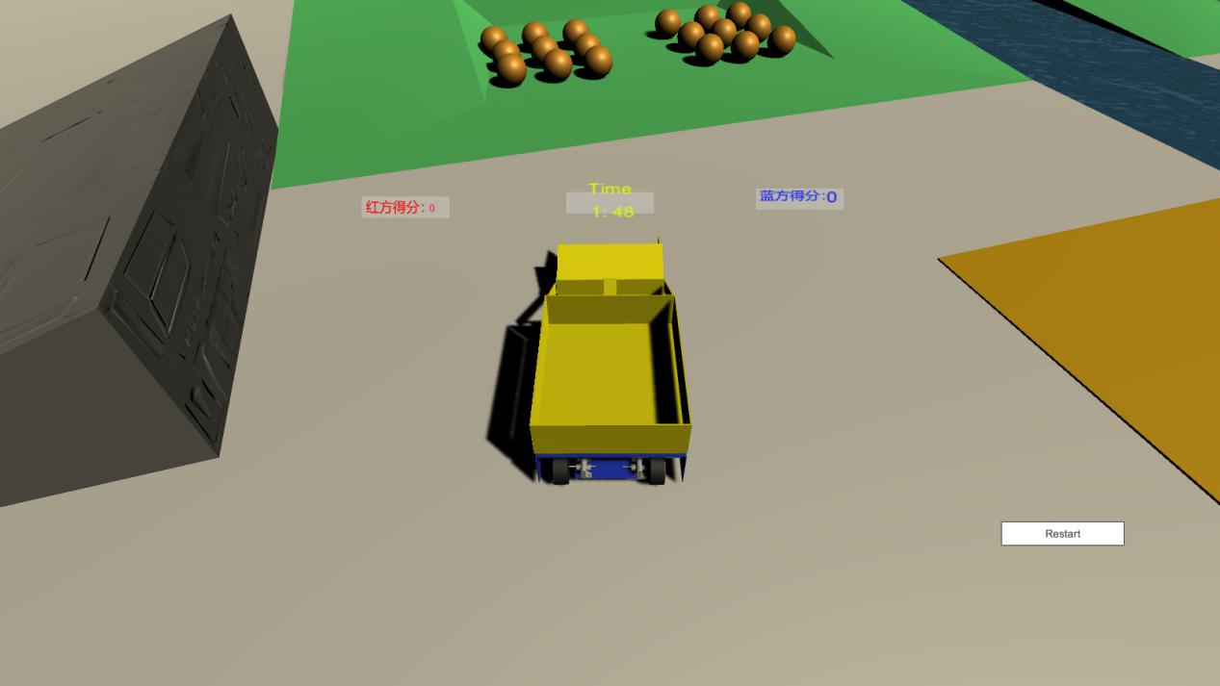

## Introduction of the Built-in Robots

Control the movement of the robots with arrow keys or *a*, *s*, *d*, *w*.

0A：

A robot with a shovel and a dumper. Use *j* and *k* to flip the dumper, while *m* and *n* are used to control the shovel.

0B：

A robot with a pincer. Use *o* and *p* to open and close the pincer.