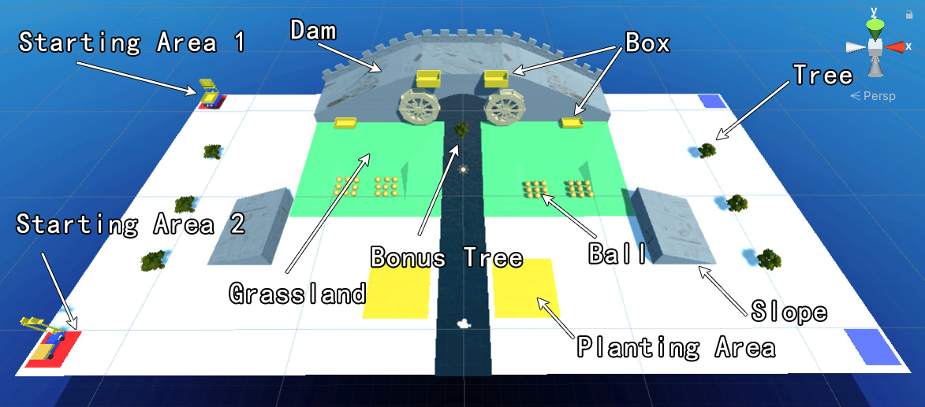

# Background

Throughout Chinese history, dealing with water bodies has always been an essential matter. For thousands of years Chinese people have been striving to prevent rivers and lakes from flooding their homes, as well as making the best use of them in irrigation, transportation and much more. In the contest, participants will design and build robots for two river-taming approaches: a) transporting materials for the construction of a dam; b) planting trees to prevent soil erosion, which raises river beds, increasing the risk of flooding.

# Scoring

Scoring rule is mainly described in two parts. Participants control their robots to take the balls to the boxes, or plant the trees onto the planting areas. For every ball put into the lower box, you get 10 points. For the higher box you get 30 points for each ball. For every tree that remains standing in the planting area, you get 50 points. You will not get any points if the tree topples over, though there are no penalties either. In the middle of the river there is a bonus tree that will start to move downstream when the match has started for 60 seconds. Successfully planting the bonus tree onto the planting area will give you an extra score（待定）. For each team, initially 18 balls are set in the grassland and 3 trees are set.

## Slope

There is a slope on each side of the field. Your robot can use the slope to get onto the top of the dam.

# Rules & Regulations

## General Principles

The rules are intended to create opportunities to learn engineering.

Those things not specifically forbidden are allowed.

## Timing and Regulation

Each round of the contest is 120 seconds long. After that period, you can not control robots.

Robots must start in starting area 1 or 2 on your own side with touching the level floor.

Starting area 1 is for ball transportation, while starting area 2 is for planting trees. Interfering with the tasks of other participants (including your teammate!) may cause serious lagging, so make sure that you choose the correct starting area.

After entering the field you can test your robot and adjust its starting position (you ***can’t*** change your starting area and task in this way). Click the “Ready” button when you are prepared. The match will automatically start after all participants are ready.

## Winning & Advancing

The contest consists of the qualifying round and the final tournament.

The qualifying round is a four-group league match. There are three teams in each league, and the top two teams of the league will advance to the final tournament. For teams that tie for wins in a league, ranking will be made according to the total score.

The final tournament is a single elimination tournament.

If a match is finished in a tie, a set of tie-breaking rules will be used in the following sequence: 1) the team that has successfully planted the bonus tree in the planting area wins; 2) the team with more balls in the higher box wins; 3) the team that has successfully planted more trees in the planting area wins.

## Control

Players must control their own robots.

You can control your robot manually by devices such as keyboards and game pads, or control it automatically with your own code.

Contestants may not deliberately interfere with the control of opposing players.

## Robot Configuration

Rigidbody: the rigidbody components in your robot must be in its default settings, which means that it should use gravity, is not kinematic, and you can not freeze its position or rotation on any axis.

Materials: the properties of colliders and and their physical materials must not be changed.

Control unit: your robots must be actuated by the actuators provided, including Bosh motors, DC motors, pumps and sky engines. Control commands must control only the actuator output, e.g., you can not change the position, rotation and velocity of objects by control commands. You can use the status of objects as input for your control, e.g., using the position of your robot as input for a feedback mechanism. You can use up to 8 Bosh motors, 4 DC motors, 4 pumps and 1 sky engine for each robot. You can not change the maximum force or torque of the actuators.

Size and weight: the entire robot must fit in the starting area, which is 0.5m * 0.5m (the height is not limited). You can use approaches such as folding to fit your robot inside. Your entire robot must weigh less than 5kg.

Total execution time: robots should be controlled smoothly. Number of mesh colliders, faces of your mesh, and the complexity of your code will affect your execution time. In order to avoid lagging you should not make them too large.

Submission: prefabs of your robots must be sent by a specified date and time to the IDC staff. If you use anything that isn’t provided by the IDC staff, e.g., scripts, prefabs, materials, you need to send them with your robot. You should name your things so that they start with your team number, and ***A*** for robots in starting area 1, ***B*** for robots in starting area 2. e.g., *0A_motor_control*, *0B_material1*, etc. You should also send a technical document that briefly describes the scripts you have used and their position in the robot.

## Sporting Conduct & Safety

Damaging, overturning, pushing, pulling, lifting, and deliberately blocking an opponent’s robot is not allowed.

Once scoring is accomplished, it cannot be reversed by defensive actions (e.g., taking a ball out of the box), but additional scoring can be prevented.

Using malware, making use of bugs, or any other action that causes the program to malfunction is prohibited.

Any person may not directly affect the motion of the robots or anything else in the field.

Any robot component or object that leaves the field can not be used.

All robots must be entirely in the starting area at starting time.

Net or other entanglement devices are not permitted, but other defensive devices are generally permitted.

Only free assets are allowed. If you use other people’s scripts, you need to inform others in your code and document.

During the match, colliders and mass can not be changed.

After the time limit, the referee will judge the winner of the match according to the rules as mentioned.

**NO POLITICAL MESSAGES ON THE ROBOTS.**

**THE JUDGES’ DECISIONS ON SAFETY MUST BE RESPECTED AND OBEYED PROMPTLY.**