Supporting Documentation

Tchemon Coulibaly

Sam Maruska

NOTE: Since there is a probability of keeping solutions in order to have a varied solution set. Upon each run, the user may get a mechanism smaller than the example, but not by a significant factor.

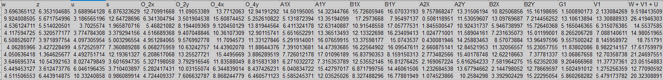

Selected Solutions of MATLAB code output. Each row is an individual solution.

The Example solution that follows is from the first row.

Page 2: P1 position of SAM mechanism

P2 position of SAM mechanism

Page 3: Position as a function of Theta from P1 to P2

SAM Mechanism at P1:

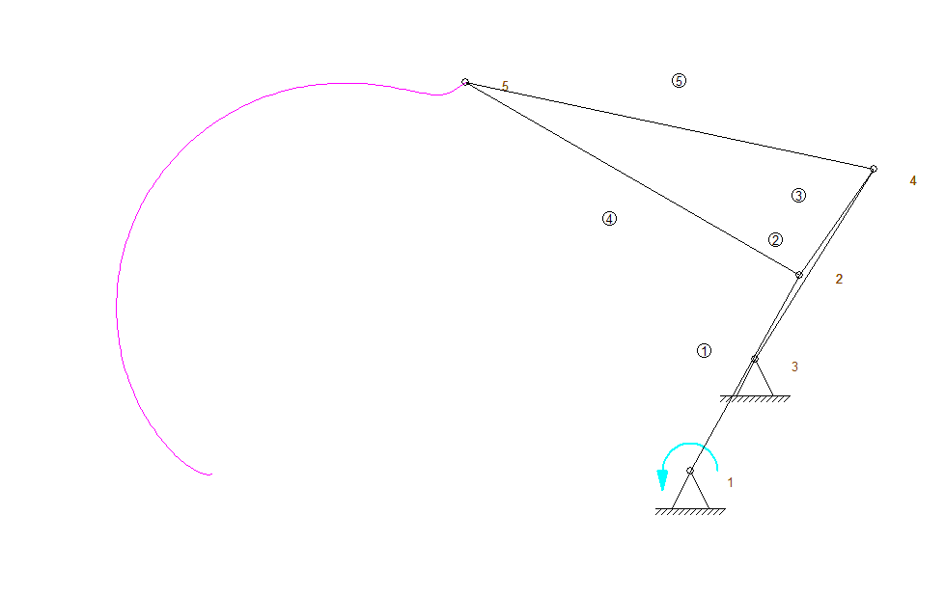

SAM Mechanism at P2:

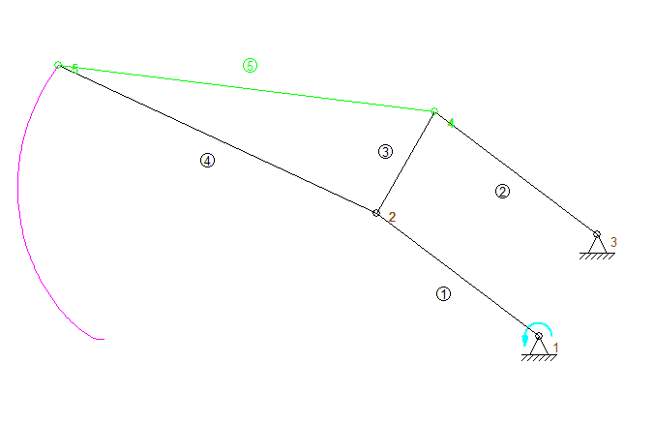

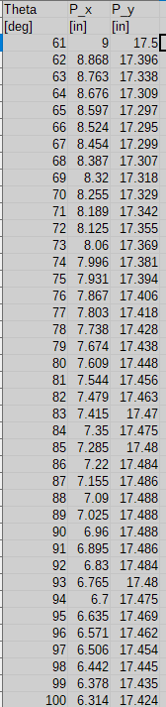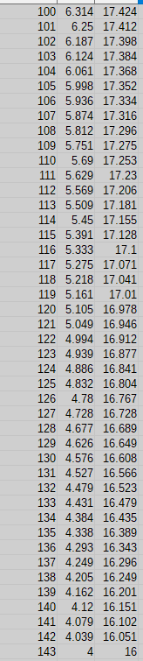 XY Data as a function of theta for point P.