PLATFORM - SET UP LIST
- Put construction adhesive (Liquid Nails) by heater
- Caulking gun
- Framing nail gun
- Galvanized Framing nails
- Screw gun with T25 bit
- Screws — 3" with T25 head
- Screws — hex head for brackets
- Brackets
- Chalk line
- Mallet
- Great Stuff cans
- 12” spacer blocks marked “SAVE”
- Jenga boards (12)

Step 1
- Set 2x6s into the jig to form the perimeter. Check the long 2x6s for straightness. If not straight, be sure to place them so that the curve is inward at the center of each board.
- In 4 places along each long side, where each of the jig stops is, position a jenga block outside the 2x6 between the outer jig stop and the 2x6, as shown in the diagram. Similarly, place a jenga block inside the 2x6 boards that form the short ends of the frame.
- Put 1 FRAMING nail in each of the corners
— one person holds flush on top and sides, other person nails
— Check the frame for square: measure the diagonals; they should be the same. Adjust as necessary.
- Put 2 more nails (total of 3) - in a vertical line at each of the 4 corners.

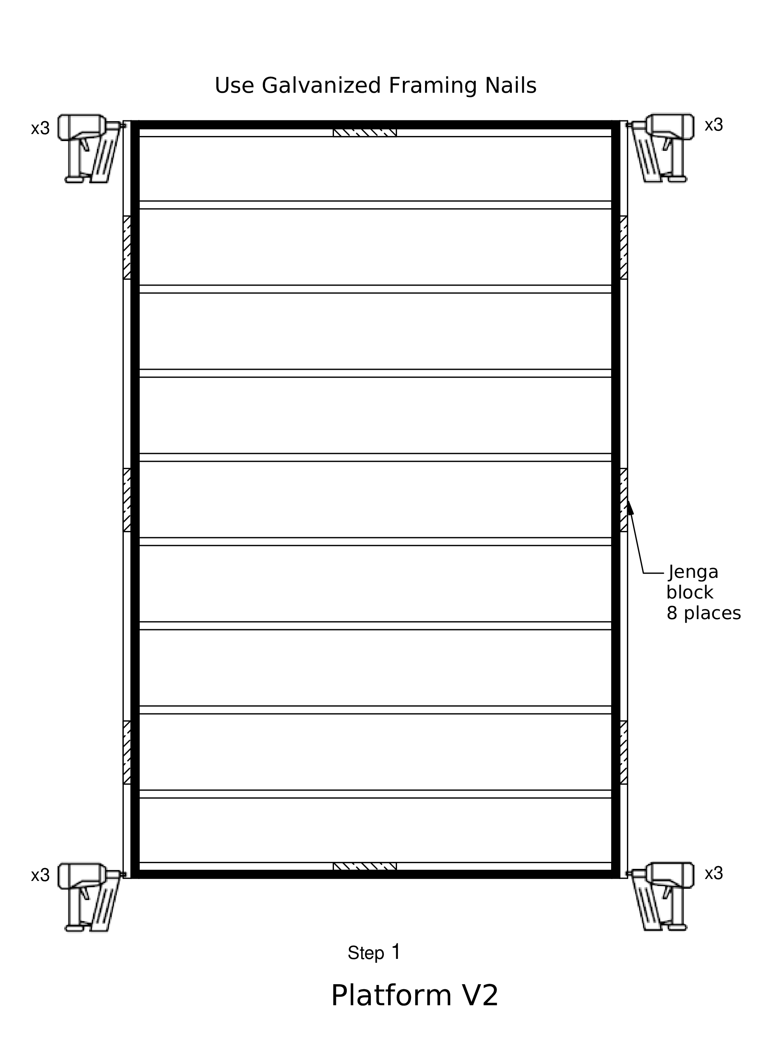

Step 2
- Remove the 2 jenga blocks from inside each end board.
- Put a second 2x6 inside the ones on each short end
— CLAMP them together
— nail these 2x6 together 8 places, centered vertically
- Put in all the inner 2x6 joists
- Team leader
— using the triangle, mark a line on the outside of the long 2x6s at the middle of the ends of each joist to indicate where the nails go.

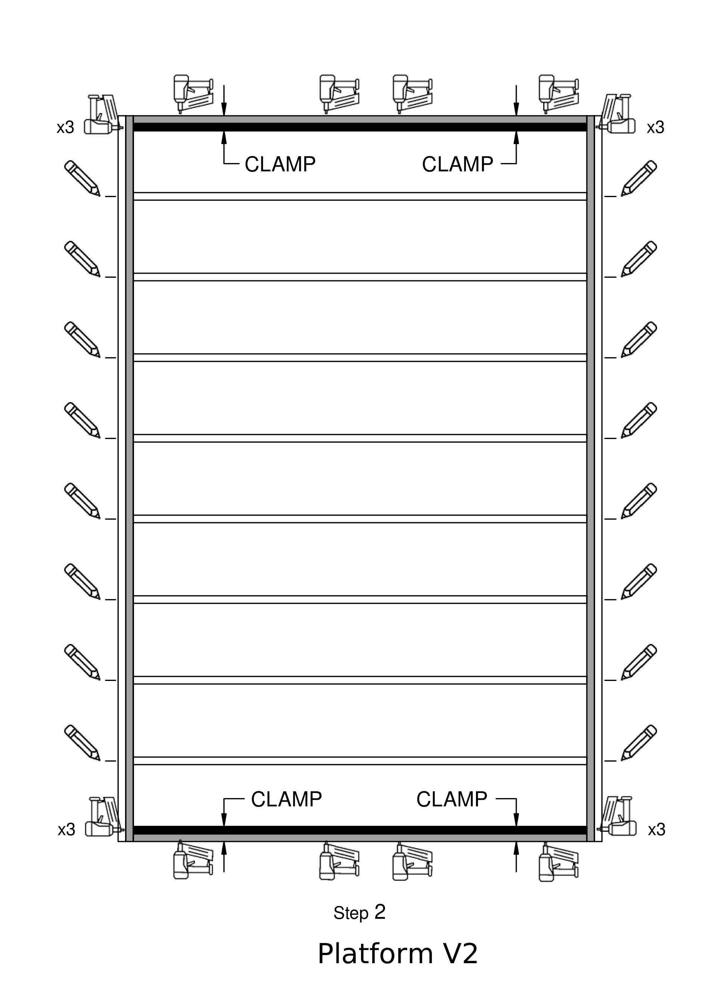

Step 3
- Put 3 nails in a vertical line on both ends of each joist
— make sure joists are flush before nailing; one person holds the joist in position while the second person nails.
— include two nails in the doubled joist ends

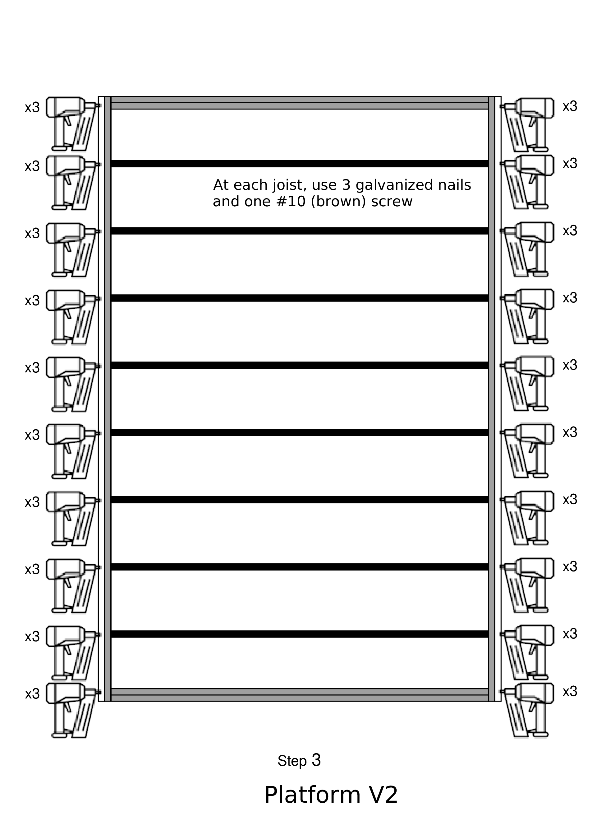

Step 4
- Remove the jenga blocks from outside the long sides of the frame.
- Position a long 2x6 outside each long side of the frame.
- Using clamps as necessary to align the two long boards, nail these boards together, one nail in the middle of each bay (between the joists), centered vertically.
- Use a pry bar to lift the frame out of the jig and slip a jenga block under the long boards in 3 places on each side

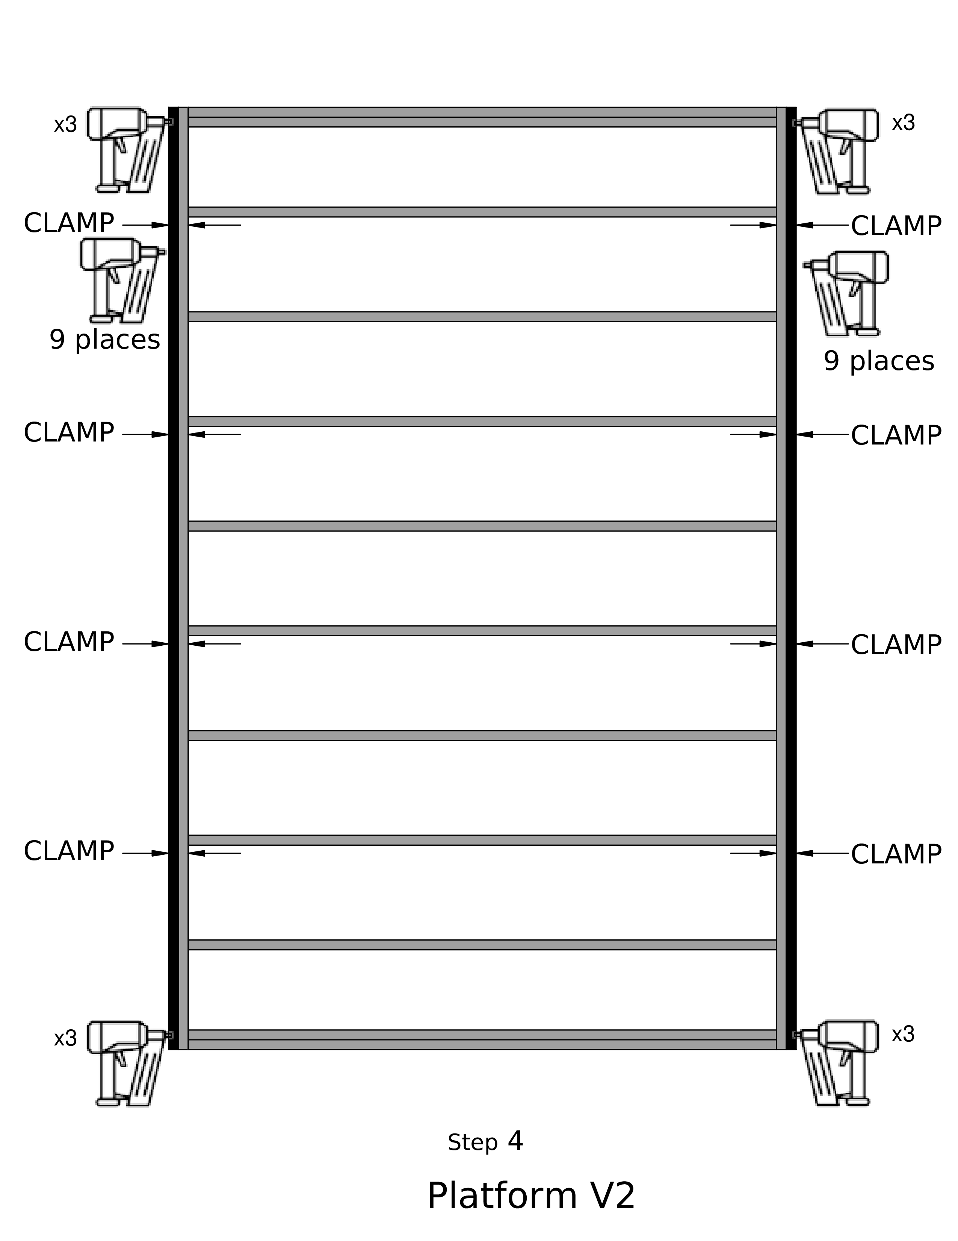

Step 5
- Put pre-cut skids into the steel building carriages
— longer part of the angled edges up
— position each 4x6 skid so that the ink mark on the 4x6 is even with the front of the carriage. The end with the mark is at the front of the home.
- Install the alignment jigs, first to the front of the skids, and then to the back. — At the front, the cross bar should stick up above the tops of the skids, and the two alignment blocks should be flush with the skid tops
— The skids should both be between the two alignment blocks
— Block the wheels on one carriage, but leave the other one free to roll.
- Measure diagonally from jig corner to corner and adjust so that the jig is square. When this is done, block the wheels on the second carriage.
- Pry the frame out of the jig, and lift the frame onto the pre-cut skids. — At the front, the frame should be up against the jig crossbar. At all four corners, the frame should fit into the metal angles. — Verify that the skids do not stick out beyond the back of the frame. If they do, they were not trimmed correctly, and this must be corrected.
- Measure the diagonals of the frame, and make sure that they are the same, so that the frame is square.
- — After any adjustments, make sure the frame is tight against the front jig crossbar.

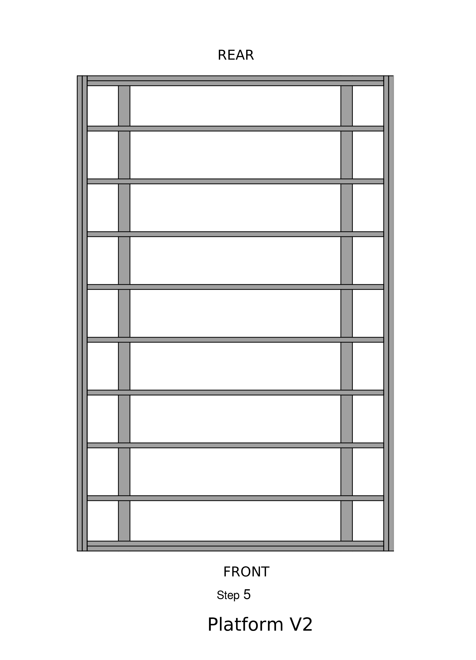

Step 6
Team Leader
- make an X where the metal brackets should go
— FOLLOW LOCATIONS on DIAGRAM
— alternate inside of the skid and outside of the skid all the way to the back
— make sure to make a mark on the inside joist of the double joist at the end
- Use a triangle to mark on the outside of the frame where the center of each joist is.You will need to know this to make chalk lines at Step 9

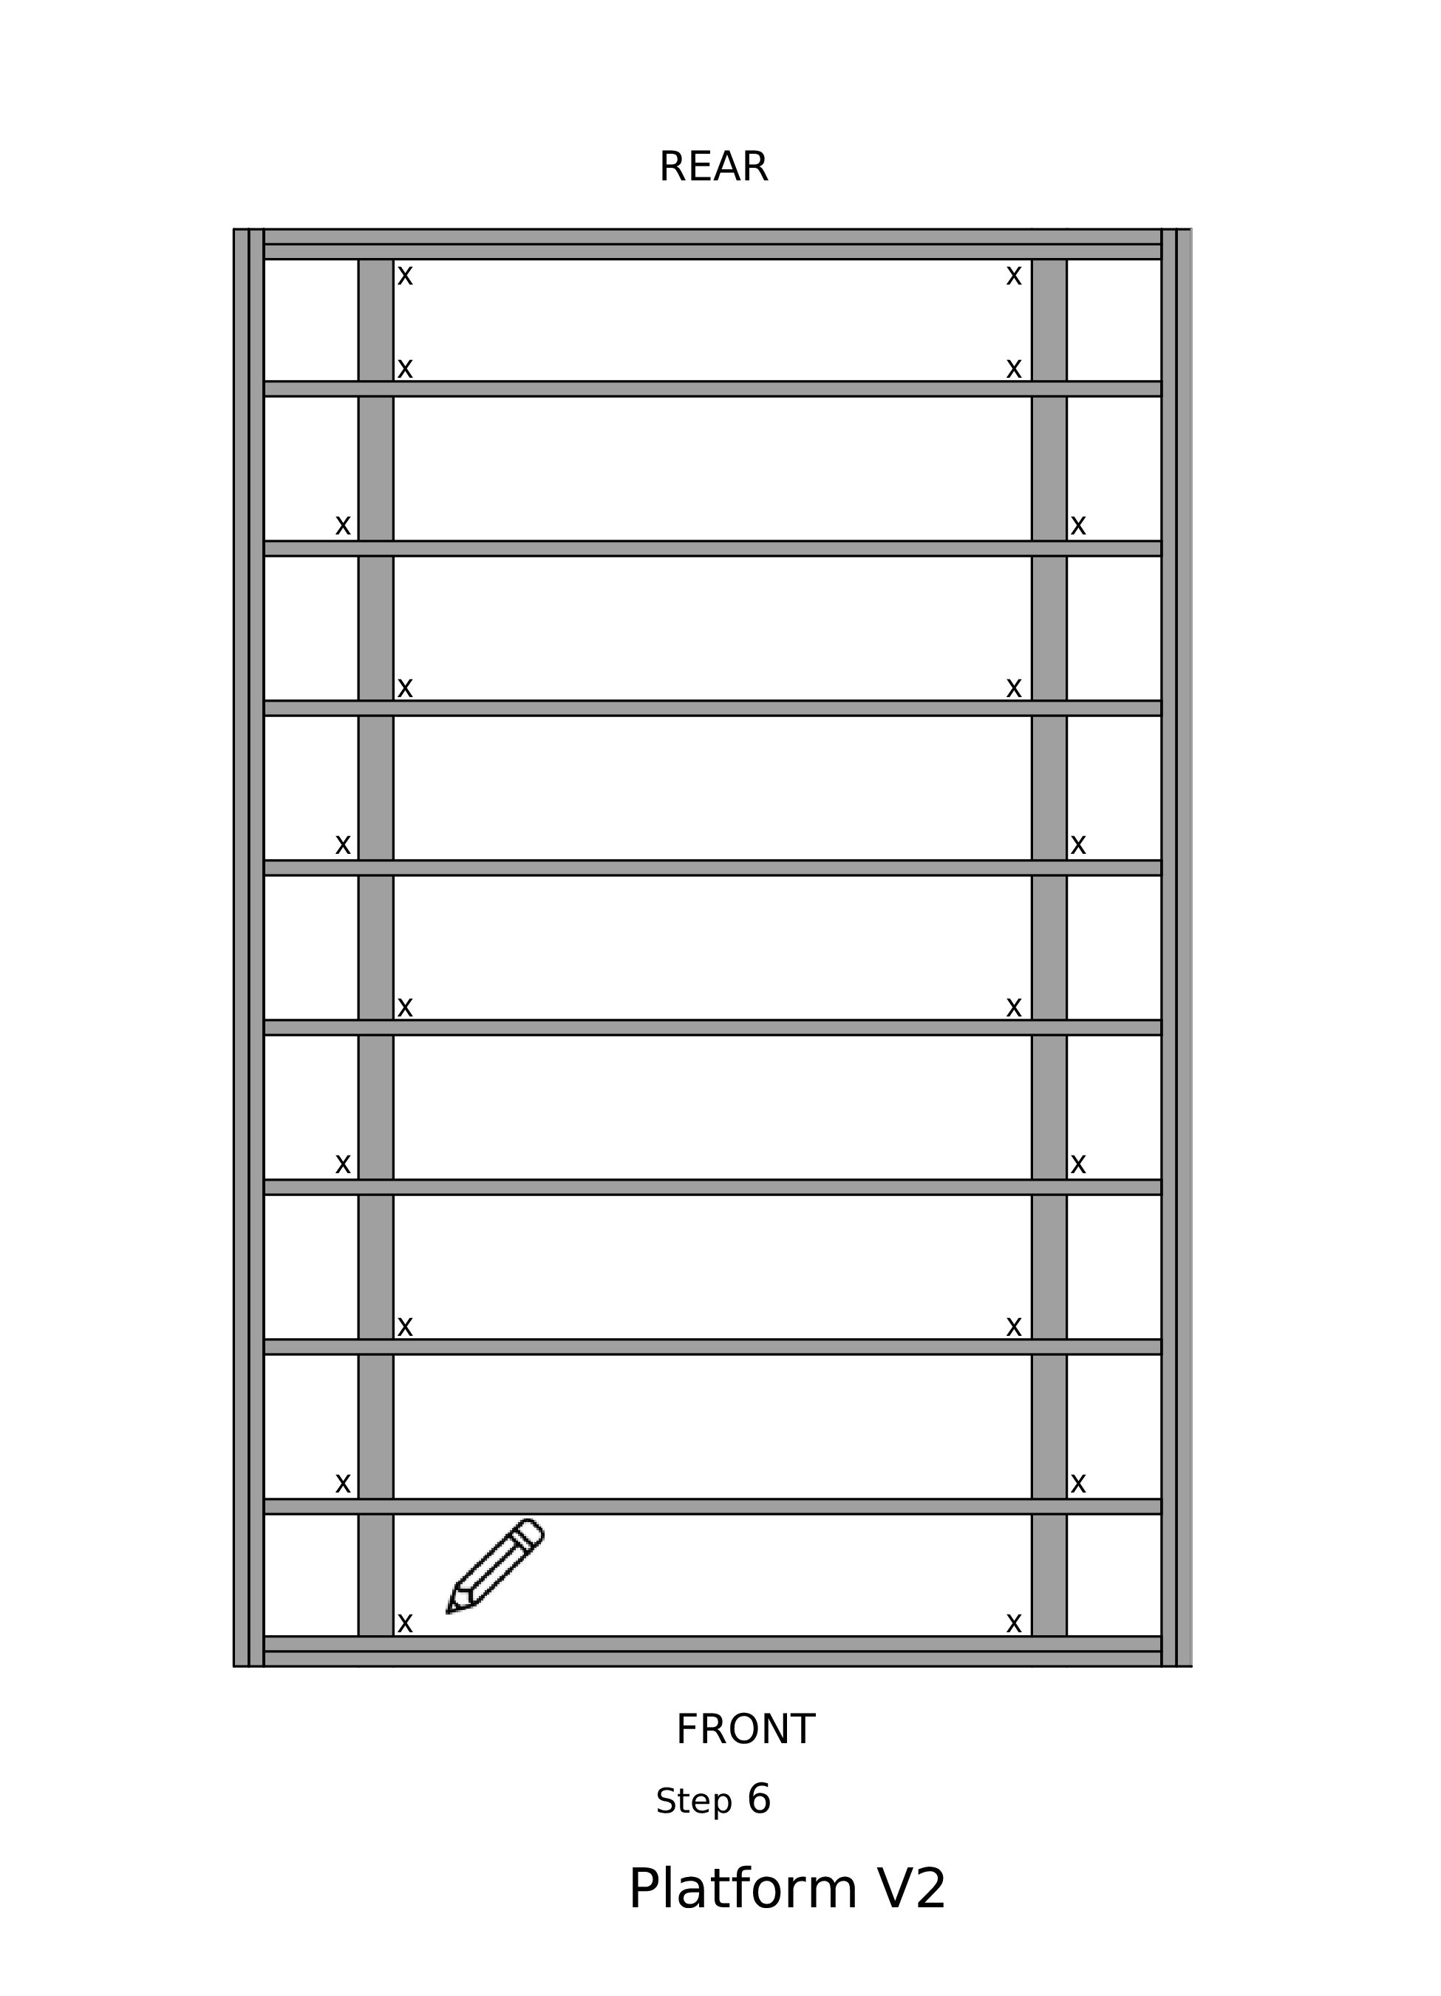

Step 7
- At each X, screw in a metal bracket — use 6 small hexagonal screws for each metal bracket
—3 on the bottom 3 on the top, attaching the frame to the skids

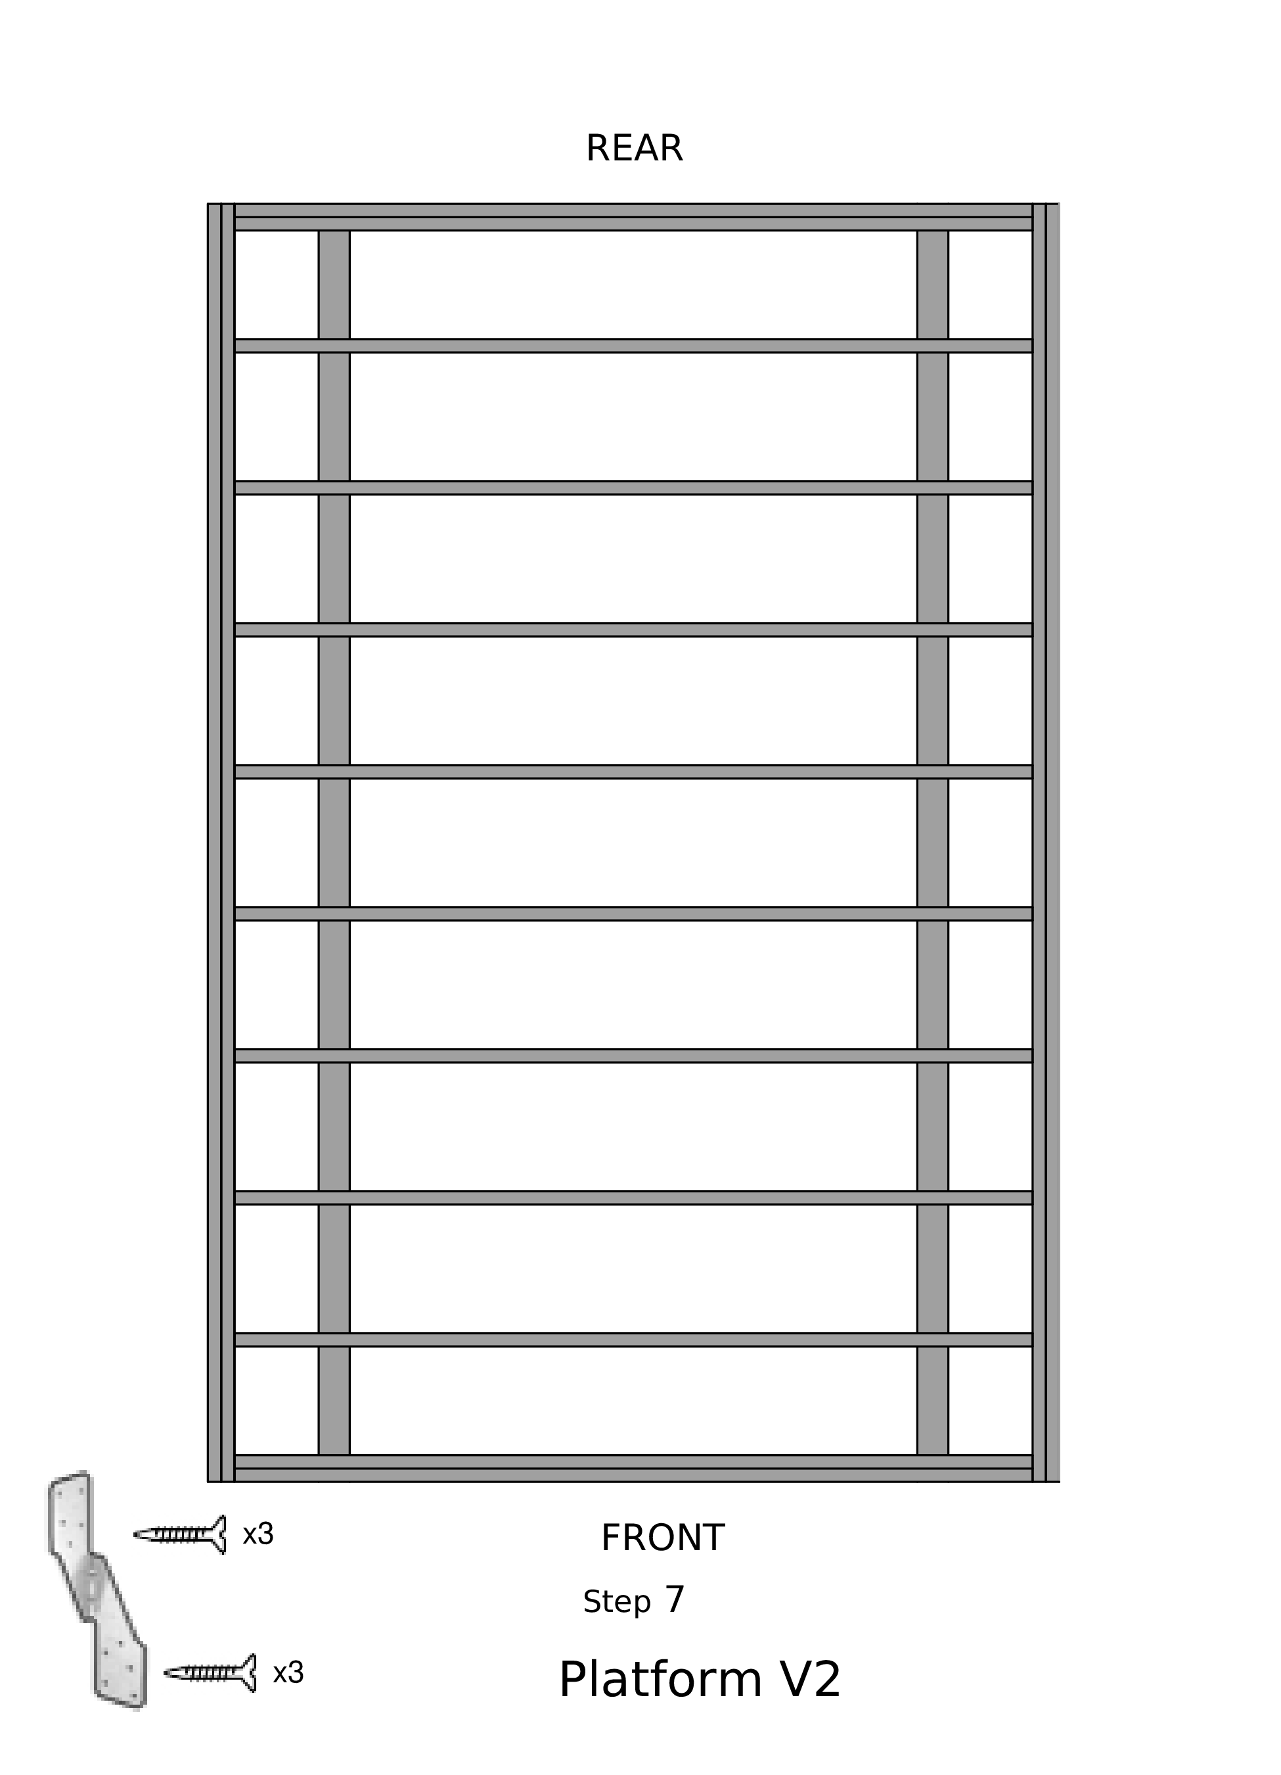

Step 8
- Place blocks labeled “SAVE” in each bay, except the front and back bays
— on top of each skid, centered between the joists.
— DO NOT NAIL — At each end, place the “SAVE END” blocks.

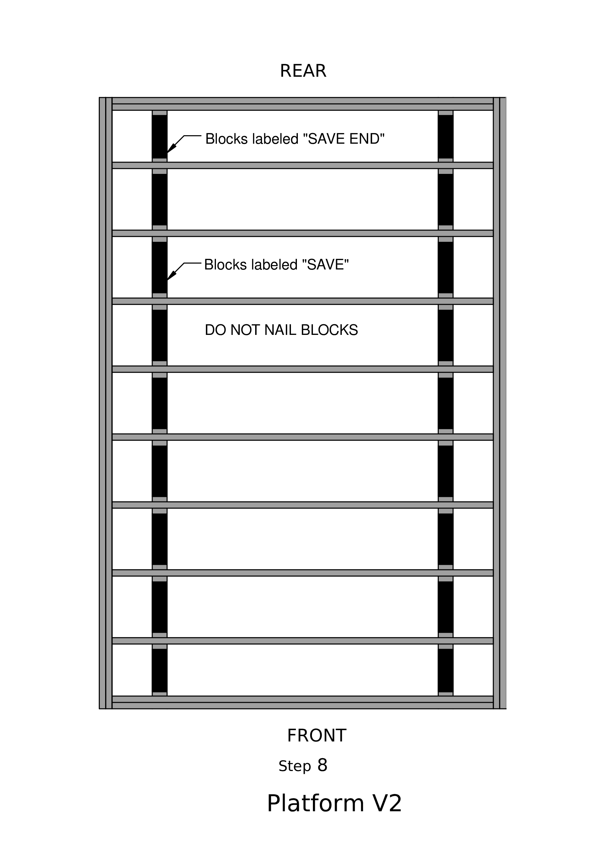

Step 9
- Put insulation foam pieces between each joist
— Cut the foam if not pre-cut. Use templates
— 2 at 11¹/₂″ wide by 89¹/₂" long
— 7 at 14 " wide by 89¹/₂" long
— use an Exacto knife with blade all the way out
- Cut the ends to fit the length, and install with silver side UP.
- Using GREAT STUFF spray cans, put lines to fill in at all the junctions between the foam and the joists.
— Start with tip of spray can at the middle, and pull towards you.
- DO NOT SET THE SPRAY CANS ON WORK STATIONS

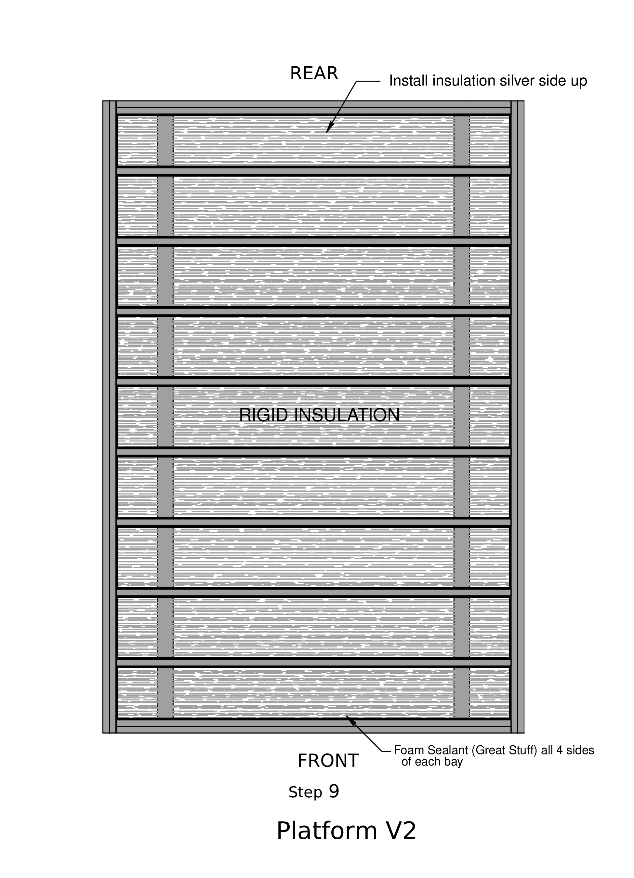

Step 10
- Under the 1st plywood panel ONLY
— put Liquid Nails construction adhesive on each of the joists and along the top and bottom
- Place the 1st plywood panel (3/4” CDX plywood)
— use panels from pile labeled PLATFORM
— line it up to be flush with the outer edges and the middle of the inner joist.
- Put a nail in that inner joist corner. Use that as the pivot point to line up the panel
- Nail about 8 inches apart along 2 edges using 3” framing nails.
-Put a chalk line at the intermediate joists
— get up on platform and closely straddle the chalk line (joist) to push the plywood board down while nailing
— walk backwards while nailing 8 inches apart.
- Nail along all chalk lines in a pattern going diagonally towards the opposite corner from where you started

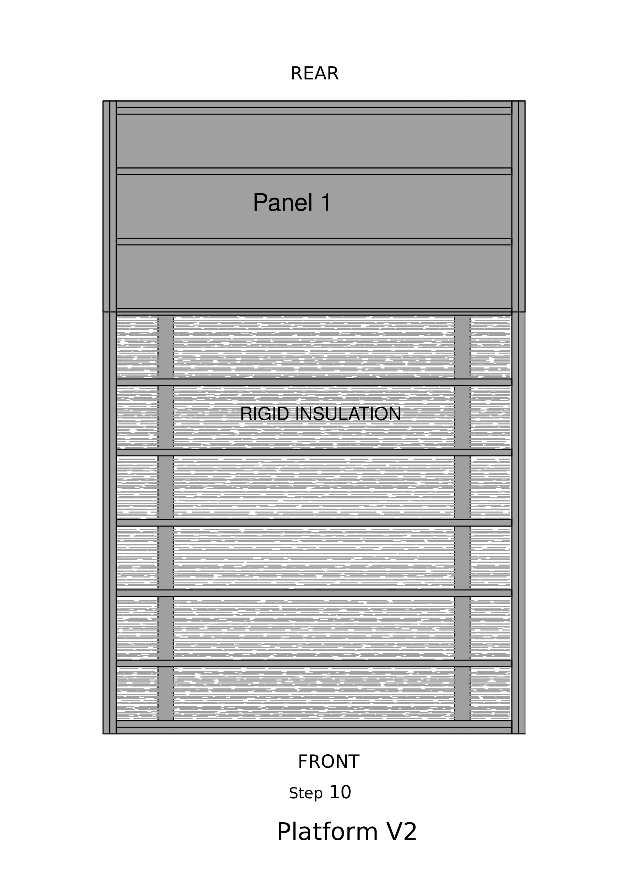

Step 11
- Apply Liquid Nails construction adhesive to the joists that will be under the 2nd plywood panel
- Place the 2nd panel
— use pivot point at the junction of the 2 panels
— along the seam, nail about every 8 inches, slightly angled in towards the junction line and alternate the sides of the junction line.
- Nail along edges and chalk lines

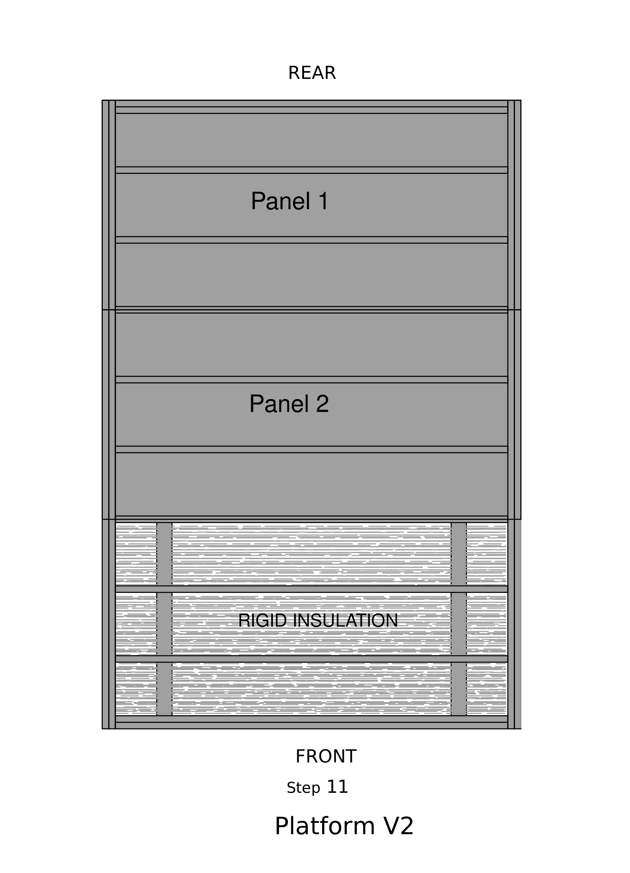

Step 12
- Apply Liquid Nails construction adhesive to the joists that will be under the 3rd plywood panel
- Place the 3rd panel
— use pivot point at the junction of the 2 panels
— along the seam, nail about every 8 inches, slightly angled in towards the junction line and alternate the sides of the junction line.
- Nail along edges and chalk lines

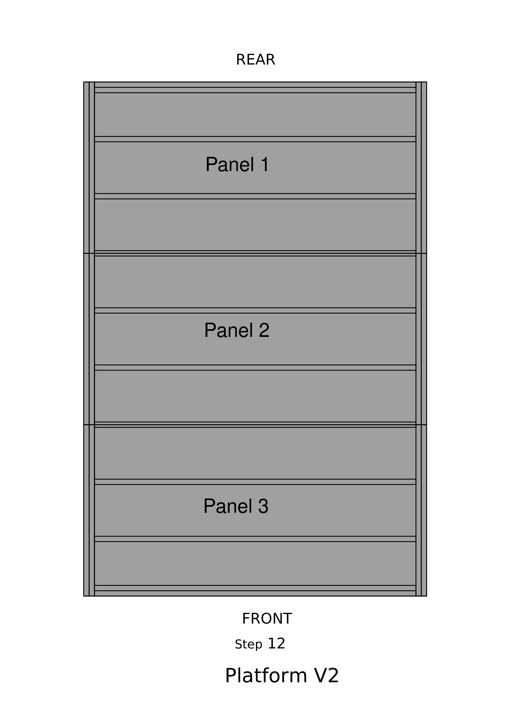

Step 13
- The next day, if necessary, router the edges of the platform (to let the adhesive dry first).
- Draw a line 3½ inches from the edge on all sides
— use the marking jig; it hangs from the back saw table. Using a felt-tip pen, hold it against the inside of the jig, and slide the jig along the sides of the platform.

