SETUP LIST
- Door:
— Drill with countersink bit
— Screw gun
— Phillips-head drive bit
— T25 drive bit
— Shims
— Chrome T25 screws
— #10 x 3” Screws (brown)
— Utility knife
- Interior Trim:
— Drill with countersink bit
— Screw gun with T25 drive bit
— Finish nailer and finish nails
— Level
— Measuring Tape — Pencil
- Install Vent Cap:
— Drill with countersink bit
— Screw gun with T25 drive bit
— #10 x 3” Screws (brown)
— Measuring Tape — Pencil

DOOR INSTALLATION

Prepare the door
- Free a door from the shipping pallet using a Phillips-head bit on a screw gun
- Lay the door face down on a work surface
- Remove all labels and packaging
- Remove plastic protectors from door jamb at the bottom
- Remove any blocking behind the molding around the door frame
- Unscrew retaining plug where doorknob will go
- Using a countersink bit, drill a hole pointing down from the top of the door to the bottom in the top trim about 1” in from the edge of the trim on both sides and centered vertically
- Make sure that the top and side door moldings are flush. Clamp if necessary.
- Install a 3” (brown) screw in these two corner spots

Prepare the opening
- Make certain that the flooring does not extend more than an inch into the door opening.
- Cut a 54” length of flexible flashing (Peel-n-Stick), and install it in the bottom of the doorway, with about 8” running up each side of the opening, and half the width sticking outside the home.
- Slit the corners, and fold the outer half of the flashing down and to the sides of the opening.

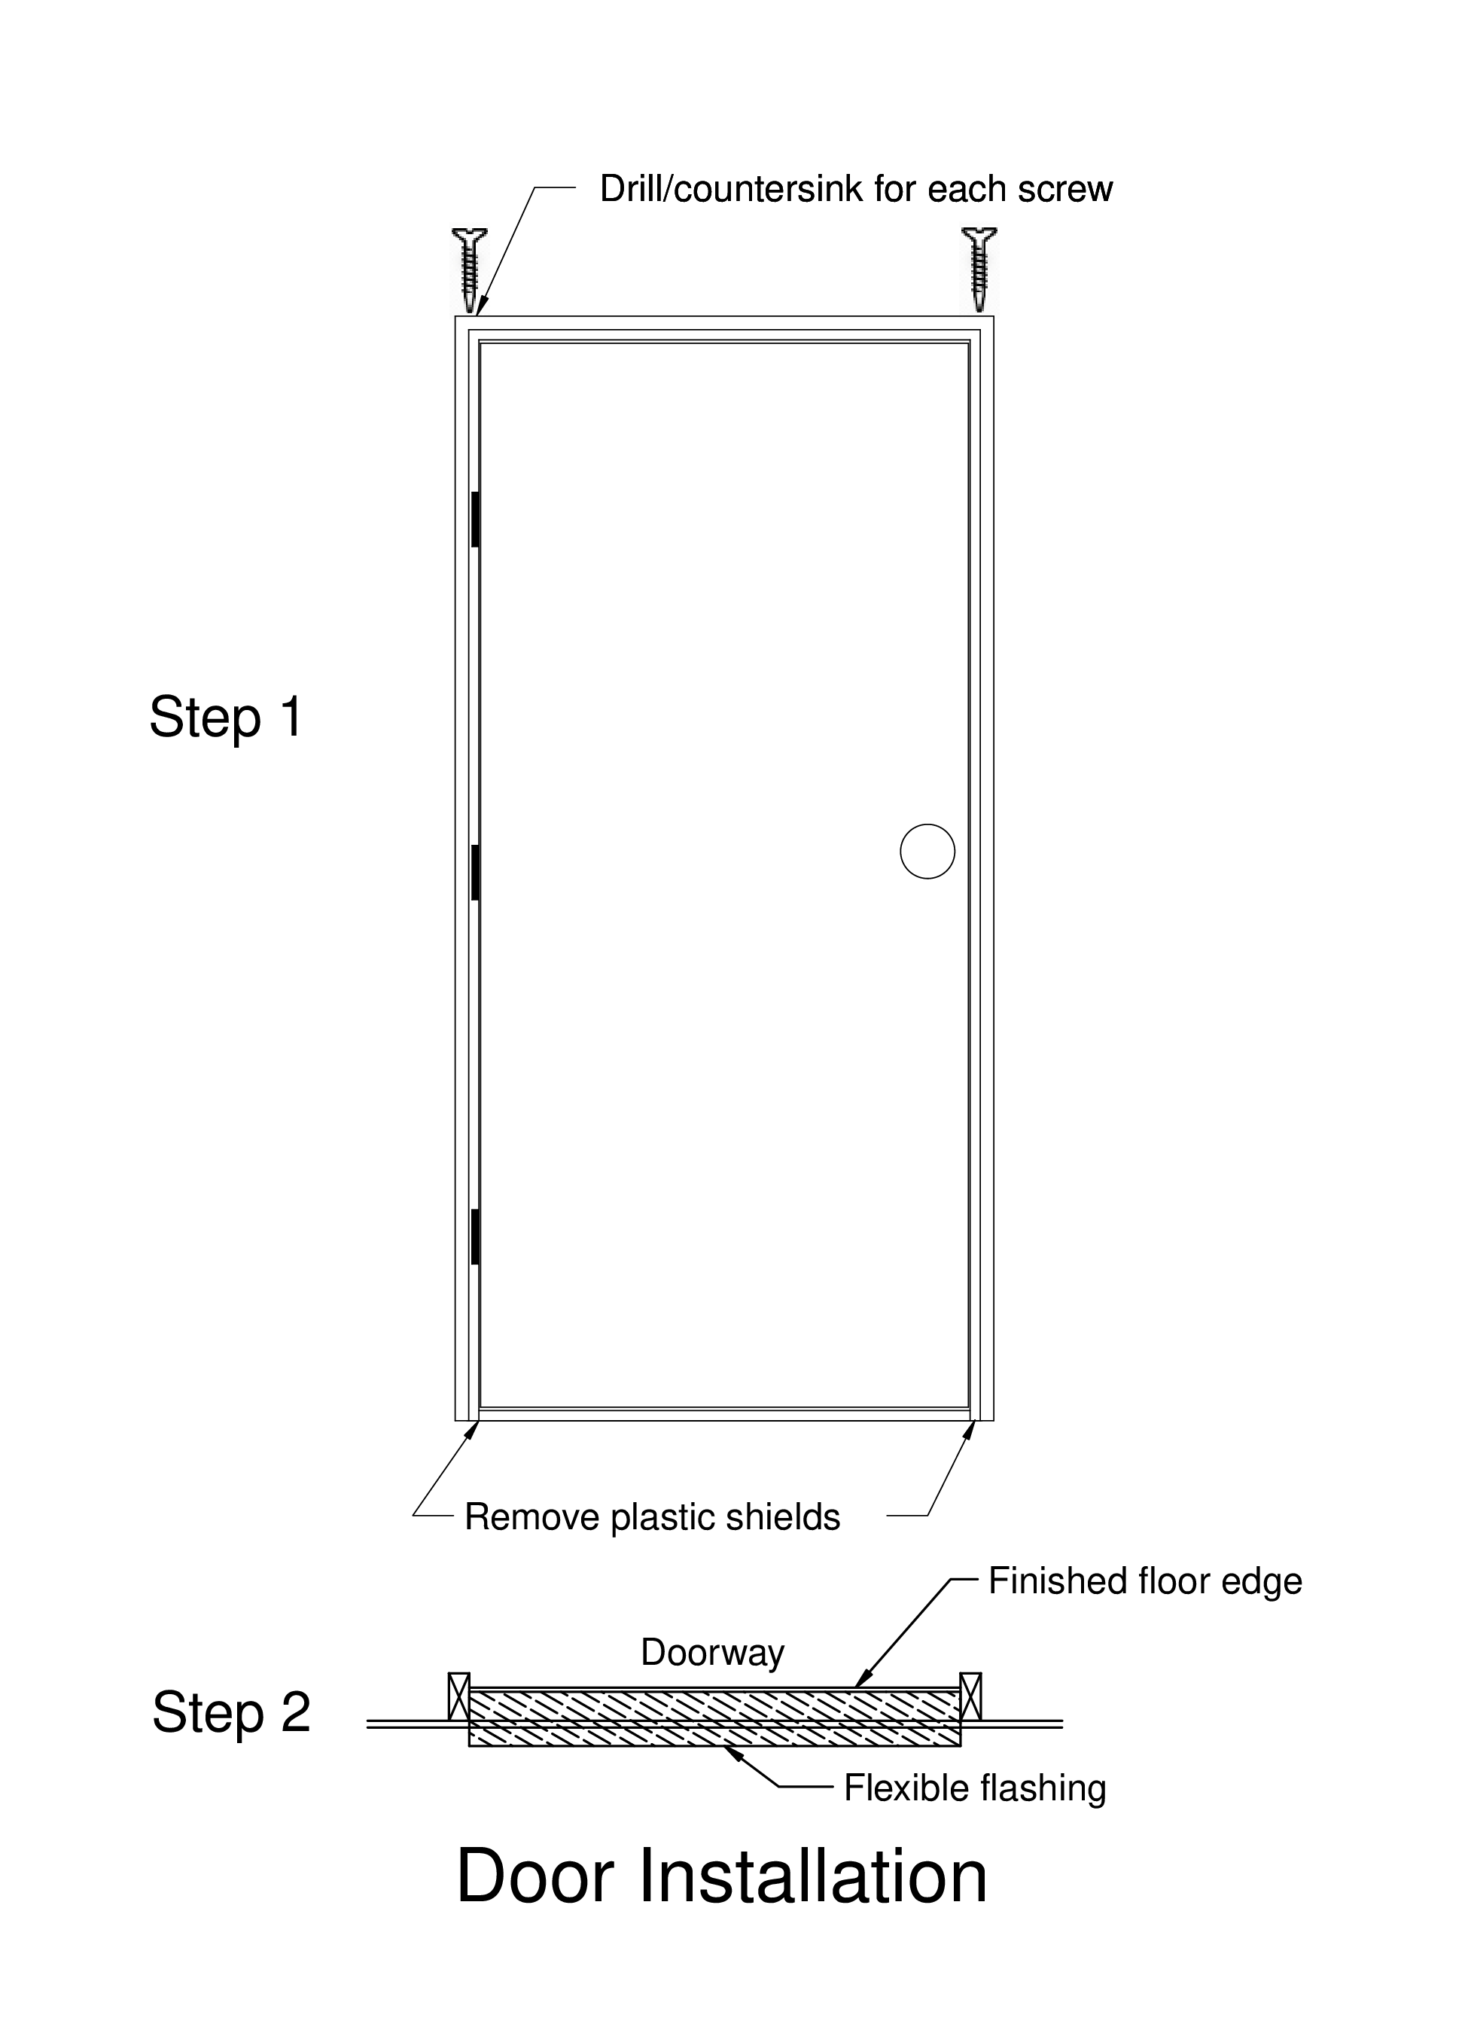

Install the door
- With 2 helpers, insert the bottom of door frame into the opening
- Push the Locking plug into the doorknob hole to free the door
- Tilt the door frame upright into the opening, and tight against siding
- Helpers hold door frame tight against siding
- Insert SHIMS as necessary to center the door in the opening and tighten any spaces
— hinge side, place shims just above each hinge
— doorknob side, place shims at same height as top and bottom hinge shims and just above doorknob opening
- Adjust and secure door frame
— Open & close door - should not hit door frame (~1/8” gap) — Adjust hinge side shims so the gap at the top is the same across door width
- Screw door frame to the opening on the hinge side
— open the door
— helper holds weatherstripping out of the way
— make sure door molding is tight against the siding — install 3” (brown) screws just behind the weatherstripping at the height of the center of each shim, starting at the top
- Screw door frame to the opening on doorknob side
— top 1st
— bottom 2nd
— insert shims both above and below the latch hole
— adjust shims above and below latch hole so the gap is approximately 1/8” between door and door jamb

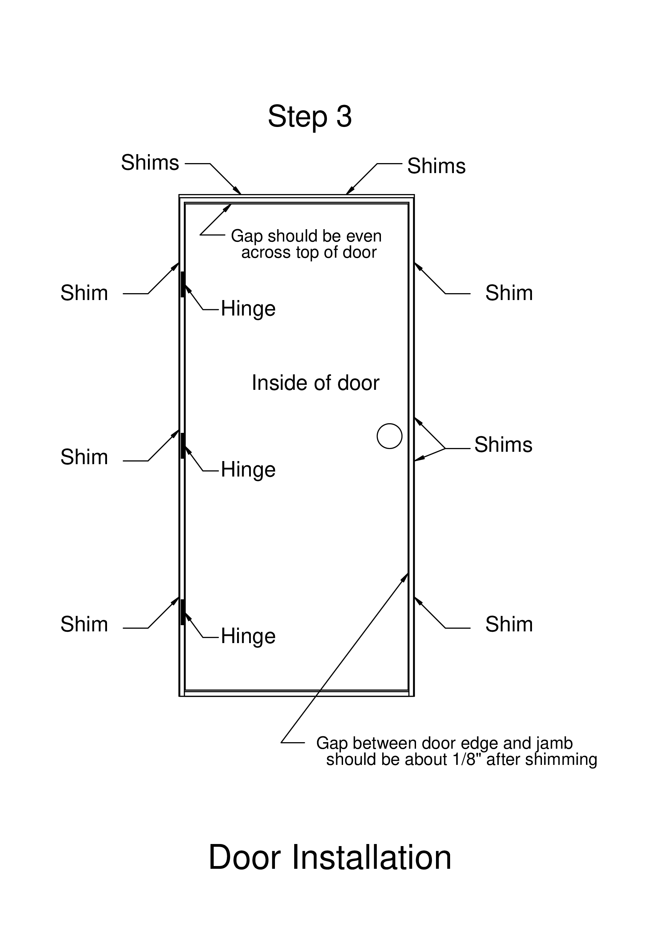
- Strengthen door latch plate
— Drill with countersink bit above and below the latch hole, as shown in the drawing
— Angle drill towards outside, to assure that screw will go into the framing
— Install 3” screws in both drilled holes, and through the shims
- If space above the door is small use shims to make it even, if large then use a piece of scrap plywood like pieces used around the inside of the windows, and then shims
- Insert shims 8-10” in from each side to fill space between top of door frame and doorway framing
- Install screws as for the sides, behind the weatherstripping.
- Install three silver screws into the holes in the metal threshold. Do not overdrive these screws; it will distort the threshold.

Finishing
- Remove one of the Phillips-head screws from each hinge, replace with 3” silver screw from kit. Discard the short screw.
- Trim off the protruding ends of the shims, flush with the wall plywood. Use a box knife to score the shim, and then snap it off.
- Remove the weatherstripping from the top and sides of the door frame, using the wide-jawed pliers to get each strip started. Save these pieces of weatherstripping. There is a collection on top of the shelving between Paint Bay C and the area where personal belongings are stowed.

