INTERIOR TRIM
- 1st Install MEDUSA** (foam backer rod) around the front and back windows. Use a piece of flooring or a putty knife to make insertion easier.
- Place small pieces of flooring as spacers for baseboards
— located at station 4
— around the perimeter to lift the baseboards up off the floor
- Use TRIM nail gun and TRIM nails
- Nailing Pattern for ALL inside trim
2 nails at one end
1 every 8”-12” in the middle
2 at the other end
Install trim in the following order

Baseboards
- Using long (8’ x 4”) white baseboards, start at the back of one side wall, nail in place to the side wall. Be sure that the baseboard rests on several spacers along its length, to assure an even gap above the finished floor.
- When these baseboards are installed, measure from ends of each board to the front wall. Cut and nail another piece of baseboard (matching the top surface with long baseboard).
3 & 4 Repeat 1 & 2 on the other side wall.
- Measure between the side baseboards at the rear wall. Measure long (about 1/16”) so it will fit snugly. Cut a length of baseboard and nail.

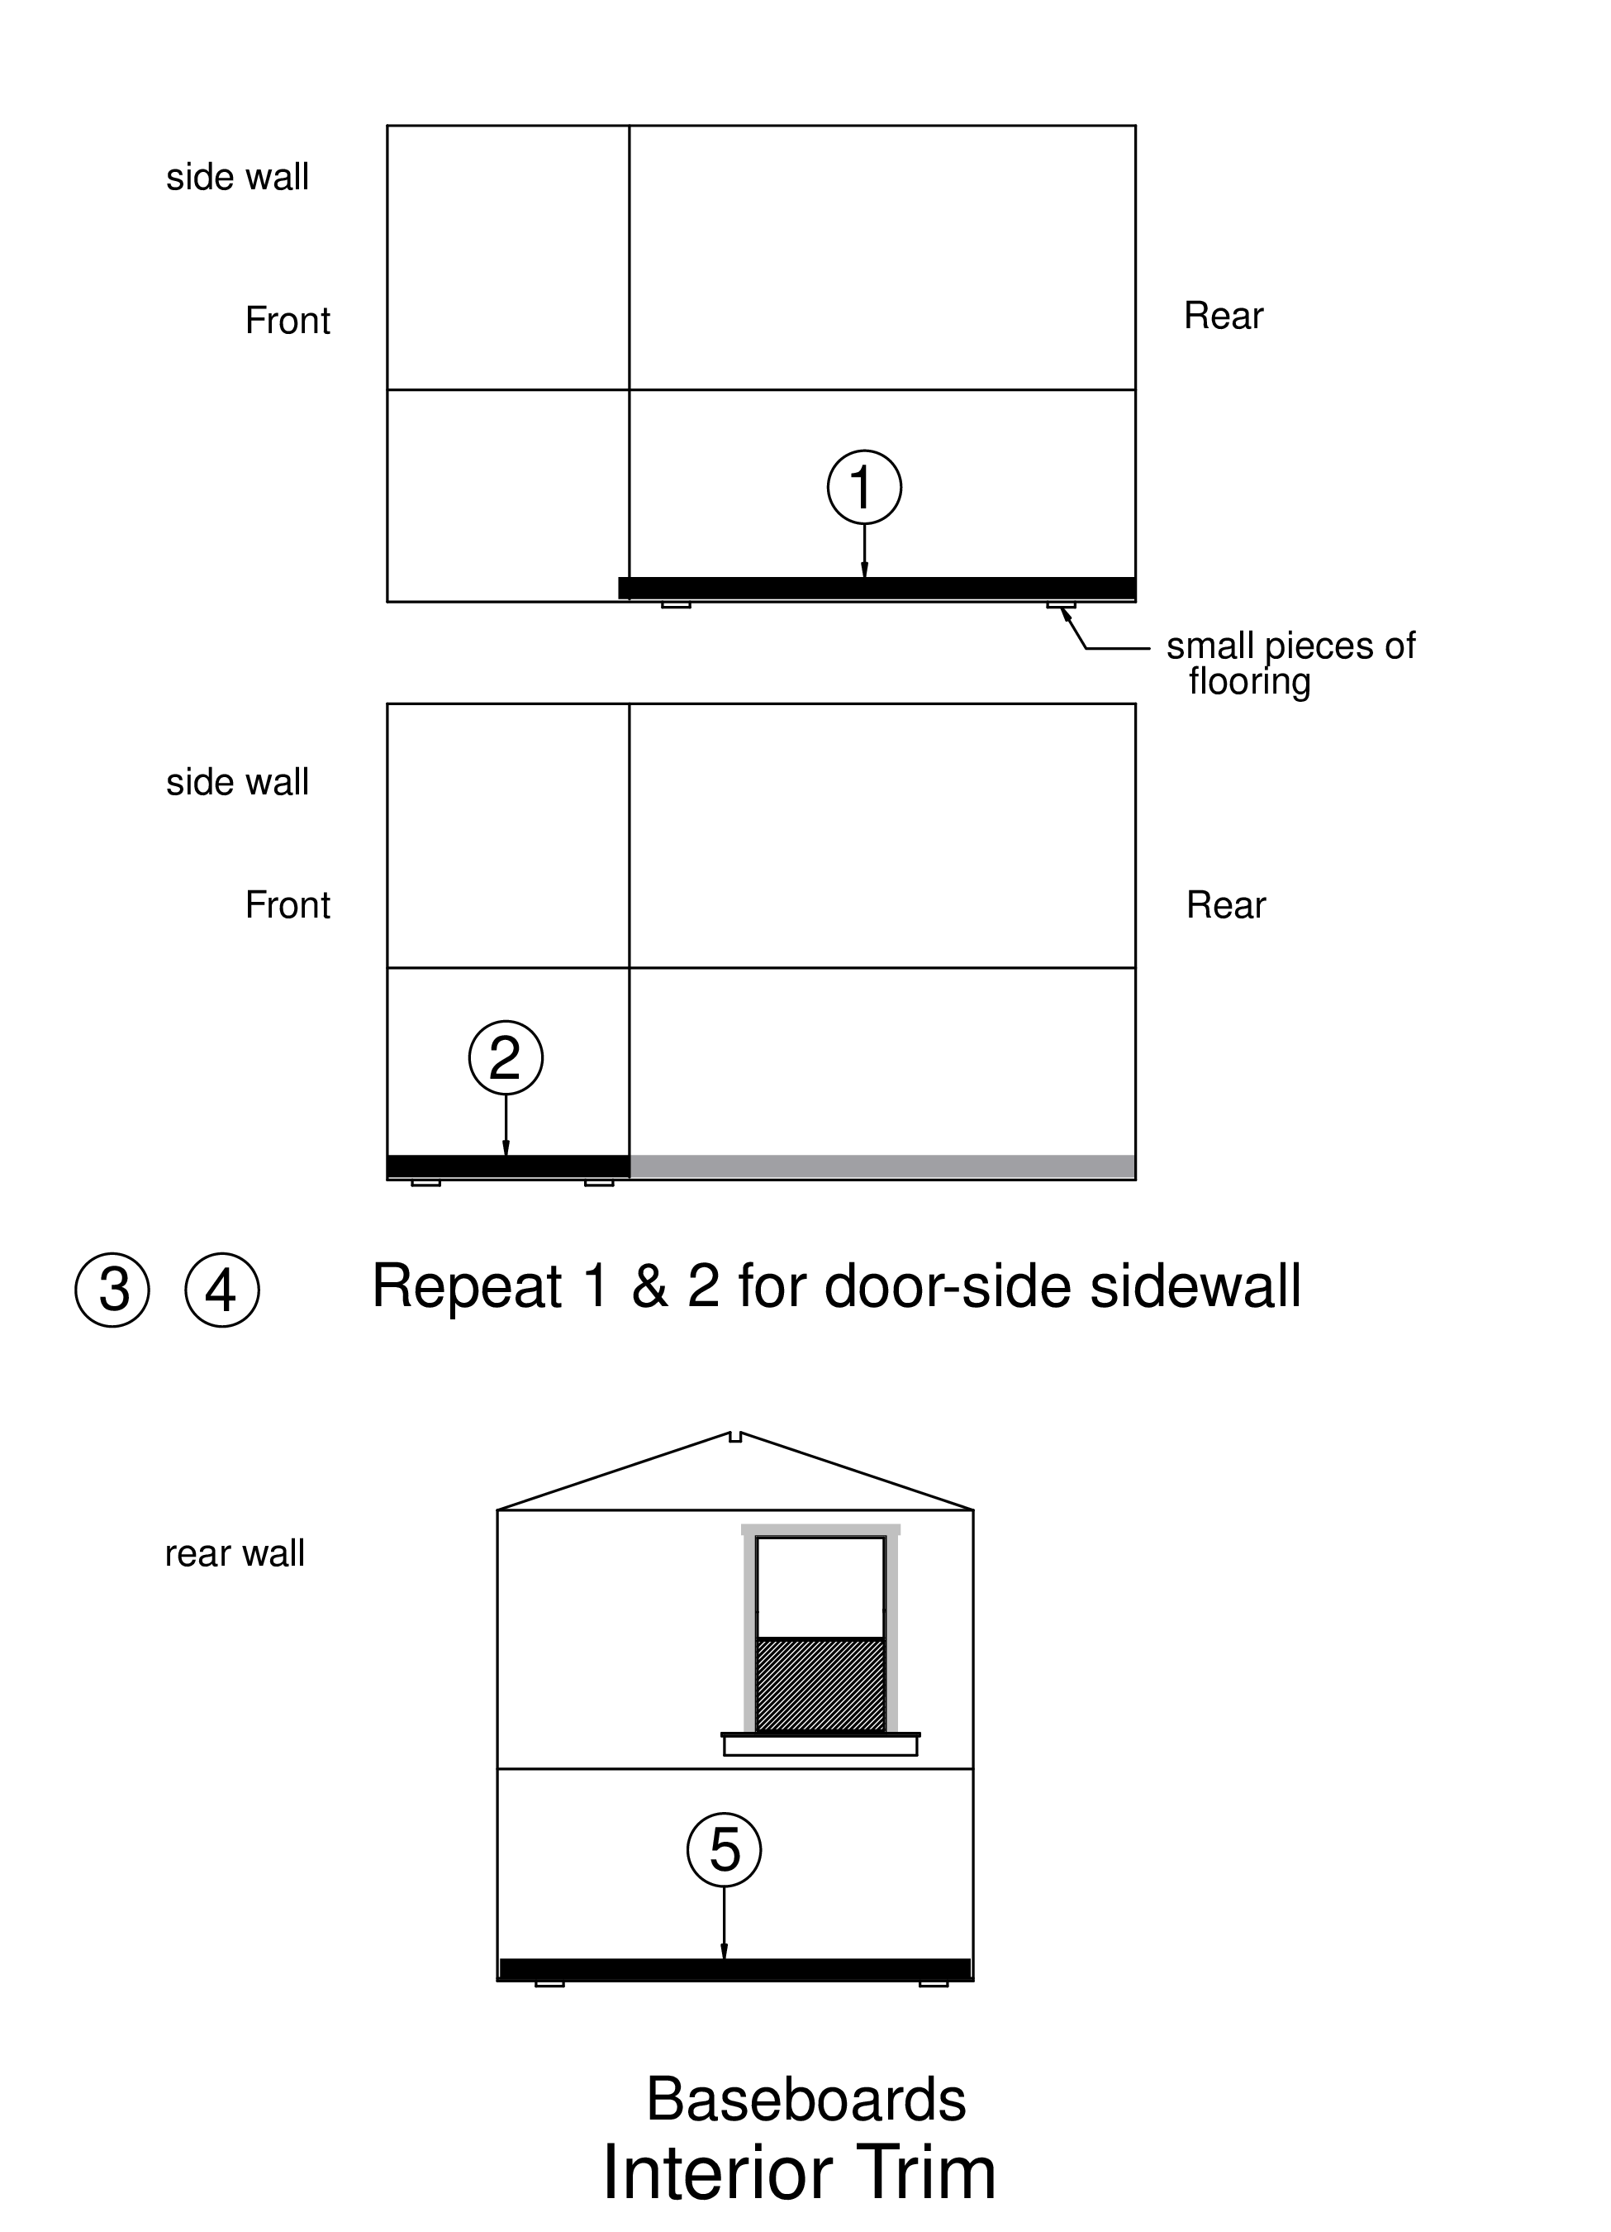

Rear Window Shelf
Check that MEDUSA (foam backer rod) is installed around the window unit.
- Use pre-cut rear shelf.
- Pre-drill three holes using countersink bit
- Position shelf in window frame, and screw in 3 LONG screws next to bottom of the window
- Cut 2x4 support block for under the shelf
— subtract 1 inch from shelf width – ½” on each side
- Center block under the shelf with long side against the wall, and 1/2” shelf overhang on each end.
- Mark on the wall where the ends of the 2x4 should be, and then mark on the 2x4 where the lines of paneling screws fall (stud markers).
- Preset 2 LONG screws in a vertical line into the block at each of the stud markers
- Position the 2x4 up against the underside of the shelf, and lined up with the end marks on the wall and drive the screws into the wall to secure the support block
- Pre-drill and insert a LONG screw next to the wall down through the shelf and into the 2x4 on each side of the window.

Rear Window Trim
- Use precut pieces for window opening side lining
- nail 1 piece to each side of the window opening, edge flush with wall. (2 nails at top, 1 every 8”, 2 at the bottom)
- Measure (very close to window) between the sides for the top of the window liner. Cut one piece that length and nail in place.
- Measure the sides of the window from shelf to top of window opening. Cut and nail 2” trim to both sides of the window, keeping the trim flush with the inside of the window lining boards.
- Measure above the window from the outer edges of the vertical trim and add one inch. Cut 2” trim and nail above the window with 1/2” overhang on each side.

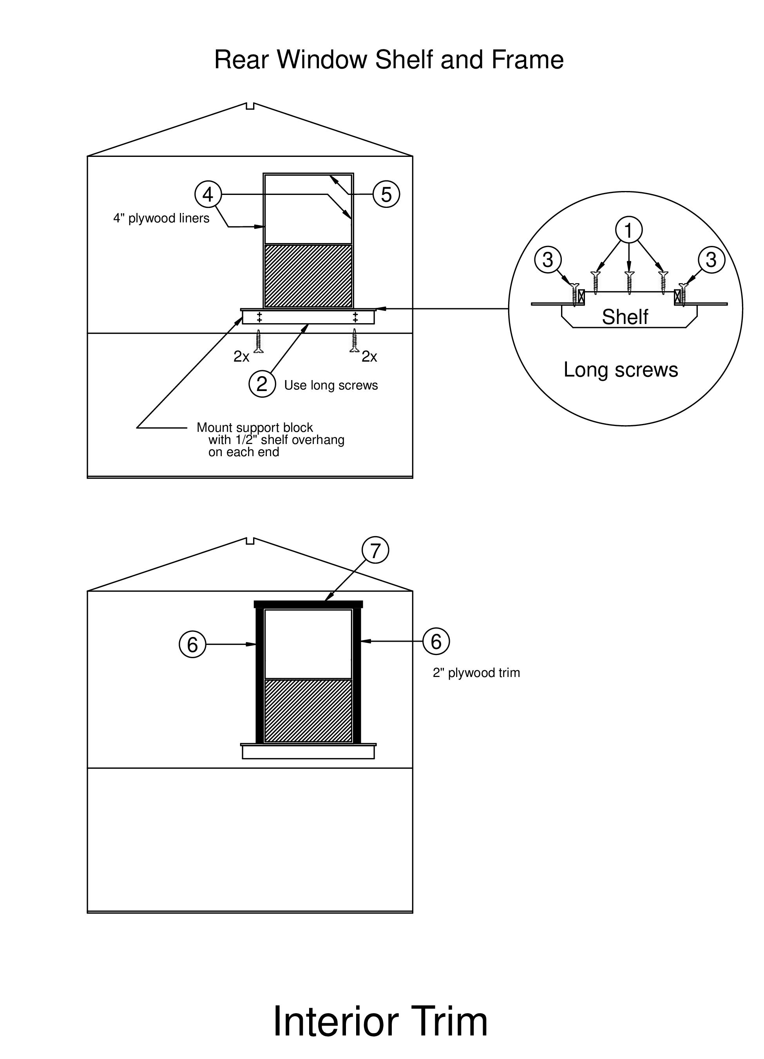

Top trim (2” trim boards)
- Start on the side walls at the back. Push the trim board up so it is tight against the ceiling. Nail
- When back upper trim is installed, measure from end of that piece to the front wall. Cut and nail.
- (& 4) Repeat 1 & 2 on the other wall
- Measure between the upper trim at the back wall.
— Measure long so it fits snugly (about 1/16”)
— Cut and nail.

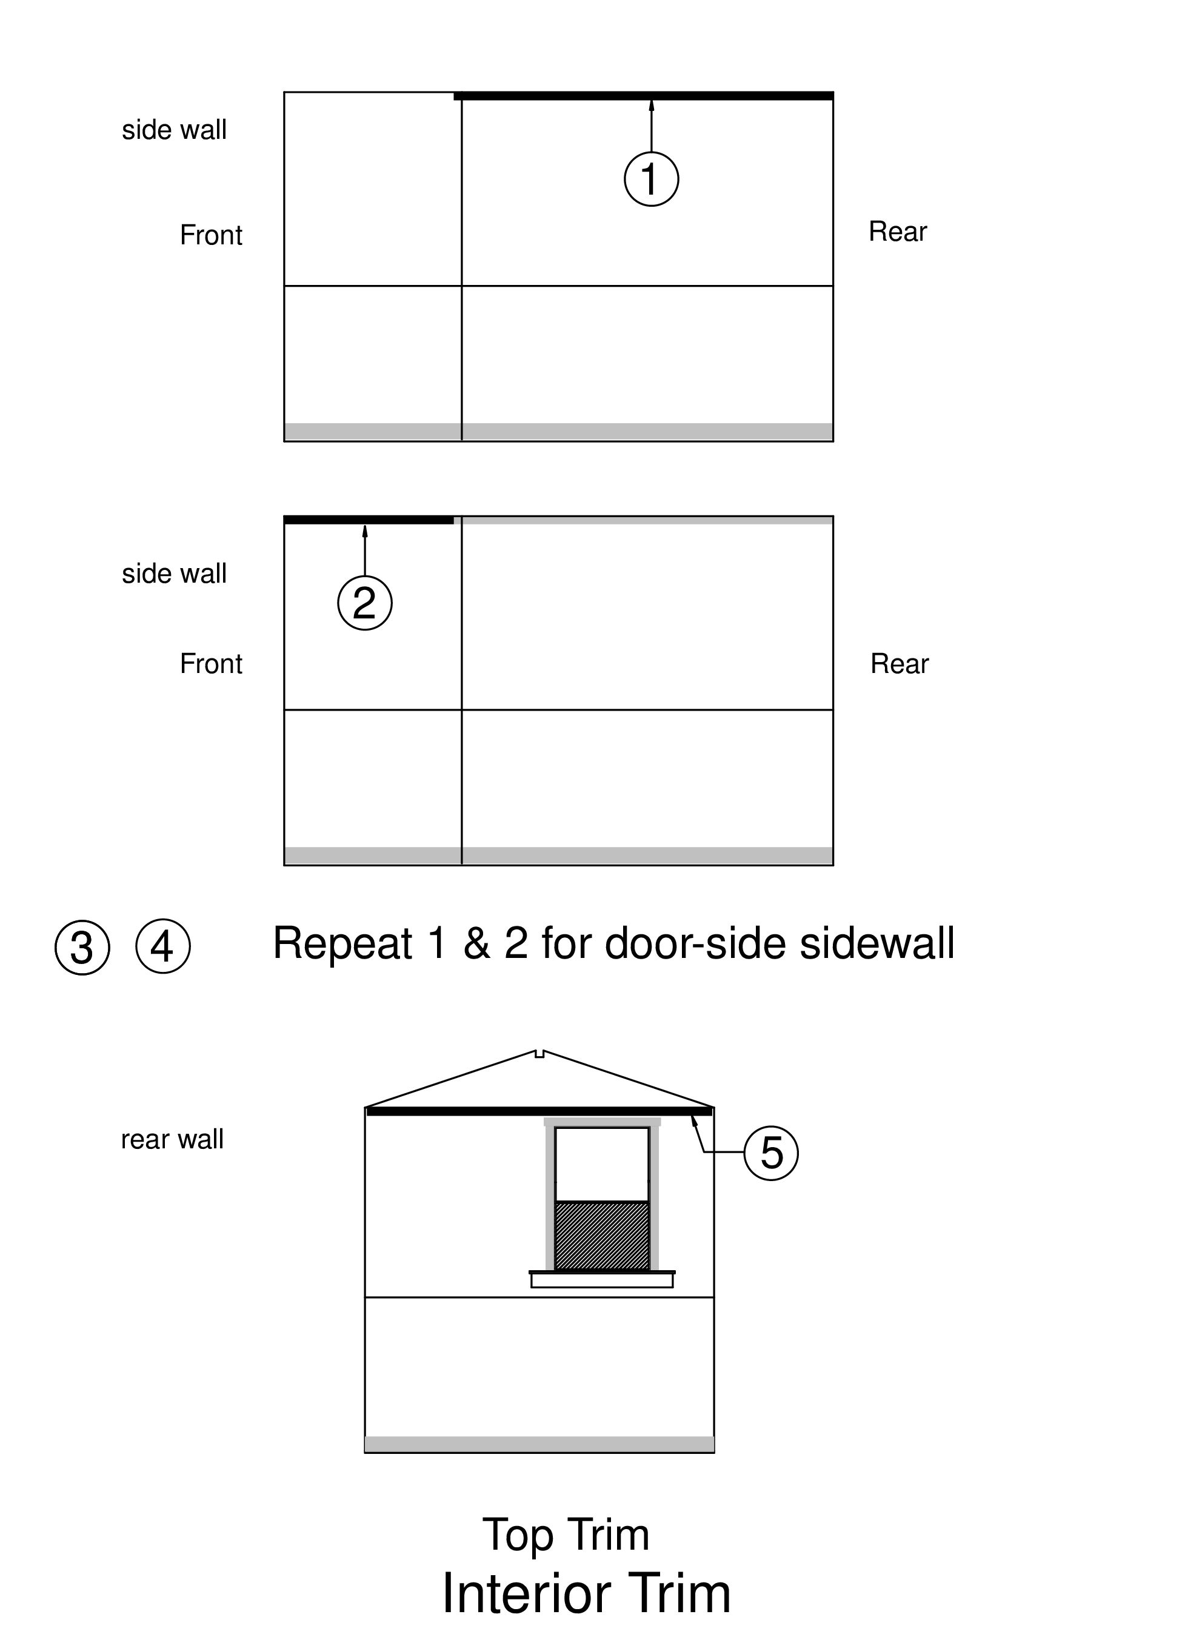

Vertical Trim (2” trim boards)
- Side walls first - measure from the top of the baseboards to the bottom of upper trim in back corner - Cut and nail. Repeat on the other wall.
- Measure at the vertical seam between the side panels from top of baseboard to bottom of upper trim. Cut and nail. Use a level to be sure this trim is vertical. Repeat on the other wall.
- On the back wall - Measure from the top of the baseboards to the bottom of upper trim in the corner. Cut and nail

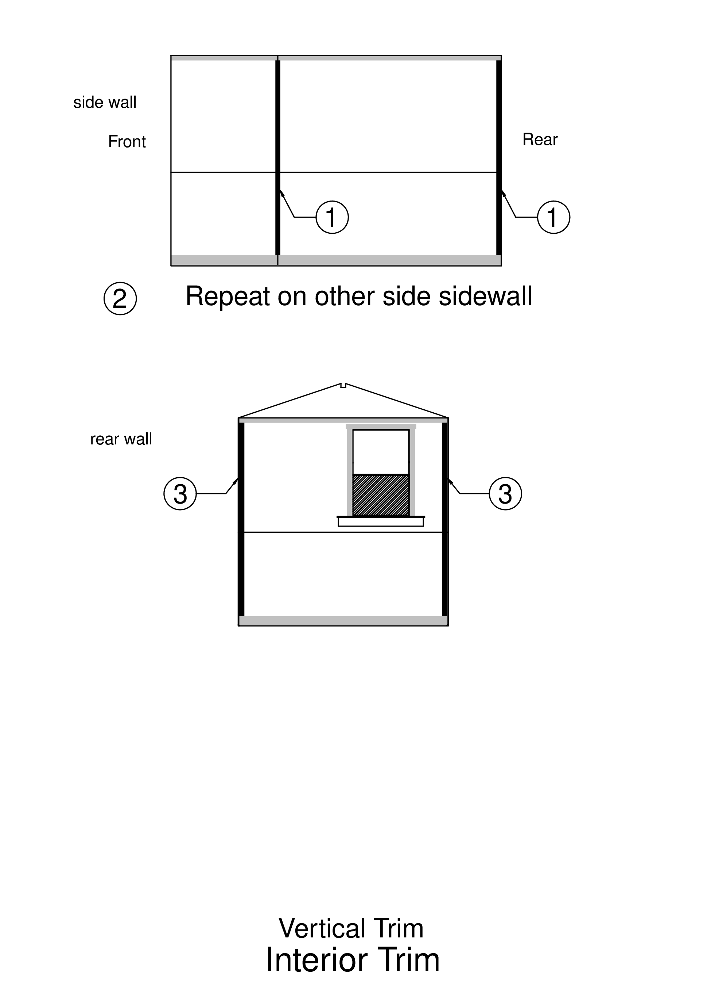

Horizontal & Triangle Trim

Back wall
- Measure from back corner vertical trim on one side to the other back corner vertical trim.
- Cut a piece of 2” trim this length plus 1/16” for a snug fit.
- Measure the height of the seam between upper and lower wall panels above floor, and mark each vertical trim at 1” below this dimension on both pieces in the corner
- Line back wall trim piece up so that its bottom edge is on these marks, and nail in place

Side walls at the back
- Measure from the back corner trim to middle vertical trim (add 1/16” so it fits snugly), and cut 2” trim to this dimension
- Measure height of joint between upper and lower wall panels above floor, and mark vertical trim at 1” below this dimension on side wall.
- Line side wall trim piece up so that its bottom edge is on these marks, check that it lines up visually with the corresponding trim on the back wall, and nail in place.
Do NOT install mid-level horizontal trim between vertical trim and front wall. This will be done after Front Wall trim.

Triangle trim
- Use precut pieces of 2” X 42” trim from the rack: 2 left, 2 right, 6 straight
- position two angled pieces on the back wall and nail.
- Position a straight piece (42”) on the ceiling and tight against each of the angled piece just installed. Nail it in place.
- Cut a piece of 2ˮ trim 12ˮ long, and install this piece vertically to cover the seam between the triangles.
- Save remaining trim pieces for the front wall triangle

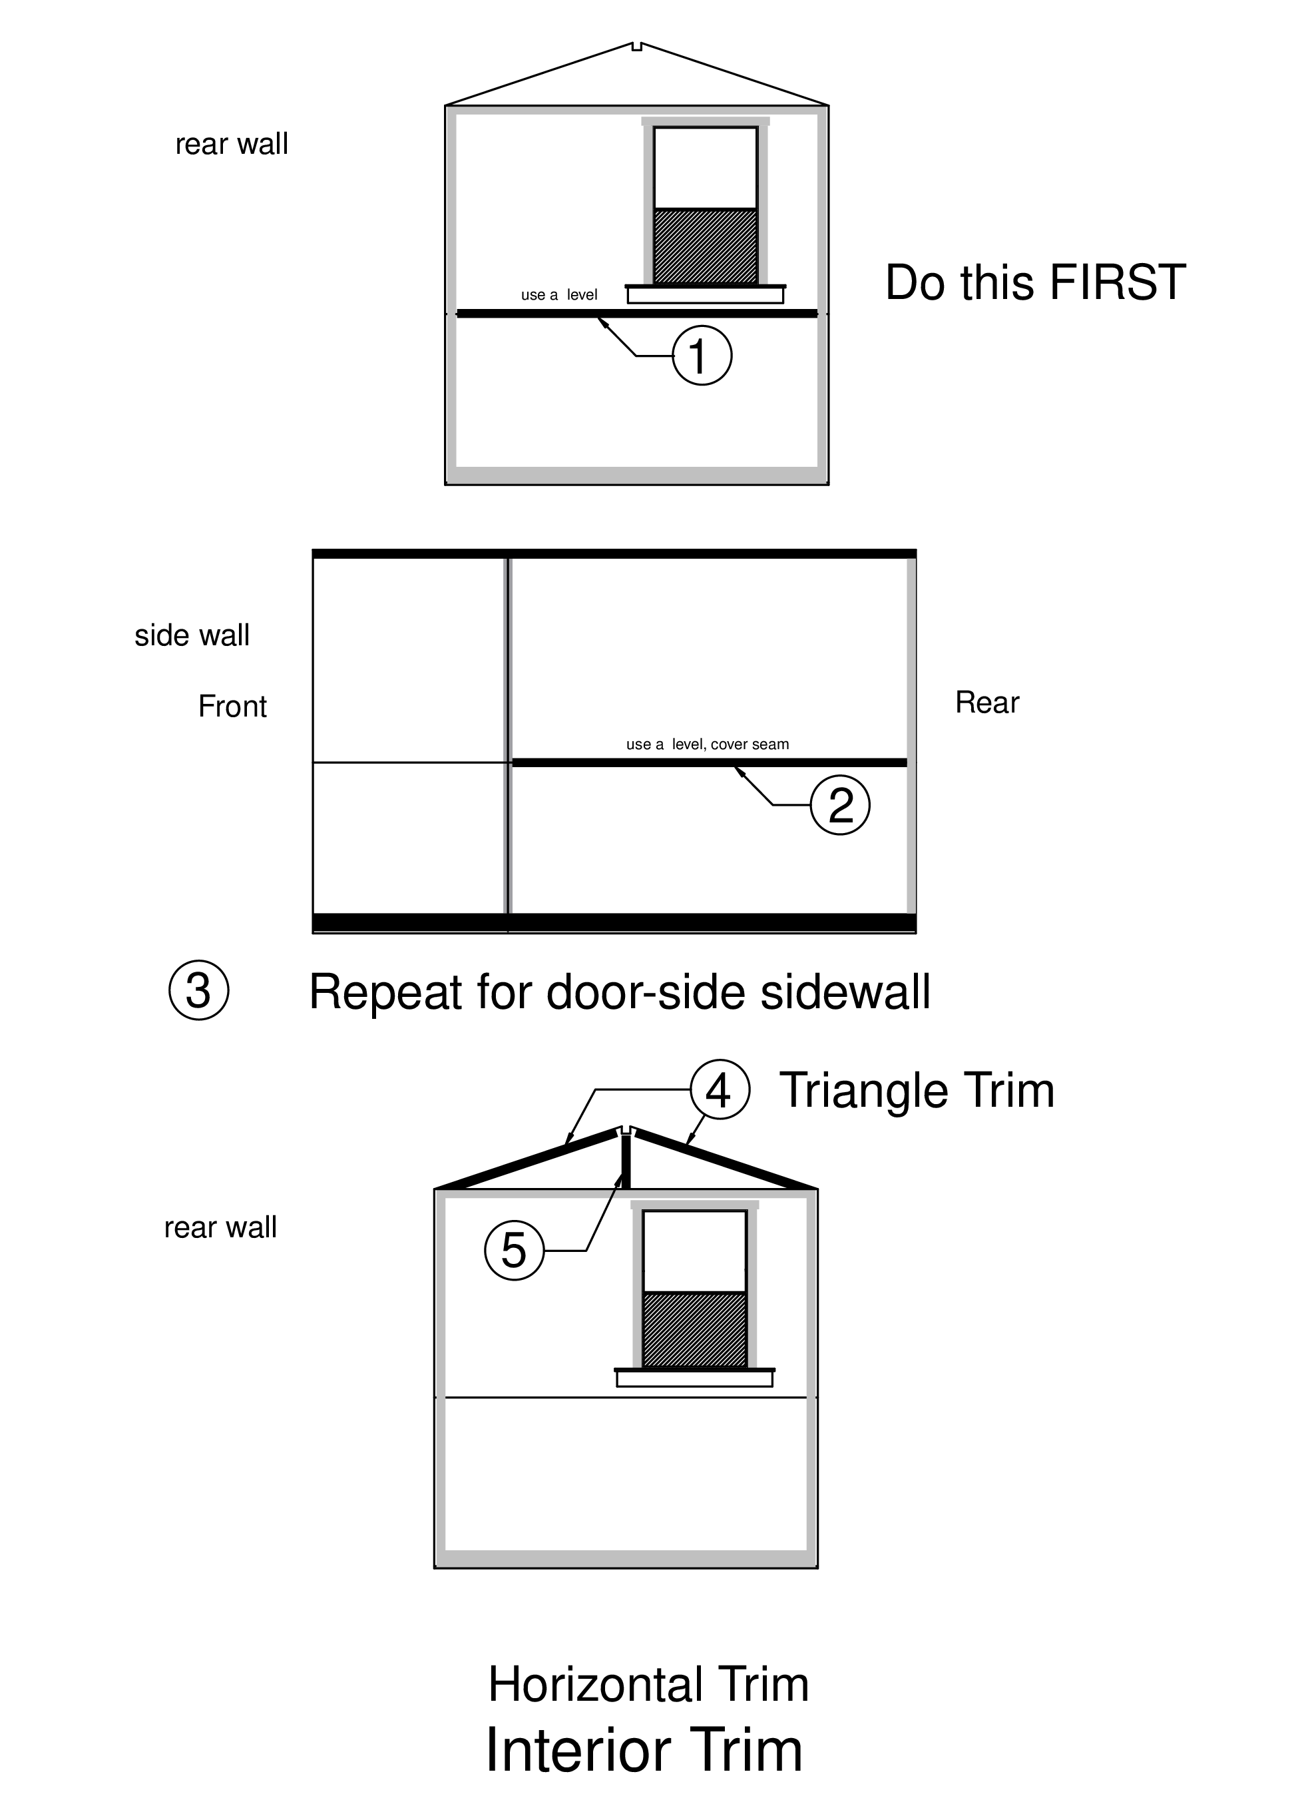

Front Wall – Shelf and Window
Check that MEDUSA (foam backer rod) is installed around the window.
The door must be installed before proceeding with the steps below.
- Measure near the floor from the center of the door jamb to the sidewall baseboard. Cut a piece of baseboard and nail in place. Do this first, to avoid hitting your head on the shelf above.
- Use pre-cut front shelf.
- Pre-drill and countersink 3 places at shelf edge near the window.
- Position shelf in window frame, and screw in with 3 LONG screws next to bottom of the window.
- Cut 2x4 shelf support block. — subtract 1/2” from shelf width
- Place 2x4 under the shelf with 4 inch side against the wall, flush with door side of the shelf and 1/2” shelf overhang on the side wall side
- Mark on the 2x4 where the line of paneling screw falls (stud marker).
- Preset LONG screws into the block as shown in the diagram
- Position the block up against the bottom of the shelf, and drive the screws into the wall
- Pre-drill and install 3 LONG screws next to the wall going through the shelf and into the 2X4 on both sides of the window as shown in diagram.
- Nail precut pieces to line the side walls of the front window opening. Be sure that the front edge of these pieces is flush with the interior of the wall panel
- Measure (very close to window) between the sides for the top of the window piece. Cut one piece that length and nail in place.

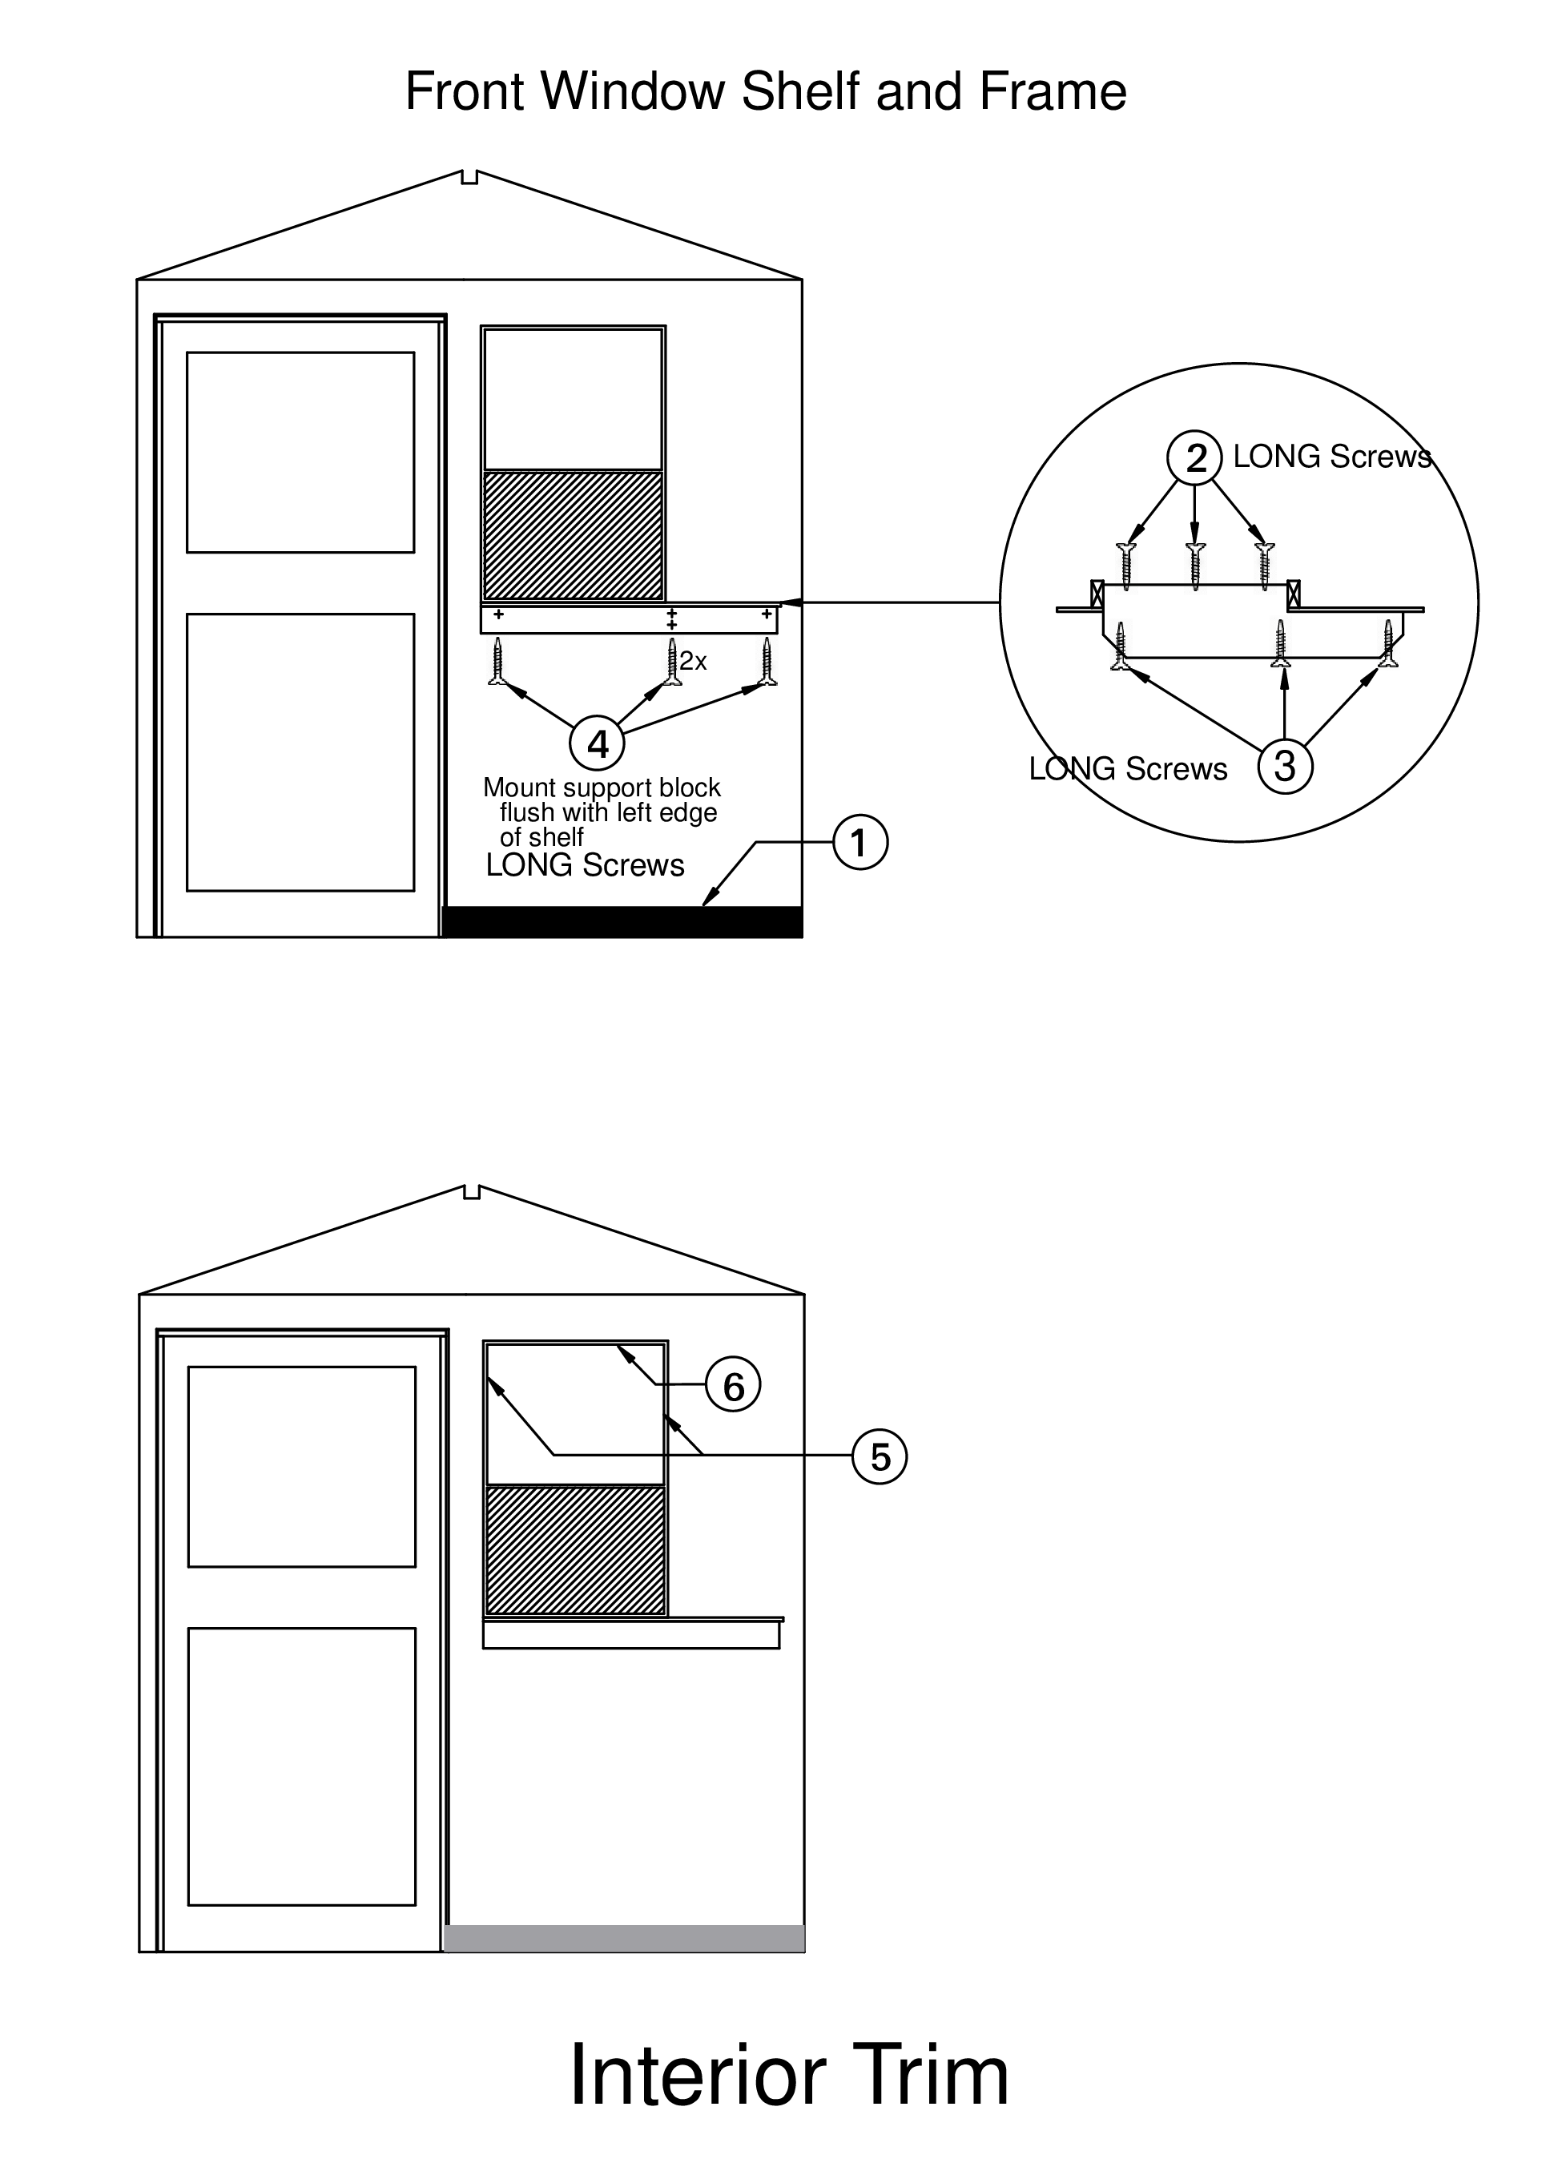

Front Wall Trim
Top diagram
- Measure horizontally from one upper corner to the other. Cut and nail 2” trim.
- Behind the door, measure from baseboard corner to the center of the doorjamb. Cut and nail a piece of 4” baseboard. This piece will be nearly square; make sure the cut edges are vertical.
- Measure horizontally from the inner edge of the window opening to the center of the door jamb next to the window ( ~5½ inches)
— rip a 10” x 96” trim board to this width on the table saw; save the narrower piece (~4½ inches) for step 4
— measure from the upper trim to the baseboard and cut the wide trim to this length
— Mark where a cutout must be made on this wide trim for the front shelf and support block
— Cut out a notch for the shelf using a jigsaw. Nail in place, being sure that the edge next to the window is flush with the window liner.
- Measure the height on the front wall behind the door from upper trim to the baseboard. Check that the narrow board from step 3 will span from the center of the door jamb to within 3/8” of the wall.
— Cut this piece to length, and nail in place, halfway across the door jamb
- Measure from the baseboard to the upper trim on the sidewall in the corner behind the door. Cut a length of 2” trim and nail. This should cover any gap at the corner.
Bottom Diagram
- Measure above the door from the sidewall trim to the 5½” board. Cut 2” trim and nail in place.
- Install 2” trim on the top and wall-side of the front window flush with window opening liner
— top trim has ½” overhang on the right side
- Measure, cut, and install 2” trim on the front wall in the corner next to the shelf end.
- Measure, cut, and install 2” trim on the side wall in the corner next to the window.
- Triangle trim
— Use remaining trim pieces saved after rear wall triangle trim
— Position the angled pieces and nail to the front wall
— Nail a straight piece (42”) on the ceiling tight against each angled piece just installed.
— Position a 12” piece of 2” trim vertically over the center seam in the front triangle and nail.

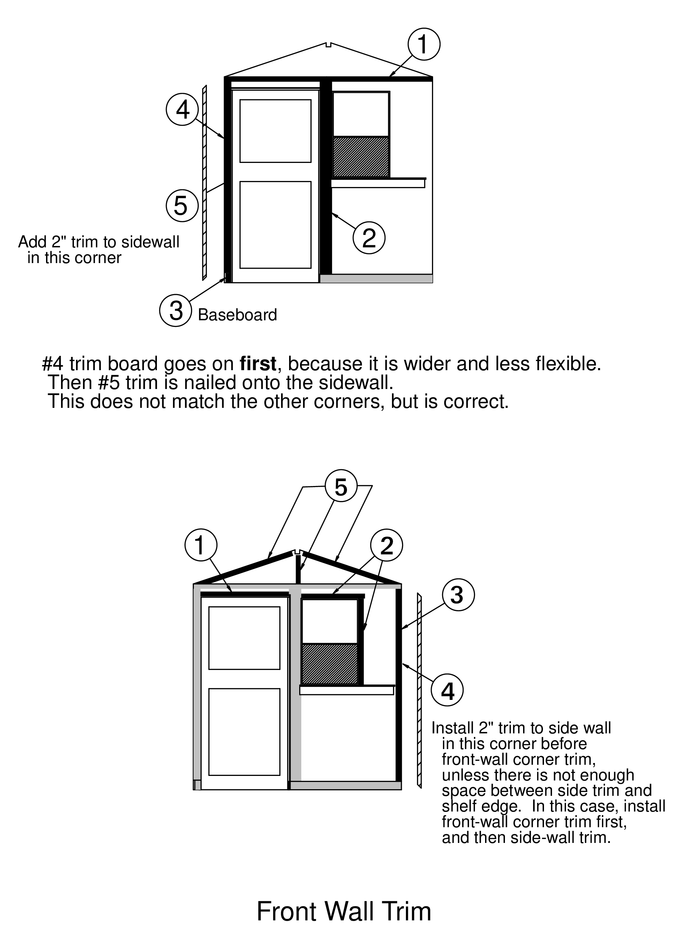

Final Trim
- Measure, cut, and place the final horizontal trim piece on the middle seam of the side wall
- Repeat for the other side wall
- Measure, cut, and place the horizontal piece that goes under the front window shelf, align with the horizontal trim at waist level on the side wall. USE a LEVEL, nail
- DON’T FORGET - Measure, cut, and nail in place a small piece of trim on the front wall behind the door, to match the middle trim on the side wall.
- Nail the remaining two pieces of 2” straight trim (42”) over the ceiling seams, tight against the top trim strips on each side wall, and extending up near the roof vent.

