STRUCTURAL TRIANGLE PARTS
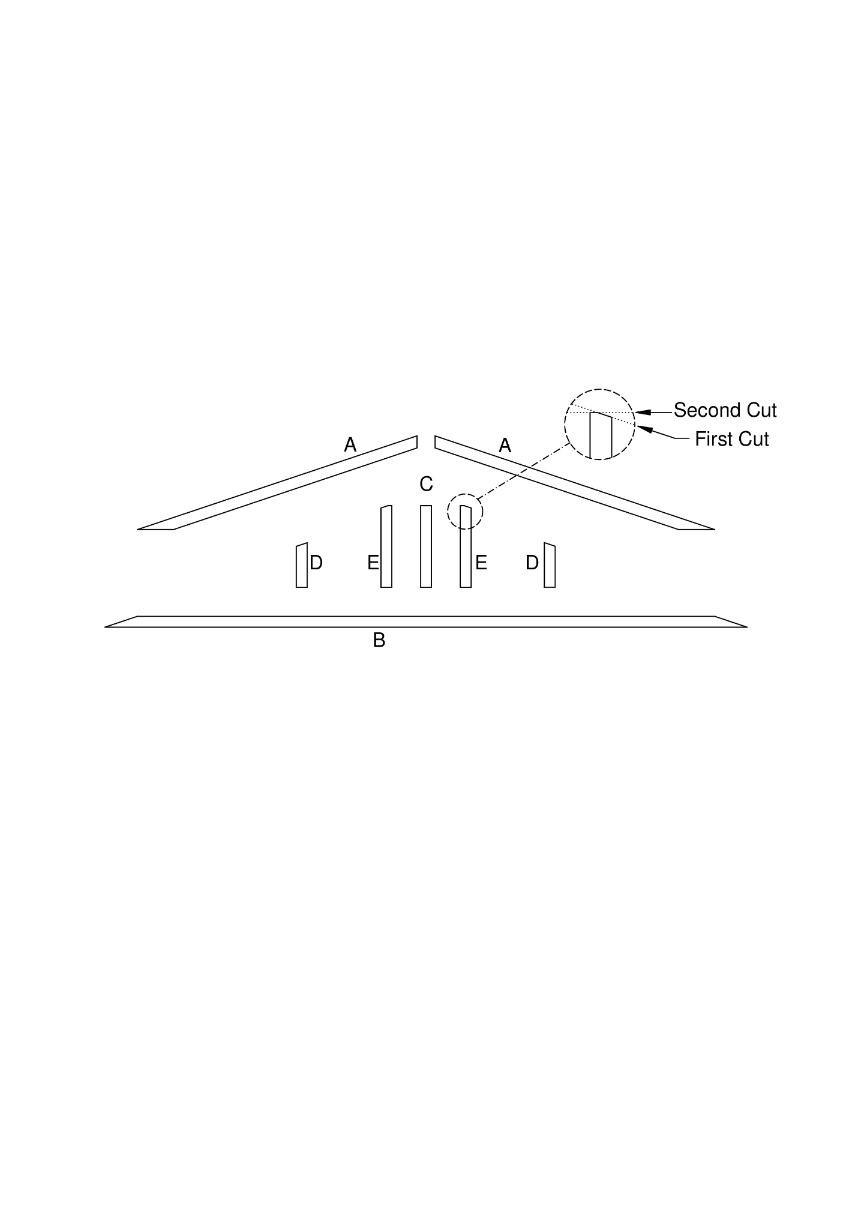
CUT FOR 6 HOMES (12 triangles)
Cut these (rough) lengths of 2x4, and place them on a yellow cart.
12 | B | 89 5/8” | Use 8’ 2x4
12 | A | 96” (no cut needed) | Use 8’ 2x4
Using the green chop saw and jig (set up for 18.5° angle cuts), trim both ends of these. The longer one is used below for A pieces
Set the (red) back chop saw to an 18.5° angle, and trim the following, setting each 2x4 on the saw table standing on its shortest edge:
24 | A | 41” | Cut two pieces from each blank, being sure that the long point previously cut is against the back rail and even with the stop
24 | D | 6-³/₁₆” | From scraps or 12” scrap blocks
24 | E | 11-⁹/₁₆” | From 12” blocks
Set the back chop saw back to 0°. Cut
12 | C | 11-⁵/₁₆” | Use 12” scrap blocks
24 | E | 11-⁵/₁₆” | Cut the tip off the slanted end of each piece

