SIDE WALL - SET UP LIST
- Put caulk by heater
- Caulking gun
- Framing nail gun
- Framing nails
- Panel nails
- Triangle
- Screw gun with T25 bit
- Long screws
- Short screws
- Chalk line
- Stapler
- Staples
- Mallet
- Hammer

Step 1
- Place 2x4s in the designated spots on the perimeter.
- When nailing corners
— line up to be flush on top and sides
— one person holds and the other nails
- Put in 1 FRAMING nail (the longer ones)
— in the upper middle of the stud to connect the corner
— in each of the 4 corners
- Put a second nail directly under each of the first nails.

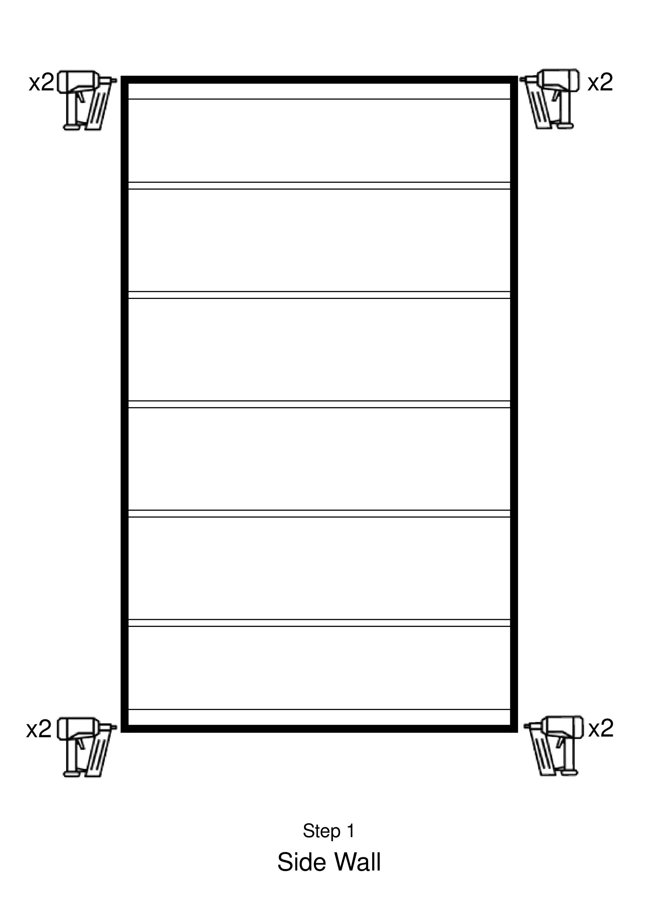

Step 2
- Place a 2x4 flat at each of the short ends. Be sure that this flat board is all the way down against the bottom of the jig.
- CLAMP the flat and perpendicular boards
- TEAM LEADER - put 2 long SCREWS into each end of the flat board and 8 SCREWS along the short side at the bottom to connect perpendicular 2x4 with the flat one. While this goes on, crew place the remaining boards in the jig.

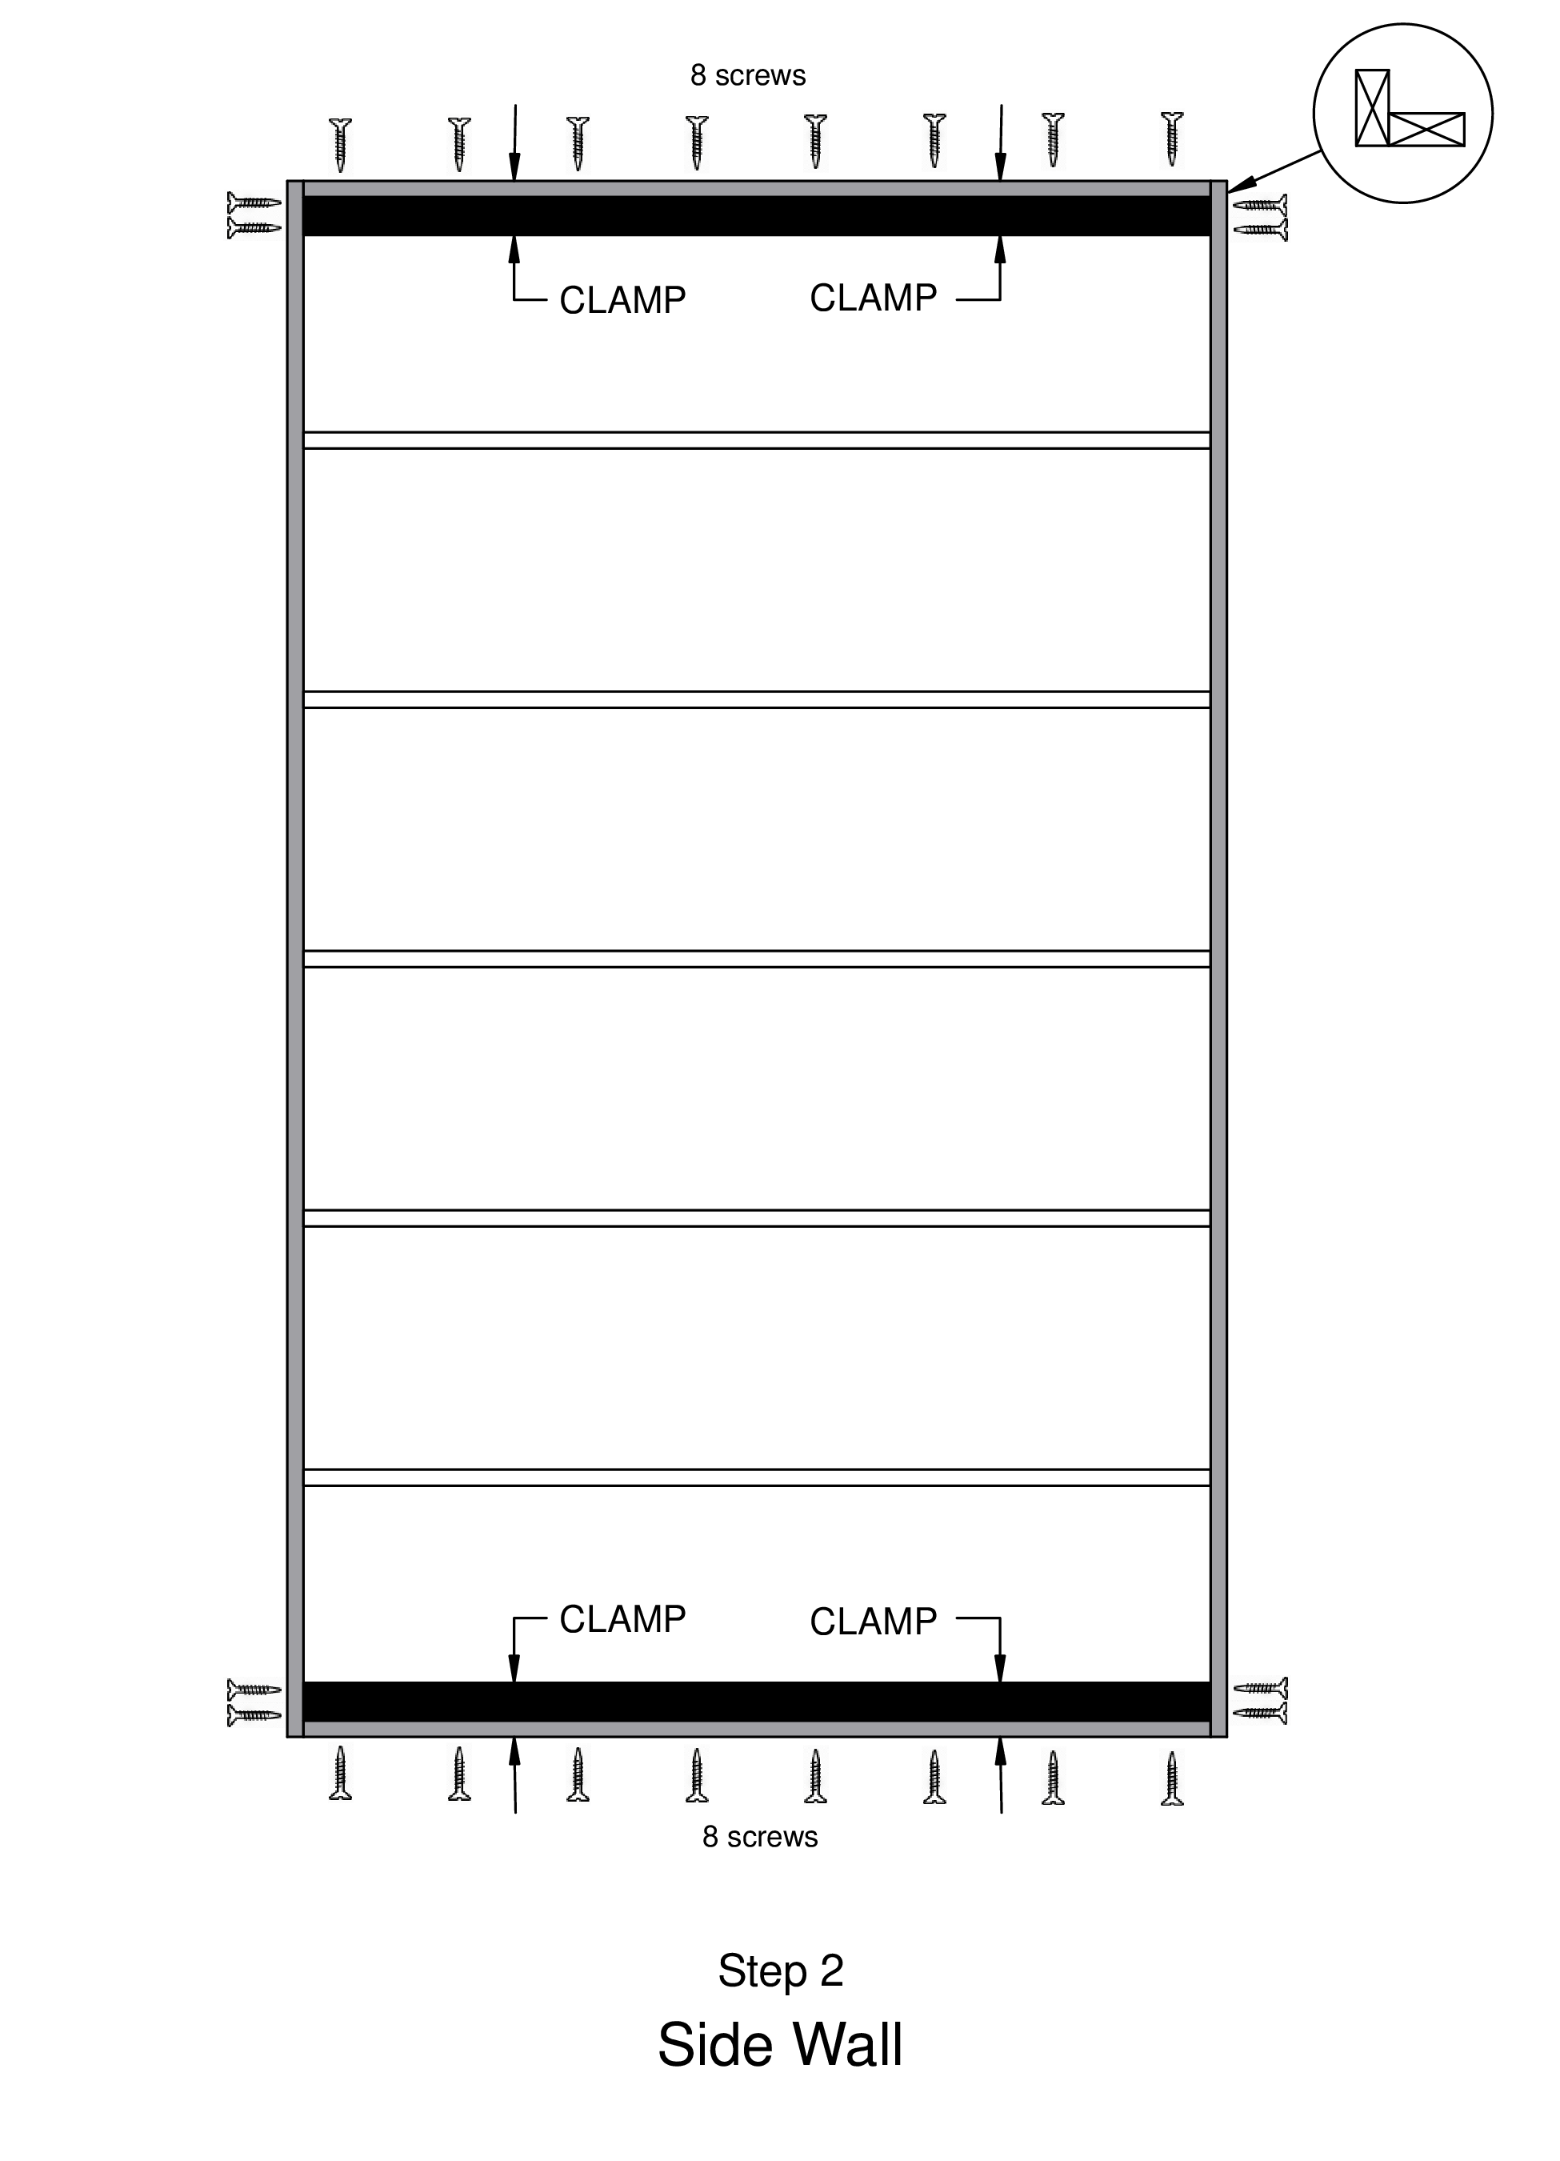

Step 3
- Place the inner 2x4 studs
— make sure the 2x4s on both sides of the middle stud are good ones, they will be the magic studs
- Team leader
– put pencil marks vertically in the middle of each of the inner studs to designate nail placement

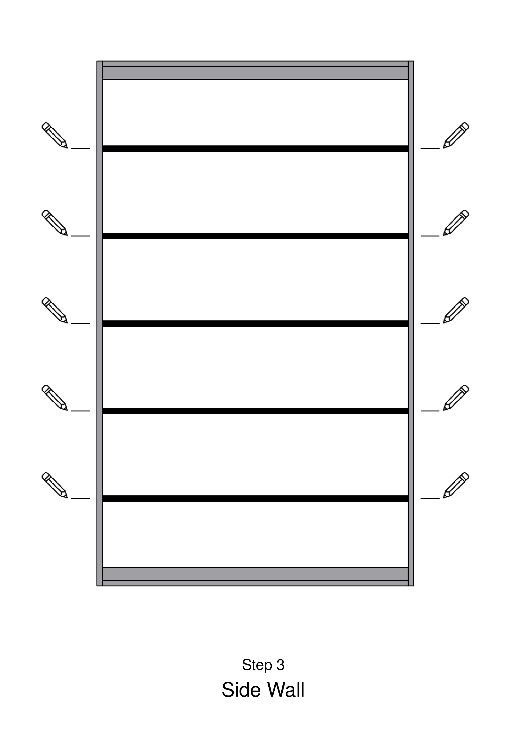

Step 4
- Put 2 FRAMING nails on the line at each stud
— put second nail directly under the first
— one person holds the stud so that it is flush while the other nails
- Check that all studs have two nails (or screws) in each end.

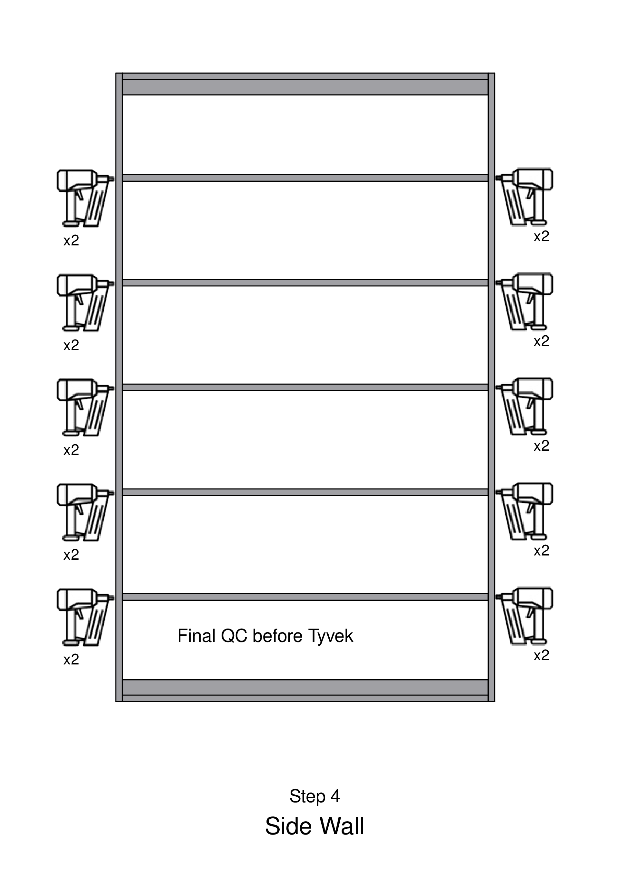

Step 5
- Place the Tyvek
— start by stapling it flush with the top
— unroll gradually as it gets stapled, not all at once
- Staple as you unroll
— 3 staples in the corners and a staple every 8 inches.
- Stretch the Tyvek so that it is tight.
- Staple top, side, bottom, side
- Staple along the length of ALL of the inner studs

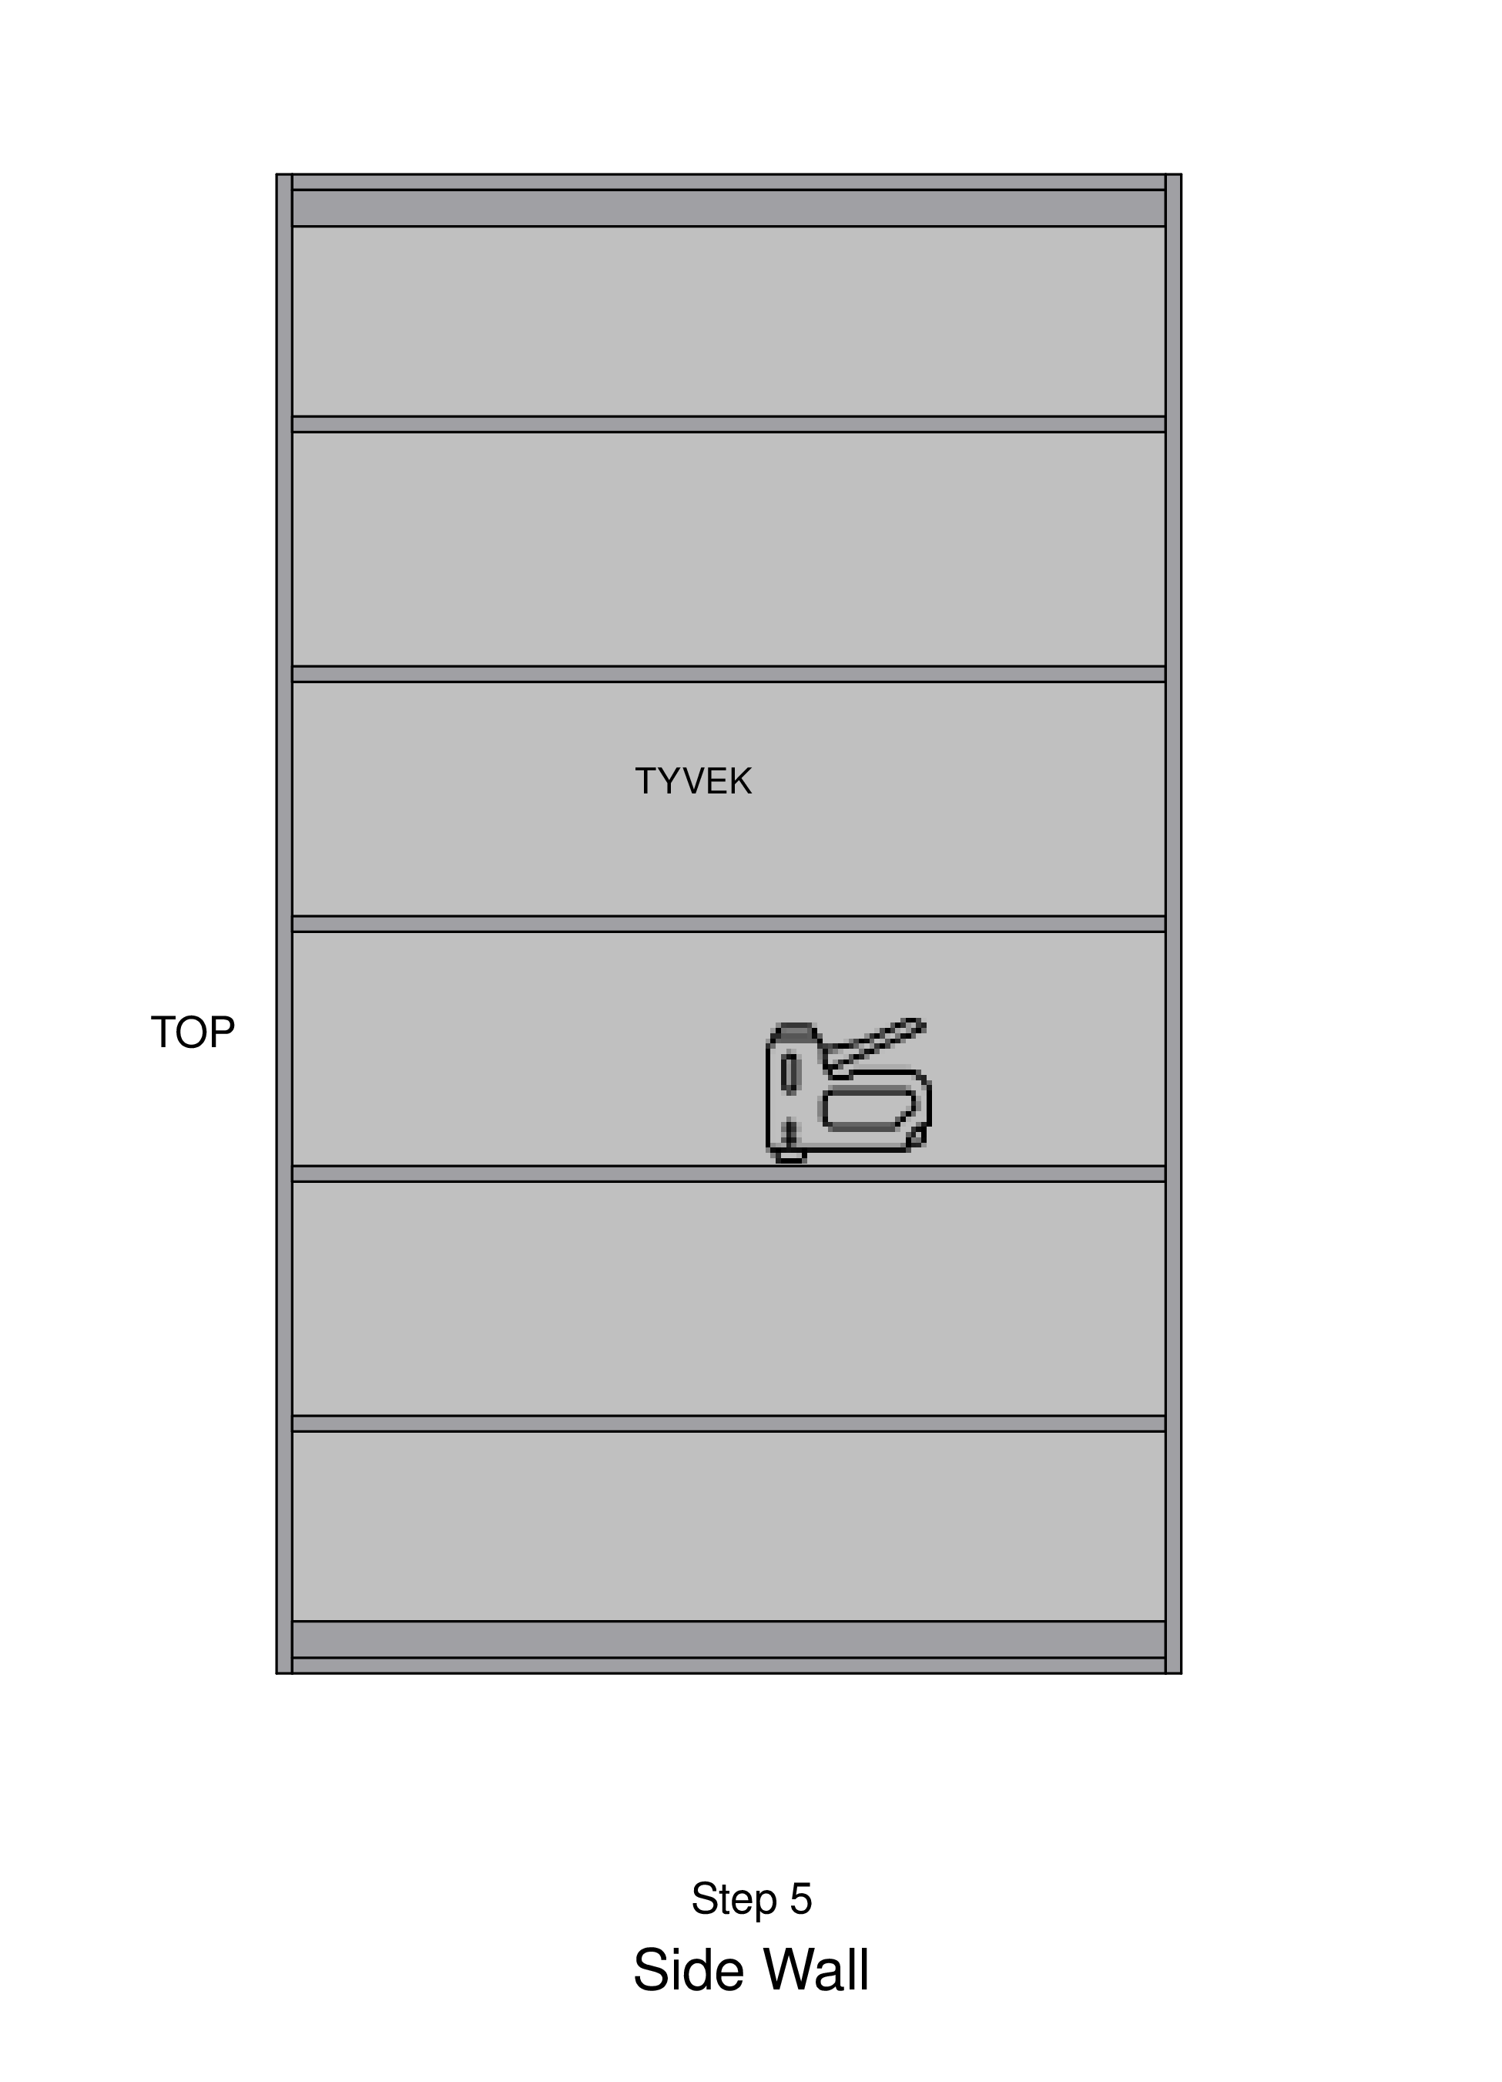

Step 6
Put PANEL nails (shorter ones) in the nail gun
- Place Panel 1, with the tongue (lower thin bit) toward the center of the wall
- Put Funky Board #2 in the slot to line up the first panel. (Funky Board found at the end of jig)
- Line the panel up flush with top, and tight against the Funky Board.
— put 1 panel nail in the top corner next to where the 2nd panel goes as a pivot point, adjust.
- Nail the panel to the studs
— along the top, sides and down each inner stud.
— use chalk lines to designate where the inner studs are.
— get on top, straddle the stud to push the panel down and walk backwards nailing along the stud/chalk line
— work your way diagonally from one corner to the opposite one.
- Place a thin line of EXTERIOR caulk
— along the outside edge of the tongue and groove part
NOTE: DO NOT nail inside the grooves, nail very close but NOT IN, angling the nail gun if necessary to be sure that each nail hits the center of the stud (where the chalk line is.)

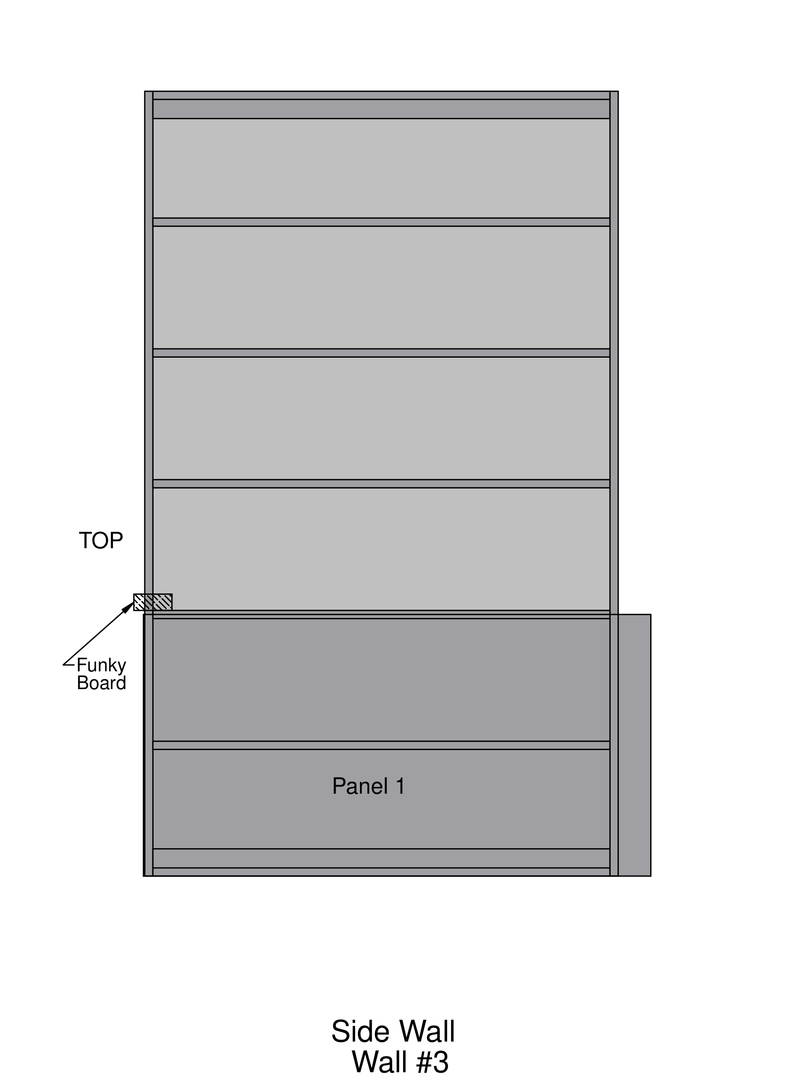

Step 7
- Place Panels 2 & 3 such that the sunken groove is the same as all the others on the panel
- Repeat the above nailing process with this 2nd panel and the 3rd one
- Staple the Tyvek to the underside of the panels at the bottom
- Trim all Tyvek to be flush with edges
— on the sides, trim the Tyvek flush with the framing.
- Team leader
— router the side so that it is flush with stud underneath
- Smooth out caulk along the panel joints, using a scrap of Tyvek or a paper towel. Do not caulk the nail heads if tilt-up is scheduled for the same day.

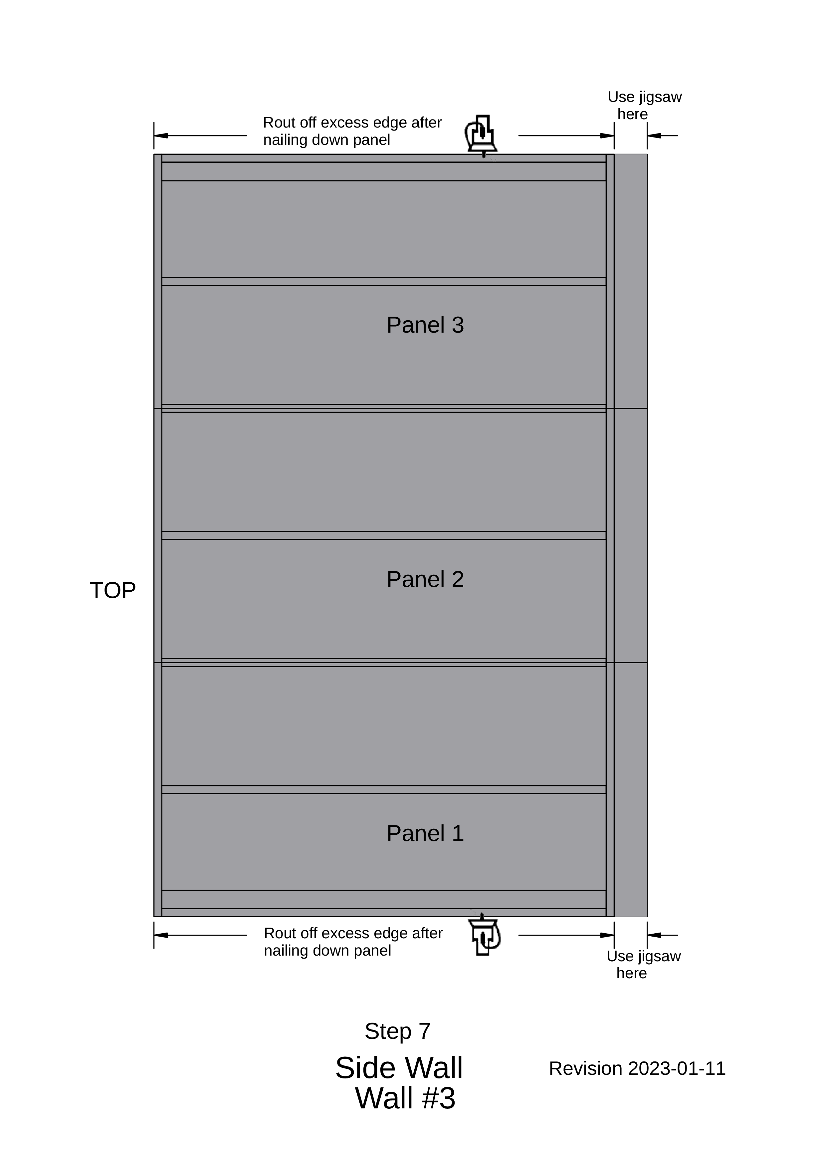

SIDE WALL ASSEMBLY CHECKLIST
- Perimeter boards
- Nail corners
- Place flat board both short ends
- Clamp
- 2 long screws at flat board ends
- 8 long screws into flat and perpendicular boards
- Place all inner boards, good ones at magic studs
- 2 nails at ends of all boards
- Staple Tyvek- top, sides and inner studs
- Panel 1 — funky board #1
- Nail (PANEL NAILS) top, sides, inner studs
- Caulk Panel 1 edge
- Panel 2
- Nail (PANEL NAILS) top, sides, inner studs
- Caulk Panel 2 edge
- Panel 3
- Nail (PANEL NAILS) top, sides, inner studs
- Staple & trim Tyvek
- Router side edges

