Floor Installation

Preparation
• Clean interior with blower, twice, including window frames and A/C cutout
• Collect tools and material:
• 4½ to 5 boxes of flooring
• Knee pads, safety glasses, ear protection, gloves
• Black marker, pencil, tape measure, utility knife, speed square, blower
• Flooring cutter, jig saw, mallet, tapping blocks, small pry bars, tapping bar

First Row – next to side wall on door side of home
• Assemble first row from three full lengths (or use 3 ripped pieces from a previous floor). The wide gray tongue on the long edge should face the interior of the home.
• Cut last length for doorway and interior wall clearance. The part that will extend into the doorway must reach to the limit line in the doorway. Use a jigsaw to cut out the corner behind the door.
• Use spacers against the walls to insure 1/8” gap

Intermediate Rows
• For even numbered rows, start with 2’ length; add 2 full lengths, and then use remainder of cutoff at the door end. For odd numbered rows, start with a full length.
• Trim off the gray tongue from the short edge of the first piece where it faces the wall. Use a spacer to insure 1/8” gap from the back wall
• Tilt each plank up about 30°, and engage the long edge with the flooring already placed. Then lower the new plank and slide it towards a previous one until the short ends overlap. Tap the joint with a block and mallet to seat the plank.
• Trim last length to match limit line in doorway (3/4” towards outside from inside of interior wall), or 1/8” less than the distance to the front wall.
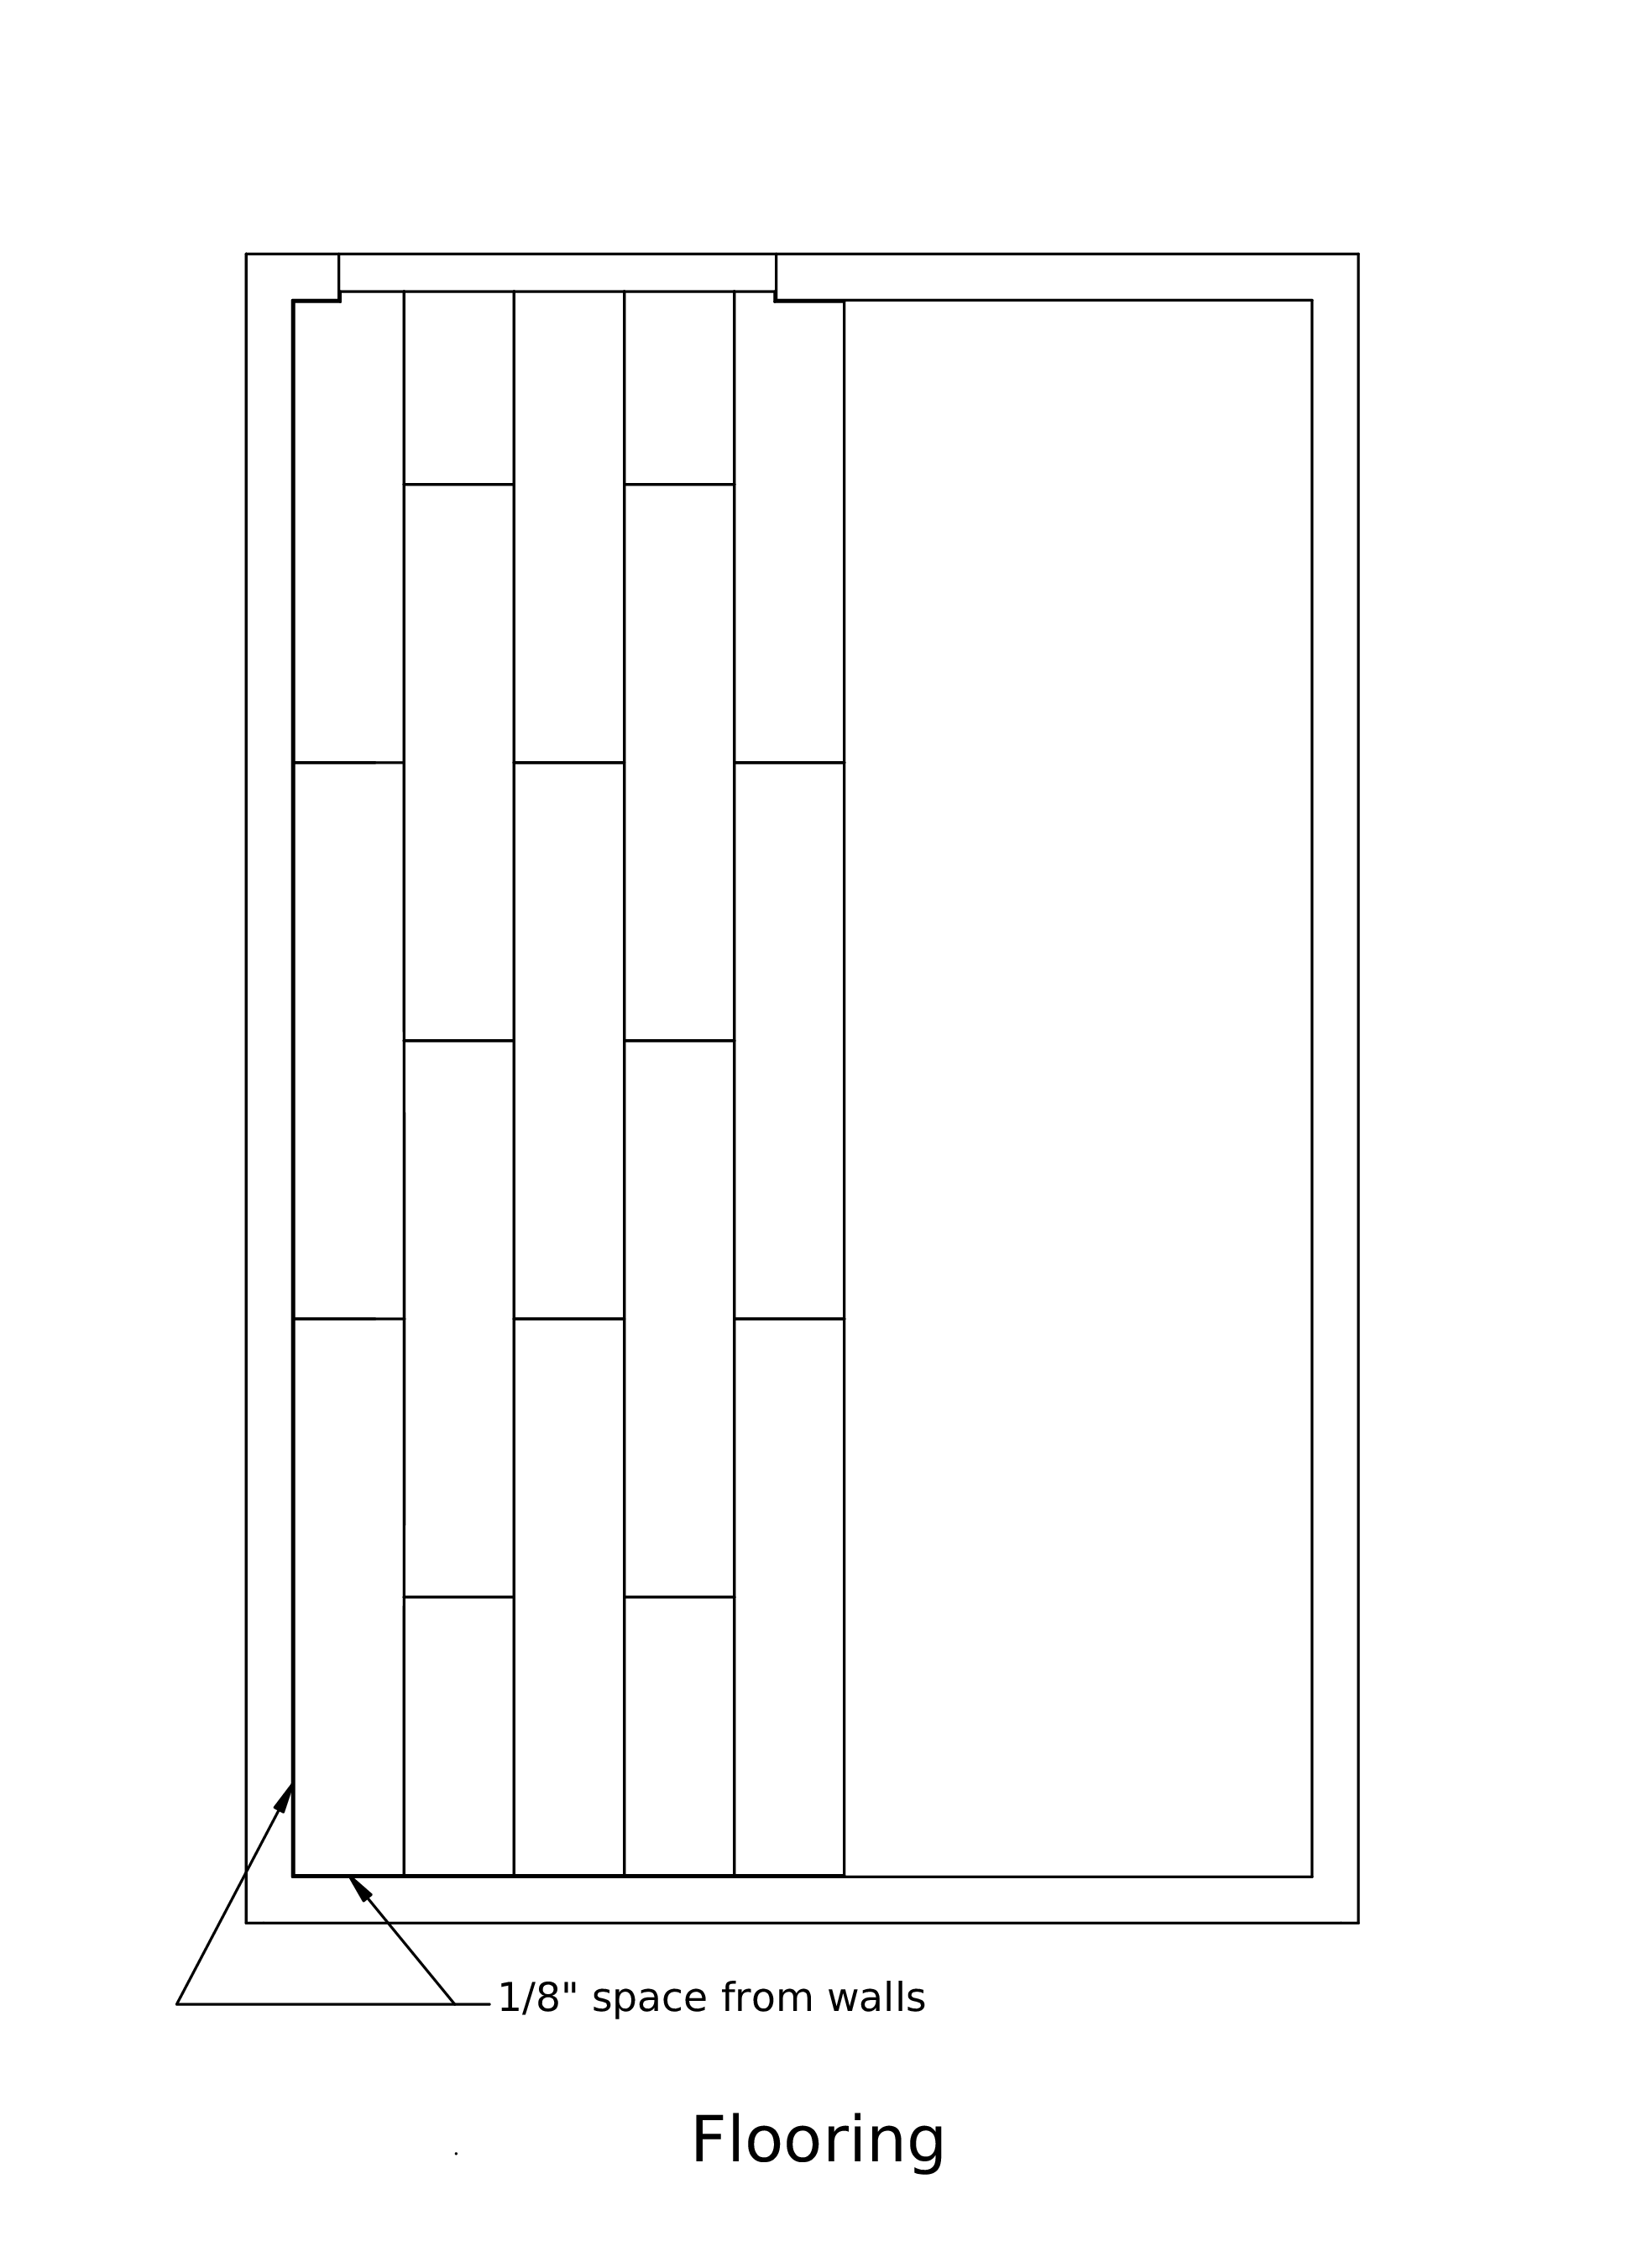

Last Row
• Measure distance from brown edge of last intermediate row to wall in several places. If the measurement varies more than ¼”, cut each piece so that there will be ¼” gap between the floor and the wall. Otherwise, use the minimum width for all three pieces
• Using the table saw set up for this, rip pieces to the required width above. Save the remaining partial pieces for the next floor.
• To complete assembly, use the small pry bars as hooks to engage the last row with the rest of the floor, and then either tap the planks together using the tapping bar, or else use the small pry bars to apply force. The flooring should lie flat when the joint is seated correctly

Doorway
• Place a 3” strip of flooring across the doorway, flush with the outside of the building. This will be secured with flexible flashing when the door is installed. The strip can either be a single 36” piece, or be made up from scraps interlocked together (5 @7” = 35”).

