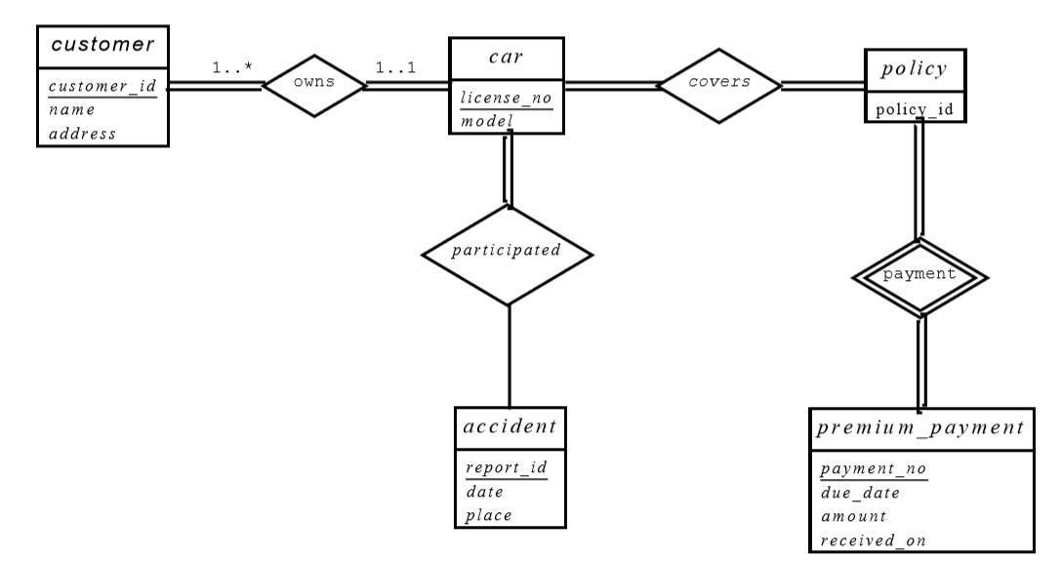**7.1:**

**7.2:**

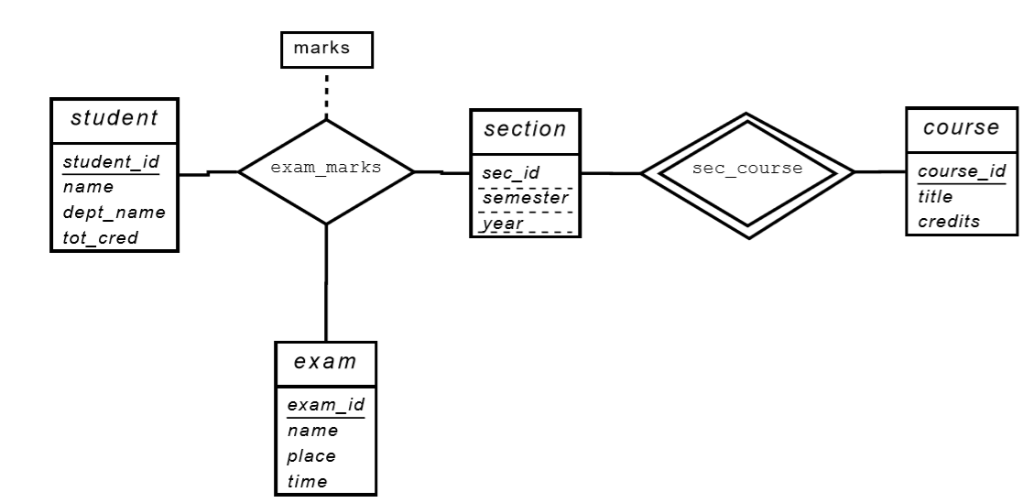**a.**

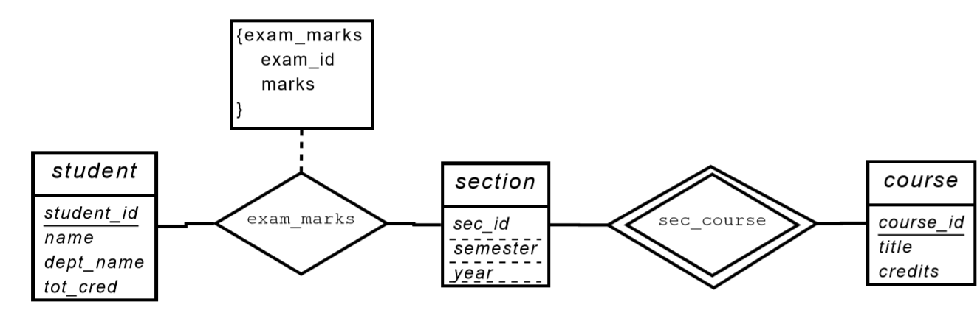**b.**

**7.20:**

**a.**

author(name, address, URL)

publisher(name, address, phone, URL)

book(ISBN, title, year, price)

customer(email, name, address, phone)

shopping basket(basket id)

warehouse(code, address, phone)

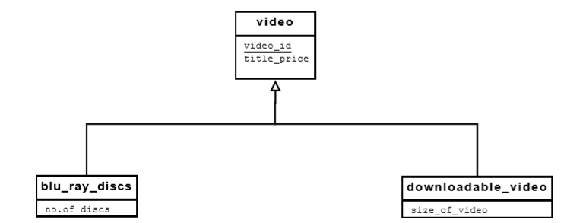**b.**

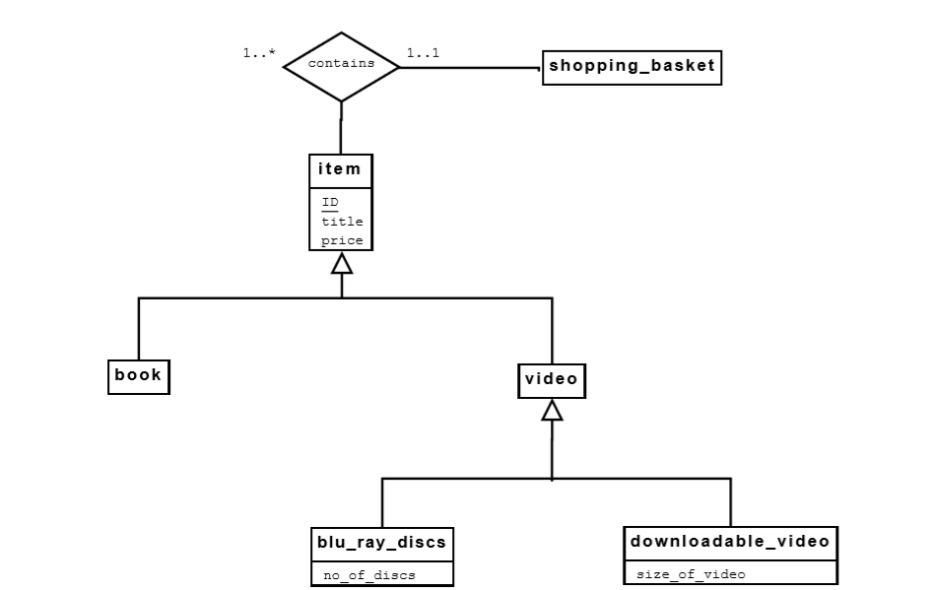**c.**