Cover page

Sample project: Combinatorics Fall 2015. Dr. Stefan Forcey

By: Stefan Forcey

1. Outline:
2. The sequence ID: [A000108](http://oeis.org/A000108) Catalan numbers.
3. The first 10 terms: **1, 1, 2, 5, 14, 42, 132, 429, 1430, 4862**

Note: the first term here is for n=0.

1. The two interpretations, as described in the OEIS.
2. Number of ways to insert n pairs of parentheses in a word of n+1 letters. [OEIS]
3. Number of plane binary trees (each branch point has two branches) with a root and n+1 leaves. [OEIS]
4. The four formulas.
5. a(n) = binomial(2*n, n)-binomial(2*n, n-1).
6. a(n) = Sum_{k=0..n-1} a(k)a(n-1-k).
7. a(n) = Prod_{k=2..n} (1 + n/k), if n>1.
8. G.f.: A(x) = (1 - sqrt(1 - 4*x)) / (2*x).
9. (Optional) The team of 2 you worked with, and list of responsibilities from steps 1-5 for each partner.

1. Illustrations of the sets for a_3=5 and a_4=15. [Each person has been assigned their own values to illustrate.]

For n=3:

1. ((ab)(cd)), (((ab)c)d), ((a(bc))d), (a((bc)d)), (a(b(cd))).
2. 

For n=4:

1. (((ab)(cd))e), ((((ab)c)d)e), (((a(bc))d)e), ((a((bc)d))e), ((a(b(cd)))e)

((ab)((cd)e)), (((ab)c)(de)), ((a(bc))(de)), (a(((bc)d)e)), (a((b(cd))e))

((ab)(c(de))), (a((bc)(de))), (a(b((cd)e))), (a(b(c(de)))).



1. Formula Demonstrations. Show work!
2. a(n) = binomial(2*n, n)-binomial(2*n, n-1).

http://www4c.wolframalpha.com/Calculate/MSP/MSP31021b0dfgcdibb47a6c00005i5f487da79h1601?MSPStoreType=image/gif&s=47&w=103.&h=36.

n=5:

http://www4c.wolframalpha.com/Calculate/MSP/MSP2164208h6g0760i37a3f00002f4b7ead6gai02a5?MSPStoreType=image/gif&s=4&w=84.&h=36.

= 252 – 210 = 42

n=6:

http://www4c.wolframalpha.com/Calculate/MSP/MSP817229fi6hf48c648h800001e1bi0e6i7882d4b?MSPStoreType=image/gif&s=52&w=84.&h=36.

=924 - 792 = 132

1. a(n) = Sum_{k=0..n-1} a(k)a(n-1-k).



n=3:



=a(0)a(2) + a(1)a(1) + a(2)a(0)

=1x2 + 1x1 + 2x1 = 5

n=4:



= a(0)a(3) + a(1)a(2) + a(2)a(1) + a(3)a(0)

=1x5 + 1x2 + 2x1 + 5x1 = 14

n=5:



= a(0)a(4) + a(1)a(3) + a(2)a(2) + a(3)a(1) + a(4)a(0)

=1x14 + 1x5 + 2x2 + 5x1 +14x1 = 42

1. a(n) = Prod_{k=2..n} (1 + n/k), if n>1.



n=5:



= http://www5b.wolframalpha.com/Calculate/MSP/MSP26451hc0ei12gfd78d5c00003hcc1d9a1he8ahg5?MSPStoreType=image/gif&s=9&w=203.&h=37.

=42

n=6:



= http://www5b.wolframalpha.com/Calculate/MSP/MSP49951ifi8bb6804f5fd900004fa6c482c6gi8507?MSPStoreType=image/gif&s=44&w=254.&h=37.

=132

1. G.f.: A(x) = (1 - sqrt(1 - 4*x)) / (2*x).

http://www5b.wolframalpha.com/Calculate/MSP/MSP28921d1gdgdga7ihiaa700006056efchh23ahae2?MSPStoreType=image/gif&s=40&w=89.&h=40.

n=7:

http://www5b.wolframalpha.com/Calculate/MSP/MSP9411ba1ga94a5e8e13g000039261i1897b766hi?MSPStoreType=image/gif&s=5&w=223.&h=42.

And 2162160/7! = 429

n=8:

http://www4f.wolframalpha.com/Calculate/MSP/MSP29091h55b03g14d5fi2d000024c6d4916ebfc52d?MSPStoreType=image/gif&s=34&w=231.&h=42.

And 57657600/8! = 1430

1. Experimental bijection.

We define a rule for taking an insertion of n pairs of parentheses in a word of n+1 letters, and creating a plane binary tree as follows:

1. Create a leaf for each letter, in a row directly below the respective letters.

((a b)( c d))



1. If two letters are adjacent (no parentheses between them) join their leaves with branches, making a branch point.

((a b)( c d))



1. Continue by joining adjacent objects with branches, where objects are leaves or branch points where the contents of a matching pair of parentheses are already meeting. Continue until there is only one branch point available, and then add the root.

((a b)( c d))



The full bijective correspondence for n=3:

|  |
| --- |
| ((ab)(cd)), (((ab)c)d), ((a(bc))d), (a((bc)d)), (a(b(cd))). |
|  |

The full bijective correspondence for n=4:

|  |
| --- |
| (((ab)(cd))e), ((((ab)c)d)e), (((a(bc))d)e), ((a((bc)d))e), ((a(b(cd)))e) |
|  |
| ((ab)((cd)e)), (((ab)c)(de)), ((a(bc))(de)), (a(((bc)d)e)), (a((b(cd))e)) |
|  |
| ((ab)(c(de))), (a((bc)(de))), (a(b((cd)e))), (a(b(c(de)))). |
|  |

Conclusion: The bijection works on n=4. The rule was followed and the function is 1-1.

Experimental superstructure: find a way to organize the set for one of the structures counted by a_n1.  Show how the rule works on the next size: a_(n1+1). Show how the rule works on the other structure, via your bijection from step 3).

We define a rule for connecting two insertions of n pairs of parentheses in a word of n+1 letters, to create the structure of a graph:

For each pair of binary trees, connect them with an edge (line) if and only if there is a single branch point for which the next branch above it changes its attachment from left to right (or vice versa), and that is the only difference between them. That is, there is a branch point which when you zoom in looks like this in the respective trees, which are the same outside the zoom: 

Superstructure for n=3, first on trees and then via bijection:

 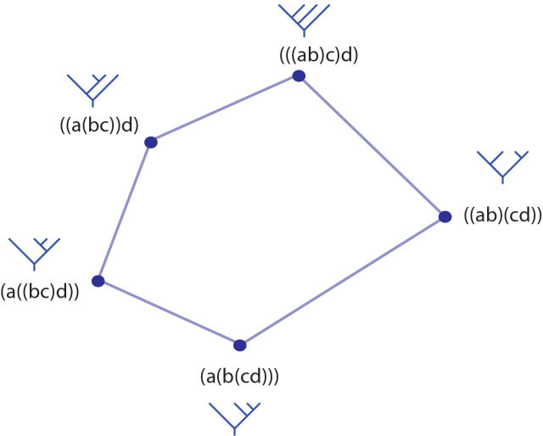

Superstructure for n=4.

1. Open question: Describe an open question about your sequence…either by researching or by your own invention.

According to the OEIS, the sequence is:

“Also coefficients of the Mandelbrot polynomial M iterated an infinite number of times. Examples: M(0) = 0 = 0*c^0 = [0], M(1) = c = c^1 + 0*c^0 = [1 0], M(2) = c^2 + c = c^2 + c^1 + 0*c^0 = [1 1 0], M(3) = (c^2 + c)^2 + c = [0 1 1 2 1], ... ... M(5) = [0 1 1 2 5 14 26 44 69 94 114 116 94 60 28 8 1], ... - Donald D. Cross” [OEIS]

The Mandlebrot Set is defined as the complex numbers c, which, when evaluated at all of the Mandelbrot polynomials give results which stay within some boundary on the complex plane. For example, if we take c = 0.3+0.1i then the results of finding c^2 +c, (c^2 +c)^2+ c, ((c^2 +c)^2+ c)^2 +c, …etc. look like this:



Notice that the Mandlebrot polynomials are not exactly the polynomials with coefficients the first n Catalan numbers. For instance, the second Mandlebrot polynomial is (c^2 +c)^2+ c = c+c^2+2c^3+c^4, while if we use just the Catalan numbers we could call this the second Catalan polynomial: c+c^2+2c^3. In fact, define the nth Catalan polynomial to have coefficients the first n Catalan numbers. The question is: what is the shape of the set of complex numbers c, which, when evaluated at all of the Catalan polynomials give results which stay within some boundary on the complex plane?

For comparison, here is a picture of the Mandelbrot set [Wiki]:



References:

[OEIS] The On-Line Encyclopedia of Integer Sequences, published electronically at http://oeis.org, 2010.

[Wiki] Wikimedia, Wolfgang Beyer.

http://commons.wikimedia.org/wiki/User:Wolfgangbeyer