NCEAS_test

Markdown test has formatting directives

## Header Two

More text here. **This is bold**

* apple
* banana
* kiwi

### Challenge

In Markdown, *Write some italic text*

1. make a numbered list
2. add a few sub-headers.
3. Use the Markdown Quick Reference (in the menu bar: Help > Markdown Quick Reference).

Re-knit your html file and observe your edits.

x <- 4*3  
x

## [1] 12

plot(rnorm(n = 100, mean = x))

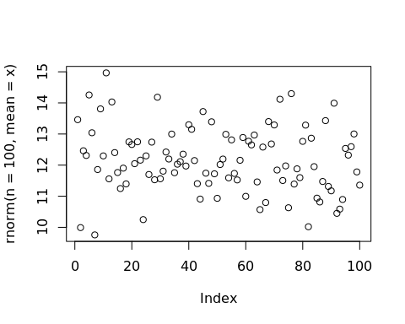

##### Links

This is a [link](http://ncease.uscb.edu)

$∑n+1$

Insert code chunk by command + option + i cntrl + alt + i

#This is a comment  
hist(rnorm(n = 100, mean = x))

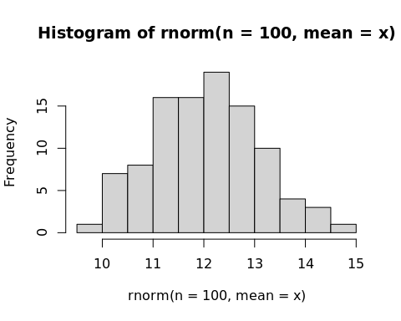

#### Next chunkeroni

print('You gots ta chill, Winston')

## [1] "You gots ta chill, Winston"