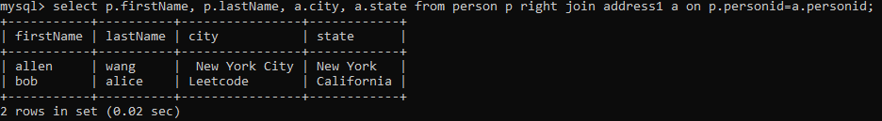

2. 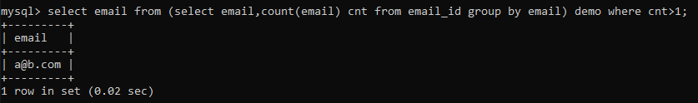

3.select e1.Name as 'Employee', e1.Salary

from Employee e1

where 3 >

(

select count(distinct e2.Salary)

from Employee e2

where e2.Salary > e1.Salary

)

;

;