**Assignment Title: Flutter App with Back4App Integration**

**Step 1: Set Up Back4App**

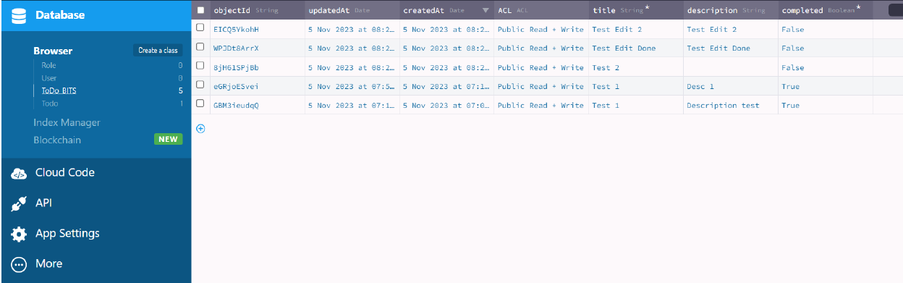

**Class name:** ToDo_BITS

**Columns:** title<String>, description<String>, completed<Boolean>

**Step 2: Flutter Setup**

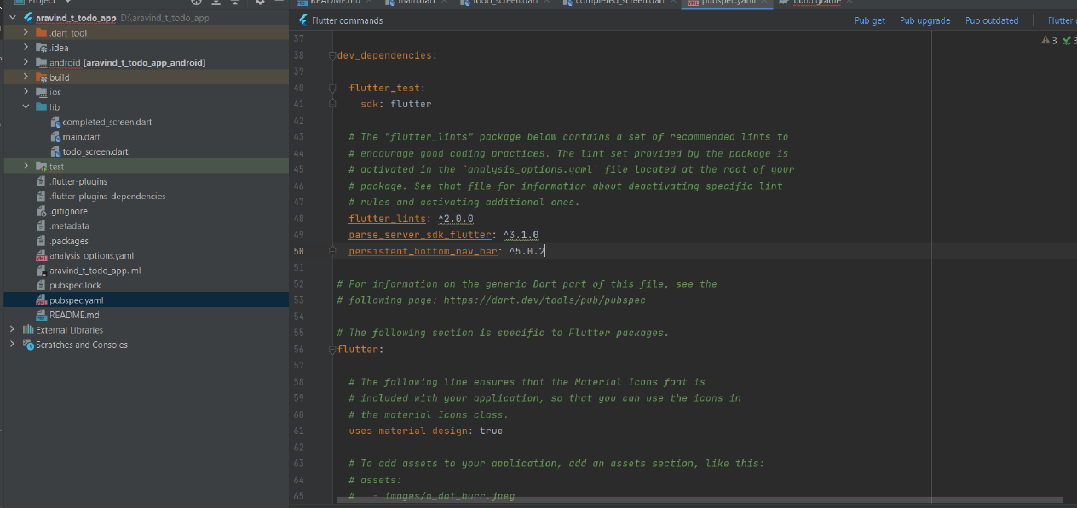

**Added dependencies :**

parse_server_sdk_flutter: ^3.1.0

persistent_bottom_nav_bar: ^5.0.2

**Initiating Parse SDK and added Keys:**

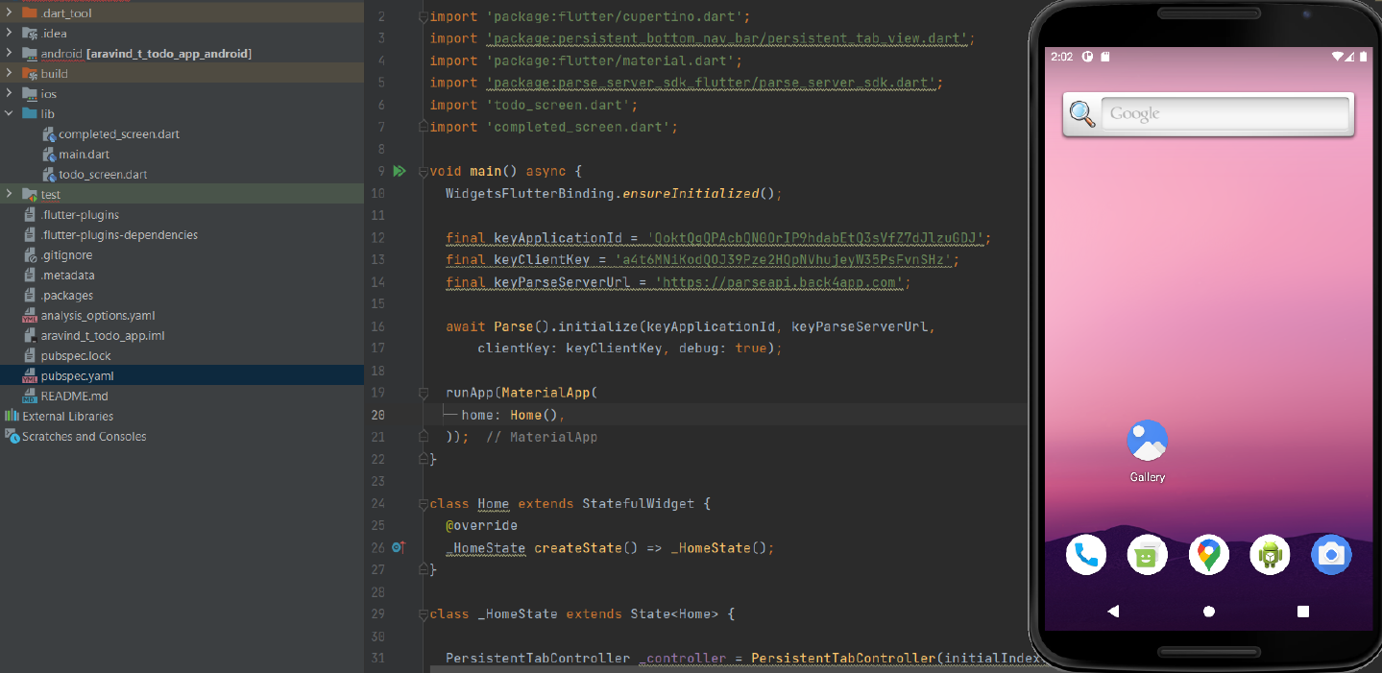

**Step 3: Task List**

There are two screens in my app, which can be navigated through the bottom navigation

bar. The first one is for creating tasks and viewing tasks. The second screen is to view

completed tasks.

Added operations:

1. Create task.

2. View task.

3. Mark as completed.

4. Edit task.

5. Delete task.

**Step 4: Task Creation:**

Task creation screen, with added tasks:



Saving tasks to Back4App:

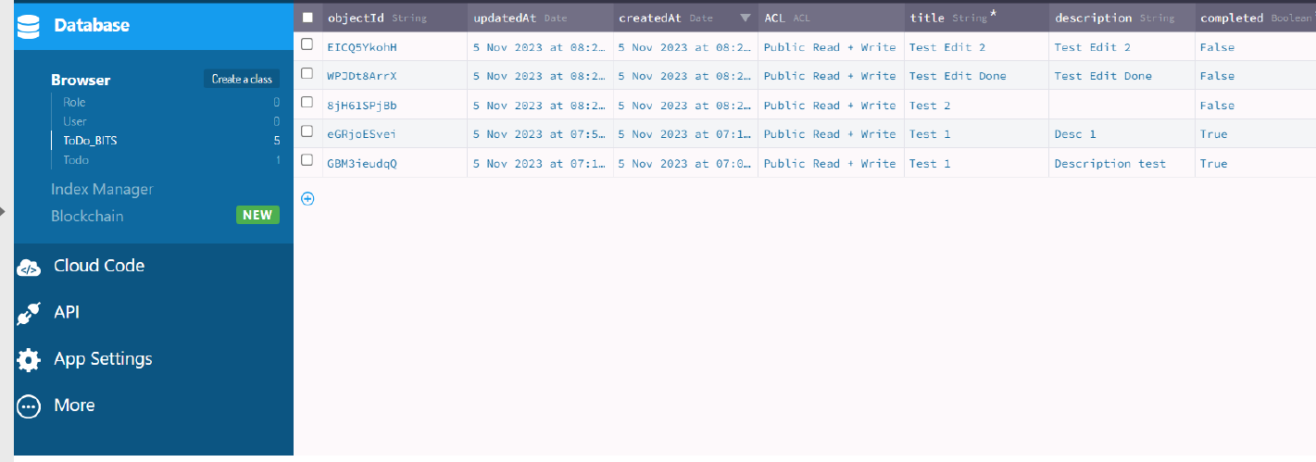

**Step 5: Task Details:**

A task detail can be viewed by tapping on the tasks. A dialogue is shown when a task is

tapped.

Details to be viewed:

Title, Description, Created at, Status of completion

Viewing task details:

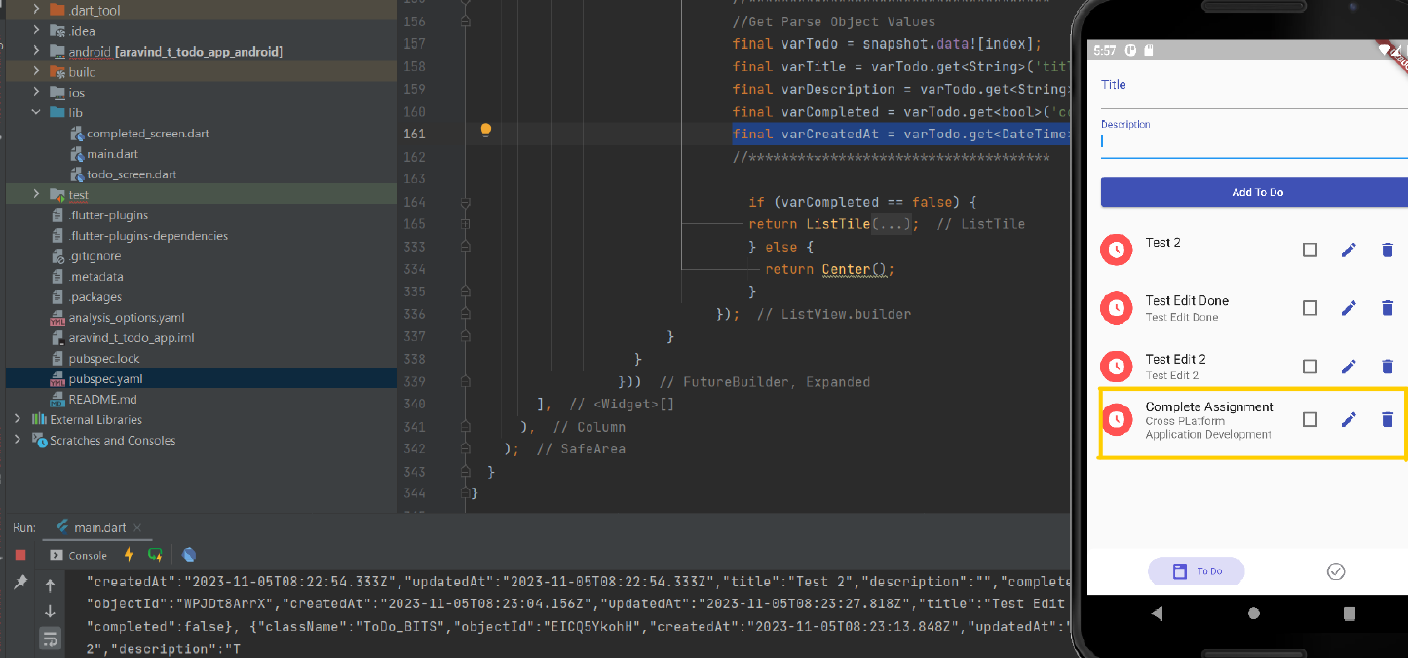

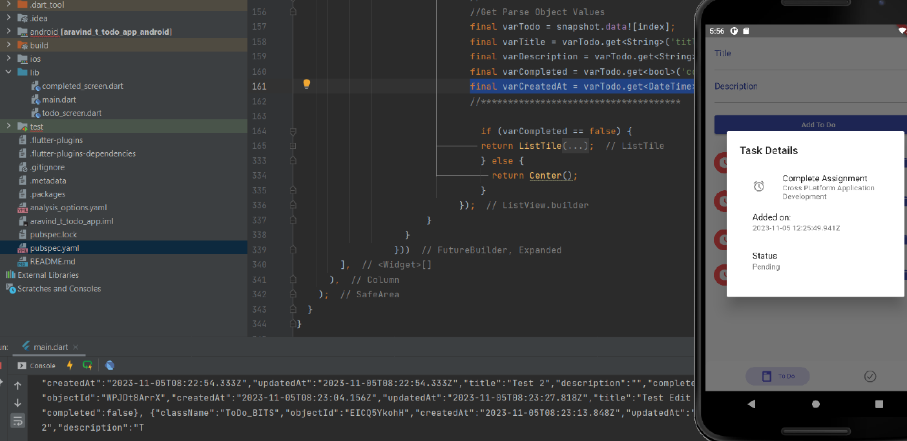

**Step 6: Bonus Features**

**Editing Task:**

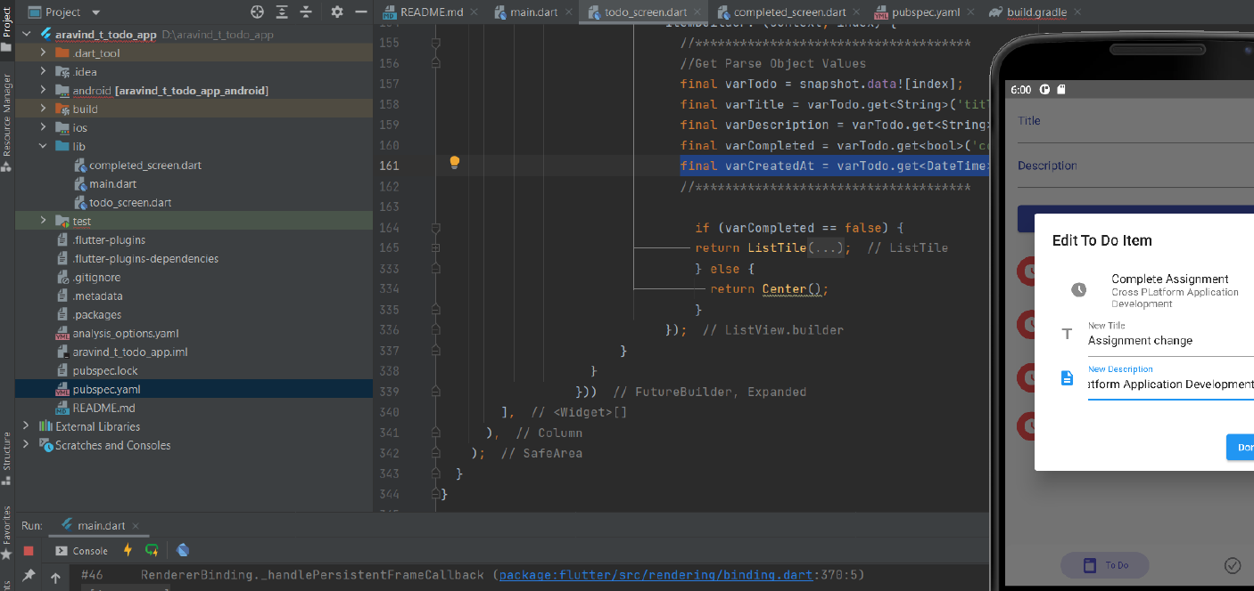

**Deleting Task:**

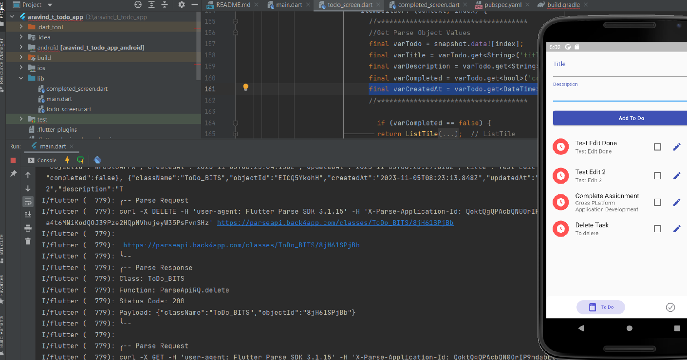

**After deletion:**

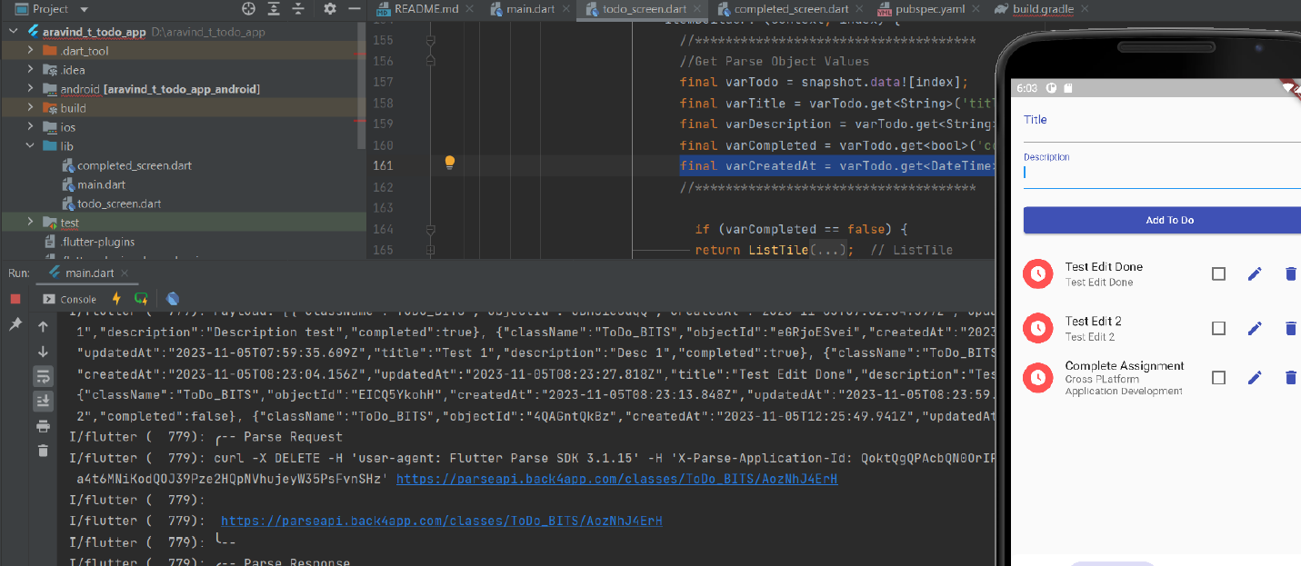

**Additional enhancement:**

**To view completed tasks on a different screen:**

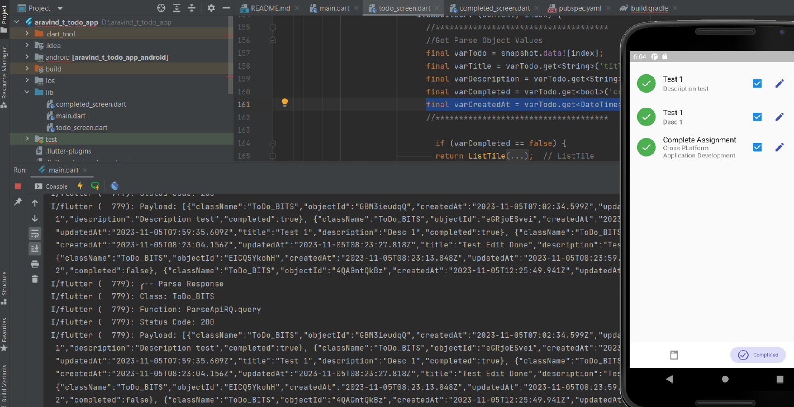

**Readme on setting up and running the app:**

**Step 1:** Download and Install Android Studio on your Laptop or PC.

**Step 2:** Download and install Latest SDK's of Flutter and Dart.

Flutter: https://flutter.dev/docs/get-started/install

Dart: https://dart.dev/get-dart

**Step 3:** Open Android Studio and set up your virtual devices (OR) Connect your Android

Device(USB Debugging enabled) to your Laptop/PC

Used Virtual device : PIXEL 4XL API 30

Refer to this link on how to set up virtual devices :

https://developer.android.com/studio/run/managing-avds

**Step 4:** Go to File -> New -> Project from version control.

**Step 5:** Under the Version control dropdown- Select "Git".

**Step 6:** Under the URL Tab paste the following:

<https://github.com/sforshubhi/CPAD_Back4App_Flutter>

**Step 7:** Choose the directory where you want the Project files to be stored.

**Step 8:** Click on "Clone" and wait for Android Studio to fetch the project files (This may take

a while based on your internet speed).

**Step 9:** Once the project files are loaded, Search for "pubspec.yaml" file in the project folder

and open it.

**Step 10:** On the top right, Android Studio might show a pop-up bar with options named "pub

get" and "pub upgrade". Click on either of these and wait for Android Studio to fetch the

necessary packages to run the application.

Refer to this documentation for more knowledge ->

https://flutter.dev/docs/development/packages-and-plugins/using-packages

**Step 11:** Once everything is done, Choose your Android device on the top dropdown button

and click on Run (A green play button on the top right) or press Shift+F10.

Wait for Android Studio to run Gradle Task and check for any version incompatibilities. Once

everything is alright, the app will be installed and run on your device.

**Concepts learned:**

1. How Back4App integrates with Flutter and cloud APIs.

2. How to create a flutter app from scratch.

3. How to perform CRUD operations over the cloud.

4. How to design and implement assignment requirements over the app.

5. How to embed packages built by Flutter community members.

6. How to upload the project to git and version control.