

**iSurvey**

**Video Repairing**



##### CONTENTS

1 Overview of the Video Repairing Process 4

2 Getting Set-up 4

2.1 Getting the Tools 5

2.2 Setting-up the Tools 5

3 Repairing the Videos 5

3.1 Step 1: Run the Perl File getOriginalMediaData.pl 5

3.2 Step 2: Run the Video Repair Tool 6

3.3 Step 3: Run the Perl File ffmpegSplitThenRecombineVRT.pl 8

4 Final Result 8

# 

**\*\* Make a backup of your data before running these tools to make sure of no data loss \*\***

# Overview of the Video Repairing Process

Below is a general overview of the complete process that you need to undertake:

1. Download the needed tools
2. Add the tools to the System Path
3. Set up a couple of parameters in the getOriginalMediaData.pl Perl script:
   1. $vidOriginalsFolder: needs to point to the folder with the original (broken) videos; .mp4 videos will be searched for in this folder and all its sub-folders
   2. $vidToBeFixedUsingVRTFolder: needs point to a folder you create (this folder must be completely separate from the folder containing the original (broken) videos). This folder will be automatically populated with videos that need to be fixed by the Video Repair Tool.
   3. $vidHaveBeenFixedUsingVRTFolder: needs point to a folder you create (this folder must be completely separate from the folder containing the original (broken) videos). This folder will contain the videos fixed by the Video Repair Tool.
   4. $maxTimeDiffAllowed: if the time (seconds) difference between the audio and video streams in a media file is greater than this, then it is assumed the media file is in error and needs to be fixed with Perl scripts and the Video Repair Tool. Otherwise, the media file is left unchanged.
   5. $iSurveyPerlFixFolder: this parameter must be "C:\\iSurveyMediaFix" and you must create a folder directly under your C:\ drive called “iSurveyMediaFix”. The two Perl files MUST be placed in this folder and run from this folder.
4. Run the Perl file getOriginalMediaData.pl (from “C:\iSurveyMediaFix”). This file is run from the command line via: **C:\iSurveyMediaFix>**perl getOriginalMediaData.pl. More information is given below.
5. Run the Video Repair Tool in Batch repair mode (add all the files in the $vidToBeFixedUsingVRTFolder for batch processing; change its output folder to be $vidHaveBeenFixedUsingVRTFolder). Access the Video Repair Tool via its Graphical User Interface (described below).
6. Run Perl file ffmpegSplitThenRecombineVRT.pl (from “C:\iSurveyMediaFix”). This file is run from the command line via: **C:\iSurveyMediaFix>**perl ffmpegSplitThenRecombineVRT.pl. More information is given below.

# Getting Set-up

This section describes how to get the necessary tools and how to set them up. Perl, MediaInfo (CLI, Command Line Interface) and FFmpeg are executables that need to be added to the system path (as the Perl scripts make use of MediaInfo (CLI) and FFmpeg so they must be able to “see” them).

The Video Repair Tool uses a Graphical User Interface (GUI) and is not called from the Perl files so this does not need to be added to the system path.

## Getting the Tools

1. Strawberry Perl: <http://strawberryperl.com/>

Download the recommended 32-bit version.

1. MediaInfo (CLI): <https://mediaarea.net/en/MediaInfo/Download/Windows>

Download the MediaInfo CLI (v0.7.85) for 32 bit Windows.

**\*\* Note: If MediaInfo (GUI) is already installed, it’ll need to be uninstalled \*\***

1. FFmpeg static builds: <https://ffmpeg.zeranoe.com/builds/>

Download the 32-bit static build of FFmpeg.

The above three tools need to be downloaded and added to the system path (explained below).

1. Grau Video Repair Tool (GmbH): <http://grauonline.de/cms2/?page_id=5>

Download: http://grauonline.de/cms2/?page_id=5#download

Purchase: <http://grauonline.de/cms2/?page_id=5#purchase>

More details are given on how to use this tool is given below.

## Setting-up the Tools

### Perl, MediaInfo (CLI) and FFmpeg

Add the executables for Perl, MediaInfo and FFmpeg to the system path environment variable as this de-clutters folders and makes execution smoother:

1. From the desktop, right-click My Computer and click Properties.
2. In the System Properties window, click on the Advanced tab
3. In the Advanced section, click the Environment Variables button.
4. Finally, in the Environment Variables window (as shown below), highlight the Path variable in the Systems Variable section and click the Edit button. Add or modify the path lines with the paths you wish the computer to access. Each different directory is separated with a semicolon, for example: C:\Program Files\MediaInfo; C:\Program Files\FFmpeg; C:\Program Files\Strawberry

### Video Repair Tool

Open the folder where the Video Repair Tool was downloaded to, look for the “gs.exe” executable and double click it to launch the GUI. Usage of the Video Repair Tool is described below.

# Repairing the Videos

## Step 1: Run the Perl File getOriginalMediaData.pl

The first step in repairing the files is to run the Perl script getOriginalMediaData.pl. There are two Perl files: getOriginalMediaData.pl and ffmpegSplitThenRecombineVRT.pl. There are a few parameters to set in getOriginalMediaData.pl, there are no parameters to set in ffmpegSplitThenRecombineVRT.pl. Follow these steps to set the parameters for getOriginalMediaData.pl:

1. You must create the folder: “C:\iSurveyMediaFix”.
2. You must put the two Perl files in this newly created folder.
3. You must set the following parameters in getOriginalMediaData.pl (under the “##### user MUST initialise these #####” banner):
4. $vidOriginalsFolder: You must set this parameter to point to the top level folder of the original (broken) videos (it will recursively search all sub-directories from here).
5. $vidToBeFixedUsingVRTFolder: You must create a new folder (in a completely different directory hierarchy to the $vidsOriginalFolder) and point the $vidToBeFixedUsingVRTFolder parameter to this folder. Files to be fixed by the Video Repair Tool will be automatically copied to this folder by getOriginalMediaData.pl.
6. $vidHaveBeenFixedUsingVRTFolder: You must create a new folder (in a completely different directory hierarchy to the $vidsOriginalFolder) and point the $vidHaveBeenFixedUsingVRTFolder parameter to this folder. Files fixed by the Video Repair Tool should go in here. In the Video Repair Tool “Options”; the “Change output folder” should point to this $vidHaveBeenFixedUsingVRTFolder folder (see the Video Repair Tool Section).
7. $maxTimeDiffAllowed: this is the time difference allowed (in seconds) between the audio stream and the video stream; if the time difference between the audio and video streams is greater than this, then the media file will be fixed. If the time difference between the audio and video streams is less than or equal to this, then the media file will be left as it is (not fixed).
8. $iSurveyPerlFixFolder: Do not change this parameter in the Perl file as it points to the “C:\iSurveyMediaFix” folder that you have just created.

Open up a command prompt, navigate to “C:\iSurveyMediaFix”, then run the Perl script by typing: “perl getOriginalMediaData.pl”.

## Step 2: Run the Video Repair Tool

### Step A: Batch Repairs

Click “Batch repairs” and then click “Add” to manually select the videos that are to be batch processed.

Add all the files from the folder $vidToBeFixedUsingVRTFolder for batch processing.

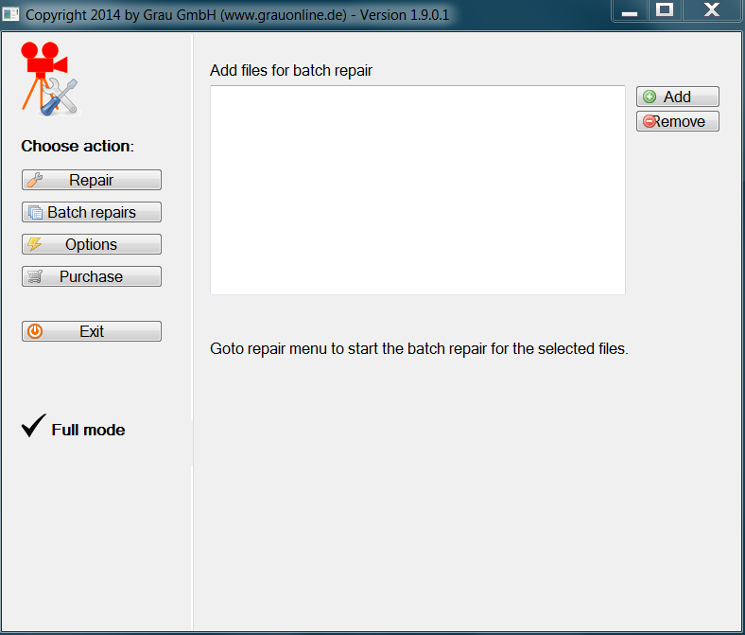

### Step B: Options

Select “Options”; keep all the default settings EXCEPT add a tick to “No CTTS repair” (as shown below).

At the bottom, there is a button to “Change output folder” of the Video Repair Tool’s fixed videos; set this to folder $vidHaveBeenFixedUsingVRTFolder (remember, this should be in a completely distinct directory hierarchy to that of the original (broken) videos).

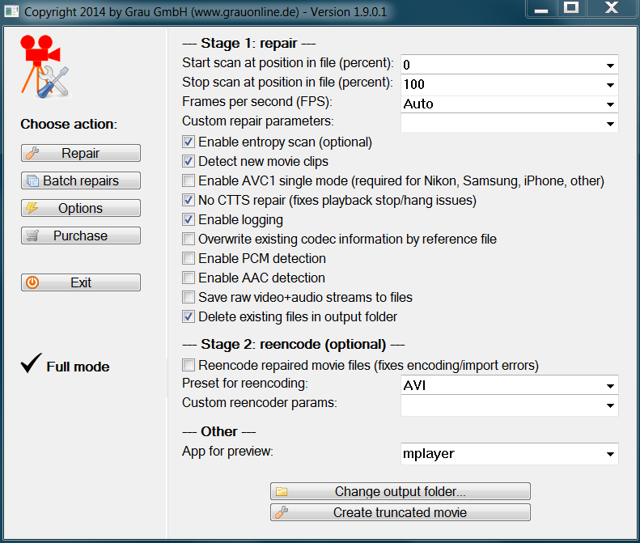

### Step C: Repair

Select “Repair”. To start the batch process and have the Video Repair Tool fix the videos and place these in our chosen output folder, merely press the “Scan” button.

As videos are fixed, they will appear as a list in the “Repaired movies clips” (as shown below).

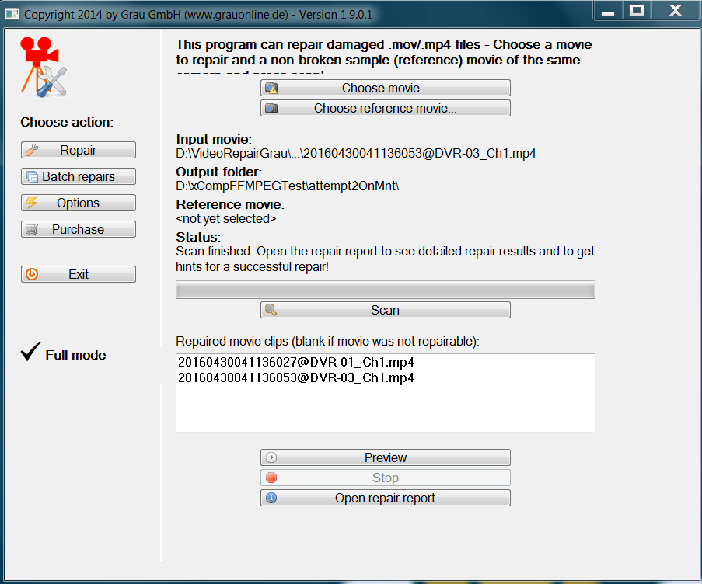

## Step 3: Run the Perl File ffmpegSplitThenRecombineVRT.pl

After running the Perl file getOriginalMediaData.pl and then running the Video Repair Tool, the last step in the process is to run the Perl file ffmpegSplitThenRecombineVRT.pl.

Open up a command prompt, navigate to “C:\iSurveyMediaFix” and then run the Perl script by typing: “perl ffmpegSplitThenRecombineVRT.pl”.

# Final Result

After running the Perl files and the Video Repair Tool, a fixed video will automatically be moved to the folder containing the original (broken) version of its self. The broken video will have “_broken” added to its moniker and the fixed video will assume the original (broken) video’s name. Thus, the fixed video will be part of the dataset and the “_broken” video will not.