Milestone 3 – Following the Travel Bug

CSCI 3172

Shannon Frederick

B00319695

Pat Crysdale

December 12, 2020

**Following the Travel Bug Web Application**

This project was created for CSCI 3172 in Fall 2020. It is an e-commerce and community site for people to gather and share ideas, tips, and lessons about van life as well as an opportunity to build and design their dream van.

This idea originated from my personal love of van life and my frustration with the inability to find a company that can help build out a van or even source a reasonable second-hand van and its' equipment in the Maritimes. The closest is Quebec then there is a great on in Ohio that is well priced if you make American dollars, but the conversion is financially not a good investment.

#### Instructions to run:

Introduction

This application is built using primarily React. Its backend is built using Node.js and many functions and features including the database and authentication system use Firebase tools.

To Run

To run the application locally, "npm start" will start the local server which should run on localhost:3000. Alternatively, the site is hosted at ‘following-the-travel-bug.web.app’ or and potentially [www.followingthetravelbug.com](http://www.followingthetravelbug.com). Below, is a link to my GitLab repository.

[**https://git.cs.dal.ca/frederick/csci3172_fttb**](https://git.cs.dal.ca/frederick/csci3172_fttb)

Features

The following pages are included in the application submission. They page names are followed by their URL path.

* Home page ('/')
* Who We Are ('/whoWeAre')
* What We Do ('/whatWeDo')
* How It Works ('/howItWorks')
* Shop ('/shop')
* Community ('/community')
* Registration ('/signUp)
* Login ('/login)
* Admin Dash ('/adminDash')
* Product Detail ('/product')
* Cart ('/cart')
* Payment ('/payment')
* Partners Page ('/partners')
* Contact Us ('/contactUs')

These pages contain mostly lorum ipsum text for text content and images are all off of Instagram and Pinterest boards. Database schema has been created even if unused by code. Please see Figures 1-4 below.

Incomplete or For Future Development

These features are portions that I would have liked to have had completed for this Milestone or features that I would ideally like to develop for future use of this application for portfolio use

* Forgot Password Page and Functionality (function created)
* Change Password Page and Functionality (function created)
* Profile page filled by database information
* A database of products to populate the Shop page, so it's not just one product available
* Further database development (Populated collections)
* Further backend interaction
* Role based authentication
* Functional Admin Dashboard (Ability to populate and manipulate the database collections)
* Careers Page

The reason many of these functions and pages were not implemented was because learning React took far longer than anticipated and the many resources available ended up with a lot of backtracking and re-creating certain components to function in all the ways necessary. Further database interaction was not yet implemented to prevent unnecessary vulnerabilities at this stage.

**Figures**

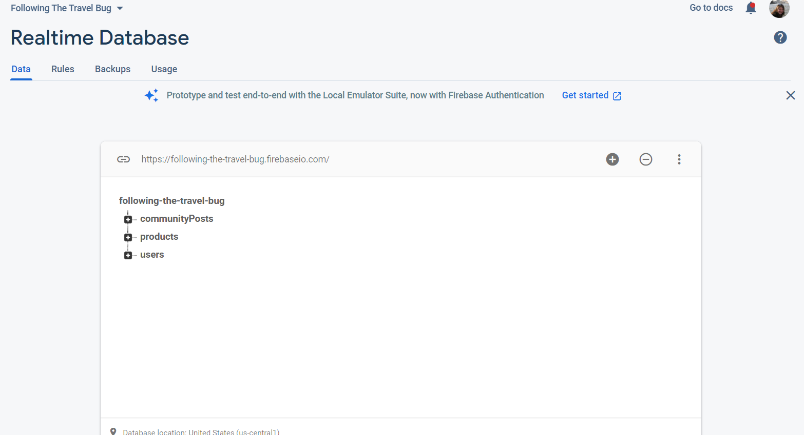

Figure : Firebase Realtime Database set up with users, products and community post collections

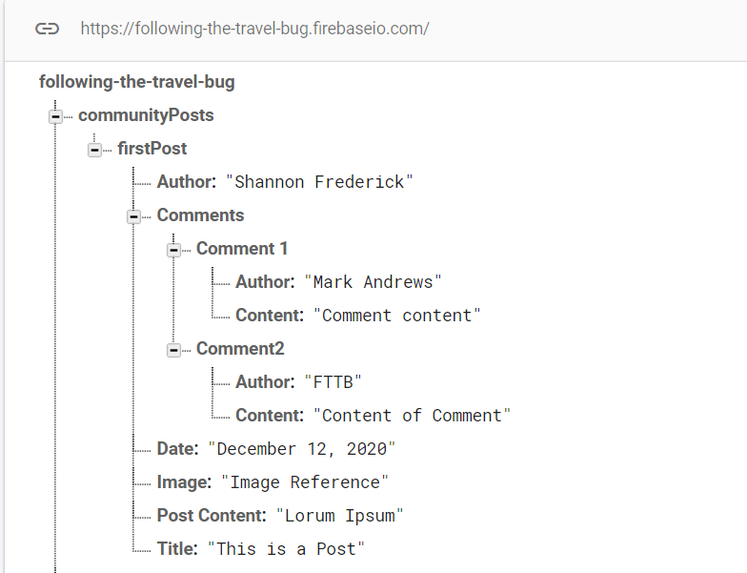

Figure : Community Posts collection with a post added and various important information added as will be with each post

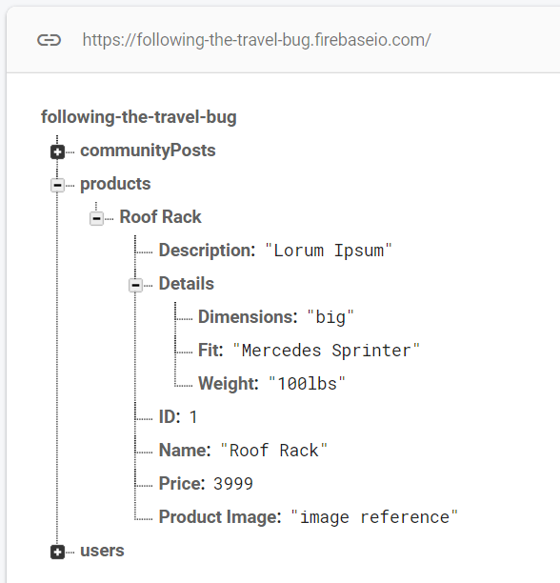

Figure : Product collection with an entry of the roof rack that is shown on the application including important details

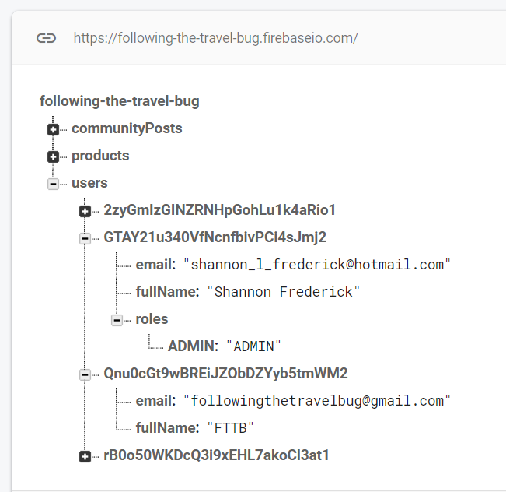

Figure : Users collection showing the email and name saved but not the password. Entries created when registering on application. Not manually input

**Citations**

Please find citations in the README file within the GitLab repository.