# R setup for Markdown

# Components

There are three components in the header:

1. style_example.docx is a Word file with the styles you want to use. Edit the layout options in this file to get different styles for Header 1, etc.
2. header.yaml is the basic yaml header for the doc.
3. citestyle.csl has the citation formatting
4. bibliography.bib is your bibliography. Refer to this when tagging references in your doc.

# Example of imported text.

Using “children,” you can have a hybrid Markdown file containing both regular Markdown in the .Rmd file, and text chunks you’ve downloaded from google drive. So! This here is text I typed straight into the Rmd, and …

This text can be edited live in google drive but all your collaborators. With this script, you can use all the usual R Markdown syntax like this using citations (here I will cite (Lowndes et al. 2017)). You can use other Rmd syntax like *italics*, **bold text**, and in this case a number from R like 5. Here is a citation of a table (Table ), and here is a citation of a figure (Figure ).

# Tables

**Table** **:** This is a caption for a table. A hot tip for tables and figures is that Markdown hates underscores in your figure ids. So if you assign a figure id, use hyphens instead.

| Label | Number |
| --- | --- |
| A | 1.0267675 |
| B | 0.8467868 |
| C | 1.1804813 |

# Figures

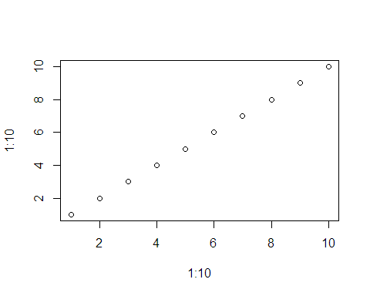

**Figure** **:** This is a caption for a figure.

# References

Lowndes JSS, Best BD, Scarborough C, Afflerbach JC, Frazier MR, O’Hara CC, Jiang N, Halpern BS. 2017. [Our path to better science in less time using open data science tools](https://doi.org/10.1038/s41559-017-0160). Nature Ecology & Evolution 1: 1–7.