Building CyberDragon from source

What you need:

1. Qt Creator IDE with Qt 5.4.1.

For Windows users get it from:
http://download.qt.io/official_releases/online_installers/qt-opensource-windows-x86-online.exe

Remember to select MinGW from Tools section when installing (I only have build with MinGW so I don't have a clue if it works with Visual Studio).

For Linux users: Either use your Linux package manager or if none is provided by your Linux distro (horror!) then get it from:
https://download.qt.io/archive/qt/5.4/5.4.1/
'
2. Perl.

For Windows users get it from: http://strawberryperl.com/
For Linux users it is probably already installed. If not then do ”yum install perl”, ”apt-get perl” or whatever package manager/command your distro is using.

3. zlib, GeoIP and OpenSSL

For Windows users I have provided pre-built zlib, GeoIP and OpenSSL binaries (just take a look at ”include” and ”libs” folders) and they will be automatically used when building under Windows.
Linux users must install the above mentioned dependencies with their package manager. Usually the ”yum install zlib-devel GeoIP-devel openssl-devel” or something similar should do the trick.

Next step: Setting up your build environment.

Before launching Qt Creator we need to install one addon module that CyberDragon needs, namely the qtftp add-on that provides FTP support.

You have to ask Digia (or maybe Nokia) why they decided in their infinite wisdom to remove FTP support from the Qt network core in 5.x.....

Without qtftp you will get ”Project ERROR: Unknown module(s) in QT: ftp” and won't be able to compile CyberDragon.

I have provided qtftp zip file with the source package so you don't have to go hunting for it.

Now, the following steps are for Windows users. Linux users can skip to step 4.

Step 1. Open your Qt 5.4 command prompt (look under from Qt | 5.4 | MinGW (32-bit) )
This is what you should see.

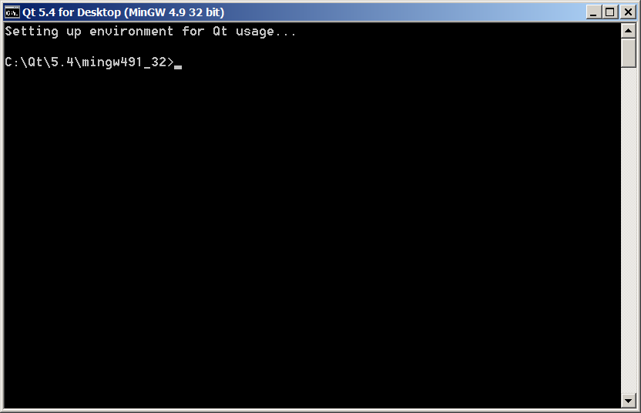

Step 2. Ensure that you have g++, mingw32-make and perl working.

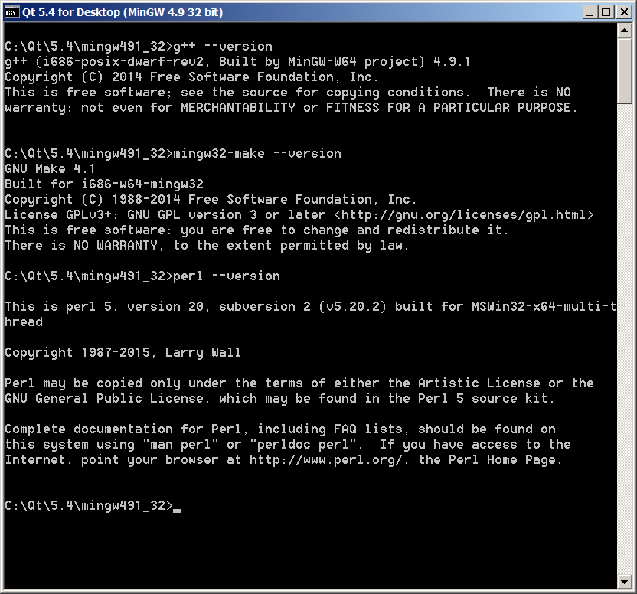

Step 3. Just in case check your path (this is only needed if you other development tools installed to your machine, like cygwin or older 32-bit MinGW). Type echo %PATH%

Make sure that C:\Qt\5.4\mingw491_32\bin, C:\Qt\Tools\mingw491_32\bin, C:\Strawberry\perl\site\bin and C:\Strawberry\perl\bin are listed before any other development tools you might have.

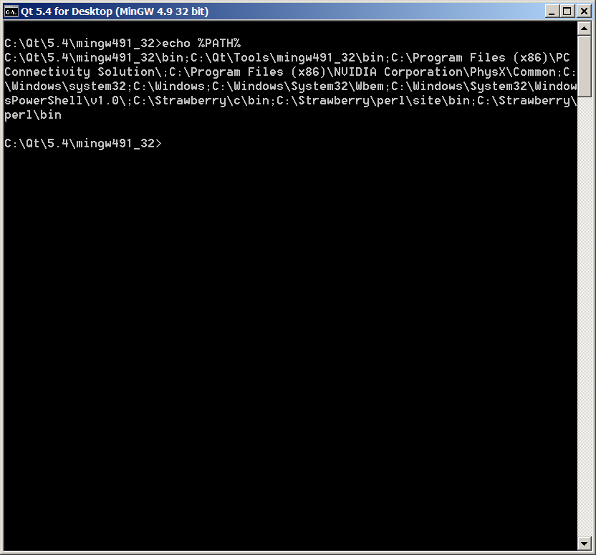

Step 4. Unzip the qtftp-master.zip that is included with the source. Windows has builtin support for zip files. Linux users should have some GUI tool for that or just use unzip from command line.
(and if you don't have unzip installed do the ”yum install unzip” or ”apt-get unzip” dance again )
Alternatively, there is also qt-qtftp.tar.gz for Linux users that you can extract with simple tar -xavf qt-qtftp.tar.gz command.

Then go to the directory where you unzipped qtftp and execute perl C:\Qt\5.4\mingw491_32\bin\syncqt.pl -version 5.4.1 for window users.

Linux users could try perl /usr/bin/syncqt.pl -version 5.4.1.

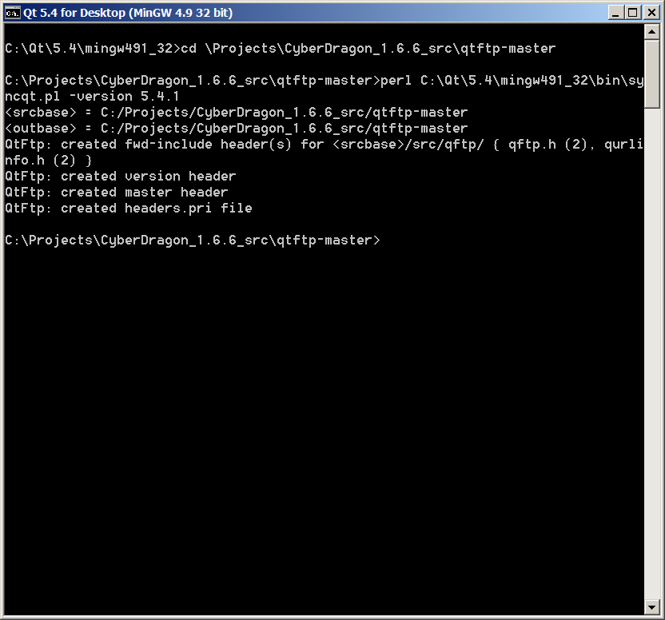

Step 5. Compile and install.
For Windows users do: qmake && mingw32-make && mingw32-make install
For Linux users do: qmake (or sometimes qmake-qt5) && make && make install

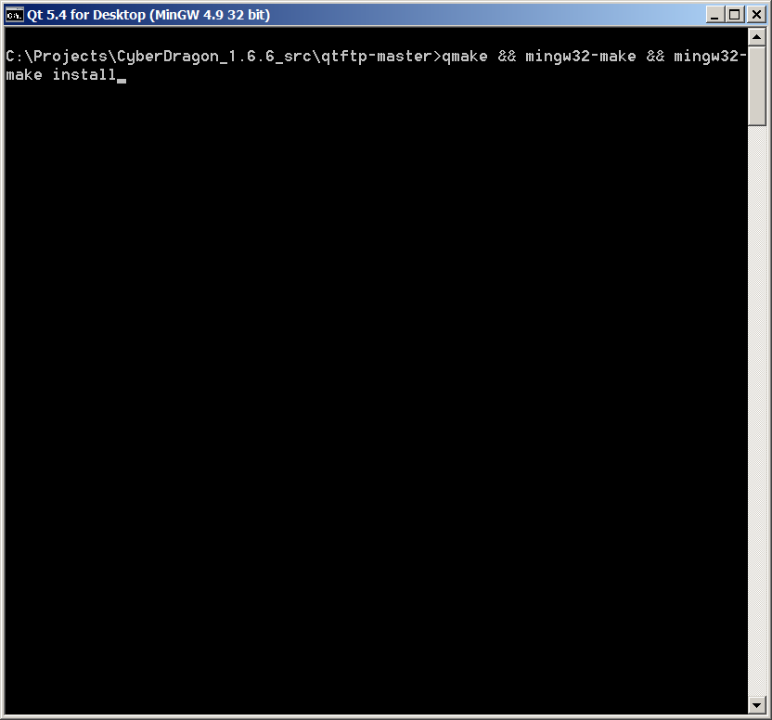

You are now ready to launch Qt Creator. Open CyberDragon.pro file and it will automatically open it with Qt Creator.

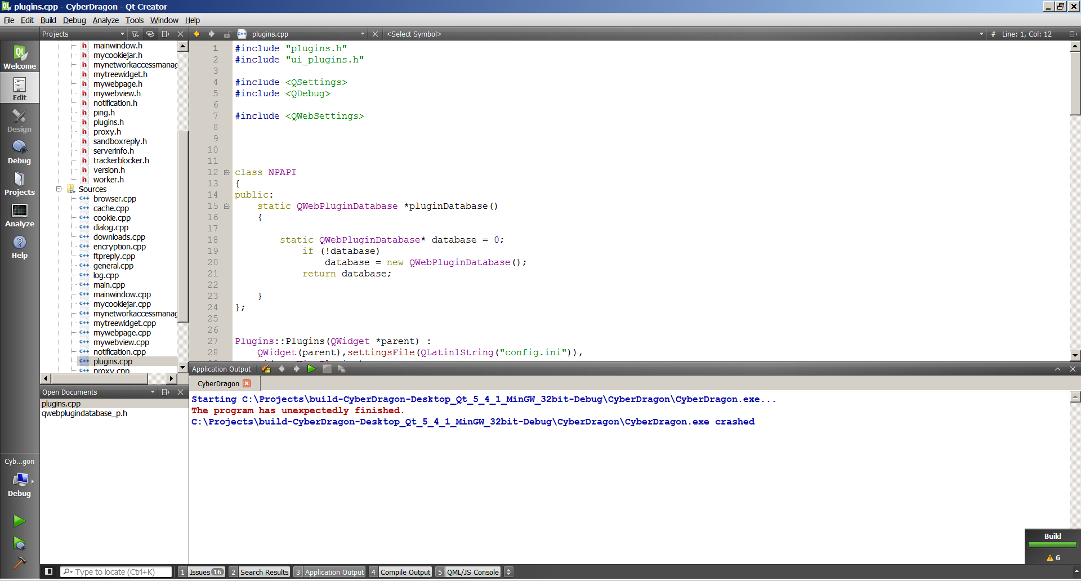
At the bottom left corner you can choose either Debug build or Release build. To build just click the upper green arrow or alternatively press Ctrl + R.

One more step before you start compiling: click the Projects button from the left and then click Add Build Step and from there choose Make

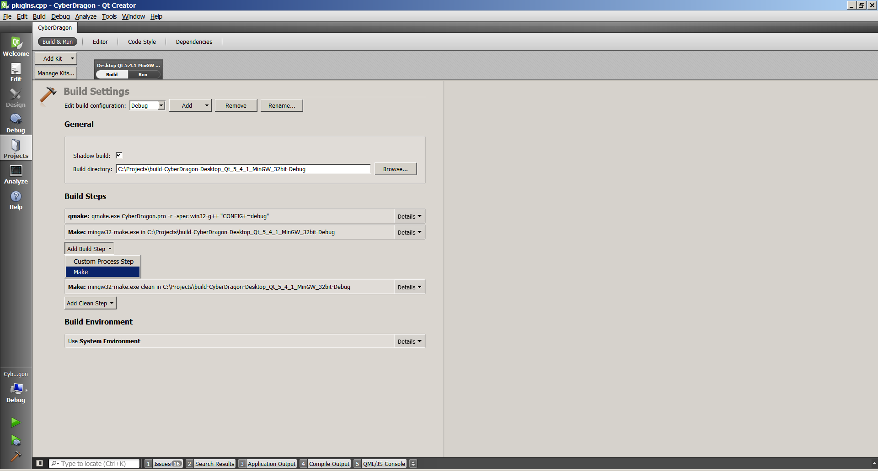

Then type install to Make arguments field.
You have to do this step for both Debug build and Release build.

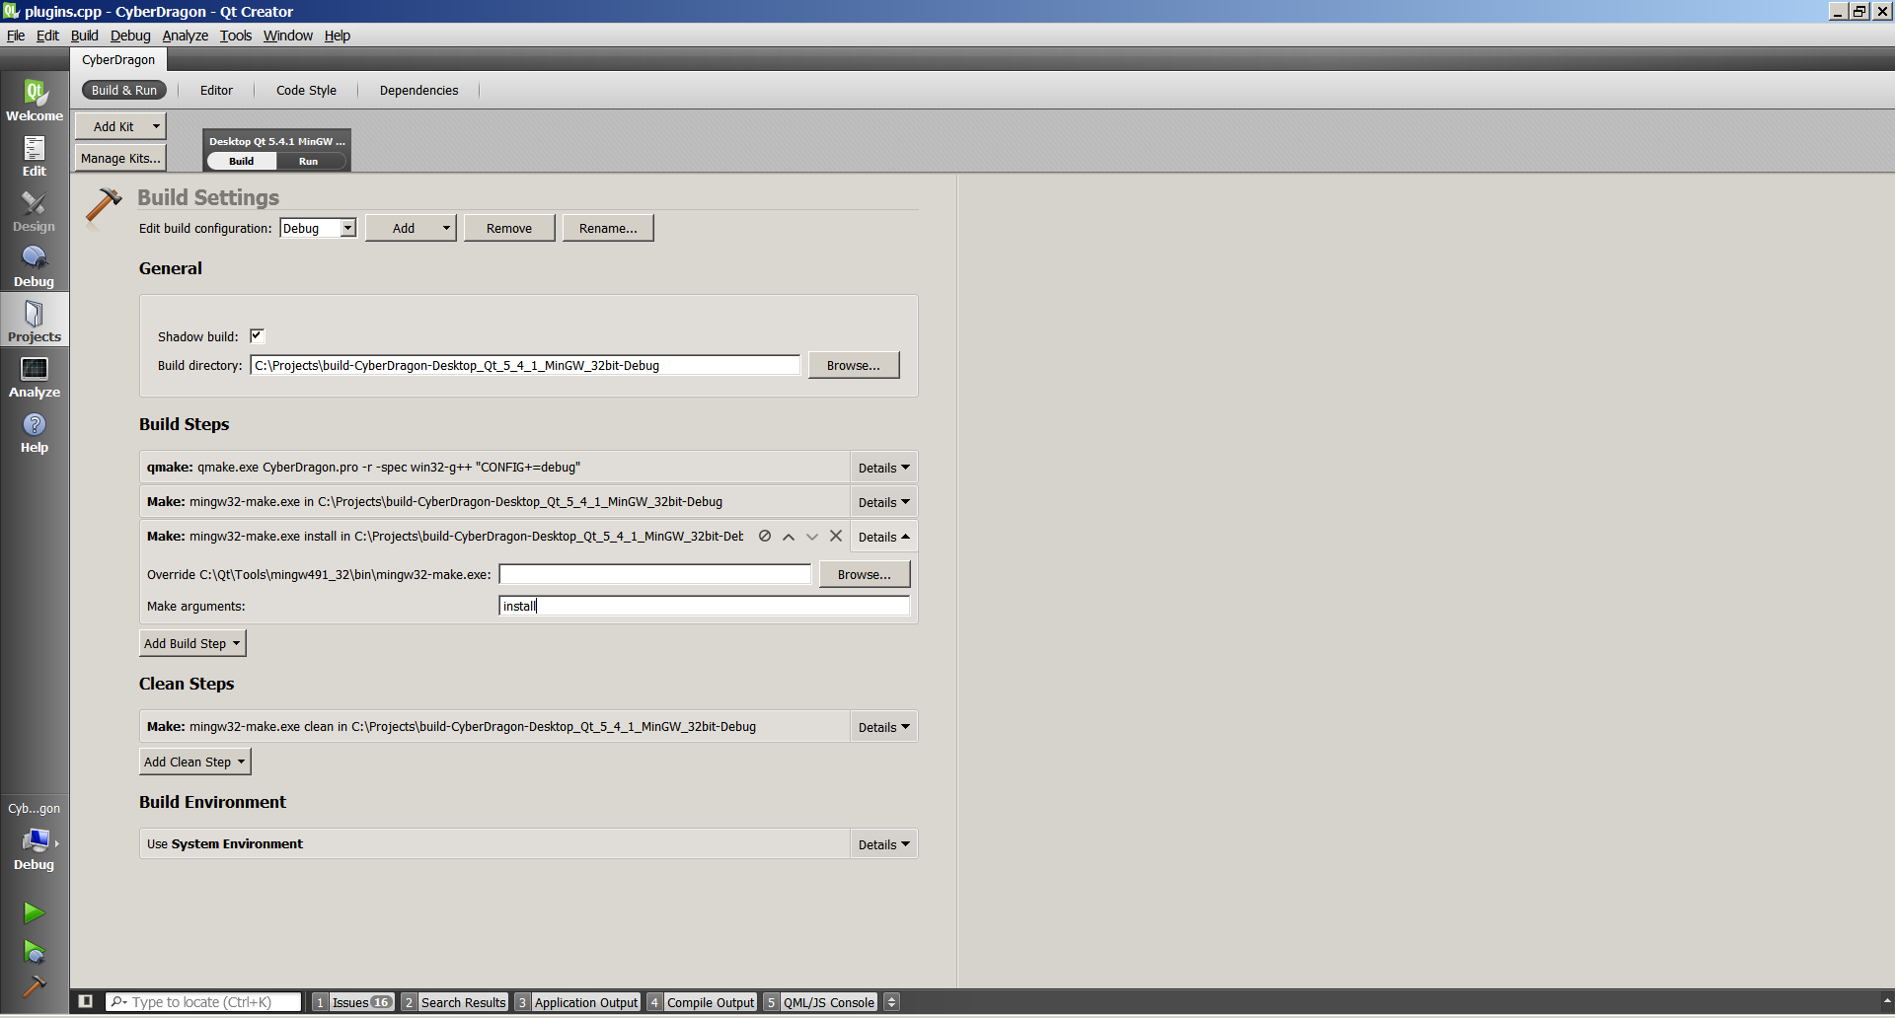
Now click the Edit button from left and then the Compile Output at the bottom.
Finally you can press that green arrow (or Ctrl + R) and watch stuff scroll ;-)
If everything went ok, it will automatically start CyberDragon after successfull compile.

Have Fun!

