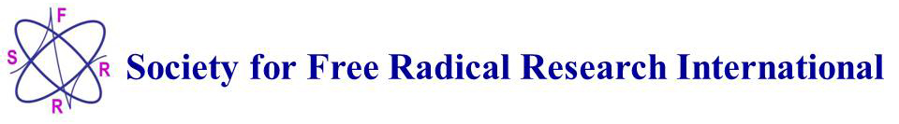

Nomination Guidelines for SFRR-I Kelvin & Joanna Davies Rising Star Award Lecture 2025

We are seeking nominations for the newly established SFRR – International Kelvin and Joanna Davies Rising Star Award Lecture 2025 to be given at the 22nd SFRR – International Biennial Meeting (hosted by SFRR-Europe) in the University of Galway, Ireland 3-6 June 2025. Further information is available from the meeting website:
https://www.sfrrgalway2025.com

The Kelvin and Joanna Davies Rising Star Award is intended to recognize an emerging leader in the Free Radical/Redox Biology field, whose record reflects ongoing and exceptional scientific growth and contributions to our body of knowledge, and increased levels of leadership, responsibility and sphere of impact. Awardees must hold an earned doctoral degree, have completed postdoctoral training, and be in the first six years of a tenure-track appointment, or equivalent. While eligible nominees will have not yet reached a senior-level position, their track record must reflect a strong career trajectory with the probability of forward advancement and potential for appointment at the highest levels.

Nomination Requirements:

Nominations for the Kelvin and Joanna Davies Rising Star Award must be submitted with the candidate's permission. Self nominations are not accepted. Nomination letters must address each of the following considerations: 1) Explain why the nominee is deserving of a Rising Star award; 2) Reference impactful publications and their scientific significance; 3) Illustrate originality of the nominee’s research program and independence; 4) Indicate other key ways in which the nominee has influenced the field of Free Radical/Redox Biology; 5) Detail any service or leadership positions the nominee has held; 6) Elucidate the nominees contributions to mentorship.

Nomination letters may be of one to three pages in length and may be signed by any number of nominators; separate nomination letters should not be submitted. While a nominee’s CV or resume provides the committee with a more comprehensive overview of the nominee's accomplishments and experiences, it is not a substitute for the detail that must be provided in the nomination letter.

These Rising Star Awards are made possible through the generosity of Profs. Kelvin J. A. Davies and Joanna M. S. Davies. The award consists of a medal and certificate, and it is a requirement that the recipient presents a lecture at the Biennial meeting where the award is made and subsequently contributes an invited Review Article to Free Radical Biology & Medicine.

Once the nominations have been received, the SFRR – International Executive Committee and members of an International Scientific Committee, including Kelvin and Joanna Davies, will evaluate these nominations and select the Rising Star Award Lecturer for 2025.

Deadline for receipt of nominations by email is 20 September 2024.

Please disseminate this ‘Call for Nominations’ to your regional SFRR membership.

Nomination(s) should be emailed as a single PDF file to Patricia I. Oteiza (Email: poteiza@ucdavis.edu).

Prof. Patricia I. Oteiza
Secretary General SFRR – International

