**Project deployment documentation**

1. Download the project from the git repository from the following link :

<https://github.com/sfshakil/FileProcessing>

1. Open the project with IntelliJ IDEA.

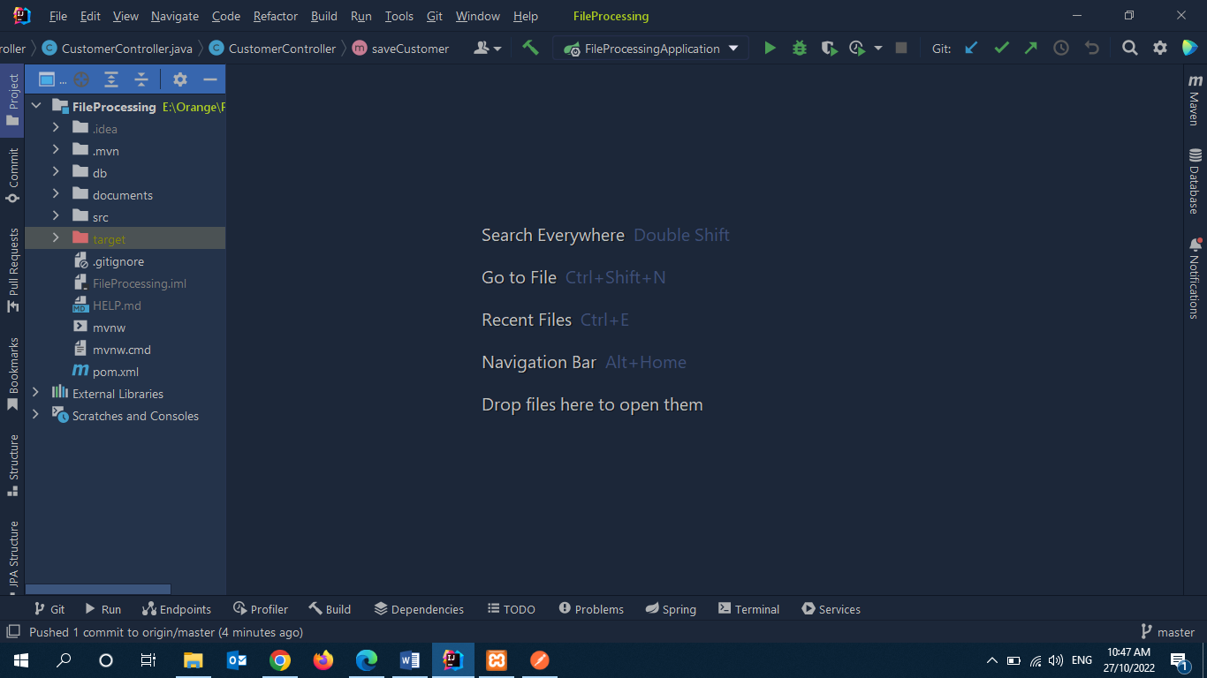

1. Import the project DB into MySQL Database. Project DB is present in the DB folder in the project folder named **orange.sql.**
2. After that debug the project and then run the project.
3. To start our file processing method we need to call a REST API using postman. URL is [**http://localhost:8035/customer/save**](http://localhost:8035/customer/save)**.** Method is the Post method.

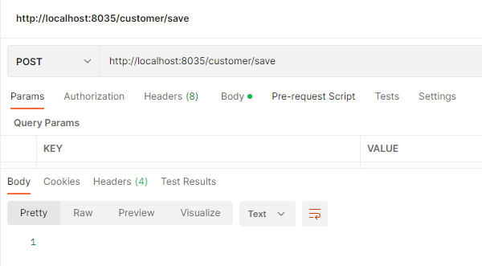

1. Then our file will be start for processing.

**Results:**

1. **Start time -- Wed Oct 26 16:15:36 BDT 2022**
2. **End time -- Wed Oct 26 16:17:34 BDT 2022**
3. **Total execution time is 1minutes 58 seconds (With DB storing time).**
4. **1231081 - Lines in the original file.**
5. **100001 - Lines after removing the duplicate.**
6. **1131080 - Duplicate lines.**
7. **99,838 - Validate lines.**
8. **163 - Invalidate lines.**