Term Project Milestone 1
CSC 667

Team-B Members: Alex Bautista, Alfred Quezada, Luis Almeida
Github Repository: https://github.com/sfsu-csc-667-spring-2018/term-project-team-b

Project Specifications

Introduction
Uno is a card game for up to 2 to 7 players, played anywhere on a flat surface, most commonly on a table. For each round in play, a dealer must be designated. For every round, players start out with 7 cards each that only each player can see, one discard pile and one stack pile. There are regular cards with a number and a color, and special action cards with an action and a color, or the infamous Wild cards. Dealer starts game by selecting top card on stack pile and placing it face up on the discard pile. Next player, usually to the left of the dealer, continues the next play, depending on the card visible on the discard pile. Players continue taking turns until one player has no more cards, and that player has called Uno correctly at the right time. This ends the round, and the winning player adds up their points by counting the leftover cards of the other players. A new round begins with last round's winner as dealer. First player to 500 points wins.

Features

Authentication and Permissions

Real Time Chat
Real time chat will be provided in two locations, one in the main lobby, after the user has successfully logged in, and the other one will be in the individual game rooms. Chat rooms show the user handle, time stamp, and message content for every message sent. Users can only chat with other users in the same game room at the same time, or in the main lobby at the same time.

Lobby
The lobby is the main page where players will be directed to first, as soon as they get through authentications and permissions. This lobby will provide a real time chat section, player list currently in lobby, and necessary features to either create or join a game.

Waiting Room
The waiting room would be where some players can wait for other players to join their game since a game can have minimum of 2 players and a maximum of 4. Waiting room will provide a player list as well as the a real time chat room only for players that are currently in the same room.

Game Page

Technologies
Heroku, Node.js, Express.js, Postgres

WireFrames

Login

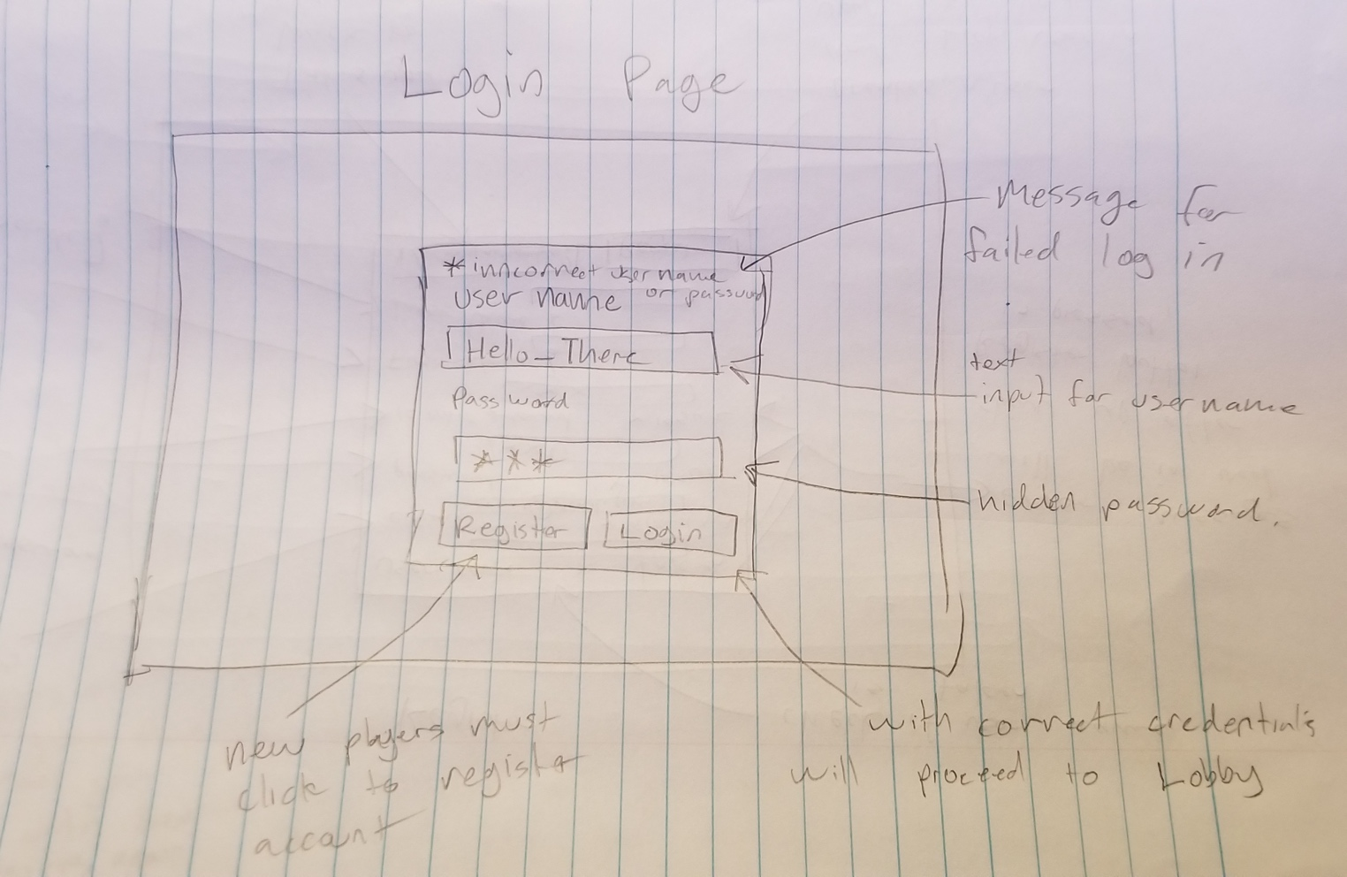

Register
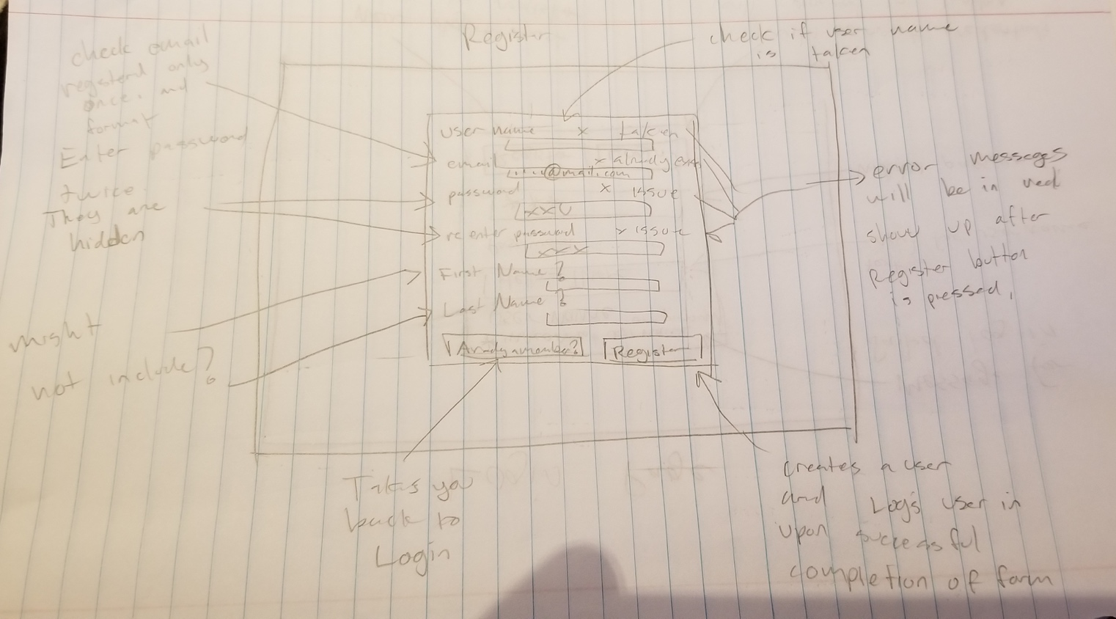

Lobby

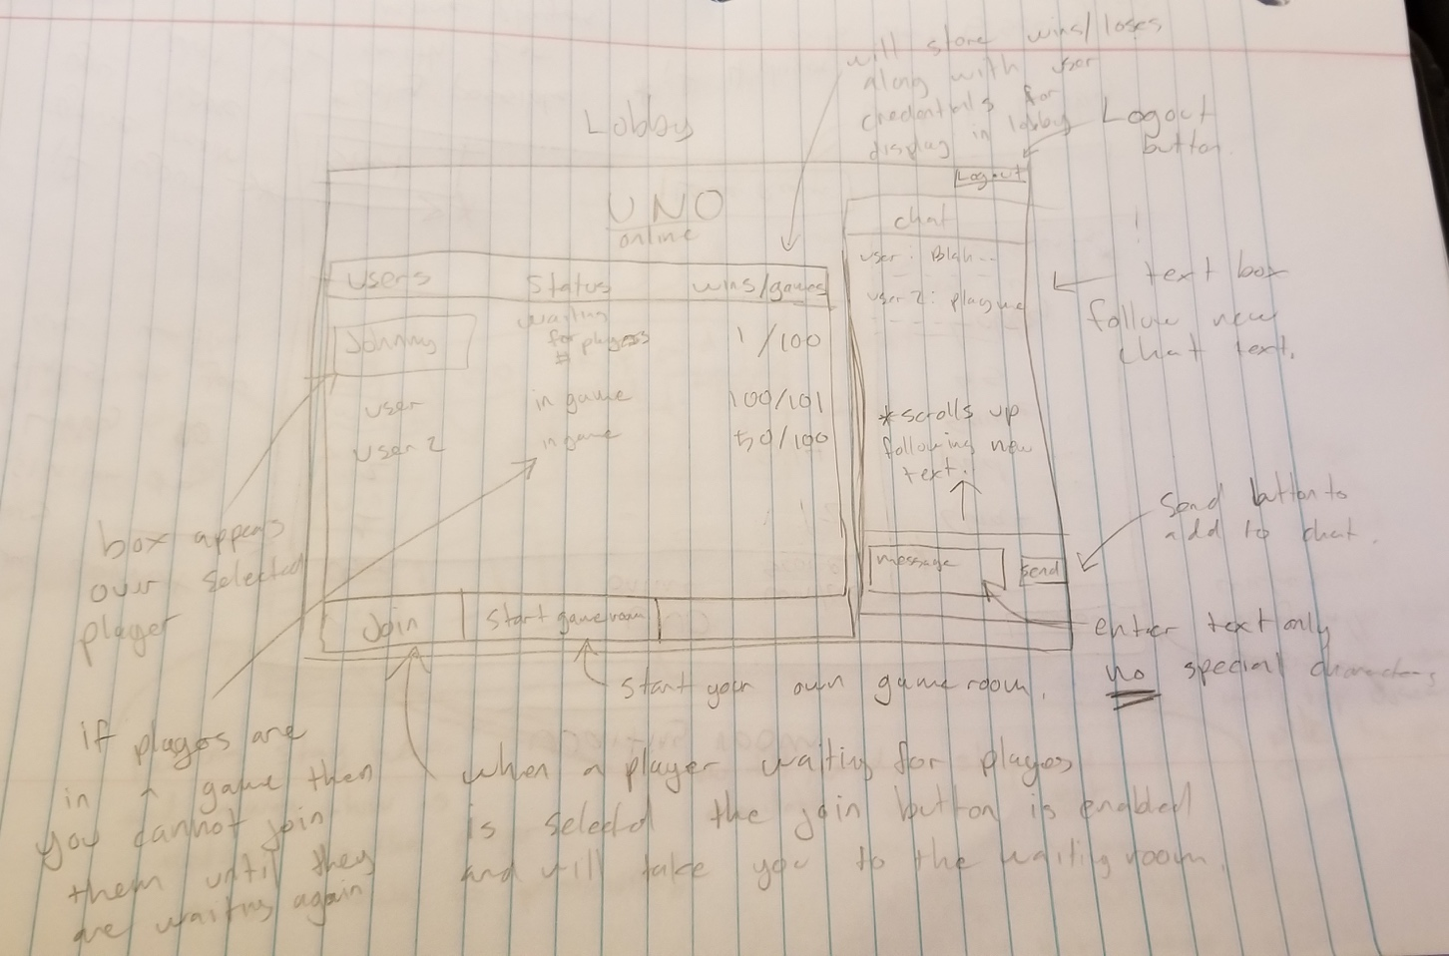

Waiting Room
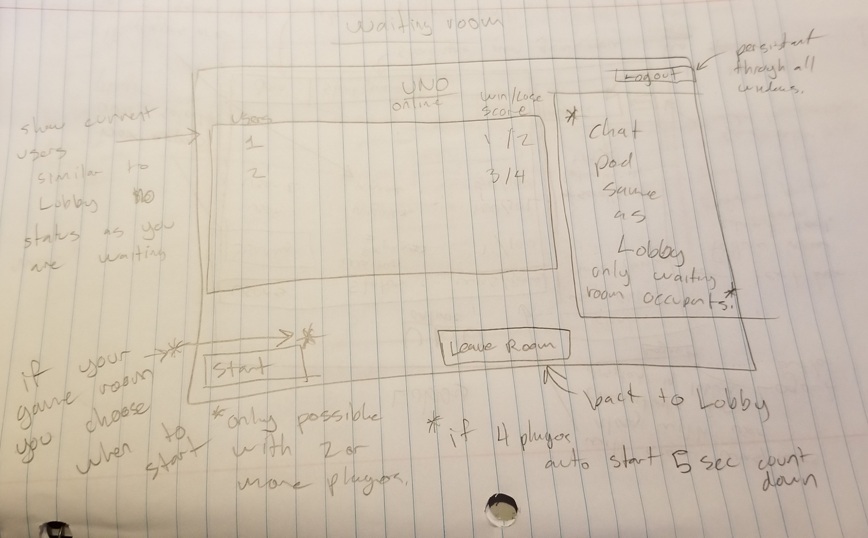

Gameroom
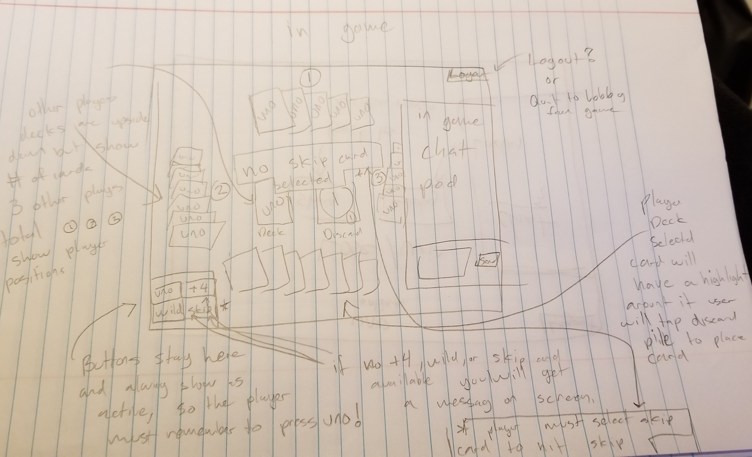

Result
