**SWINDON FILM SOCIETY**

**…. for the best in world cinema**

**ANNUAL REPORT 2019-20 SEASON**

**Introduction**

Last season’s films had consistently good attendances and were well received. Unfortunately, due to the start of the coronavirus lockdown in March, we were unable to show our final two films *1945* and *The Wife*. We have chosen films for the new season as usual, but are awaiting the Wyvern’s confirmation of a start date.

Once again, we were really pleased with the contribution made by the Wyvern staff and volunteers.

**Finance**

*These notes should be read in conjunction with the annual financial accounts which have been audited.*

***OUTLINE:*** ln the year ending July 2020, the Society made a profit of £1,328. To put this into perspective, please look at the lncome & Expenditure Statement, which gives the figures for the past 7 years, starting with the year 2013-14 This continues an ongoing trend of an overall profit over the past 3 years, with a slight decrease from 2018-19.

***INCOME:*** Total income has decreased by £1,053 over the previous year 2018-19. We received £40 more in membership fees but £1115 less in ticket sales. The costs of membership and ticket admissions were unchanged from 2018-19 but, overall, there were fewer *Season* and *Pay as You Go* members. This was affected by the cancellation of the last two films as the season was brought to an abrupt end due to the global pandemic. The attendance numbers had been comparable to the previous year’s up until that point.

***SPENDING:*** Our spending also decreased by £829 compared to the year before. The two biggest costs continue to be the hire of the Arts Centre and paying the film licences. We are grateful to lan Robertson, retired accountant, who has once again been kind enough to examine our books and sign them off free of charge

***SUMMARY:*** As the Society Treasurer, I welcome our overall financial stability; this gives us some leeway when considering options for restarting future film seasons in this unprecedented time. We would rather be showing films than remaining closed and in order to do so, it may be necessary to accept a less profitable period of operations, for example, if we have to restrict audience numbers.

**Membership**

The figures for this year represent the totals for 12 films rather than the full season of 14 films due to the early termination of the 2019-20 season because of the national lockdown in response to the COVID-19 pandemic. This may go some way to explain the reduction in membership from previous years.

SFS membership for the 2019-20 season dropped from the previous year, however whilst there was a significant reduction in the number of *‘Pay as You Go’* members, season ticket membership rose slightly. The total number of members was 215. This compares with 236 members in 2018-19 and an average of 243 over the last five years.

49 members (23%) joined the Society for the first time this season, this is a drop from last year’s total of 89 first time members. However, the core membership continues to be very loyal: 112 people (52%) have been members for 5 years or more and 76 people (35%) have been members for 10 years or more.

**Membership over the last 5 years:**

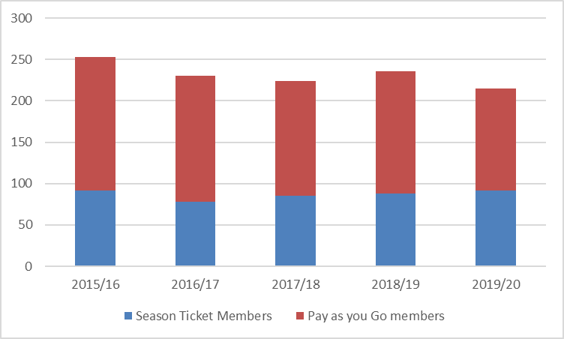

**Film Audiences and Reactions**

Audience attendance stayed level this year with an average attendance of 105 people. The best attended film was the Japanese film *Shoplifters,* 132 people saw this film, and *The Guilty* had the smallest audience at 87.

Audience reactions averaged at 79%, the highest rate in the last 5 years. The top scoring film was *The Guilty* with 90%, whilst the lowest rated film was *Foxtrot* with 64%.

|  |  |  |  |  |  |  |  |  |  |  |  |  |  |  |  |  |  |  |  |  |  |  |  |  |  |  |  |  |  |  |  |  |  |  |  |  |  |  |  |  |  |  |  |  |  |  |  |  |  |
| --- | --- | --- | --- | --- | --- | --- | --- | --- | --- | --- | --- | --- | --- | --- | --- | --- | --- | --- | --- | --- | --- | --- | --- | --- | --- | --- | --- | --- | --- | --- | --- | --- | --- | --- | --- | --- | --- | --- | --- | --- | --- | --- | --- | --- | --- | --- | --- | --- | --- |
| |  |  |  | | --- | --- | --- | | **Film** | **Attendance** | **Score %** | | Leave No Trace | 98 | 83 | | A Fantastic Woman | 90 | 78 | | Wajib | 110 | 73 | | Summer 1993 | 110 | 72 | | Cold War | 98 | 76 | | The Guardians | 93 | 75 | | Faces Places | 106 | 81 | | Shoplifters | 132 | 81 | | Foxtrot | 106 | 64 | | The Divine Order | 110 | 86 | | The Guilty | 87 | 90 | | Woman at War | 114 | 85 | | 1945 | - | - | | The Wife | - | - | | **Average** | **105** | **79** | | **Average attendance and scores**  **over the last 5 years:** |

**Marketing and Advertising**

Similarly, to the previous seasons, in 2019 we continued to write, print and distribute our traditional material for the SFS: season brochure, posters, advertisements, synopsis sheets, membership cards, reaction slips etc. Our friendly designer Rachel Martin was on board as always, and she continued to support us with all these pieces. Rachel has been most helpful, and her creative touch is always much appreciated.

When possible, we also continued to include articles and adverts in the local print media (*The Handy Mag*, the Wyvern brochure 3 times/year), and continued to receive a lot of support from *The Swindonian* team in the online space. Content has also always been shared with various other websites (*Total Guide to Swindon, Swindon Web,* Wyvern Theatre). Special thanks to Richard Turpin, our very own webmaster, who has kept our fantastic swindonfilm.org.uk website updated throughout the season, as always.

Unfortunately, as we all know, the season was cut short due to the national lockdown, and we were not able to show the last two films in March and April. All work with, and across, all these media stopped as a result, and we have not been able to promote the SFS since.

In spite of events, we did, however, decide to put ourselves in a position where we actually have a programme ready, and the entire committee worked together to line up a programme of 14 fantastic films. When a new season can finally be organised with the Arts Centre/Wyvern Theatre, we will review dates and assess how and when these films can be shown.

On a personal level, I will be leaving the committee this year due to moving away, but I have full confidence that the committee will continue to bring you many more fabulous SFS seasons in the years to come. I want to take the opportunity to thank all committee members for their kindness and friendship in the years I was active in the group, and wish all the best to everyone.

**Current Season 2020-21**

The new categories of *Season Ticket* and *Pay as You Go Ticket*, which replaced the *Full* and *General Membership* categories last season, proved to be a good idea and will be used from now on. Unfortunately, the current season which should have commenced in September, is still postponed until further notice by the coronavirus restrictions. We are looking forward to showing the films chosen for the season when the Arts Centre reopens. The films chosen generally deal with lighter social issues rather than being too pessimistic. Meanwhile, we are continuing to maintain our first-class website and seeking to improve our visibility around the town. The membership will be kept informed of developments and we welcome any comments and suggestions for future screenings.

Meanwhile, thank you for your continued support and enjoy all the films!

**Swindon Film Society - November 2020**

A member of Cinema for All / British Federation of Film Societies

swindonfilm.org.uk